Chapter 9: Segmental Ventricular Function and Ischemia

Q1: Which of the following has the least effect on the interpretation of interventricular septal wall motion:
A) Right bundle branch block (RBBB)
B) Constrictive pericarditis
C) Left bundle branch block (LBBB)
D) Right ventricular pacing

Answer: A.
RBBB “In addition, the presence of a LBBB, right ventricular (RV) volume overload, constrictive pericarditis, ventricular pacing or the postoperative state after cardiac surgery often complicates the assessment of inter-ventricular septal wall motion.”

Q2: A dobutamine stress test results are shown in the table below. Which wall is hibernating?

Dobutamine dose | Anterior wall | Anterolateral wall | Inferolateral wall | Inferior wall | Inferoseptal wall | Anteroseptal wall
0 mcg/kg/min | Normal | Hypokinesia | Akinesia | Mild hypokinesia | Normal | Normal
5 mcg/kg/min | Normal | Hypokinesia | Severe hypokinesia | Moderate hypokinesia | Normal | Normal
15 mcg/kg/min | Normal | Hypokinesia | Mild hypokinesia | Severe hypokinesia | Hypokinesia | Normal
20 mcg/kg/min | Normal | Hypokinesia | Akinesia | Severe hypokinesia | Hypokinesia | Normal

A) Anterior wall
B) Anterolateral wall
C) Inferolateral wall
D) Inferior wall

Answer: C.
Inferolateral wall. Hibernation is a state of persistently impaired myocardial function at rest from reduced coronary blood flow. Therefore, partial or complete restoration of coronary blood flow to normal is required to resolve hibernation, which involves surgery, percutaneous coronary intervention (PCI) and/or afterload reduction. Demonstration of increased contractility in a hypokinetic or akinetic region suggests that the regional systolic function will improve either after revascularization in the case of hibernating myocardium or spontaneously after recovery from stunning. A biphasic response to increasing dobutamine doses characterized by enhanced thickening at low doses (5–10 µg/kg/min) followed by deterioration of thickening at higher doses (>10 µg/kg/min) is the most accurate echocardiographic criterion to detect viable but hypoperfused myocardium.

Q3: Which of the following is true concerning myocardial rupture of the left ventricle?
A) It accounts for less than 1% of all in-hospital deaths in the post infarction period
B) It is more common in older patients
C) Anterior wall rupture is the most common site of occurrence
D) Lateral wall rupture is the most common site of occurrence

Answer: B.
Rupture of the LV free wall is usually a sudden event, which accounts for 8–17% of all in-hospital deaths in the postinfarction period. It occurs in elderly hypertensive patients with Q-wave infarcts. There is an equal distribution of myocardial rupture sites between the anterior, posterior, and lateral walls. Usually, there is an acute clinical deterioration with recurrent chest pain, massive hemopericardium, hemodynamic deterioration, electromechanical dissociation, and sudden death within minutes It is more common in older patients.

Q4 (see video Chap9_Q4): The image shown is best representative of what condition?
A) A large basal/mid anterior left ventricular (LV) aneurysm
B) A large basal/mid anterior pseudoaneurysm
C) A large basal/mid inferior aneurysm
D) A large basal/mid inferior pseudoaneurysm

Answer: C. A large basal/mid inferior aneurysm. The clip shows an aneurysm with the typical features of an akinetic segment, a wide neck that persists in diastole and a well defined subendocardium. In contrast a pseudoaneurysm is characterized by a narrow orifice arising from the ventricular chamber and represents chronic ventricular rupture which is contained by pericardium. Pseudoaneurysms have a high incidence of spontaneous rupture. The 60° image plane in the mid esophagus demonstrates the inferior wall segments on the left and anterior segments on the right.

Q5 (see video Chap9_Q5-6A and video Chap9_Q5-6B): A 70-year-old male presents with an acute MI and dyspnea. Which of the following diagnoses is most likely based on the images shown?
A) Pericardial tamponade
B) Left ventricular (LV) to right atrial fistula
C) LV pseudoaneurysm
D) Ventricular septal defect (VSD)
E) Ruptured sinus of Valsalva aneurysm

Answer: D.
Ventricular septal defect. There is septal drop-out between the LV and right ventricle suggestive of a VSD. Color Doppler also reveals left-to-right shunt through the defect. The associated aneurysm on the clip is a true aneurysm.

Q6 (see video Chap9_Q5-6A and Chap9_Q5-6B): Which coronary artery is most likely to have been occluded to result in the pathology demonstrated?
A) Left anterior descending (LAD) artery
B) Septal perforator artery
C) Circumflex artery
D) Right coronary artery (RCA)

Answer: D.
Right coronary artery. The lesion is in the mid inferoseptal segment, which is supplied by the RCA.

Q7: Which sentence of the followings is correct about coronary circulation?
A) System dominance is defined by the artery providing the posterior descending artery (PDA)
B) System dominance is defined by the artery providing the postero-lateral artery (PLA) branch
C) The posterior descending artery arises from the right coronary artery (RCA) in 20% of patients
D) The posterior descending artery arises from the circumflex in 80% of patients

Answer: A
An artery providing the PDA and the PLA defines coronary arterial system dominance. The commonest pattern is right dominance in about 85% by the RCA

Q8: What is the structure marked by the arrow?
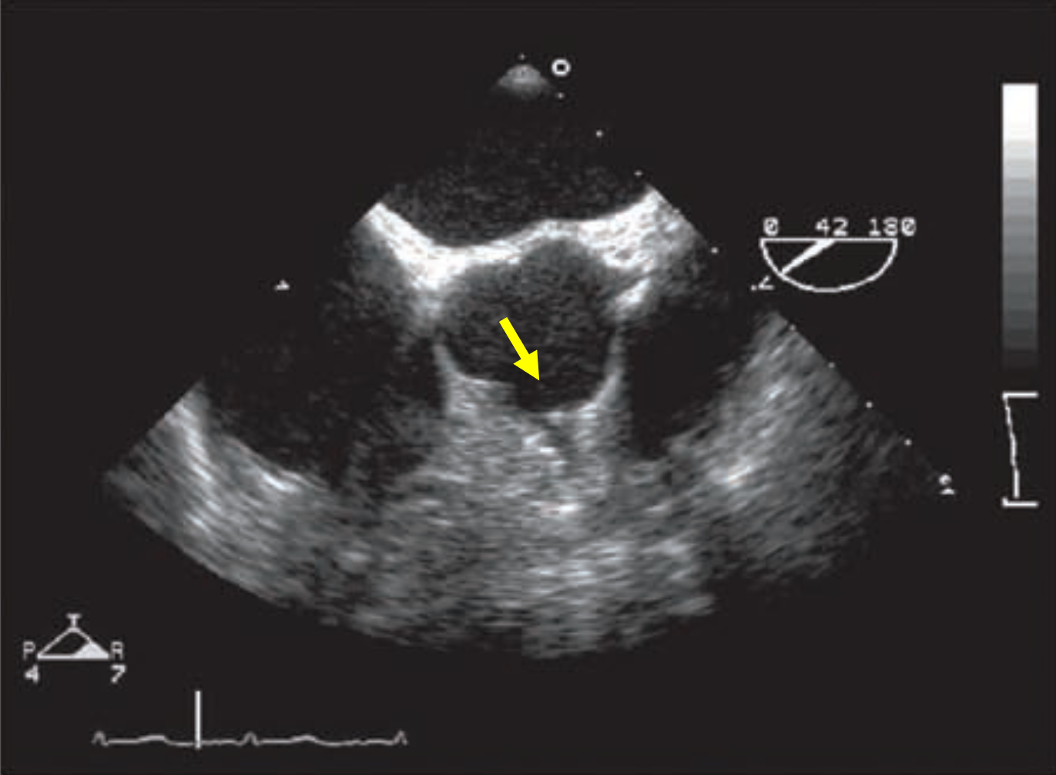
A) Left main coronary artery
B) Left anterior descending artery
C) Left circumflex artery
D) Right coronary artery

Answer: D.
The right coronary artery can be seen in some patients intraoperatively.
(see video Chap09_Q8)
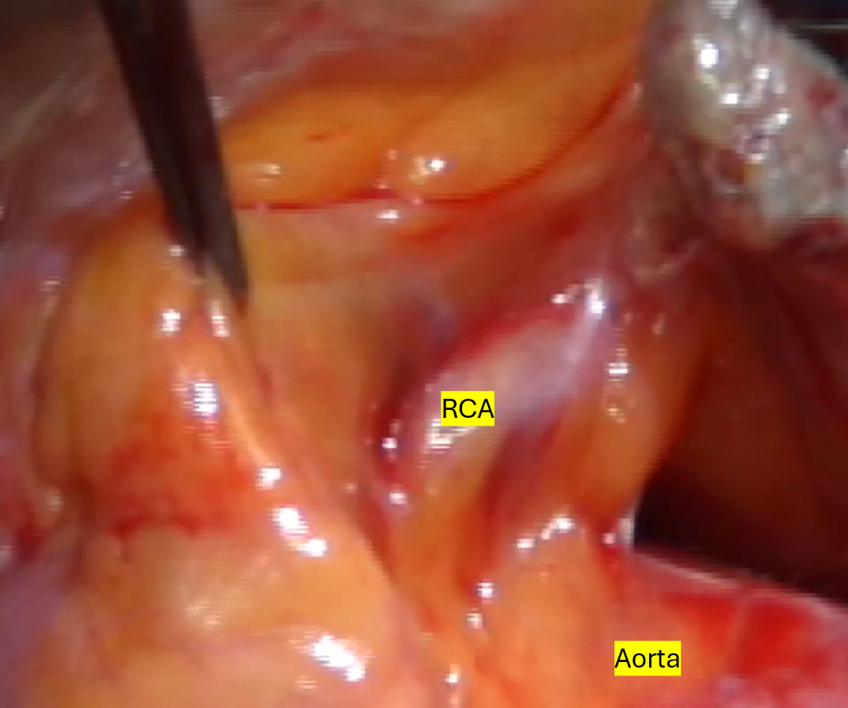

Q9: Which sentence of the followings is incorrect?
A) Acute ischemia is usually manifested as a regional wall motion abnormality
B) Global ventricular dysfunction may result from high-grade obstruction of one or more arteries perfusing a large area
C) Global ventricular dysfunction may result from the acute obstruction of one artery in the setting of previous infarction in other areas.
D) Global hypokinesia rule out coronary artery disease as a cause of left ventricular (LV) dysfunction

Answer: D
Although acute ischemia appears echocardiographically as regional wall motion abnormality (RWMA), global ventricular dysfunction may result from high-grade obstruction of one or more arteries perfusing a large area, acute obstruction of one artery with a previous infarction in other areas or an ischemic mechanical complication such as papillary muscle rupture

Q10: Which sentence of the followings is incorrect?
A) Segmental wall motion abnormality is defined as hypokinesis when contraction is normally directed, but reduced in magnitude
B) Segmental wall motion abnormality is defined as akinesis when the contraction is absent
C) Segmental wall motion abnormality is defined as dyskinesis when there is systolic bulging
D) Segmental wall motion abnormality is defined as dyskinesis when there is diastolic bulging

Answer: D
The assessment of regional myocardial function is by observing wall thickening and endocardial motion of the myocardial segment. A regional wall motion abnormality (RWMA) is hypokinetic when contraction is inwards but reduced in magnitude, akinetic when it is absent, or dyskinesis when there is a movement in the opposite direction (systolic bulging)

Q11: According to Wall Motion Score Index, a score of 4 is given for?
A) Aneurysmal segment
B) Dyskinetic segment
C) Hypokinetic segment
D) Akinetic segment
E) Hyperkinetic segment

Answer: B
A score of 1 is a normal contracting or hyperkinetic segment, 2 is a hypokinetic segment, 3 is akinesis, and 4 is a dyskinetic segment or aneurysmal (diastolic deformation) segment.

