Chapter 11
Cardiomyopathy

Q1: In patients with severe hypertrophic cardiomyopathy, subaortic obstruction is characterized by which of the following?
A) Mid-systolic closure of the aortic valve
B) Late peaking high velocity in the outflow tract
C) Systolic anterior motion of the mitral leaflet
D) All of the above

Answer: D.
All of the above. As the left ventricular outflow tract (LVOT) obstruction begins in mid- or late systole, the aortic cusps may close prematurely as a result of the reduced flow in the later half of the ejection period. This mid-systolic closure is best appreciated using M-mode of the aortic valve (AoV) at the mid-esophageal long-axis (LAX) view.” “The LVOT obstructive dynamic gradient is late peaking and significantly rises in mid- to late systole. The CW Doppler velocity profile takes a characteristic dagger shape in contrast to the more symmetrical shape of a fixed valvular stenosis or a regurgitant jet of MR. Maneuvers to modify the loading condition should unmask latent LVOT or mid- ventricular obstructions. Performing a Valsalva maneuver or inhalation of amyl nitrite is often impractical in sedated patients; instead, intravenous or sublingual nitroglycerin administration can be used to decrease preload and, to a lesser extent, afterload to provoke or enhance the obstruction. The systolic anterior motion (SAM) of the mitral valve (MV) and its contact with the septum is best evaluated in the mid-esophageal five chamber or LAX views. The extent and duration of the mitral-septal contact can also be appreciated using M-mode of the left ventricle (LV) in the same views. Significant LVOT obstruction is present when the septal contact lasts at least 30% of the systole duration, giving the highest SAM severity grade of 4+.

Q2: In addition to two-dimensional imaging, which of the following signs is associated with poor left ventricular systolic function:
A) Premature mitral valve closure
B) Increased mitral E-point to septal separation
C) Left atrial enlargement
D) Tricuspid regurgitation

Answer: B.
Increased mitral E-point to septal separation “Increased mitral E-point to septal separation is due to a combination of left ventricular dilatation and reduced mitral leaflet motion due to low transmitral flow rates. “

Q3: Which complication is the most frequent after the surgical procedure required to treat the pathology shown in the following echocardiography image?
A) Significant mitral regurgitation
B) Complete heart block
C) Ventricular septal defect
D) Systolic anterior motion of the mitral valve

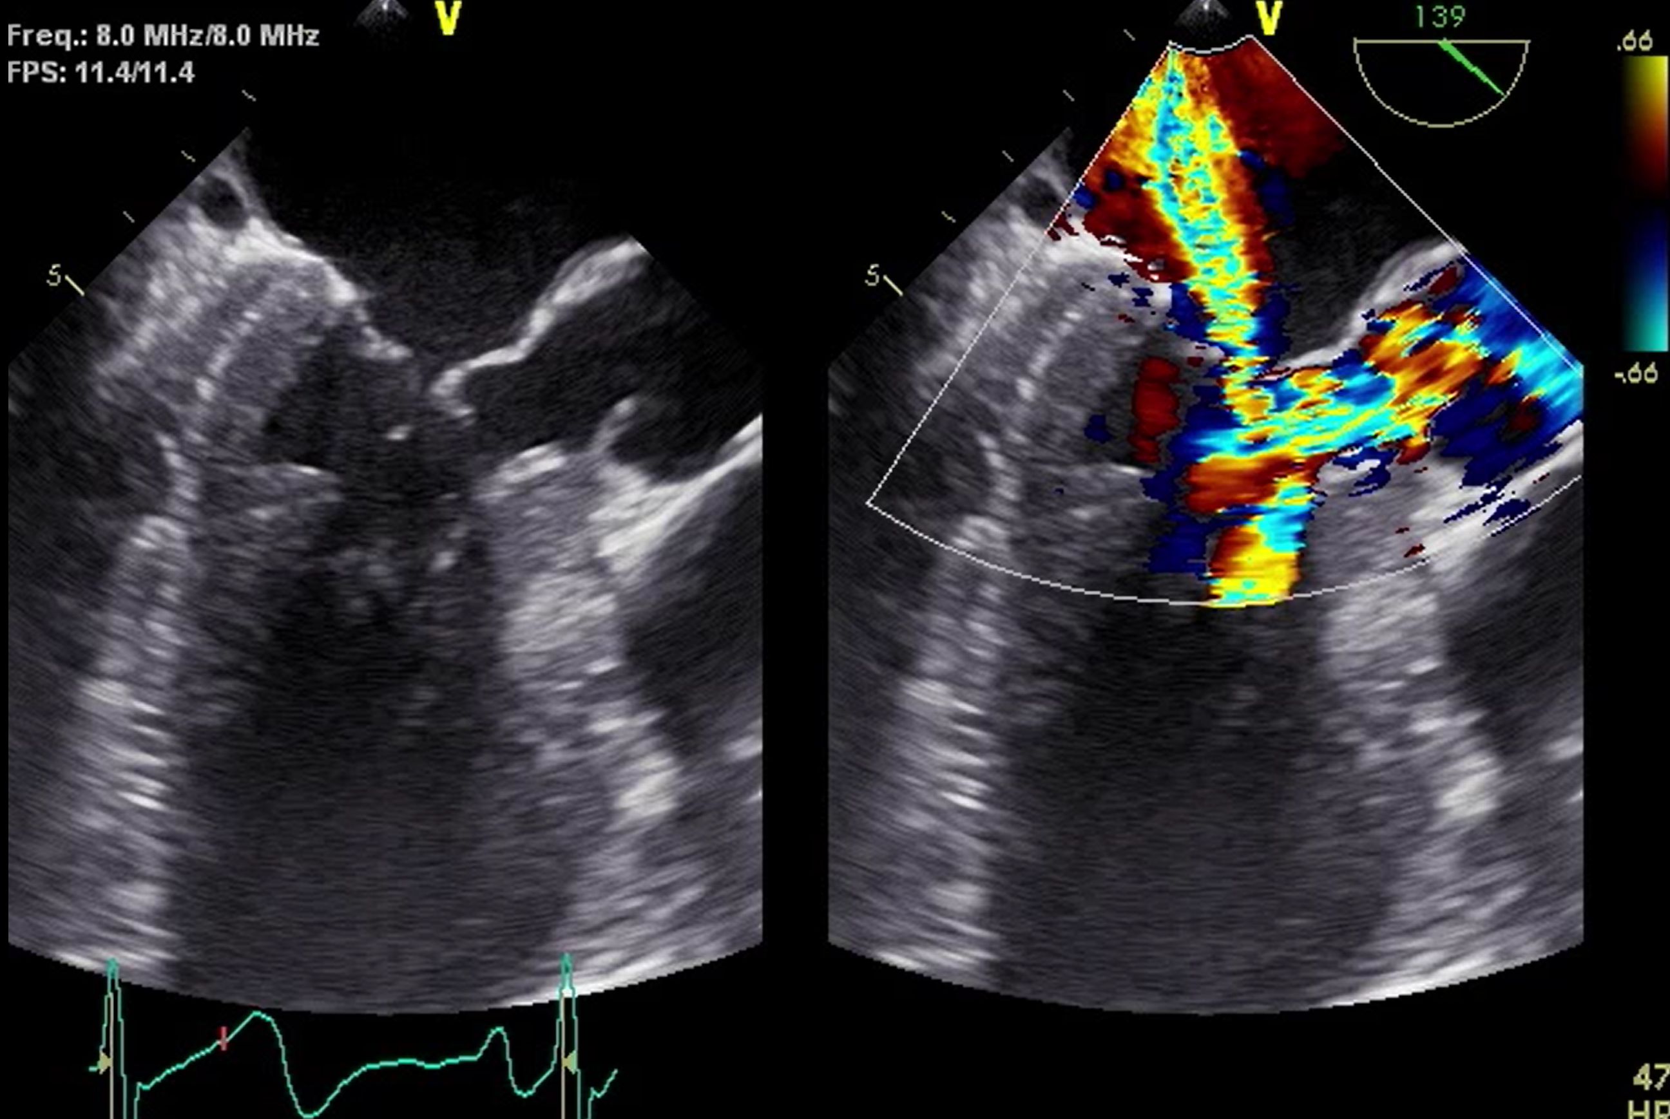

Answer: B.
Complete heart block “Excessive muscle resection can create complete AV block (7% of cases) or a ventricular septal defect, either acutely or during the healing period.”

Q4 (See video Chap11_Q4). This patient develops hypotension after aortic valve replacement. Treatment of hypotension involves all of the following, with the exception of:
A) Volume replacement
B) Phenylephrine infusion
C) Vasopressin infusion
D) Dobutamine infusion

Answer: D.
Dobutamine infusion. Caring for a hypertrophic obstructive cardiomyopathy (HOCM) patient can be challenging, as inotropes and vasodilators can, paradoxically, decrease cardiac output (CO) by increasing LVOT obstruction. Invasive hemodynamic monitoring with Swan-Ganz catheter demonstrates elevated filling pressures that are difficult to interpret with significant diastolic dysfunction. Transesophageal echocardiography is particularly useful in providing direct evaluation of LVOT obstruction, SAM, and degree of mitral regurgitation (MR). By integrating hemodynamic and echocardiographic monitoring data, it is easier to administer the ideal amount of fluid or to introduce and titrate drugs that reduce the inotropic state (calcium channel blockers, β- blockers) or increase systemic vascular resistance (vasopressors) to minimize LVOT obstruction.

Q5: The M-mode image shown is most consistent with which of the following?
A) Diastolic heart failure
B) Dilated cardiomyopathy (CMP)
C) Hypertrophic obstructive cardiomyopathy (HOCM)
D) Restrictive CMP
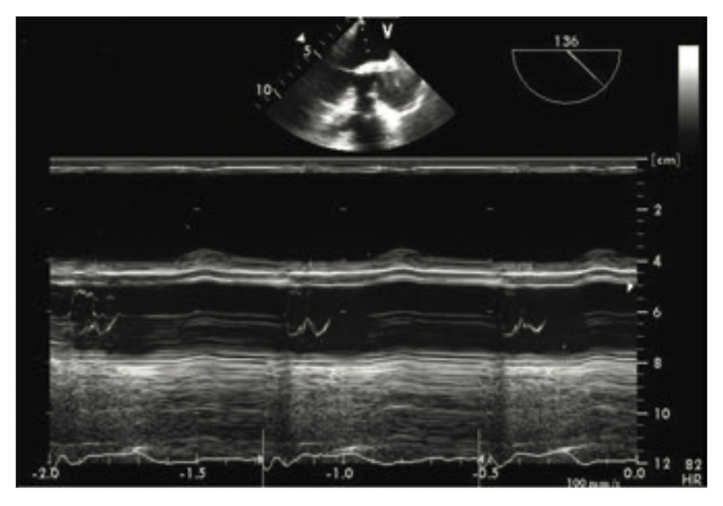
Answer: C.
HOCM “This mid-systolic closure is best appreciated using M-mode of the aortic valve (AoV) at the mid-esophageal long-axis (LAX) view. “

Q6: Which sentence of the followings is correct about hypertrophic cardiomyopathy?
A) This disorder has an estimated prevalence of 1/500 individuals in the general population
B) It can be found in 0.5% of the patients referred for an echocardiogram
C) The estimated annual mortality rate is 1% to 2% with sudden death, the first manifestation in as many as 10%.
D) All of the above

Answer: D
HCM is the commonest inherited cardiomyopathy, with an estimated prevalence of 1:500 to 1:200. The estimated annual mortality rate is around 3% whereas sudden death is often the first disease manifestation.

Q7: What is the percentage of apical hypertrophy in patients with hypertrophic cardiomyopathy in western country?
A) 0.5%
B) 1-10%
C) 15%
D) 20%
E) 38%

Answer: B
Apical hypertrophic cardiomyopathy (apHCM) is a phenotypic variant of HCM involving the LV apex. Accounting for 1 to 10% of HCM patients in Western countries, apHCM is more prevalent (38%) in Asia.

Q8: Which sentence of the followings is incorrect about hypertrophic cardiomyopathy?
A) The mitral valve (MV) may be intrinsically abnormal
B) The papillary muscles can be displaced anteriorly
C) The mitral leaflets can be elongated
D) This end-stage HCM is different from dilated cardiomyopathy (DCM)

Answer: D
However, longstanding HCM might develop, with the replacement of hypertrophic segments by thinner, dysfunctional fibrotic wall dilating the LV systolic and diastolic dimensions. This end-stage HCM is indistinguishable from DCM.

Q9: These images were obtained before and after giving a certain drug. Which medication of the followings is mostly given for this case?
A) IV digoxin
B) IV furosemide
C) IV amiodarone
D) IV metoprolol

Answer: D
The initial management of asymptomatic HCM patients with LVOTO is with negative inotropic drugs such as non-vasodilating beta-blockers or non-dihydropyridine calcium channel blockers.

Q10 Which of the following options would be the best additional therapy for a patient presenting with hypotension and this echo image? (See video Chap11_Q10)
A) Increase with epinephrine infusion dose
B) Sodium nitroprusside infusion
C) Intra-aortic balloon counterpulsation
D) Increase the phenylephrine dose

Answer: D
Systolic anterior motion is best treated medically with additional intravascular volume administration or by the increasing of afterload such as with increasing doses of phenylephrine. Increasing the epinephrine infusion would more than likely increase the dynamic outflow tract obstruction, as would decreasing the afterload with sodium nitroprusside, or IABP insertion.

