Chapter 12:
Pericardium

Q1: Regarding the echo findings in cardiac tamponade, from the following choose the best answer:
A) Right atrial systolic collapse
B) Blunted tricuspid inflow peak velocities
C) Right ventricular systolic collapse
D) Evidence of excess pericardial fluid

Answer: A. During cardiac tamponade, the intrapericardial pressure exceeds the right atrial systolic pressure, leading to inversion or systolic collapse of the right atrial free wall. This is recognized as an early sign of tamponade, as the right atrium is the one with the lowest intracavitary pressure. When this collapse lasts for more than one-third of systole, is a sensitive (nearly 100%) and specific indicator of cardiac tamponade diagnosis. The mid-esophageal four-chamber view is probably the best view to visualize this collapse. The presence of early diastolic collapse of the right ventricle, is more specific but less sensitive to diagnose tamponade when compared to right atrium collapse.”

Q2: Which would be expected in patients with constrictive pericarditis but not in restrictive cardiomyopathy (RCM)?
A) Lateral mitral valve annular tissue Doppler E_{m} < 7 cm/s
B) Exaggerated Doppler respiratory variations in transmitral and transtricuspid inflow velocities
C) Biatrial enlargement
D) Moderate to severe pulmonary hypertension

Answer: B.
Exaggerated Doppler respiratory variations in transmitral and transtricuspid inflow velocities are present in constrictive pericarditis. Newer techniques like tissue Doppler imaging (TDI) of the mitral annular motion or color M-mode seems promising in discriminating the two pathologies. In RCM, the mitral annular e velocity is decreased while in constrictive pericarditis the e velocity e is usually >7 cm/s; with color M-mode, mitral flow propagation velocity is <45 cm/s in RCM Some other but less specific findings such as elevated pulmonary pressures, more than moderate MR (or TR) or increased wall thickness may all suggest the presence of RCM. In contrast, finding a thickened or calcified pericardium and annulus reversus where the septal e velocity is higher than the lateral e velocity suggests constrictive pericarditis.

Q3: Which would be expected with a patient with tamponade physiology during spontaneous inspiration?
A) Exaggerated tricuspid peak flow velocity increases by 20%
B) No change in tricuspid or mitral peak flow velocities
C) A decrease in stroke volume through the pulmonic valve
D) An increase in stroke volume through the left ventricular outflow tract (LVOT)

Answer: A.
Exaggerated transtricuspid peak flow velocity increases by 20% “With normal physiology, small increases (<15%) in tricuspid and pulmonic peak flow velocities and right ventricular (RV) stroke volume (SV) and corresponding decreases (<10%) in left-sided parameters are seen during inspiration (Figure 12.17). These respiratory variations are markedly increased in tamponade. Both tricuspid and pulmonic valve peak velocities nearly double with spontaneous inspiration, while both mitral (E velocity) and aortic valve (MV, AoV) velocities are decreased by more than 25%.

Q4 (see video Chap12_Q4): A 68-year-old male develops unexplained hypotension twelve hours after his coronary artery bypass graft procedure. An emergent TEE is performed in the cardiac intensive care unit. Which of the following most accurately reflects the diagnosis?
A) Aortic dissection
B) Cardiac tamponade
C) Pericardial effusion
D) Anterior wall myocardial ischemia

Answer: B.
Cardiac tamponade The image displayed is the transgastric two-chamber view. A large pericardial collection with thrombus is demonstrated in association with reduced left ventricular filling volume.

Question 5 (see video Chap12_Q5): In the video shown, what is the diagnosis?
A) Right pleural effusion
B) Left pleural effusion
C) Pericardial effusion
D) Both left pleural effusion and pericardial effusion

Answer: B.
Left pleural effusion. Pericardial and pleural effusions may coexist in the same patient. They can be recognized by locating the position of the descending thoracic aorta and by identifying the pericardium as the membrane separating the two echo-free spaces. Indeed, the presence of a small pericardial effusion often aids in the accurate identification of a pleural effusion. Note also the thickening of the aortic wall consistent with an aortic hematoma.

Q6: What is the structure marked by the arrow?
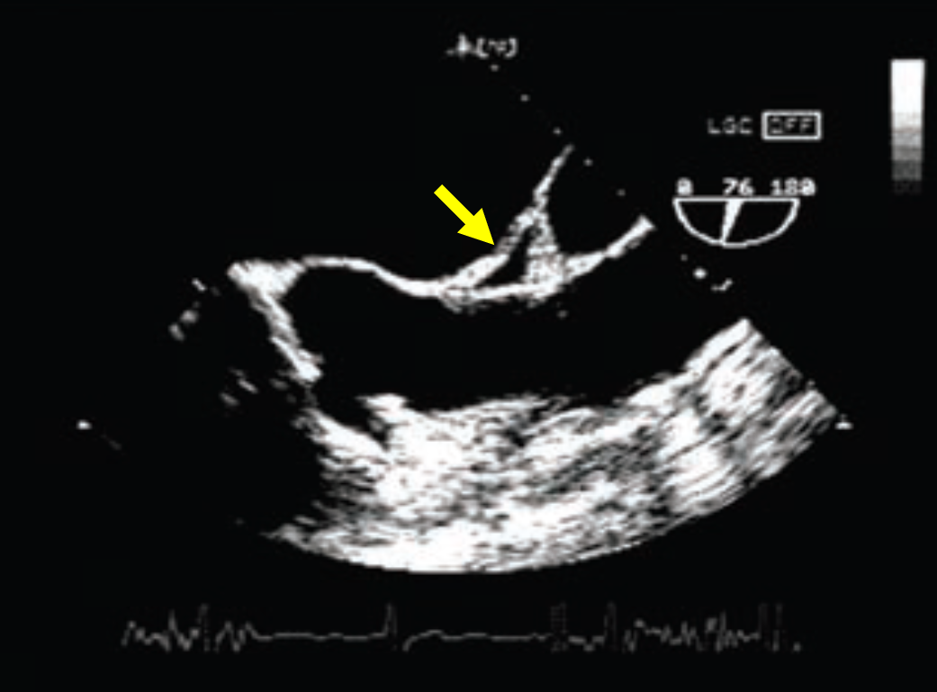
A) Transverse pericardial sinus
B) Oblique pericardial sinus
C) Aortic root abscess
D) Right pulmonary artery

Answer: A
The transverse sinus rests beneath the ascending aorta and pulmonary artery, on the superior surface of the left atrium

Q7: What is the structure marked by the arrow?
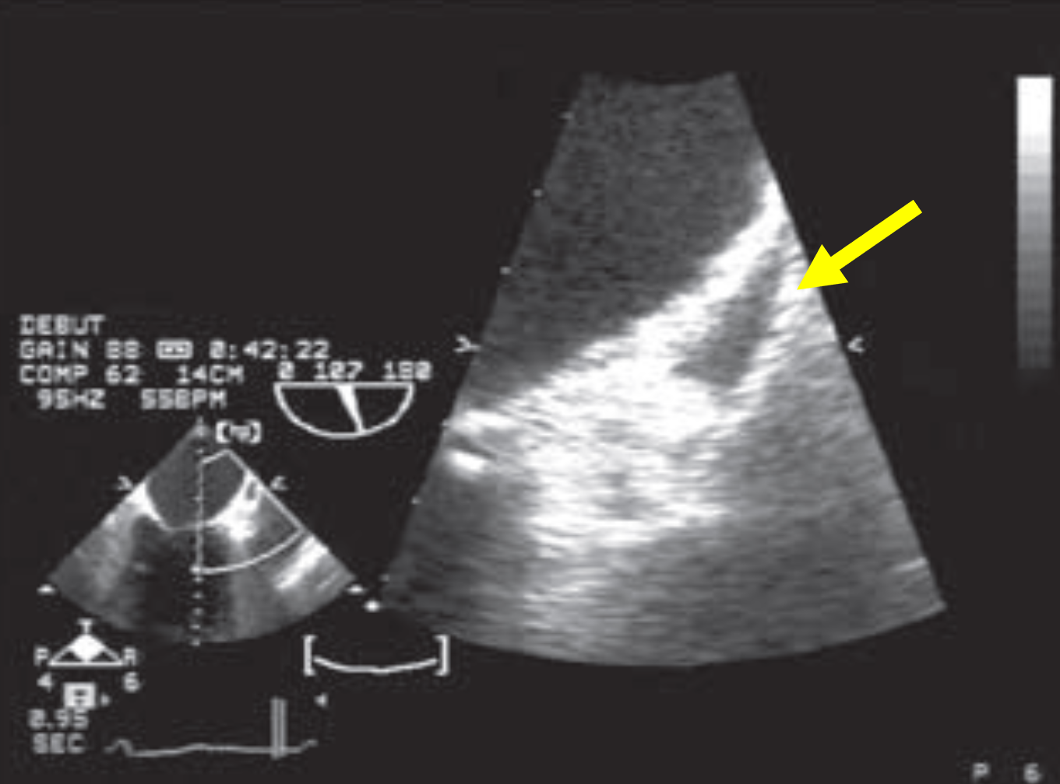
A) Left atrial appendage
B) Aortic root abscess
C) Pericardial effusion
D) Right pulmonary artery

Answer: C
A pericardial effusion appears on echocardiography as an echolucent space between the parietal and visceral pericardial layers.

Q8: What is the structure marked by the arrow?
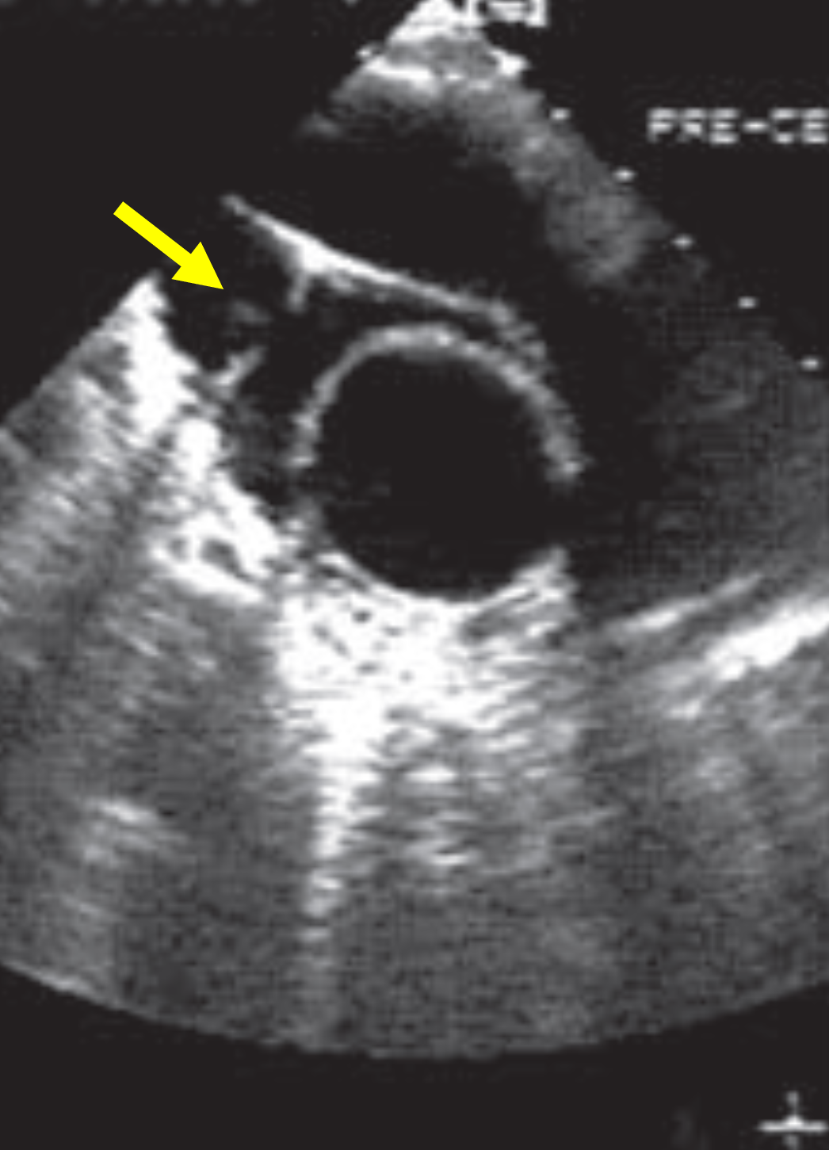
A) Main pulmonary artery
B) Superior vena cava (SVC)
C) Pericardial effusion
D) Right pulmonary artery

Answer: B
Note also that anechoic region between the SVC and ascending aorta corresponding to fluid in the transverse sinus.

Q9: Which sentence of the followings is incorrect?
A) In the mid-esophageal (ME) four-chamber (4C) view, an isolated echo-free space superior to the right atrium (RA) most likely represents pleural fluid.
B) In the ME 4C view, an isolated echo-free space superior to the right atrium (RA) most likely represents pericardial fluid.
C) The echo-free space is posterior to the descending thoracic aorta in the case of a pleural effusion
D) In the ME 4C, an isolated echo-free behind the left atrium (LA) most likely represents pericardial or pleural fluid.

Answer: A
A left pleural effusion may mimic a pericardial effusion, with the fluid located posterior to the descending aorta in a TTE parasternal long axis view or in a TEE descending aorta short axis view. When the fluid location is between the descending aorta and heart, the fluid is pericardial rather than pleural

Q10: Which sentence of the followings is incorrect?

A) Cardiac tamponade occurs when a pericardial pressure causes the pericardial pressure to exceed the intracardiac pressure, resulting in impaired cardiac filling
B) The amount of fluid is more important than the rapidity of fluid accumulation for the occurrence of tamponade
C) A slowly expanding pericardial effusion (PE) can become quite large (up to 1000 mL) with little increase in pericardial pressure
D) Rapid accumulation of fluid, with a volume as small as 100 mL, may be sufficient to cause cardiac tamponade.

Answer: B
When a moderate to large PE generates enough pressure to exceed the intracardiac pressure, this causes cardiac tamponade, a life-threatening condition that impairs cardiac filling. The amount of pericardial fluid alone is of less importance than the rapidity of fluid accumulation for tamponade to occur.

