Chapter 13 :
Echocardiography During Cardiac Surgery

Q1: Which of the following TEE views can help coronary sinus catheter insertion?
A) Lower esophageal view at 0°
B) Bicaval view at 100°
C) Transgastric right ventricular longitudinal view at 90°
D) All of the above

Answer: D.
All of the above.
The lower esophageal level at 0° can image the CS in long-axis. However, a modified bicaval view at 100 ±10° best provides catheter guidance while locating the orifice of the sinus from this plane: as the inferior vena cava (IVC) appears, rotating the probe shaft toward the patient’s left; can identify the CS following its course in the left atrioventricular groove, where it appears in cross -section as a circular structure. A transgastric right ventricular (RV) longitudinal view at 90° can also show the CS.

Q2: How often is a left superior vena cava can be observed in adult?
A) 0.5%
B) 1%
C) 2%
D) 5%

Answer: A
Finally, during difficult catheter insertion, TEE may disclose a persistent left SVC known to be present in 0.5% of adults and 1% of children The left SVC usually connects to the RA dilating the coronary sinus (CS) but may sometimes open into the left atrium (LA) (unroof CS), resulting in a right-to-left shunt. Catheter tip placement in the CS via a persistent left SVC may lead to arrhythmias or angina and preclude the insertion of a retrograde cardioplegia catheter.

Q3: What would you tell the surgeon before insertion of the retrograde cardioplegia canula based on this video (see video Chap13_Q3)
A) The coronary sinus is too small
B) There is an Eustachian valve that would impede insertion of the catheter
C) There is a Thebesian valve that would impede insertion of the catheter
D) The coronary sinus is of adequate dimension

Answer C
CS catheter insertion from the RA is often uncomplicated and its position easily confirmed by palpation and pressure tracing measurements. However, difficult insertion may be anticipated when ostial abnormalities, the thebesian valve and a small or stenotic sinus from previous procedures, are present. In these circumstances, TEE can assist cannulation, and confirm and monitor adequate or aberrant catheter placement

Q4 Following the beginning of cardiopulmonary bypass, you observe the following (see video Chap13_Q4). Which statement is incorrect
A) This is a rare complication occurring in less than 0.2%
B) The mortality is higher when present before cardiopulmonary bypass than post-operatively
C) High suspicion and the rapid increase in aortic dimensions and/or a color change visually perceivable in the ascending or transverse aorta constitute keys to an early diagnosis <
D) It can be missed by TEE

Answer: B
Disruption of atherosclerotic plaques or thrombi and dissection may occur during aortic manipulation with cannulation, cross-clamping, side-clamping, and clamp removal. The frequency of intraoperative aortic dissection during cardiac surgery is infrequent at 0.16%. While its mortality rises to 20% when discovered intraoperatively versus 50% for dissections diagnosed postoperatively. High suspicion and the rapid increase in aortic dimensions and/or a color change visually perceivable in the ascending or transverse aorta constitute keys to an early diagnosis. TEE can miss an acute aortic type A dissection limited to the distal ascending aorta and/or proximal aortic arch

Q5 (see video Chap13_Q5): In the video shown, what would you suggest to the surgeon?
A) Allow the air to flow out of the ascending aorta through an aortic root vent or the antegrade cardioplegic with the patient’s head down
B) Aspirating air through fine needles located in the LA or the LV apex
C) Expelling air out of the LV by agitation
D) All of the above

Answer: D.
All of the above Intracoronary and intracardiac air. ME AoV LAX view in a 70 year-old man undergoing aortic valve replacement. Air bubbles are directed into the right coronary artery (RCA) and in the ascending aorta

Q6 What is shown in this image (see video Chap13_Q6)?
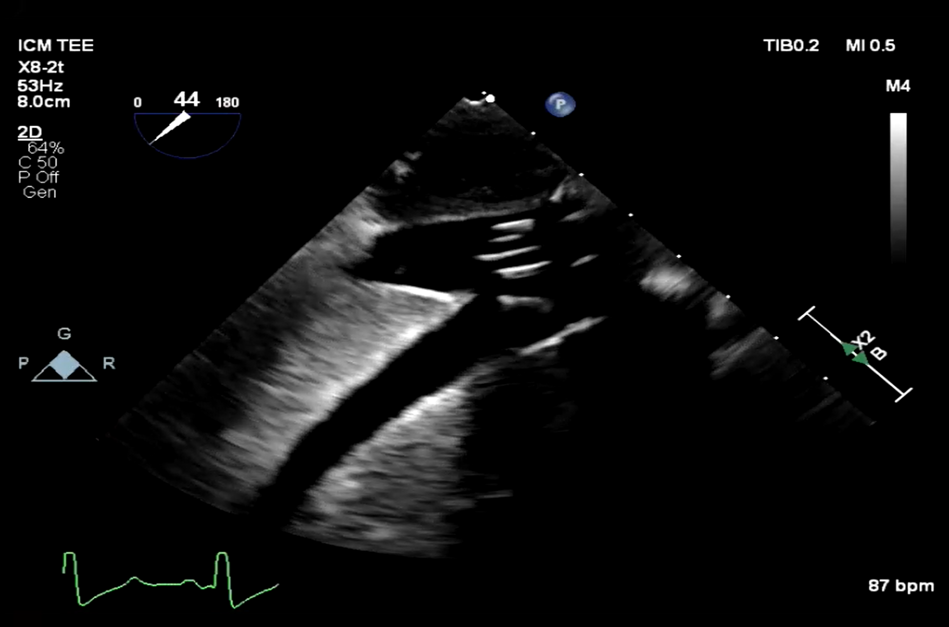

A) There are 2 inferior vena cava (IVC) canula
B) The IVC canula is not adequately positioned
C) There is a mirror image of the IVC canula
D) The IVC canula is not deep enough

Answer C
This is an example of a mirror image of the IVC canula which is well positioned otherwise. During venous cannulation, IVC cannula malposition in a suprahepatic vein impairs venous return to the CPB reservoir, and, when recognized, repositioning the cannula under TEE guidance can easily correct this.

Q7 What is the most likely cause of hemodynamic instability after cardiopulmonary bypass in this patient after heart transplantation (see video Chap13_Q7)?

A) Iatrogenic tricuspid stenosis
B) Iatrogenic inferior vena cava stenosis
C) Right upper pulmonary vein stenosis
D) Persistent mitral stenosis

Answer B
Exclusion of obstruction to IVC flow from iatrogenic stenosis following cannula removal should involve identifying a dilated IVC and reduced or absent hepatic venous flow

Q8 Why this patient became hemodynamic unstable upon sternal closure following coronary revascularisation? (see video Chap13_Q8)
A) Cardiac tamponade
B) Myocardial ischemia
C) Hypovolemia
D) Diastolic dysfunction

Answer B
During sternal closure, mammary artery flow can be compromised resulting in regional wall motion abnormality which are reversible upon reopening the sternum

Q9 Unstable after cardiac surgery for coronary revascularisation. What is the structure identified by the arrow (see video Chap 13_Q09)?
A) Cardiac hematoma
B) Thickened pericardium
C) Pericardial fat
D) Pericarditis.

Answer C
This is typical of a pericardial fat commonly observed in patients with obesity or dyslipidemia. Note the homogenous and non intense signal which is similan on the anterior portion of the heart. Echocardiographic differentiation of epicardial fat and pericardial effusion can be subtle. Epicardial fat is usually more echogenic or granular, less mobile, and located more anterior than the posterior pericardial effusion.

Q10. Why is this 49 year-old man unstable after a Ross procedure? (see video Chap13_Q10)
A) Myocardial ischemia
B) Air embolisation
C) Hypovolemia
D) Right ventricular dysfunction

Answer: B.
The most frequent location of intracardiac air in patients undergoing left cardiotomy is the RUPV, followed by the LV, LA, and right sinus of Valsalva. Air will typically go in the right coronary artery and end up into the inferior wall of the left ventricle as in this patient.

