Chapter 15
Aortic Valve Surgical and Non-Surgical Management

Q1-Which one of the following statements is correct (see videos, Chap15_Q1 A to Chap 15_Q1D)?
A) The aortic valve (AoV) appears normal in structure
B) There is a prolapse of the left coronary cusp
C) There is a prolapse of the right coronary cusp
D) There is mild aortic insufficiency
E) There is a dissection of the aortic wall

Answer C
Cusp prolapse is present whenever the free edge of one or more AoV cusps overrides the aortic annular plane. As in mitral valve (MV) prolapse, the resulting regurgitant jet is eccentric in the opposite direction to the pathologic cusp. A right coronary cusp (RCC) prolapse gives rise to a posterior jet, while left coronary cusp (LCC) or non-coronary cusp (NCC) prolapse will cause an anterior jet. Here, the short-axis (SAX) analysis and multiplane reconstruction (MPR) of the AoV will help distinguish between a prolapse of the LCC or the NCC.

Q2-Which surgical option is the most appropriate?
A) A valve sparing procedure with associated cusp repair
B) A tube graft to the ascending aorta
C) A Bentall procedure
D) Isolated repair of cusp prolapse

Answer A
One or more aortic cusps can have an excess of tissue or mobility, resulting in some cusp prolapse. There are 3 types of cusp prolapse based on the portion of the cusp overriding the plane of the aortic annulus, as described in Chapter 14. Surgical correction of a cusp prolapse usually comprises a triangular resection, or plication, of the middle portion of the prolapsing cusp occasionally with reinforcement of the free edge by an over-and-over suture. This is sometimes associated with a sub-commissural plasty made at the level of the inter-leaflet triangles.

Q3- The patient underwent an AoV sparing reimplantation with a Valsalva prosthesis, Non-coronary cusp (NCC) plication and free margin resuspension of the 3 aortic cusps. Which one of the following statements is correct (see video Chap15_Q3A and Chap15_Q3B)?
A) Risk of recurrent AoV regurgitation and need for reoperation within 8 years is high
B) This is a good result
C) Cusp coaptation length is adequate
D) Aortic regurgitation is mild and acceptable
E) There is no residual cusp prolapse

Answer A
The more predictive criteria of AoV repair failure are the level at which coaptation occurs and the effective height (eH). In fact, the level of cusp coaptation should be above the aortic annulus; if there is residual billowing or prolapse, the risk for recurrent AoV regurgitation is >70%. The eH should be ≥ 9mm and reach the middle of the sinus of Valsalva. The coaptation length should be ≥ 4mm to avoid a 30 to 40% chance of recurrent AR in follow-up.

Q4- All those factors would favor transcatheter aortic valve implantation instead of surgical aortic valve replacement except?

A) High surgical risk
B) Mild mitral regurgitation
C) High SYNTAX score
D) Porcelain aorta

Answer: C.
The SYNTAX score derives from the coronary angiogram and describes the complexity of coronary artery disease (CAD). The SYNTAX score is the sum of the points assigned to each lesion in vessels with >50% diameter narrowing in vessels > 1.5 mm diameter. The coronary tree is divided into 16 segments. Many characteristics contribute to the score, including bifurcation and trifurcation lesions, ostial lesions, tortuosity, length of the lesion, calcifications and thrombus. A computer algorithm calculates a sum value for the SYNTAX score: low < 18, intermediate range from 18 to 27, and high score > 27. Surgical aortic valve replacement is recommended in patients with high SYNTAX score > 32. (See Figure 15.3)

Q5 67-year-old man with previous aortic valve replacement. Based on the following figures (mean gradient 13 mmHg) and video Chap15_Q5, what is the severity of the prosthetic aortic valve?
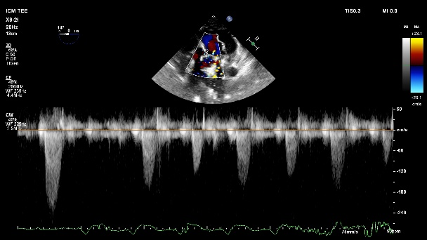
A) Moderate prosthetic aortic valve stenosis
B) Severe prosthetic aortic valve stenosis
C) The prosthetic aortic valve is most likely severe due to significant left ventricular cardiomyopathy
D) Transcatheter aortic valve implantation should be considered

Answer: C
In order to evaluate the severity of aortic valve prosthesis, it is important to obtain Doppler velocities across the aortic valve in order to calculate the DVI or Doppler velocity index which is the ratio of the velocity of the left ventricular outflow tract over the velocity of the prosthetic valve. In patients with severe left ventricular dysfunction, the mean gradient across the prosthetic valve will be reduce and not reflect the severity of the stenosis. Severe AS may occur with a lower transvalvular gradient and velocity in patients with a low cardiac output. This patient was schedule for heart transplantation.

Q6 46-year-old woman with unicuspid aortic valve stenosis. Is she a candidate for a Ross procedure? (see Video Chap15_Q6A, Chap15_Q6B and Chap15_Q6C)
A) The Ross procedure can be performed
B) The left ventricular strain is abnormal and a ross procedure should not be performed
C) The aortic valve is too calcified to consider a Ross procedure.
D) There is more that trace pulmonary valve regurgitation and am epicardial echocardiography of the pulmonic valve should be performed.

Answer D.
In a Ross procedure, TEE should carefully evaluate both the aortic and the pulmonic valve prior to cardiopulmonary bypass (Figure 15.24, see Figure 6.22). Multiple studies have shown that the main predictors of late pulmonary autograft failure are pre-operative aortic regurgitation, an aortic annulus ≥27 mm and a size mismatch between the aortic and pulmonary annuli. Pulmonic regurgitation is a relatively common finding, and any PR with a jet length of < 10 mm is normal or physiologic. Dense, broad-based jets as seen in this patient are more likely to reflect severe PR, regardless of jet length or area. In doubt, epicardial echocardiography should be performed. In this case, it revealed a significant PR and the Ross procedure was canceled. Abnormal left ventricular strain is not currently used as a criteria in Ross procedure.

Q7 Following aortic valve replacement, the following was observed (see Video Chap15_Q7A)
A) A right upper pulmonary vein stenosis was present
B) A ventricular septal defect was present
C) There is color Doppler acceleration in the superior vena cava
D) There is a right coronary fistula

Answer: C
This view is a transgastric view where the right atrium is in the middle, tricuspid valve on top and superior vena cava (SVC) on the bottom. Acceleration in the SVC can result in a SVC syndrome (see Figure 13.11). In this case, the SVC compression was a result of external compression by sponges. Removal of those result in normalisation in the color Doppler signal (see video Chap 15_Q7B)

Q8 55-year-old man hemodynamically unstable after a Ross procedure. Identify the mechanism? See figure and see video Chap15_Q8A and Chap15_Q8B
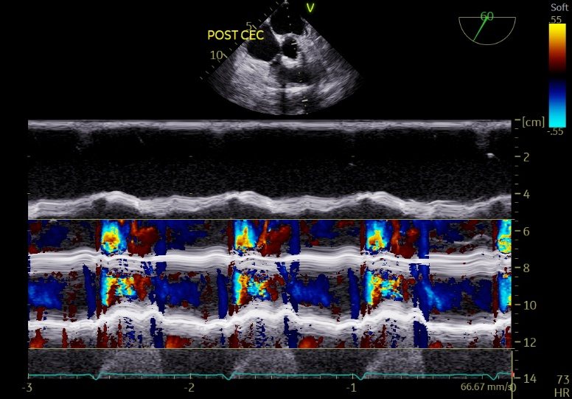

A) Right ventricular outflow tract obstruction
B) Hypovolemia
C) Vasodilatation
D) Diastolic dysfunction

Answer A
Those mid-esophageal and transgastric views illustrate dynamic right ventricular outflow tract obstruction (RVOTO) that can occur in any conditions associate with increased right ventricular (RV) contractility or reduced RV afterload. It is possible to monitor simultaneous the RV and pulmonary artery pressure (PAP) waveform from the RV pacing port of a PAC to confirm the diagnosis. (See Figure 10.30) Color M-mode should show the simultaneous appearance of RVOT collapse and associated flow acceleration. If the continuous wave Doppler tricuspid regurgitation pressure gradient is superior to the systolic PAP, then suspect RVOTO.

Q9 What are the major determinants in order to determine the transcatheter heart aortic valve dimension?
A) Left ventricular outflow tract diameter measures using transthoracic echocardiography
B) Aortic valve perimeter derived from computed tomography for self-expanding valve
C) Aortic valve annular area based on transesophageal echocardiography
D) 3D annular area for self-expanding valve.

Answer: B
The aortic valve annular area helps select transcatheter heart valve size in balloon-expandable valves, while multi-detector computed tomography derived annular circumference or perimeter selects the valve size of self-expanding valves, as per manufacturer-generated algorithms. See eTable 15.13 and eTable 15.14

Q10 All those elements are bioprosthetic valve dysfunction red flags except
A) Acceleration time (AT)/ left ventricular ejection time (LVET) >0.32
B) Increase in mean gradient ≥10-20 mm Hg during follow-up
C) Effective orifice area <1.1 cm²
D) Doppler velocity index (DVI) >0.35
Answer: D
The DVI < 0.35 may indicate severe aortic valve prosthetic dysfunction. (See Table 15.3)

