Chapter 17

Q1 This TEE is taken pre bypass on a 55-year-old female with exertional dyspnea. Identify the INCORRECT statement. (see video Chap17_Q1)
A) Excessive leaflet motion is demonstrated
B) Myxomatous pathology is demonstrated
C) Likelihood of successful repair exceeds 95%
D) There is bi-leaflet involvement

Answer: C
Bileaflet pathology is demonstrated with lower success rate of repair. The success rate for repair is higher for posterior leaflet pathology than for anterior or bileaflet involvement. The probability of successful MV repair for primary and secondary MR depends on several factors summarized in Table 17. 4.

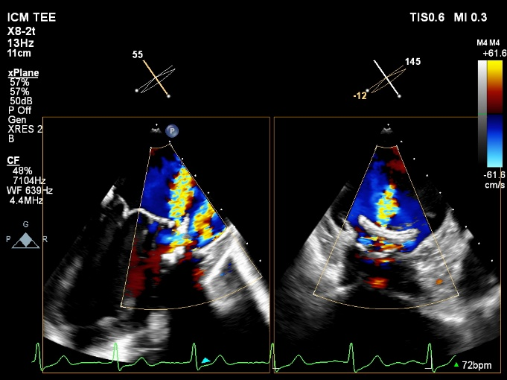
Q2 Where is located the prosthetic paravalvular mitral regurgitation? (see Video Chap17_Q2)

A) 12 o’clock
B) 3 o’clock
C) 6 o’clock
D) 9 o’clock

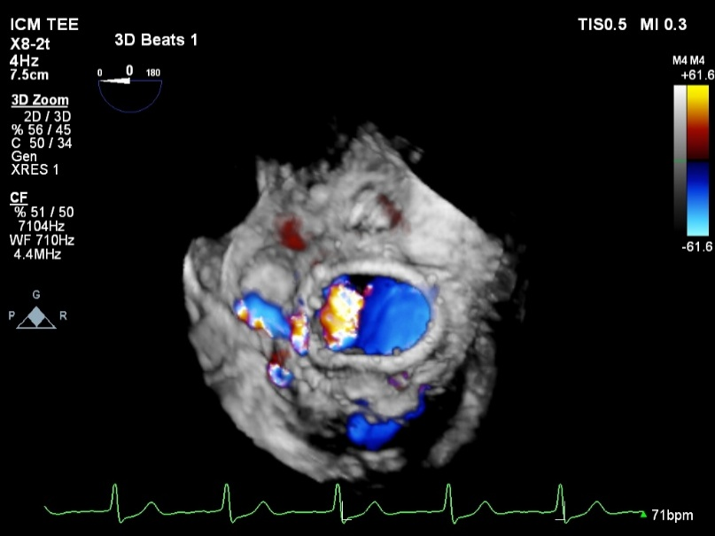
Answer: D.
On this mid-esophageal biplane view of the left ventricle, the abnormal regurgitant jet is anterior and close to the position of the left atrial appendage. The use of 3D echocardiography confirms the 9 o’clock position of the paravalvular leak.

Q3 Which statement is FALSE in percutaneous mitral balloon commissurotomy (PMBC)
A) PMBC is the preferred first-line intervention for rheumatic mitral stenosis (MS) or select patients with congenital MS
B) PMBC can be considered when the underlying pathology involves primarily calcification of the mitral annulus and not the commissures
C) Anatomic characteristics predicting unsuccessful PMBC outcomes include asymmetric commissural fusion, severe subvalvular apparatus involvement and severe commissural calcification
D) The definition of procedural success is a reduction in MS severity to mild, with less than moderate mitral regurgitation.

Answer B.
Although calcific MS is becoming more prevalent in clinical practice, PMBC is not an option when the underlying pathology involves primarily calcification of the mitral annulus and not the commissures (see Figure 16.37).

Q4 Which statement is INCORRECT regarding mitral annular calcification (MAC)?
A) There is no universally accepted classification of MAC severity using echocardiography
B) The most common region with MAC is P1.
C) MAC that results in a transmitral mean gradient of ≥ 3 mmHg or extensive leaflet calcification makes the MV unsuitable for repair.
D) Extensive MAC bears the risk of postoperative para-valvular or para annuloplasty ring leakage and atrioventricular dissociation

Answer: B
The distribution of MAC varies with the P2 region most involved (see Figure 17.29).

Q5 All those are risk factors for systolic anterior motion following mitral valve repair EXCEPT?
A) Anterior mitral valve leaflet (AMVL) length in end-diastole > 20 mm
B) Posterior mitral valve leaflet (PMVL) length in end-diastole > 15 mm
C) AMVL/PMVL ratio ≤1.3
D) Septum to leaflet coaptation length (SLCL) in end-systole > 25 mm

Answer D
The shorter the SLCL (< 25mm), the higher the risk of SAM. (see Figure 17.26)

Q6. Complication of mitral valve repair include all the following EXCEPT?
A) Ligated or distorted circumflex artery in 1.8% of cases
B) Peri-annular leak in up to 2% of cases
C) Residual mitral regurgitation is more likely if the coaptation length is less than 7 mm
D) Iatrogenic mitral stenosis

Answer B.
Significant peri-annular leaks are uncommon after mitral valve (MV) repair. A systematic examination of leaks and evaluation of their severity should occur as with MV replacement (MVR). In the long term, annular dehiscence with peri-annular leak is an infrequent condition and often results from degenerative disease, endocarditis or implantation of an excessively small annuloplasty ring

Q7 What complication occurred after mitraclip insertion in this 72-year-old woman? (see video Chap17_Q7A)
A) Transverse sinus hematoma
B) Oblique sinus hematoma
C) Pulmonary emboli
D) Tamponade

Answer: B.
Perforation of the posterior wall of the left atrium can lead to an hematoma located in the oblique sinus. This form of posterior mediastinal hematoma was confirmed using computed tomography. (see video Chap17_Q7B)

Q8 Identify the correct statement regarding mitraclip position (See video Chap17_Q8)
A) The mitraclip position is at A1PI
B) The mitraclip position is at A2P2 before full closure
C) The mitraclip position is at A2P2 after full closure
D) The mitraclip should be repositioned

Answer B.
The MitraClipTM system comprises two arms with two corresponding grippers to grasp the opposing edge of the AMVL and PMVL for re-approximation during closure. Grippers can be independently lowered or raised; therefore, correct gripper identification (anterior or posterior) must occur with the arms open at 120°-180° by actuating one at a time, a maneuver called the gripper wave or gripper identification, done in the ME LAX view or 3D en face surgical view.

Q9 Complications following mitral valve transcatheter edge-to-edge repair include all the flowing EXCEPT?
A) Residual mitral regurgitation
B) Pericardial tamponade
C) Myocardial infarction
D) Systolic anterior motion (SAM)

Answer. D.
The Alfieri technique which is the surgical equivalent of the mitral valve transcatheter edge-to-edge repair can be used as a form of treatment for SAM. This approach will remove the anterior mitral valve leaflet away from the left ventricular outflow tract. See Table 17.11.

Q10 Which statement is FALSE regarding coronary artery perfusion in mitral valve repair?
A) Abnormal regional wall motion in the lateral region should raise suspicion in left circumflex (LCx) suturing
B) LCx suturing typically happens in the P1 region, where the LCx artery course is closest to the native mitral annulus
C) Regional wall abnormality in the inferior territory should raise suspicion of ligated right coronary artery.
D) A ligated or distorted LCx artery complicates 1.8% of MV surgical procedures

Answer C.
Compromise of the LCx artery can occur during the suturing of an annuloplasty ring or prosthetic valve. Usually, this happens in the P1 region, where the LCx artery course is closest to the native mitral annulus. Regional wall abnormality in the inferior territory is typically a result of air embolism in the right coronary artery.

