Chapter 18:
Tricuspid valve

Q1: Which of the following pictures of TEE show the perfect time and incidence for the tricuspid valve annular diameter measure?
A) | 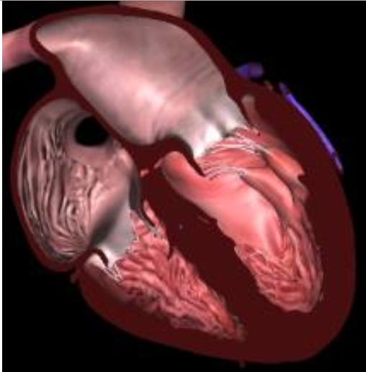 | B) | 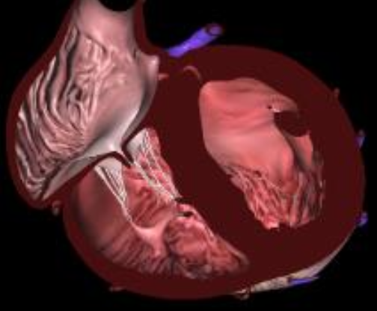
C) | 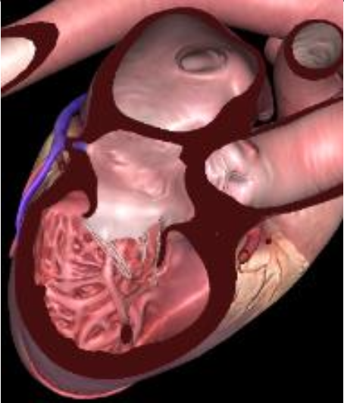 | D) | 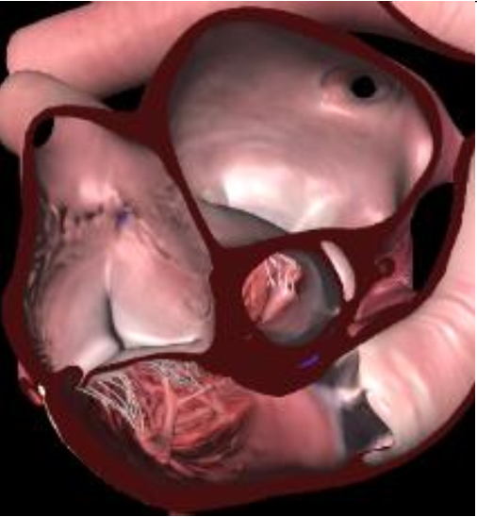

Answer: C.
The TV annular diameter is underestimate in 4C end diastole (see figure 18.1) so the adequate view is the modified bicavale one (angle 90-120). (see figure 18.10).

Q2: Here is your exam plan for the tricuspid valve in 2D TEE. Link the letter A,B,C,D to the correct TEE views. Which color corresponds to which leaflet?

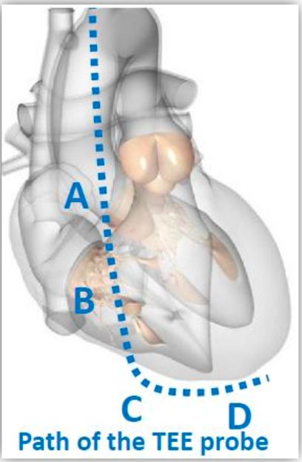

1 | 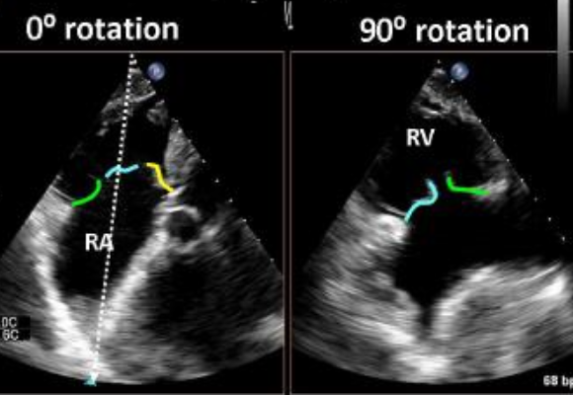 | 2 | 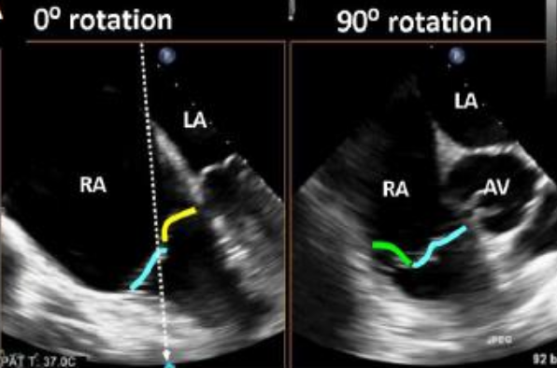
3 | 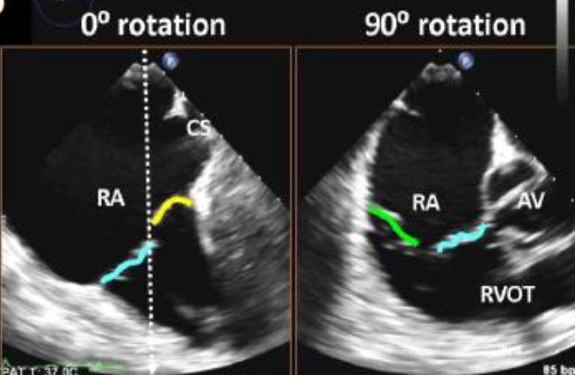 | 4 | 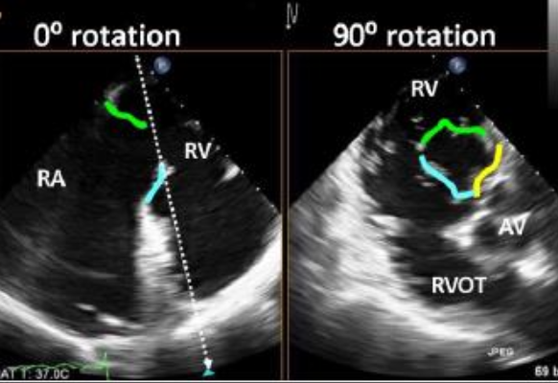
Answers:
A correspond to 2 = mid esophageal
B correspond to 3 = distal esophageal (we see the coronary sinus)
C correspond to 4 = transgastric (only 2D view with all the three leaflets)
D correspond to 1 = deep transgastric

Yellow septal leaflet
Green posterior (inferior) leaflet
Blue anterior (superior) leaflet

Q3: Concerning the tricuspid valve anatomy, which sentence is CORRECT?
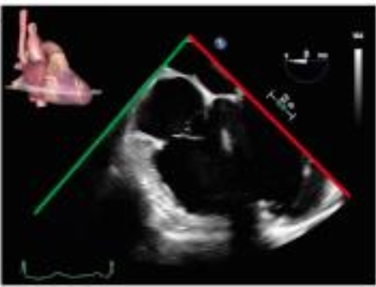
A) The image shows the anterior and septal leaflet
B) The image shows the upper and posterior leaflet
C) The image shows the anterior and septal leaflet
D) The image shows the septal and inferior leaflet

Answer: A.
The anterior leaflet (also called superior) is higher than the posterior one so it can be seen in five chambers view (See Figure 18.6). The posterior (also called inferior) leaflet appears when viewing the coronary sinus (See Figure 18.7) while the anterior leaflet is present when seeing the left ventricular outflow tract or aortic root. The leaflet close to the CS ostium is the septal leaflet. The septal leaflet is always seen in 4 chambers view and is close to the LVOT (See Figure 18.12) Pushing the probe further down the RV inflow outflow view is seen reveals the anterior and posterior leaflets when rotating the probe to the right (See Figure 18.13). At aortic root or valve cusp level, when a single leaflet is present, it usually is the anterior leaflet (See Figure 18.16).

Q4: Concerning the tricuspid valve regurgitation, which sentence of the following is INCORRECT?
A) The most frequent type of tricuspid annular is dilatation of the mural annulus, which supports the anterior and posterior leaflets with little change in the septal annular dimensions
B) The PISA method will overestimate severity, but it remains a reference parameter to quantify tricuspid regurgitation severity
C) Vena contracta (VC) width is a semiquantitative parameter measured in the mid-oesophageal four chambers view. A VC width > 7 mm at a Nyquist limit between 50-60 cm/s is a better predictor of severe TR than regurgitant color flow area
D) These two images show severe tricuspid regurgitation

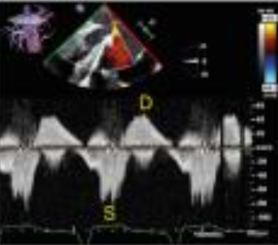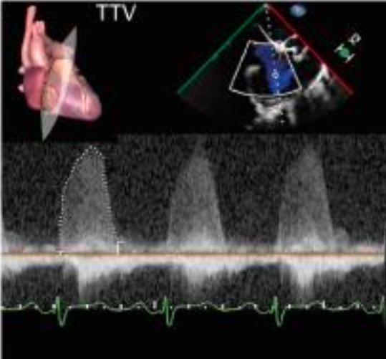

Answer B:
Quantitative methods for grading TR include EROA and regurgitant volume calculated by the PISA method, but only a few studies have validated this approach. It is important to consider that the actual ROA is noncircular, so the PISA method underestimates severity, but it remains a reference parameter to quantify TR severity
A dense triangular continuous wave Doppler jet correlates to severe tricuspid regurgitation. High velocity turbulent systolic flow reversal assessed by pulsed wave Doppler in the hepatic veins is a specific sign of severe tricuspid regurgitation (See Figure 18.22).

Q5: Concerning tricuspid valve interventions, which sentence is INCORRECT?
A) For surgery, tenting distance and tenting volume predicts residual tricuspid regurgitation post annuloplasty, especially with a tethering distance of > 7.6 mm, a tethering area of > 1.63 cm² and a tenting volume > 1.68mL
B) Tricuspid valve prosthetic obstruction must be evoked with a peak velocity > 1.5m/s, a mean pressure gradient > 10mmHg and a PHT < 240ms
C) For transcatheter tricuspid valve replacement, the superior venous cave approach is favoured because of its easier alignment with the tricuspid annulus
D) For transcatheter tricuspid valve replacement, the first clip should be central between the septal and anterior leaflets to maximize the annuloplasty effect

Answer: B.
In case of obstruction, the flow through the prosthetic valve slows so the PHT longer (> 240ms). The right circulation is a low-pressure circulation so a mean pressure gradient > 5mmHg through the prosthetic valve is already abnormal (see table 18.6)

Q6. Based on the following figure, where V_{TR} is the peak tricuspid regurgitant velocity and RAP is the right atrial pressure (RAP), what is the right ventricular systolic pressure (RVSP) in this patient
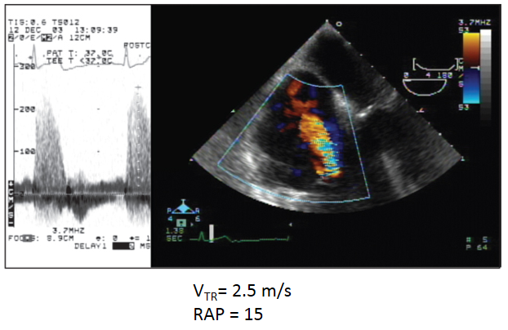A) 10 mmHg
B) 21 mmHg
C) 40 mmHg
D) The RVSP cannot be determined with the above information

Answer: C
The peak tricuspid regurgitant velocity reflects the peak pressure gradient between the RV and the right atrium during systole.
The RVSP is estimated using CW Doppler by the following equations:
RVSP = 4(Vtr)² + RAP
RVSP = 4(2.5)² + 15 = 40 mmHg
The RVSP should be the same as the PASP as long as there is no obstruction in the right ventricular outflow tract and at the pulmonic valve.

Q7. Which is the most likely cause of new onset tricuspid regurgitation in this 84 year-old man following aortic valve replacement and coronary revascularization? (see Video Chap18_Q7A and Video Chap18_Q7B)
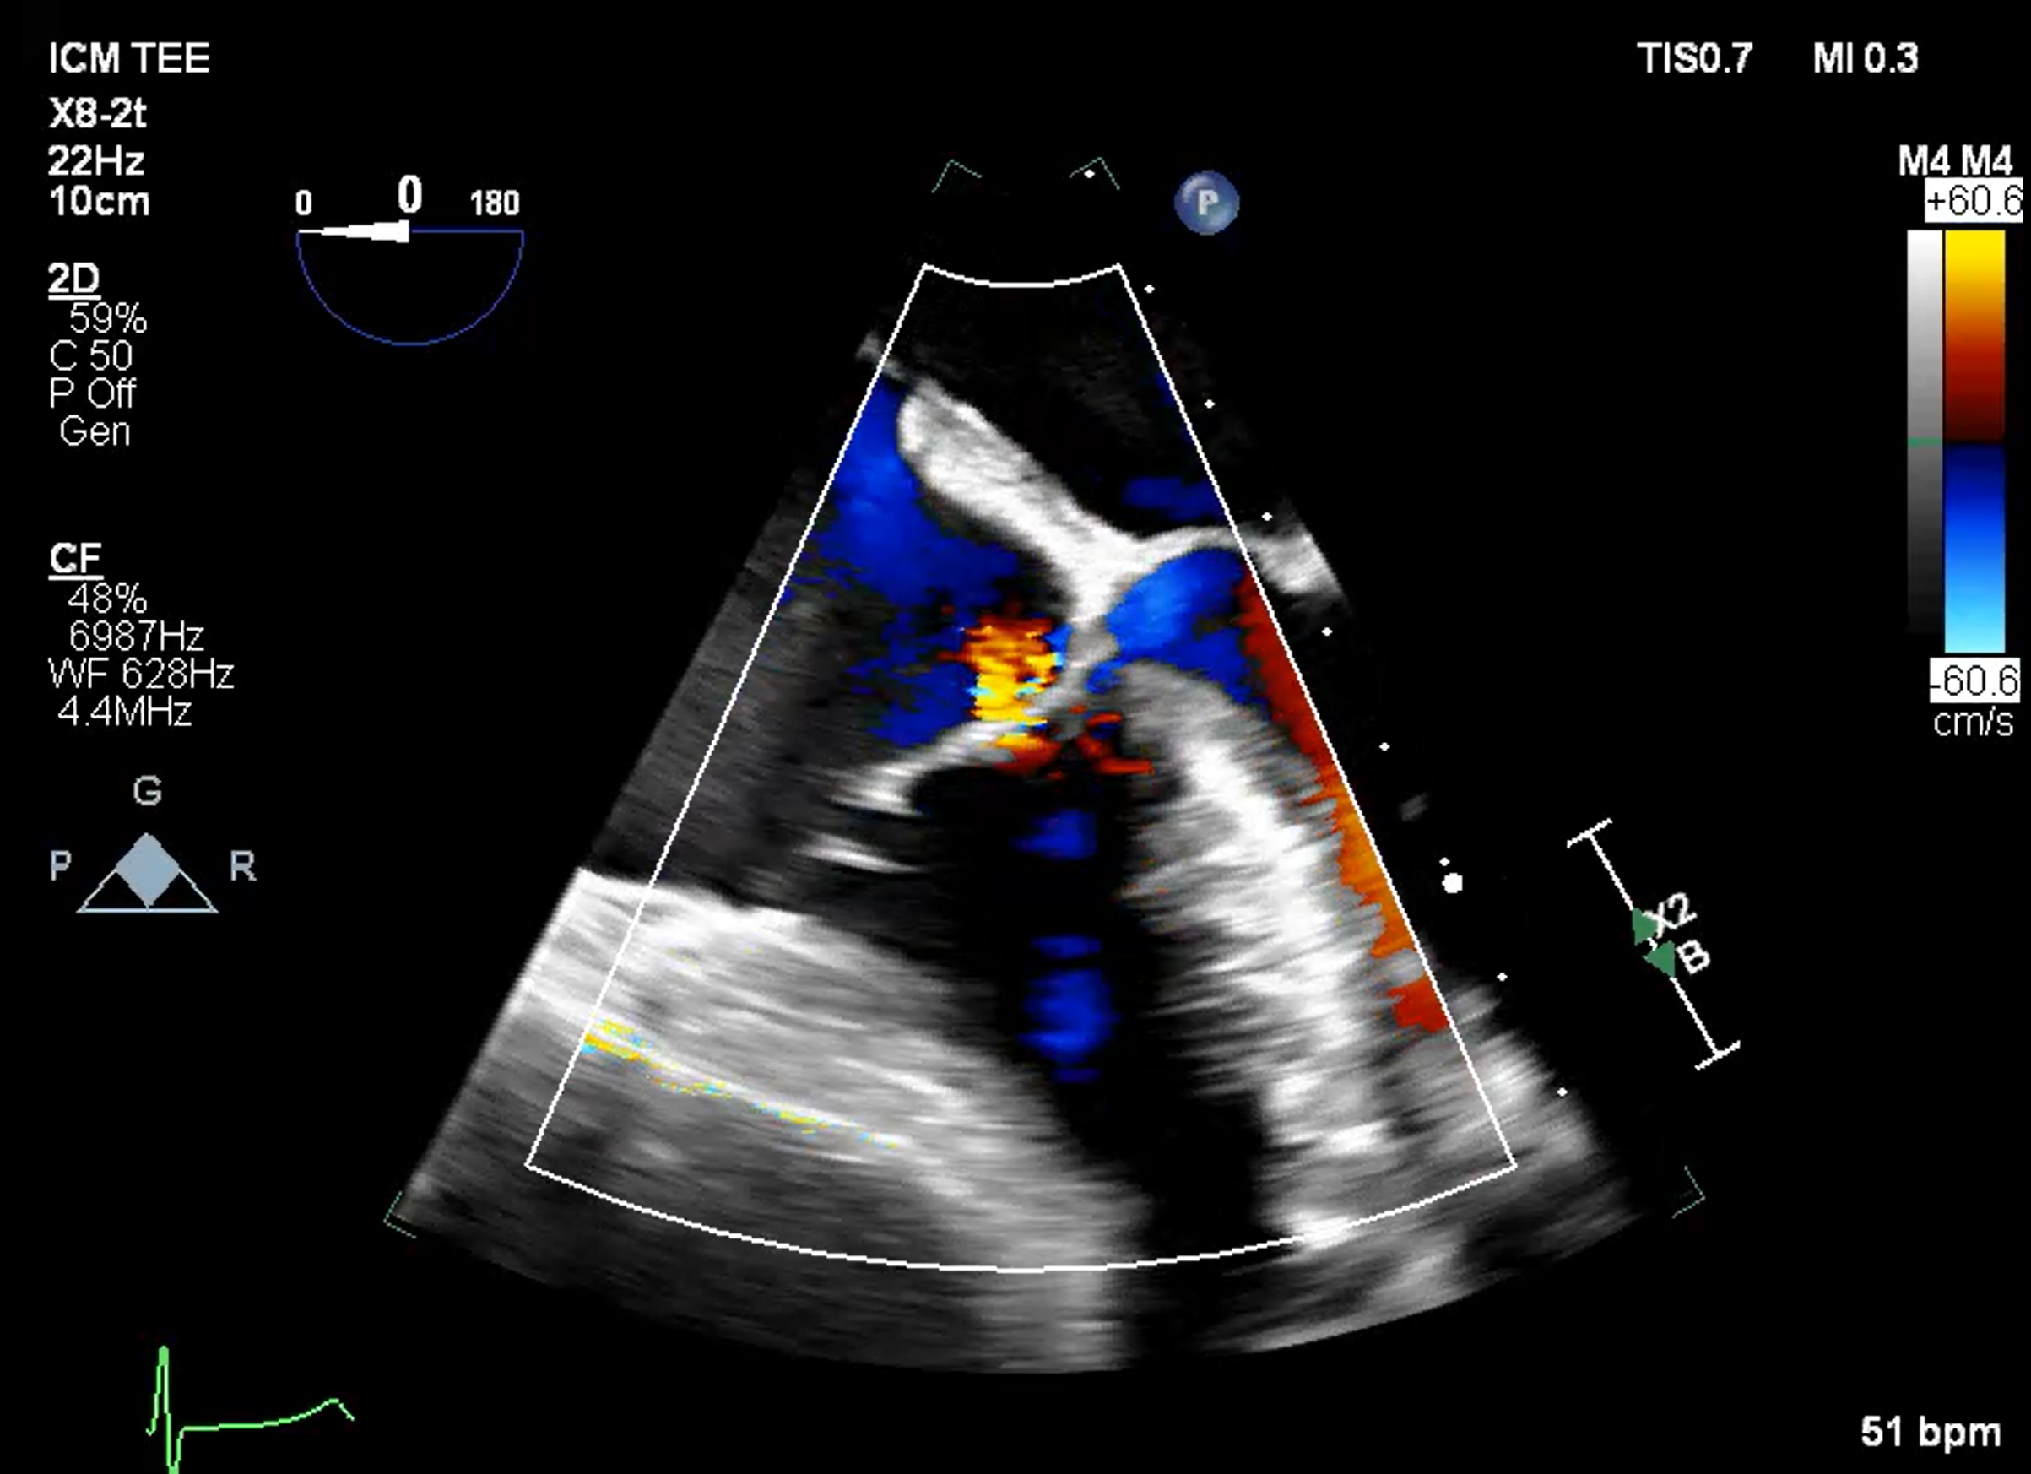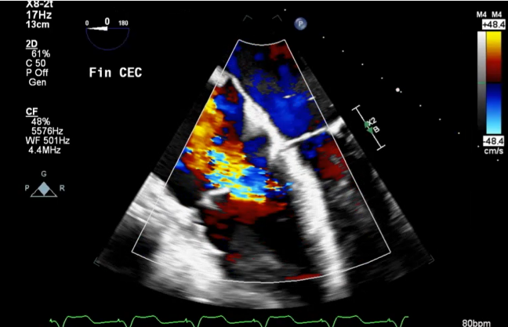

A) Primary tricuspid regurgitation
B) Secondary tricuspid regurgitation
C) Tricuspid regurgitation related to interaction of the pulmonary artery catheter
D) Tricuspid regurgitation related to the pacemaker dysynchrony.

Answer: D
There are two TR types: secondary or functional TR (90% of TV diseases) and primary or organic regurgitation (8-10% of TV diseases) (Table 18.2). Secondary TR is further divided into two phenotypes, atrial and ventricular. Moderate to severe TR involves leaflet pathology or annular dilation. Pacemaker lead interaction with the leaflet (i.e., leaflet entanglement or impingement) is a primary TR cause. In contrast, RA and RV remodeling without lead TV leaflet interference or cardiac remodeling from pacing are causes of secondary TR. Pacemaker can cause dyssynchrony as in this case. Indeed, return to sinus rhythm was associated with resolution of tricuspid regurgitation (see Figure below).
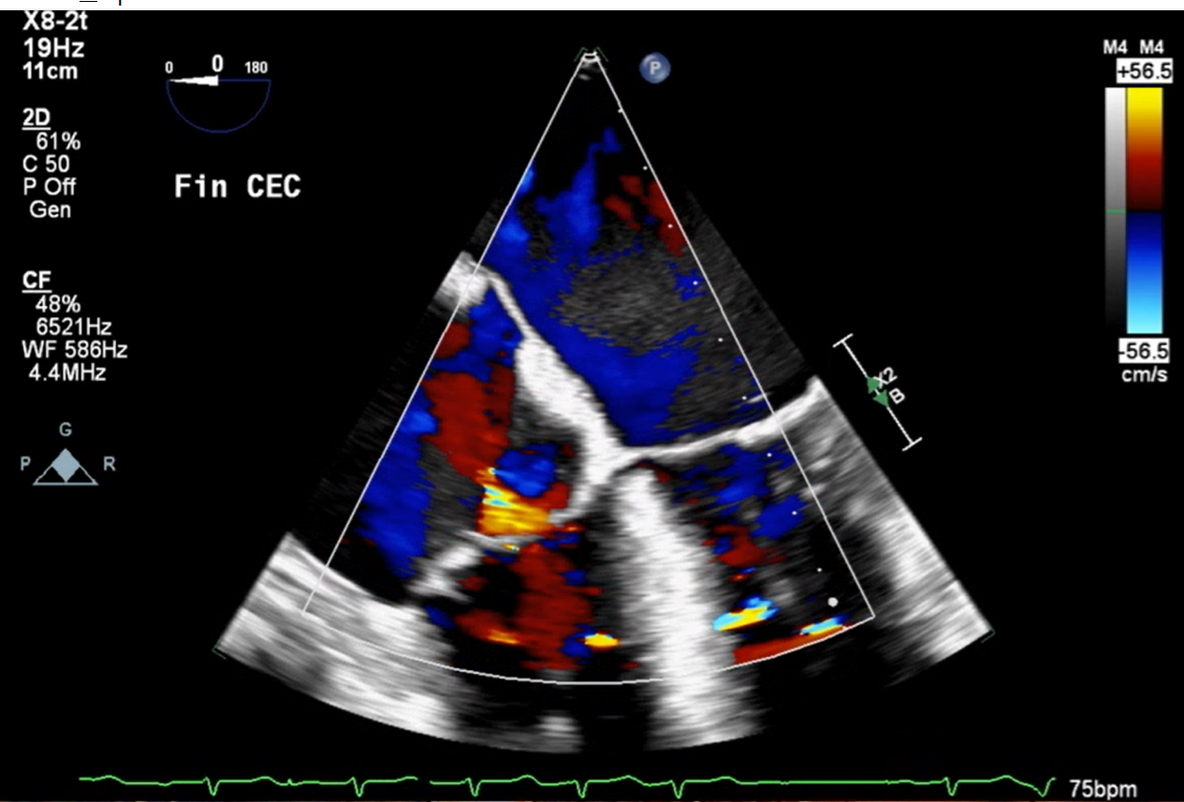

Q8 What is the type of tricuspid valve in this video (see video Chapter 18_Q8)

A) Type 1
B) Type 2
C) Type 2
D) Type 4

Answer. D
This is a type 4 that occurs in 2% of tricuspid valve. A proposal to standardize TV nomenclature includes six subtypes which describe every leaflet and scallop combination (see figure 18.4)
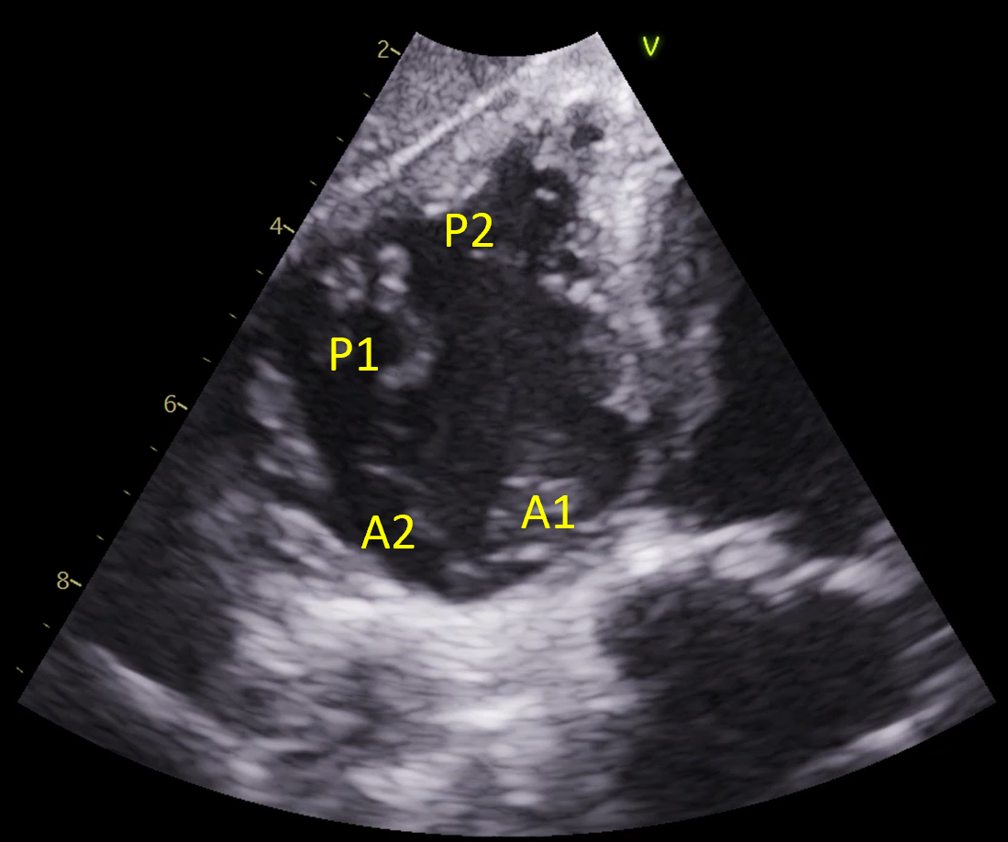

Q9 Which statement is true regarding tricuspid valve transcatheter edge-to-edge repair (TV-TEER) in the following video (see video Chap18_Q9)

A) The TV-TEER grasping is between the septal and posterior leaflet
B) The TV-TEER grasping is between the anterior and posterior leaflet
C) The TV-TEER grasping is between the anterior and septal leaflet
D) TV devices are identical to the mitral devices

Answer C.
The first clip position should be central between the septal and anterior leaflets to maximize the annuloplasty effect. TV devices are identical to the mitral devices but with an adapted delivery system for easier navigation through right heart anatomy.

Q10 What is the major complication of transcatheter tricuspid valve repair system such as the Cardioband?

A) Right ventricular perforation
B) Embolisation
C) Right coronary artery artery occlusion
D) Right ventricular failure

Answer: C
The procedure is challenging because of the complex right heart anatomy requiring precise navigation and alignment, particularly considering the variability between the IVC and TV annulus. RCA proximity poses a significant risk of complications. Performing RCA angiography post procedure can exclude new obstruction. A study by Körber et al. demonstrated a 97% technical success rate and reduced TR grade ≥1 in 88% of patients using the Cardioband direct annuloplasty system. Still, the procedure took over 4 hours, and 15% of patients developed RCA complications.

