Chapter 19: Pulmonic valve

Q1: Which of the following is TRUE regarding PV anatomy?
A) The PV and TV are anatomically contiguous.
B) The PV is located inferior and medial to the aortic valve.
C) The 3 PV cusps are named left, right and non.
D) The PV is a semilunar valve without chordae.

Answer: D
Positioned in the crescentic, pyramid-shaped right ventricle (RV) that supports the low-pressure pulmonary circulation, the PV is anterior and superior to the tricuspid valve (TV) in the RV outlet. Unlike the aortic valve (AoV) and mitral valve (MV), the TV and PV are anatomically discontiguous, separated by a body of myocardium called the infundibulum (or conus). The PV is situated anterior, left, and superior to the AoV, as summarized by the mnemonic PALS (pulmonic, anterior, left, superior). The PV is a semilunar valve with two posterior cusps (right and left) and one anterior cusp, in a mirror image to the AoV

Q2: PV dysplasia is associated with which congenital syndrome?
A) Noonan syndrome
B) Shone complex
C) Trisomy 21
D) Williams’s syndrome

Answer: A
A dysplastic PV is associated with Noonan syndrome and balloon valvuloplasty may not be as successful as for a dome-shaped PV, in the absence of commissural fusion.

Q3: Which of the following is the most common method of assessing the severity of PV stenosis?
A) PVA by planimetry
B) Continuity equation
C) Doppler analysis of transvalvular flow
D) PISA

Answer: C
In contrast to other cardiac valves, quantification and grading of PS severity is based almost entirely on transpulmonary velocities. Other methods, such as the calculation of PV area by planimetry, are often inaccurate, as inadequate imaging planes result in measurement errors. Valve area calculation via the continuity equation or proximal isovelocity surface area methods is technically possible, but not validated for PS.

Q4 Which of the following IS NOT an indication of severe pulmonic regurgitation (PR)?
A) A jet width to annulus ratio >70%
B) A dense PR jet with a pressure-half time (PHT) < 100msec
C) Early termination of PR flow
D) Diastolic flow reversal in the main pulmonary artery (PA)

Answer: D
The 2017 ASE guidelines specify five criteria for severe PR: a jet width to annulus ratio >70%, a dense PR jet with a PHT < 100 msec, early termination of PR flow, diastolic flow reversal in the branch PAs (not the main PA) and RV dilatation with normal function.

Q5 What is the structure indicated by the arrow? (see video Chap19_Q5)

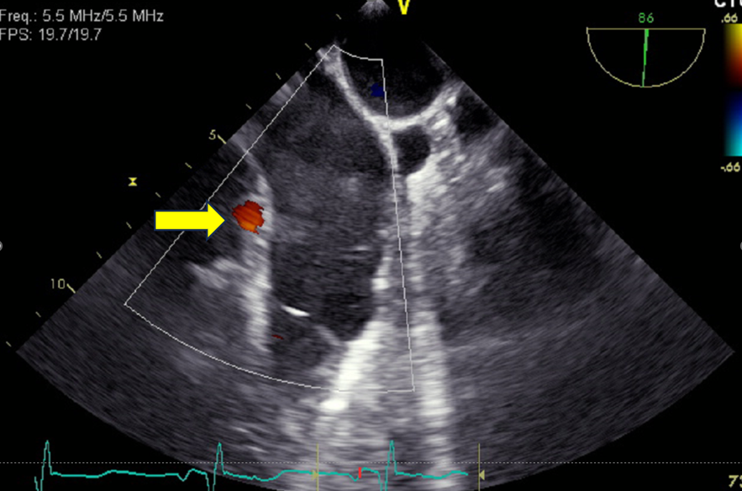
A) Right coronary artery
B) Left main coronary artery
C) Left anterior descending artery
D) Coronary sinus

Answer: C
This is the left anterior descending artery (figure 19.4) close to the pulmonic valve left cusp. The flow can be compromised during any procedure involving the pulmonic valve such as a Ross procedure.

Q6 Which statement is FALSE regarding pulmonic valve stenosis
A) Moderate stenosis is defined as a peak velocity between 3-4 m/s with a mean gradient between 36 and 64 mmHg
B) Pulmonic valve area can be calculated to determine severity of pulmonic valve stenosis
C) The current recommendation is for balloon pulmonary valvuloplasty in asymptomatic patients with domed valve morphology and peak echocardiographic gradient >60 mmHg (mean > 40)
D) Congenital or acquired PS may be subvalvular (infundibular), valvular or supravalvular

Answer B:
In contrast to other cardiac valves, quantification and grading of PS severity is based almost entirely on transpulmonary velocities

Q7 What is the etiology of the increase velocity across the pulmonic valve (see Video Chap19_Q7)
A) Right ventricular outflow tract obstruction
B) Tetralogy of Fallot
C) Pulmonic valve stenosis
D) Supravalvular stenosis

Answer: D
This is a deep transgastric basal view showing a supravalvular pulmonic valve stenosis. Congenital or acquired PS may be subvalvular (infundibular) (Figure 19.10), valvular or supravalvular (Figure 19.11), so identifying the level of obstruction may help in the differential diagnosis.

Q8 All of the following are causes of right ventricular outflow tract obstruction (RVOTO) EXCEPT:
A) Left mammary harvesting
B) Inotropic agents
C) Left-sided tension pneumothorax
D) Right sinus of Valsalva aneurysm

Answer A
It is typically during right mammary harvesting that RVOTO can be observed. Extrinsic compression, such as the sinus of Valsalva aneurysm (see Figure 10.29), during right mammary artery harvesting (see Figure 13.24), dynamic RVOTO (see Figure 10.30) and left tension pneumothorax (see Figure 32.10) can result in RVOTO.

Q9 Which statement is TRUE regarding the pulmonary regurgitation index (PRI)?
A) A PR index > 0.77 define severe pulmonic valve regurgitation
B) The PR index corresponds to the duration of pulmonic regurgitation divided by diastolic time
C) The PR index corresponds to the duration of diastolic time divided by the duration of pulmonic regurgitation
D) The PR index has been validated in large cohort of patients

Answer B
The PRI (Pulmonic regurgitation duration/total diastolic time) < 0.77 (Figure 19.13) correlate with severe PR, although it remains unvalidated in a large population.

Q10 What is the significance of the color M mode signal indicated by the arrow in a 77-year-old woman after coronary revascularisation?

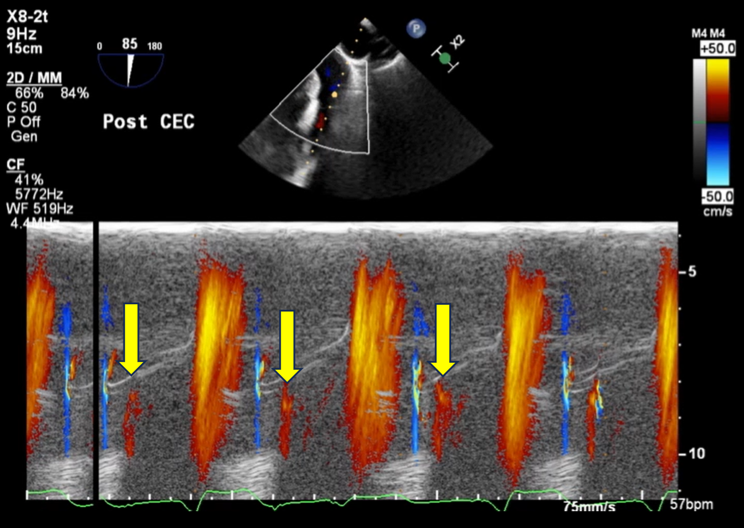
A) Pulmonic valve regurgitation
B) Artifact
C) Severe right ventricular failure (RVF)
D) Pulmonic valve stenosis

Answer C
Diastolic opening of the pulmonic valve occurs when the right ventricular diastolic pressure exceeds the diastolic pulmonary pressure. This is typical of RVF (see Figure 10.37) and can be seen by looking at the right ventricular pressure waveform where the pressure changes can be seen. (see video Chap19_Q10)

