Chapter 20: minimal invasive cardiac surgery

Q1: Concerning mitral valve procedure, which sentence is INCORRECT?
A) A patent foramen ovale can be found in 10% to 39% of patients and must be closed at the end of the procedure
B) Relative contra-indications include severe aortic regurgitation
C) Relative contra-indicationsinclude severe atherosclerotic aortic disease
D) Recognizing a left pleural effusion early is important if planning for one lung ventilation

Answer: A
A patent foramen ovale must be closed at the beginning of the procedure to avoid repeated flooding of the operating field and air embolism

Q2: Which of the following pictures show the perfect positioning of anaortic balloon endoclamp?
A | 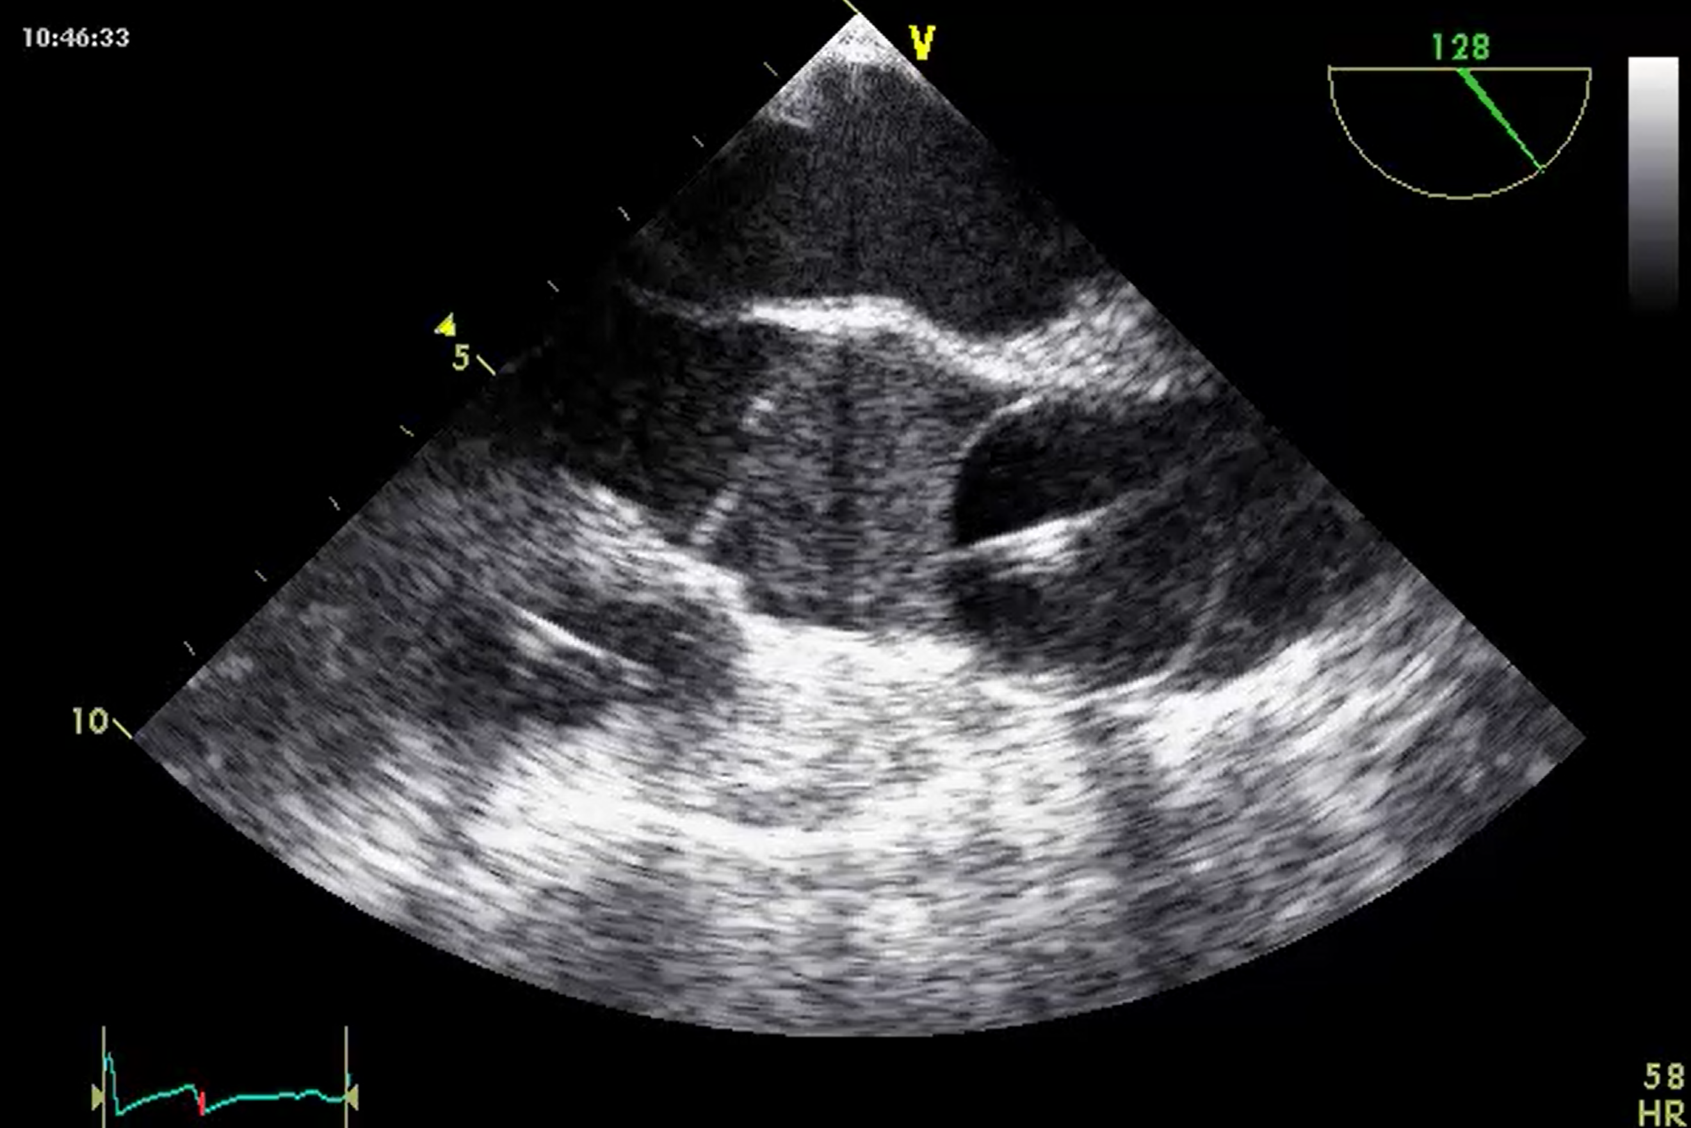 | B | 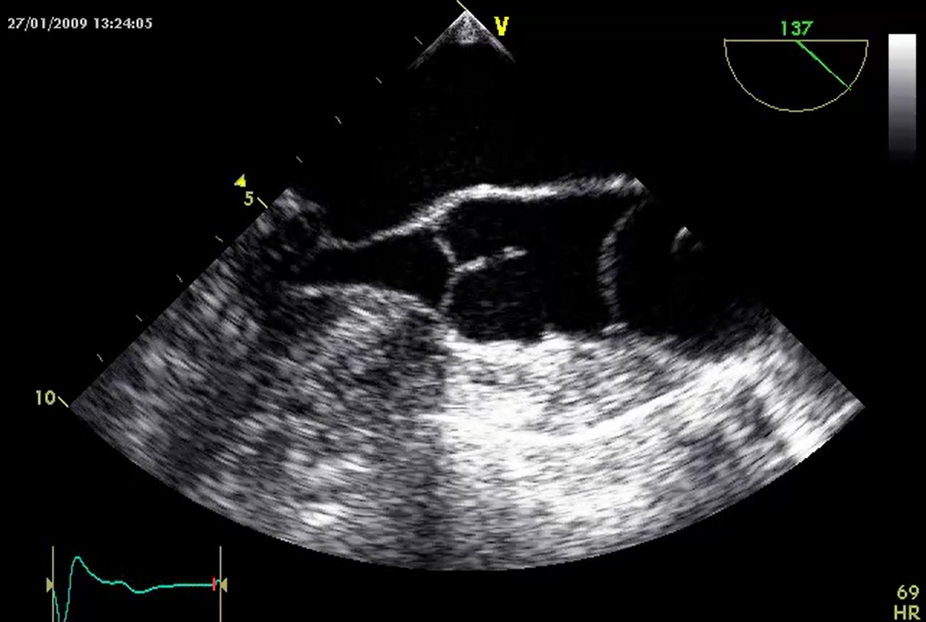
C | 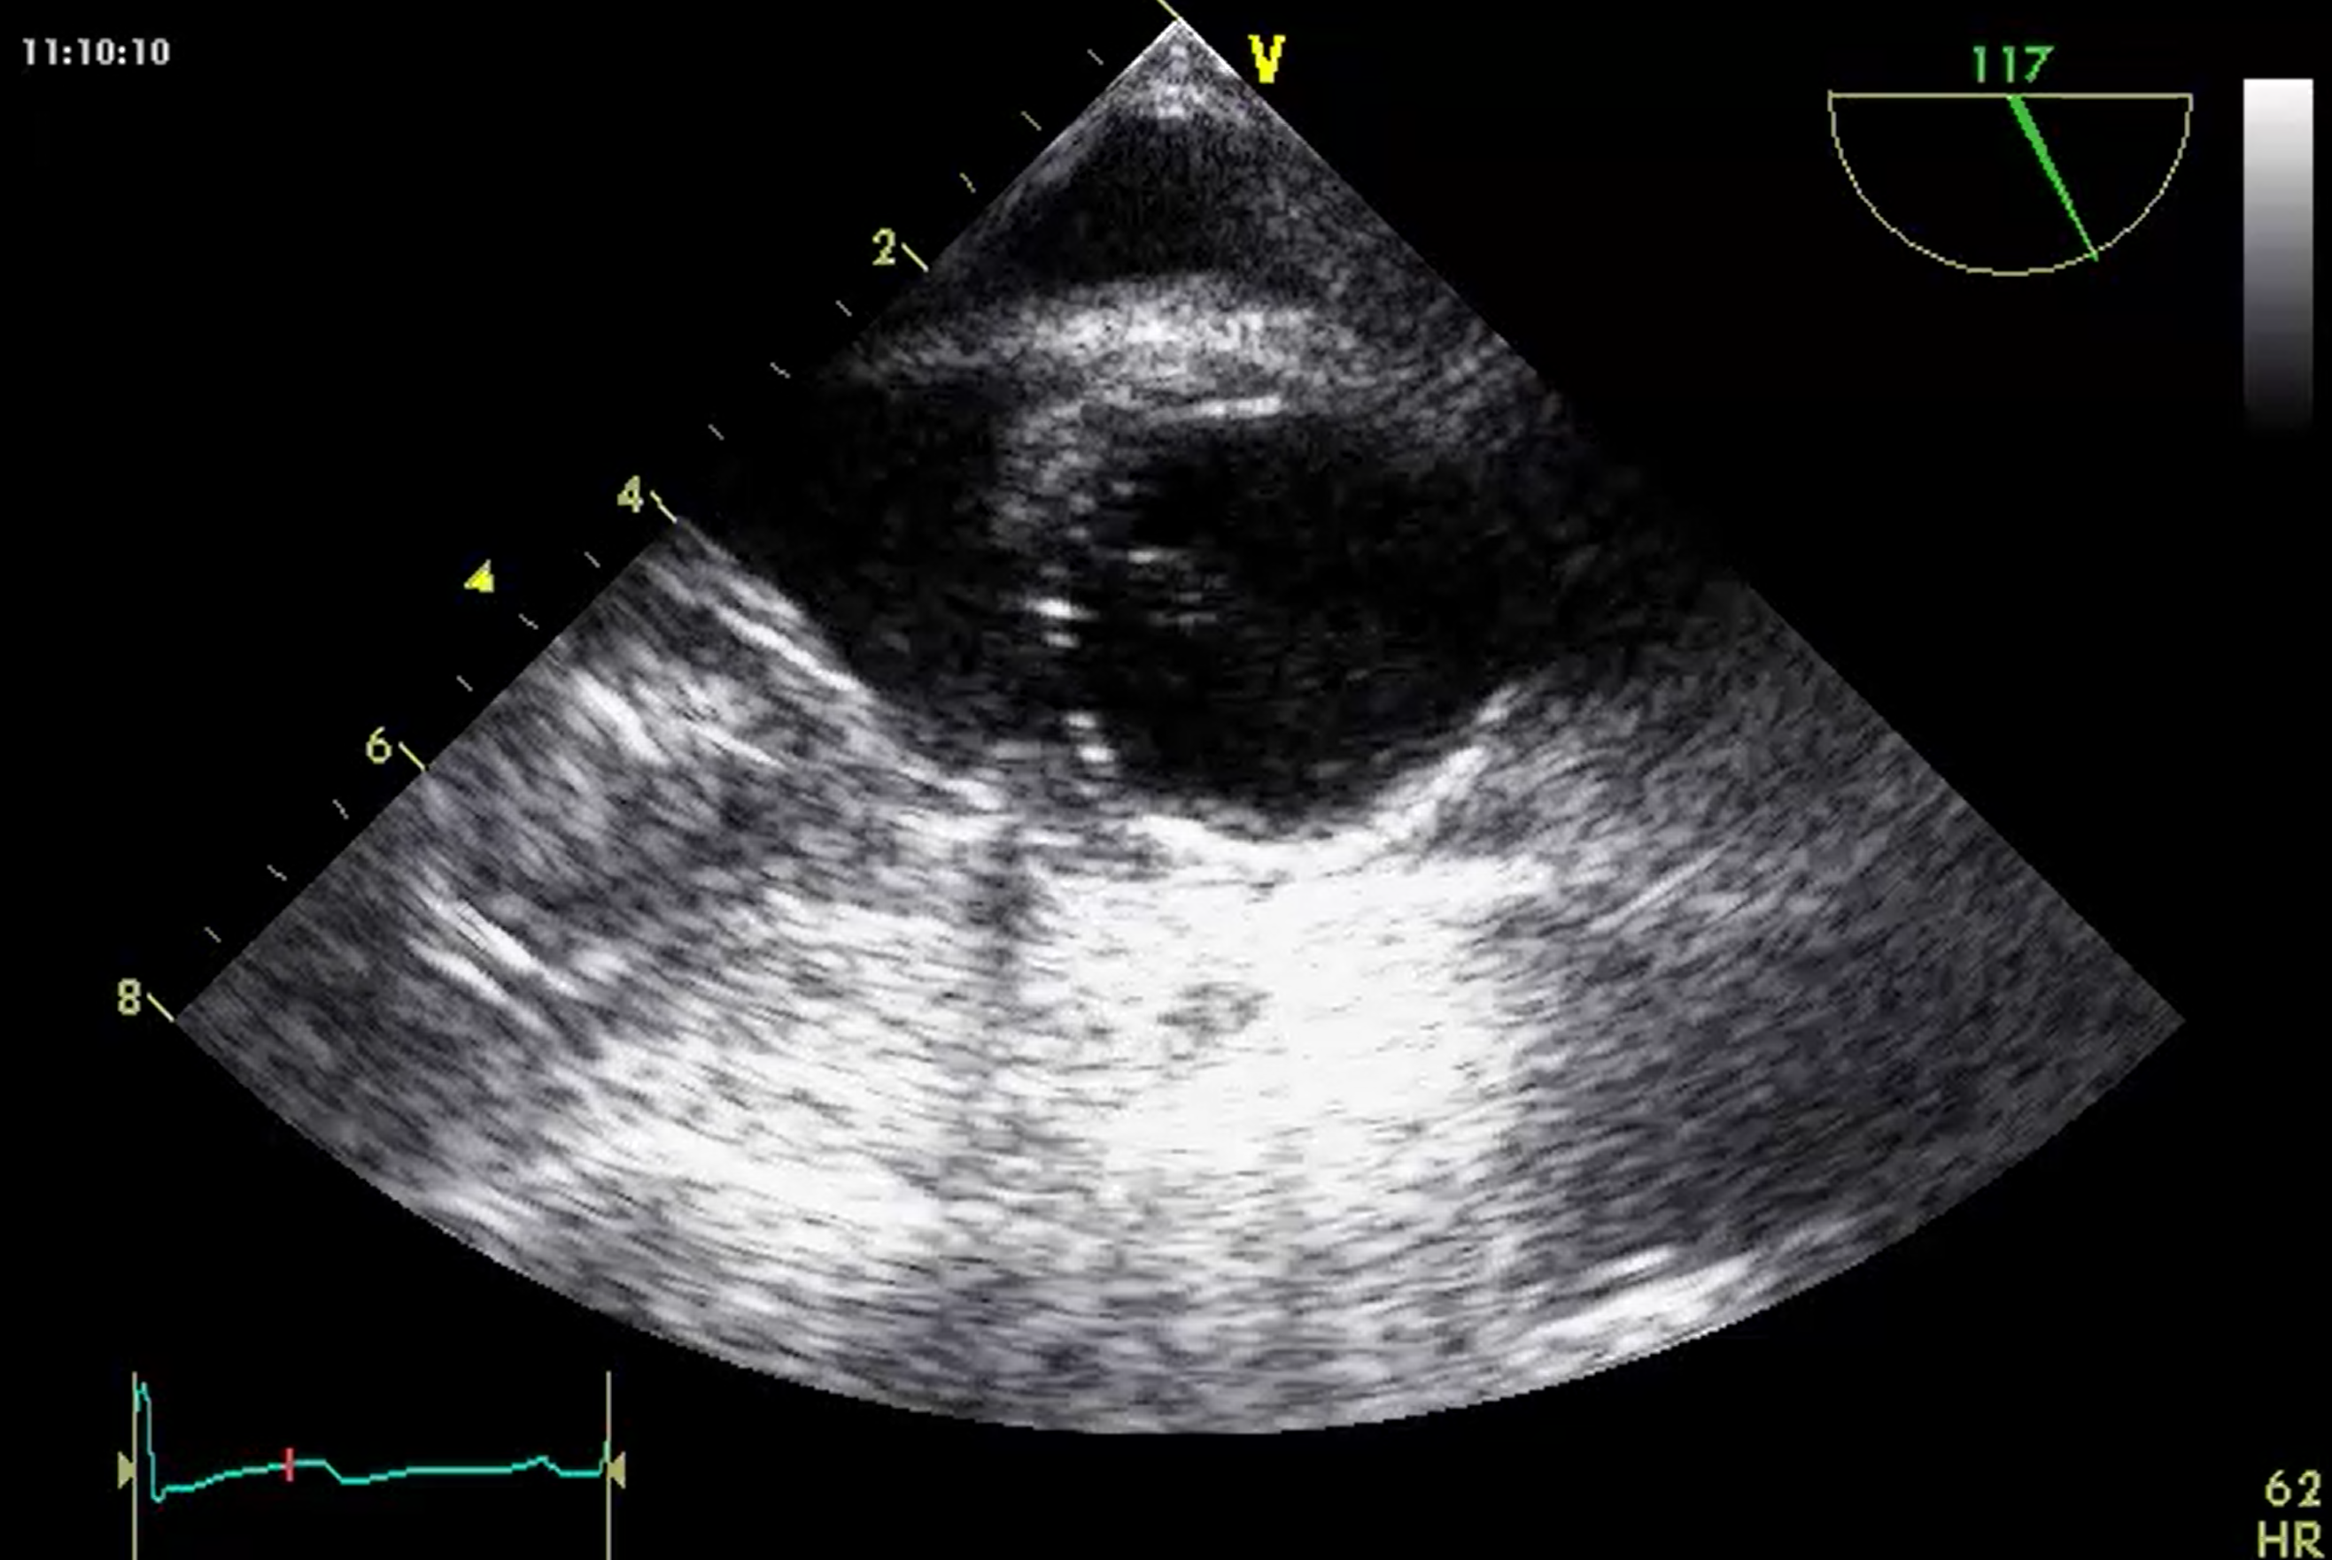 | D | 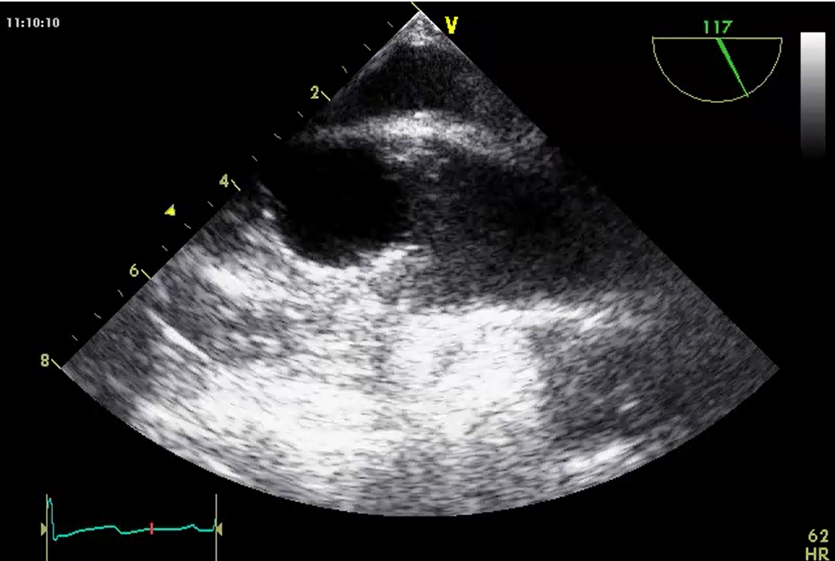

Answer: A
(See figure 20.14). The aortic balloon endoclamp zone lies between the STJ and the right brachiocephalic trunk with an ideal position 1-2 cm above the STJ without obstructing the coronary ostia.

Q3: Which anatomical structure is marked with a star in the following pictures?

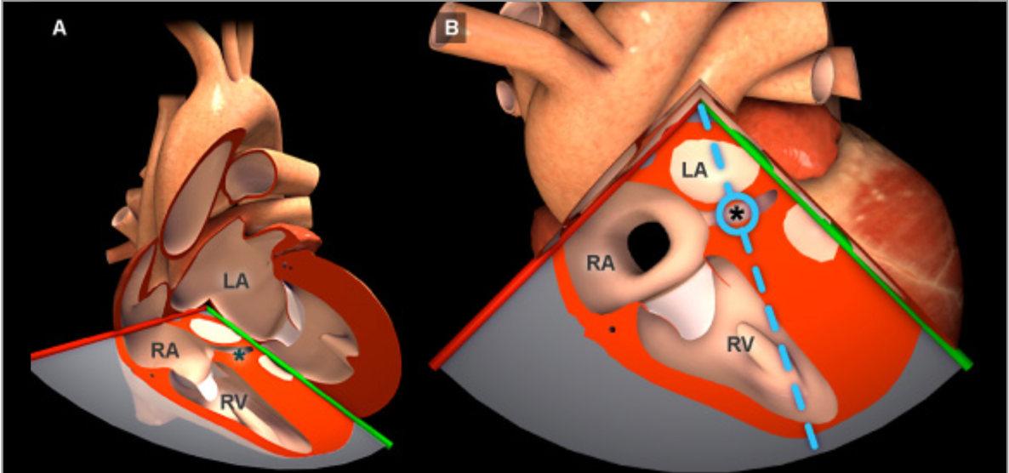

A) Right atrium
B) Superior cave vein
C) Septal tricuspid leaflet
D) Coronary sinus

Answer: D.
This is the coronary sinus (CS), just above the tricuspid valve. This structure is very important to identify for retrograde canulation. (Image from https://pie.med.utoronto.ca/tee/). A low esophageal view at 0° can confirm the catheter in the CS (see Figure 20.20). Catheter advancement should be under fluoroscopic guidance since TEE only shows the CS ostium, and progression within the small median vein increases risks of perforation. Advancing the catheter as distal as possible just before the before the great cardiac vein increases its stability (see Figure 20.18).

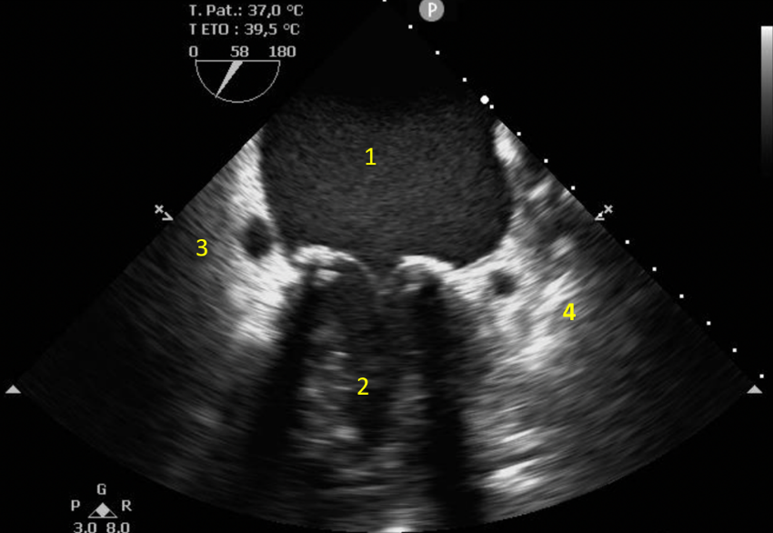
Q4: Select the appropriate name for the 4 structures in the following view
A) 1 = left atrium, 2 = left ventricle; 3 = coronary sinus; 4 = circumflex artery
B) 1= left atrium; 3 = left ventricle; 3=circumflex artery; 4= coronary sinus
C) 1= right atrium; 2 = right ventricle; 3 = coronary sinus; 4 = circumflex artery
D) 1= right atrium; 2 = right ventricle; 3 = circumflex artery; 4 = coronary sinus

Answer A.
A detailed exam of coronary circulation is important to detect any aberrant anatomy such as a circumflex passing close to the mitral annulus (see Figure 9.15). Knowledge of this condition could prevent trauma or iatrogenic occlusion to the circumflex artery during mitral annuloplasty (see Figure 9.11).

Q5: You are the cardiac anesthesiologist of a patient going under robotic assisted procedure for coronary revascularization with a hybrid approach. The patient has a history right coronary artery stent angioplasty and is going under surgical approach for the left coronary artery. What do you suspect with the following picture?

Before:
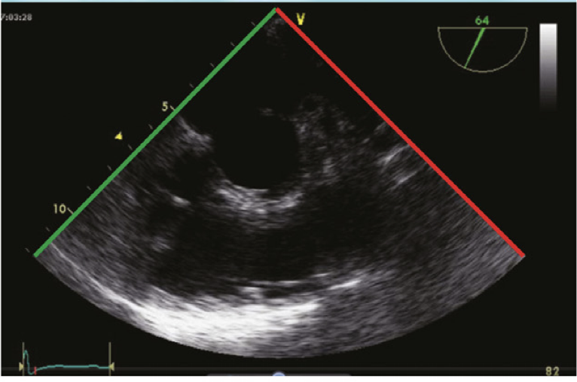

After:
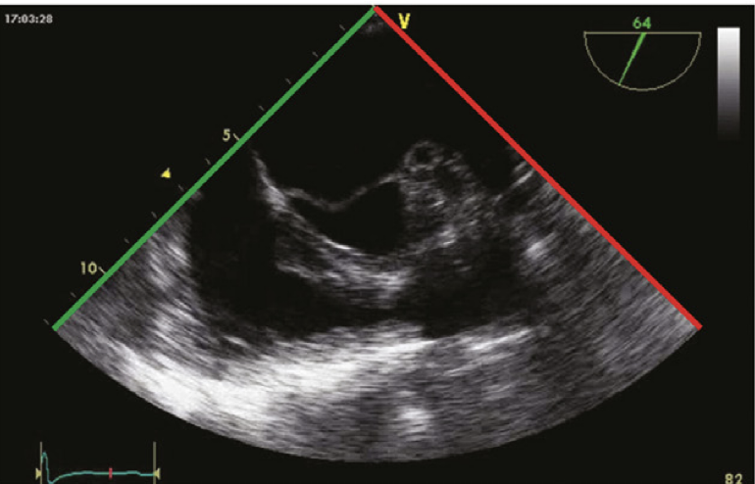

A) Right ventricular outflow tract ischemia
B) Mechanical right ventricular outflow tract
C) Dynamic right ventricular outflow tract
D) Left mammary artery spasm

Answer B
This is typical aspect of mechanical RVOT obstruction owing to the trocar insufflation pressure being over 10cmH2O (see Figure 20.33, 20.34) similar to a left tension pneumothorax (see Figure 32.10). Reducing the insufflation pressuremay also help by reducing the pulmonary artery pressure. Right sided dysfunction is a frequent cause of conversion to conventional cardiopulmonary bypass, especially in patients with associated right coronary artery disease.

Q6 How do you evaluate regional wall motion (RWM) in this 63 year-old man undergoing robotic revascularization? (see Video Chap20_Q6)
A) There is abnormal RWM in the anterior portion of the heart
B) There is no RWM abnormalities
C) The RWM abnormalities are most likely secondary to the pressure of the retractor on the heart
D) This is most likely secondary to abnormal right coronary artery perfusion abnormality

Answer C.
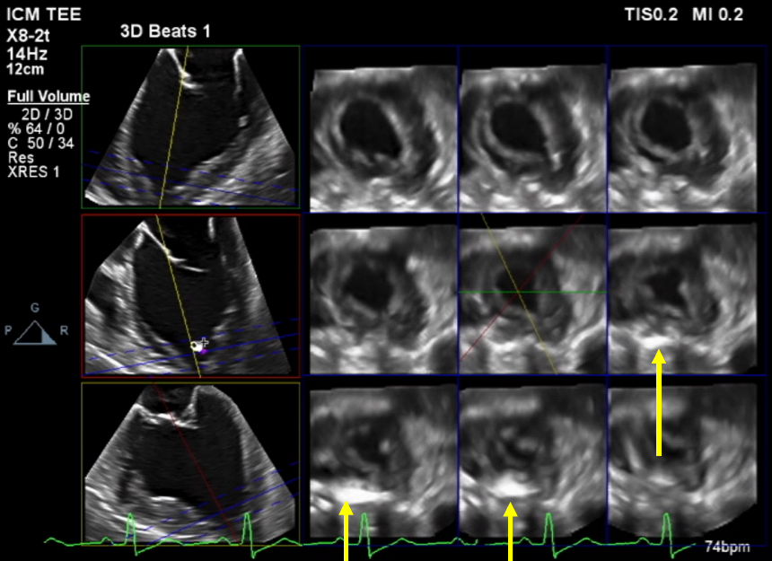
The arrows in this multislice left ventricular view (see figure below) in this patient indicate the retractor used in robotic surgery which are causing the regional wall motion abnormality. In robotic revascularisaiton, it is mostly the left anterior coronary artery that is revascularized.

Q7 Identify this complication following minimally invasive cardiac surgery. (see video Chap21_Q7A)

A) Left ventricular regional wall motion abnormality
B) Pericardial tamponade
C) Right ventricular failure
D) Right ventricular regional wall motion abnormality

Answer: B
Pericardial tamponade is secondary to right ventricular perforation (see video Chap21_Q7B). In such a case, the minimally approach should be converted to a sternotomy.

Q8 What is the mechanism of hemodynamic instability during robotic surgery (see Video Chap20_Q8A)?

A) Dynamic right ventricular outflow tract (RVOT) obstruction
B) Mechanical RVOT obstruction
C) Myocardial ischemia
D) Pericardial tamponade

Answer B
In this patient the left sided pneumothorax (as a result of thoracic carbon dioxide insufflation) was compressing the RVOT in diastole. Mechanical RVOT obstruction was present in diastole. Dynamic RVOT obstruction typically occurs in systole. Pericardial fat was present anteriorly to the RVOT. M-mode can be used to confirm the diastolic obstruction (see Video Chap20_Q8B)
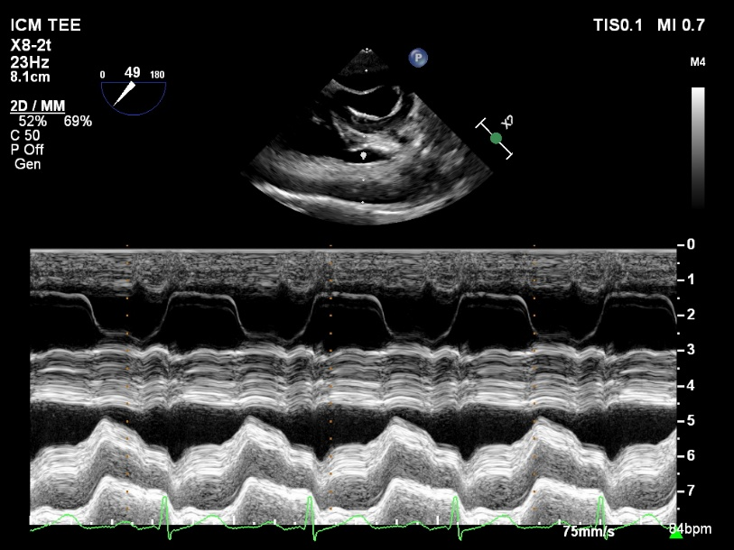

Q9 Radial (pink) and femoral (red) pressure before and during insertion of the aortic canula. What is the appropriate diagnosis?

Before (13:55)
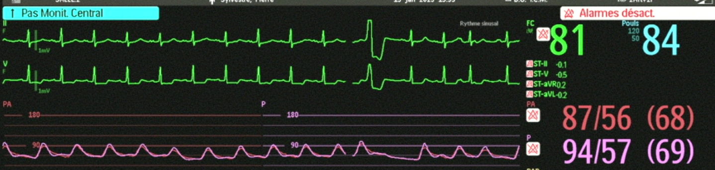
After (13:56)
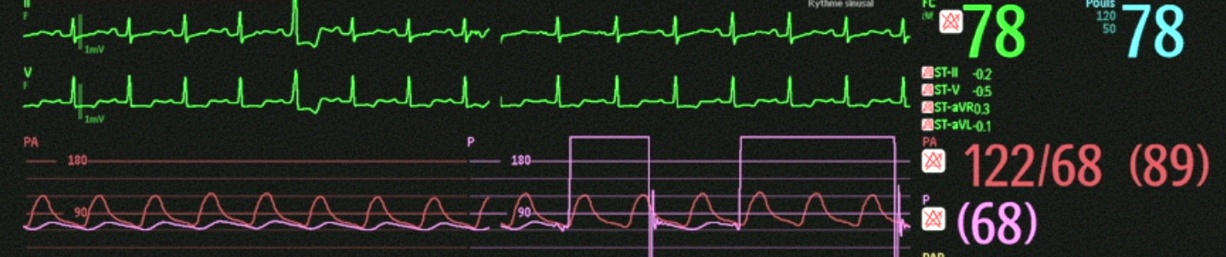
A) The is inappropriate damping on the radial artery
B) The patient has received vasoactive agents
C) There is local compression of the radial artery
D) The aortic canula is positioned in the left subclavian artery

Answer: D
In this patient the aortic canula was seen in the aortic arch but the distal portion was in the left subclavian artery. (see Video Chap_Q9) Pulling back the canula resulted in normalization of the radial artery.
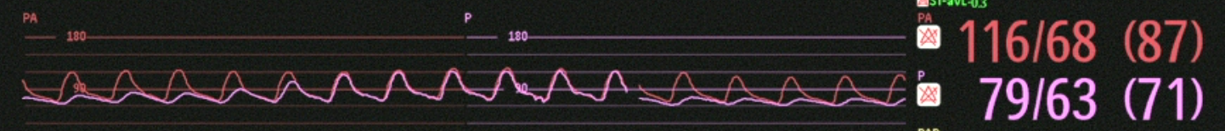

Q10 All of the following are important considerations in minimally invasive cardiac surgery in patients undergoing reoperation EXCEPT the following:
A) Mediastinal adhesions might require endovascular pacing prior to the procedure
B) Pericardial adhesions will make the LA opening more difficult, increasing the risk of perforation and hemorrhage
C) Minimally invasive procedure is contra-indicated in previous valvular surgery
D) Cardioplegia might be challenging in a patient with previous coronary revascularization with mammary graft permeability

Answer: B.
There might be a restriction to surgical access by a thoracoscopic approach, including but not limited to difficulties with trans-thoracic aortic clamping, epicardial temporary pacing wire insertion, and isolation of both venae cavae for snaring. The procedure is technically more challenging or in some cases impossible. These situations mandate discussion with the surgical team to ensure safe procedural planning.

