Chapter 24:
Endograft placement in aortic disease

Q1. All of these are advantages of endovascular aortic surgery in older patients EXCEPT:
A) Decrease physiological stress response.
B) Shorter hospital stays.
C) Minimal long-term post procedure follow-up.
D) Quicker return to normal activities.

Answer C
One of the main disadvantages of endovascular aneurysmal repair is the requirement for a yearly computed tomography (CT) scan. With the progressive aging of the population and the associated increase in comorbidity, advantages of endovascular surgery include decreased stress response, less perioperative complications, shorter hospital stay, and quicker return to normal activities.

Q2. Which of these is not a role of TEE during endovascular aortic surgery?
A) Rapidly identify intraoperative cardiac ischemia during stent deployment.
B) Confirm the nature and extension of the aortic pathology.
C) Confirm the correct guide placement in the true lumen.
D) Determine the endograft size and landing zones in elective procedures.

Answer D
In all elective and most urgent endovascular procedures, the indication for endovascular repair as well as the endograft size and proximal landing zone are selected preoperatively based on the CT scan and/or magnetic resonance imaging studies. However, both TEE and fluoroscopy can be used to confirm these during the procedure.

Q3. Which statement about type III endoleaks is correct?
A) They donot require further intervention since they will self-resolve with time.
B) They result from inadequate apposition of overlapping endograft joint.
C) They are caused by the porosity of the endograft material.
D) They can further be classified into IIIa and IIIb depending on the localization of the leak.
E) They can be corrected by coiling the culprit collateral vessel in a future intervention.

Answer B
Type III endoleak, or graft defect, is a result of inadequate apposition of overlapping endograft joints or a tear of the graft fabric. Type I and III endoleaks are clearly associated with future aneurysm expansion and should, therefore, be corrected by balloon dilation or additional endograft insertion. Type I endoleak occurs at the attachment sites and can involve the proximal (type IA) and/or distal ends of the endograft (type IB). They are usually large and result from incomplete adhesion of the endograft to the aortic wall. To decrease their occurrence, balloon inflation after endograft deployment is normally performed at the proximal and distal ends to mold the endograft to the aortic wall. Type II endoleak, or branch leak, is due to retrograde blood flow into the aneurysm sac from one or more aortic collateral vessels. Type IV endoleak is due to blood flow into the aneurysm sac due to the porosity of the graft fabric. Type IV endoleak generally does not require any further intervention.

Q4. Concerning endoleaks following endovascular aortic repair, which of the following statement is FALSE?
A) Pulse wave Doppler velocity can help differentiate the type of endoleak.
B) TEE is useful to detect type I endoleak especially in curved section of the aorta.
C) Type I endoleak should be treated before leaving the operating room.
D) Fluoroscopy is more sensitive than TEE to detect small endoleaks.

Answer D
TEE is the most sensitive tool for detecting endoleaks immediately after endograft deployment. Small endoleaks may be missed by angiography because the amount of dye within the leak is not detectable by fluoroscopy or because the imaging view is inadequate. The use of TEE is often superior to angiography in the detection and characterization of type I endoleaks, due to incomplete endograft apposition to the aortic wall. This is particularly useful in sections of the aorta that are highly curved such as the aortic arch. Endoleaks may also be better defined by TEE than by angiography because it is sometimes difficult to differentiate a transient type IV endoleak from the more significant type I or III endoleaks immediately after endograft graft insertion. A pulsed wave Doppler velocity cutoff value of 50cm/s has been advocated to enable differentiation of type IV endoleaks (slow blood flow) from type I, II or III endoleaks (high-velocity flows). Endoleaks that appear several weeks, months, or even years after the insertion of an endograft are called secondary endoleak. They are probably related to dislodgment of the endograft, to structural changes of the aortic wall, or to endoleaks that were simply not diagnosed at the time of insertion. Secondary endoleaks are the main cause of late treatment failure in the endovascular approach. Aneurysm expansion in the absence of visible endoleak has been reported with the hypothesis that endoleaks are not always visualized by current imaging methods, such as angiography or CT.

Q5. In blunt traumatic thoracic aortic injury, the incidence of the aortic tear being at the aortic isthmus is approximately:
A) 40-50%
B) 60-70%
C) 80-90%
D) 90-100%

Answer C
Blunt chest trauma is the most common cause of traumatic thoracic aortic injury. The majority of aortic tears (80–90%) occur in the descending thoracic aorta at the aortic isthmus, just distal to the left subclavian artery and proximal to the third intercostal artery. With sudden deceleration, the more mobile aortic arch swings forward, producing a combination of torsion, shearing, and bending stresses on the aorta at the isthmus, leading to disruption.

Q6. Which if these statement on endograft placement in aortic disease is TRUE:
A) For aneurysms less than 12 cm in length, a single graft can be used.
B) Minimal overlap of endograft is usually sufficient to avoid secondary type III endoleaks.
C) The longest graft possible should be used in treating thoracic aneurysm to avoid Ib endoleaks.
D) The TEE is not a valuable tool to rule out the presence of thrombus or small ulcer at the proposed graft landing sites.

Answer A
With shorter aneurysm lengths of coverage required, 12cm or less, a single graft can be used. For an aneurysmal segment greater than 12 cm, two or more endografts may be required to achieve complete coverage of the aneurysm. In case multiple endografts are required, TEE should be focused on ensuring that sufficient overlap exists between endografts. Balloon dilation may be required at the landing zones and at the sites of endograft overlap. Thoracic aorta repairs require the use of the shortest possible endograft to avoid the risk of occluding thepatent aortic branches and limit the likelihood of spinal cord ischemia. In cases where the aortic lesion is difficult to define or to localize, such as with the presence of small ulcers causing an intramural hematoma, or for the localization of the entry site of an aortic dissection, TEE imaging can be superior to fluoroscopy. For example, TEE can demonstrate that the normal aorta adjacent to the aneurysm is dilated and partially filled with mural thrombus making it a poor site for the endograft landing zone. Both intraoperative fluoroscopy and TEE can provide guidance for precise positioning of the device across an aortic lesion. However, when an aneurysm is located at the junction of the arch and descending aorta, intraoperative angiography may not be able to visualize it properly.

Q7 All are high-risk features for acute intervention in uncomplicated acute type B aortic dissection EXCEPT?

A) Entry tear > 10 mm
B) False lumen diameter >20 mm
C) Pleural effusion
D) Maximal aortic diameter > 50 mm

Answer: C
High risk imaging and clinical finding are listed in Table 24.4.

Q8 During stent insertion for an aortic arch aneurysm, the following is observed on an upper esophageal biplane view (see video Chap24_Q8). Which is the correct statement?

A) There is an aneurysmal rupture
B) This is the tip of the atrial appendage in the transverse sinus
C) This is a left superior vena cava with a thrombus
D) This is a dissection the innominate artery

Answer B:
The circumflex artery and coronary sinus can be seen on the right which correspond to the left atrial appendage region.

Q9 These images are from before and after the deployment of an aortic endograft in a 69-year-old man. Which statement is CORRECT? (see Video Chap24_Q9A and Video Chap24_Q9B)
Before
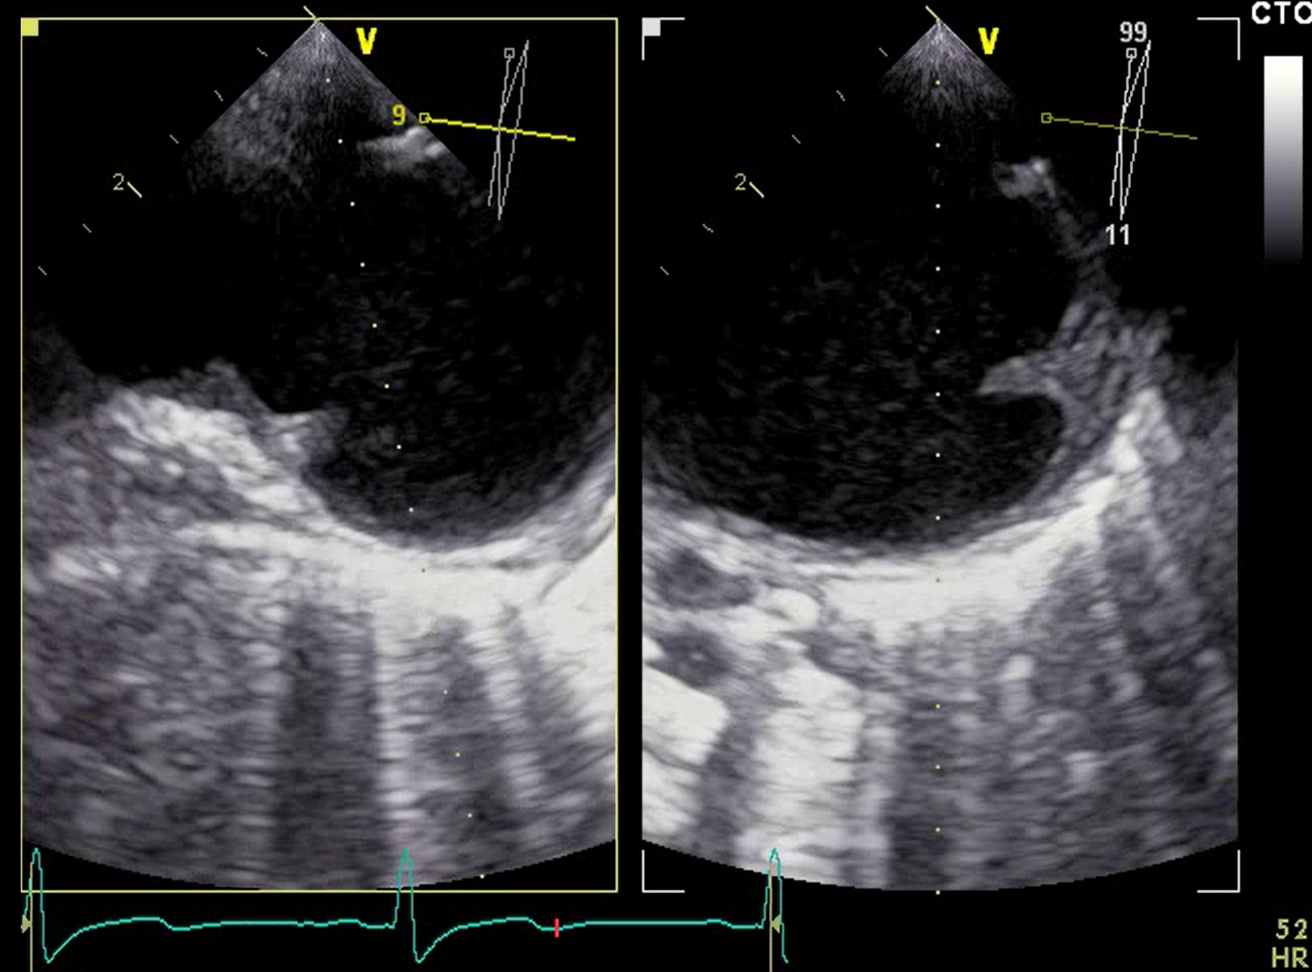
After
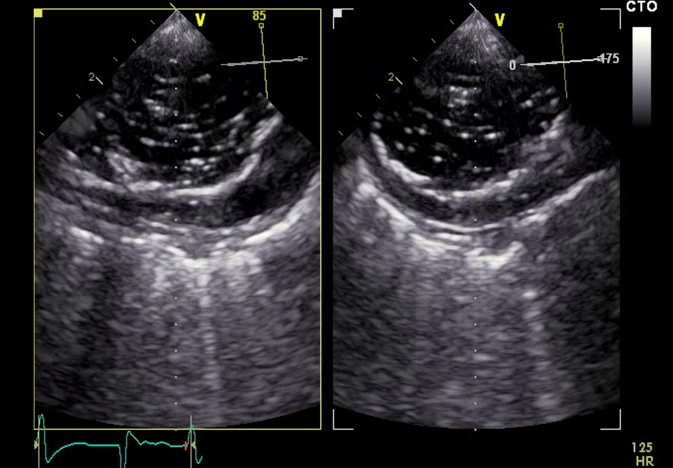
A) The is a type 1A leak
B) Air is present within and outside the endograft
C) There are no consequences of air embolization in such cases
D) The stent is unstable

Answer: B
Leaks are typically diagnosed using color Doppler imaging. Air bubbles appear as highly mobile, strongly echogenic dots, often accompanied by side lobe and reverberation artifacts with acoustic shadowing. There is an association between the total number of air emboli quantified using transcranial Doppler in cardiac surgery and adverse outcome (see chapter 13)

Q10 Which of the following statements is FALSE regarding endoleaks?
A) Type I is an attachment site leak
B) Type II is a branch leak
C) Type IIII is a graft defect
D) Type IV is detected using a 20 cm/s pulsed-wave velocity threshold

Answer: D.
(see Table 24.5) TEE is the most sensitive tool for detecting endoleaks immediately after stent graft deployment. Angiography may miss small endoleaks because the amount of dye within the leak is undetectable by fluoroscopy or the imaging view is inadequate. TEE is often superior to angiography in detecting and characterizing type I endoleaks, from incomplete stent graft apposition to the aortic wall. This is most useful in the highly curved aortic sections, such as the aortic arch. TEE may better define endoleaks than by angiography because it is sometimes difficult to differentiate a transient type IV endoleak from the more significant type I or III endoleaks immediately after stent graft insertion. A PWD velocity cutoff value of 50 cm/s enables the differentiation of type IV endoleaks (slow blood flow) from type I, II or III endoleaks (high-velocity flows).

