Chap 29

Q1 Which of the following statements is FALSE regarding the use of transesophageal echocardiography (TEE) in non-cardiac surgery?
A) Intraoperative rescue TEE is indicated in patients with unexplained hemodynamic instability regardless of the surgical procedure.
B) Intraoperative rescue TEE is indicated in patients with unexplained hemodynamic instability regardless of the patient’s pre-operative medical conditions.
C) TEE is the preferred imaging modality for hemodynamic assessment intraoperatively, in awake patients prior to the induction of anesthesia and, once extubated, during the anesthesia recovery phase.
D) TEE provides high-resolution images of the posterior cardiac structures whereas TTE offers very good visualization of the anterior and apical cardiac structures.

Answer: C
Although TEE is the preferred imaging modality for hemodynamic assessment intraoperatively, transthoracic echocardiography (TTE) is a more suitable modality for cardiovascular evaluation in awake patients prior to the induction of anesthesia or, once extubated, during the anesthesia recovery phase.

Q2. Which of the following statements is FALSE regarding the hemodynamic assessment using TEE?
A) The easiest way to measure the left-sided CO is by measuring the LVOT diameter from the mid-esophageal LAX view and the VTI of the LVOT from the deep TG view.
B) In an unstable patient, qualitative assessment of the motion of the RV lateral wall and the septum are often adequate to provide a quick assessment of the RV systolic function.
C) Acute RV systolic dysfunction should raise the suspicion of pulmonary embolism.
D) Atrial septal defect and patent foramen ovale are infrequent causes of hypoxemia during non-cardiac surgery.

Answer: D.
Atrial septal defect and patent foramen ovale are common causes of right to left shunt and hypoxemia particularly during laparoscopic procedures, orthopedic, neurosurgical and trauma.

Q3.In which of the following non-cardiac surgery is TEE seldom used?
A) Elective lung resection surgery
B) Vascular surgery
C) Hepatobiliary surgery
D) Neurosurgery

Answer: A.
TEE is seldom used during elective lung resection surgery, as there is a lack of clinical utility. However, its use can be helpful during surgery for mediastinal masses to evaluate the extent and invasion of surrounding structures, such as the atria, pulmonary veins, pulmonary artery, or SVC. It would mainly be used as a rescue if a patient becomes hemodynamically unstable.

Q4. In patients undergoing non-cardiac surgery, which of the following is the least frequent cause of hemodynamic instability?
A) LV dysfunction
B) RV dysfunction
C) Hypovolemia
D) Pericardial effusion and tamponade

Answer: D.
An early study involving rescue TEE showed the most common causes of hemodynamic instability were LV dysfunction (45%), RV dysfunction (30%) and hypovolemia 16%. The etiology will also vary if rescue TEE is used intra or post-operatively. For instance, in a series of 364 rescue TEEs, hypovolemia was the most common cause intraoperatively (32.2%) but RV dysfunction, the most common post-operatively (24.1%), with confirmation of these findings by a recent study.

Q5. What is the most likely cause of the hepatic venous Doppler signal in this hemodynamically patient after a T3 renal cell carcicoma resection?
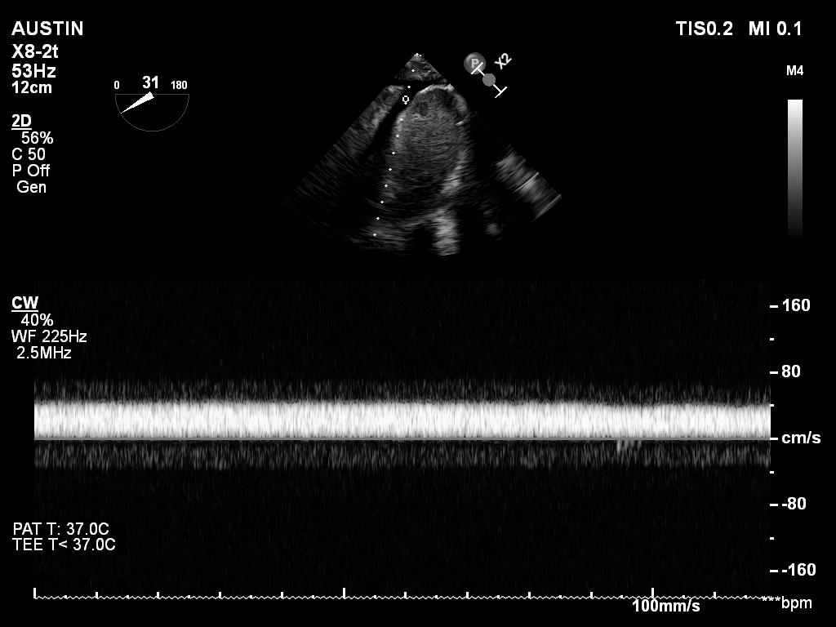
A. Hypovolemia
B. Right ventricular dysfunction
C. Hepatic vein stenosis
D. Inferior vena cava stenosis

Answer D:
T3 renal cell carcinoma can be associated with IVC thrombus that need to be removed intraoperatively at the time of the nephrectomy.
See eTable 10.2 summarizes the criteria for inferior vena cava (IVC) stenosis. In IVC stenosis. IVC diameter will be more than 17 mm, spontaneous echo contrast will appear in IVC. The IVC and hepatic vein flow interrogation: area of no flow (color-coded black) in regions that are not perpendicular to the Doppler beam. Finally hepatic vein flow velocity will show loss of quadriphasic pattern, appearance of monophasic flow, blunting of peak velocity (< 40 cm/s) and in some case flow reversal.

Q6. Which statement is FALSE regarding diastolic function in non-cardiac surgery?
A) In elderly patients, abnormal E/e` ratio does not increase the need for vasoactive agents.
B) Acute diastolic dysfunction with hemodynamic instability may occur in patients undergoing aortic surgery as a sign of coronary artery disease.
C) Relaxation abnormalities often appear in hemodynamically unstable patients and is typically associated with a prominent v wave on the pulmonary artery catheter.
D) Patients with LV diastolic dysfunction undergoing non-cardiac surgery incur a higher risk of major adverse cardiac events.

Answer C.
Surgical patients with significant diastolic dysfunction are susceptible to hemodynamic instability. Patients with LV diastolic dysfunction undergoing non-cardiac surgery incur a higher risk of major adverse cardiac events. However, in elderly patients, abnormal E/e` ratio does not increase the need for vasoactive agents in non-cardiac surgery. Intraoperative TEE can help with goal-directed hemodynamic management in patients with significant diastolic dysfunction. A change in diastolic function and the development of acute diastolic dysfunction with hemodynamic instability may occur in patients undergoing aortic surgery as a sign of coronary artery disease. Early recognition and treatment of acute diastolic dysfunction may be crucial in preventing postoperative adverse outcomes. Restrictive diastolic function often appears in hemodynamically unstable patients before or after cardiac surgery, and is typically associated with a prominent v wave on the pulmonary artery catheter

Q7. Which statement is TRUE regarding venous air embolism (VAE)?

A) Transcranial Doppler (TCD) is the most sensitive method to detect
B) Lethal dose of air in human is in the range of 3–5 mL/kg.
C) TEE is recommended for VAE monitoring.
D) Algorithms for automatic detection of VAE using TEE are highly specific.

Answer B.
TEE is unquestionably the most sensitive device to detect VAE with a detection threshold for air as low as 0.02 mL/kg. TCD is sensitive to detect arterial air embolism. The most frequent alternate device is precordial Doppler ultrasound. This device has a detection threshold for air as low as 0.05 mL/kg, is cheap, non-invasive and requires little specialist training to use. In contrast, TEE is more expensive, requires specialized expertise and training to interpret, and requires constant observation by the anesthesiologist at the expense of other clinical tasks. Algorithms for automatic detection of VAE using TEE lack specificity. These shortcomings may explain the limited uptake of the technique in practice. However, TEE offers the additional ability to detect a PFO or atrial septal defect. Such structural lesions may heighten the risk of a disabling or lethal complication at a lower volume of air entrained (<3 to 5 mL/kg) necessary to cause an air lock in the RVOT (see Figure 29.3).

Q8. Which statement is INCORRECT regarding orthopedic surgery and the risk of hemodynamic instability in bone cement implantation syndrome (BCIS)?
A) Severe cardiorespiratory complications occur in 2% with an intraoperative mortality of 0.5%.
B) Risk factors include the emergent need for surgery, nature of the surgical procedure and multiple patient co-morbidities, particularly for fractured femoral neck.
C) Embolization of bone cement and other debris into the pulmonary circulation presumably causes acute RV dysfunction through chemical and mechanical effects.
D) Perioperative cardiorespiratory complications occur in 5% of patients who receive a cemented prosthesis.

Answer D.
A cause of intraoperative instability common during, but not exclusive to, hip arthroplasty is bone cement implantation syndrome (BCIS). Perioperative cardiorespiratory complications occur in 20% of patients who receive a cemented prosthesis; these are severe in 2% with an intraoperative mortality of 0.5%. Embolization of bone cement and other debris into the pulmonary circulation presumably causes acute RV dysfunction through chemical and mechanical effects.

Q9 The role of TEE in pulmonary thromboendarterectomy include all the following EXCEPT:
A) Monitor pulmonary artery (PA) pressure
B) Detect residual thrombus in the PA
C) Excluding interatrial septal defect
D) Evaluate left and right ventricular function

Answer: A
Pulmonary thromboendarterectomy is the treatment of choice for patients suffering chronic thromboembolic pulmonary hypertension (see Figure 29.8). TEE is essential to exclude interatrial septal defects with intracardiac shunt, evaluate biventricular function and detect any residual thrombus left within the pulmonary artery post-procedure (see Figure 29.9 & Figure 29.10). Although TEE can be used to estimate PA pressure, it remains limited in terms of continuous monitoring. In such case, hemodynamic measurements using a PA catheter with continuous RV pressure waveform is more appropriate in order to detect RV dysfunction and failure.

Q10 Intraoperative TEE is indicated in non-cardiac surgery in all those conditions EXCEPT:

A) Low cardiac output
B) Intraoperative cardiac arrest
C) Persistent unexplained hypoxemia
D) Left bundle branch block (LBBB)

Answer:D
See Table 29.4: Intraoperative indications of TEE include: unexplained persistent hypotension (not responding to traditional therapy), persistent unexplained hypoxemia, low cardiac output or heart failure and intraoperative cardiac arrest. LBBB is more commonly associated with left ventricular dysfunction but is not an indication for intraoperative TEE.

