Chap 32 MCQ Extra-Cardiac Transesophageal Ultrasonography

Q1. Which of the following statement is FALSE regarding this extra-cardiac transesophageal ultrasonography (see video Chap32_Q1)?
A) This complication may be found after extracorporeal membrane oxygenation (ECMO) weaning.
B) Pulmonary embolism and RV failure are potential complications.
C) Anticoagulation is the treatment of choice.
D) This is a benign finding.

Answer: D
This is a thrombus in the inferior vena cava (IVC) and can lead to significant complications if not treated accordingly. IVC thrombus commonly occurs after ECMO weaning.

Q2. This TEE was performed in a 43-year-old female with staphylococcus bacteremia. (See video Chap32_Q2) Which of the following is the most likely diagnosis?
A) Aortic dissection
B) Intramural hematoma
C) Aortitis with periaortic abscess
D) Aortic pseudoaneurysm

Answer: C
This is a view of the upper part of the descending thoracic aorta that shows significant heterogeneous thickening around the aorta compatible with a periaortic abscess and aortitis. CT and TEP scan confirmed the diagnosis.

Q3. A 53-year-old female has been put on mechanical ventilation because of severe hypoxemia. According to this lung ultrasonography, which of the following is not part of the differential diagnosis (see video Chap32_Q3A and Chap32_Q3B)?
A) Left heart failure
B) Pneumonia
C) Pneumothorax
D) Acute respiratory distress syndrome

Answer: C
This lung TEE shows B-lines (ie shiny vertical lines arising from the pleural interface and moving along with the parenchymal pleura throughout the respiratory cycle) and an area of consolidation. The presence of B-lines excludes the diagnosis of pneumothorax. However TEE probe is positioned posteriorly and could miss an anterior stable pneumothorax.

Q4. The liver and its vessels (hepatic veins, portal vein and hepatic artery) are easily examined by TGAUS. Which of the following statements is FALSE?
A) The hepatic veins and the portal vein have a normal triphasic flow (systolic, diastolic and atrial reversal).
B) The absence of portal velocity signal in a patient in shock can be a sign of abdominal compartment syndrome.
C) Air resulting from intestinal ischemia may be present in the portal vein of hemodynamically instable patients.
D) A portal vein pulsatility index (PVPI) > 0.5 may be a sign of high right atrial pressure, moderate or greater tricuspid regurgitation and RV dysfunction.
E) Reversal of the systolic forward flow velocities in the hepatic veins may be a marker of severe tricuspid regurgitation.

Answer: A
The hepatic veins have a normal triphasic flow. However, the portal vein has a normal laminar or monophasic flow.

Q5. The main indication of TELUS is the evaluation for acute hypoxemia. Which of the following statements is FALSE?
A) TELUS has a high sensitivity to detect non-tension pneumothorax and right pleural effusion.
B) Vertical “B-lines” can be present in patients with cardiogenic edema or in patients with ARDS.
C) Pneumonia, atelectasis, pulmonary contusion, neoplasm and pulmonary infarction all result in a similar pattern of consolidation.
D) The number of “B-lines” is proportional to the amount of extravascular lung water.
E) “A-lines” are artifactual horizontal lines and the distance between them is constant and equal to the distance between the probe and the first pleural line.

Answer: A
Although TELUS has a high sensitivity to detect left side pleural effusion, effusion as big as 200 ml can be missed on the right lung. Also, since air tends to accumulate in the non-dependent area of the lung, which is inaccessible to TELUS in supine patient, it is highly unlikely that a TEE approach could be of any diagnostic value for non-tension pneumothorax.

Q6 78-year-old man undergoing percutaneous tricuspid valve replacement. What are the findings? video Chap32_Q6
A) Pericardial effusion
B) Pleural effusion
C) Ascites and bowel edema
D) Normal left ventricular function

Answer: C
Note the floating liver into the ascites. In addition, there is significant stomach edema which is characteristic for severe venous congestion often accompanied by portal or splenic venous pulsatility as shown below.
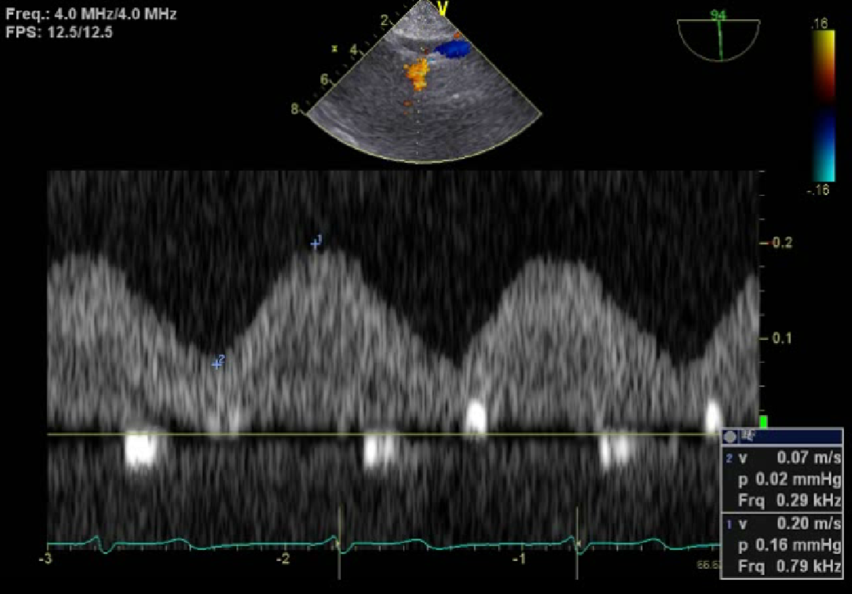

Q7 What is the structure anterior to the aorta in this 73-year-old man prior to aortic valve replacement and ascending aorta surgery? (see video Chap32_Q7A)

A) Left pleural effusion
B) Mediastinal mass
C) Stomach
D) Hemothorax

Answer: C
In the lower portion of the thoracic aorta, part of the stomach can be seen adjacent to the aorta in some patients. The irregular contour, the proximity to heart which makes the area pulsatile and the peristaltism confirms the diagnosis. The use of biplane (see video Chap32_Q7B) further demonstrates the non-pleural origin of this structure.

Q8. What is the etiology of systemic and cerebral desaturation in this 80-year-old woman after coronary revascularization (see video Chap21_Q8)?
A) Tamponade
B) Hypovolemia
C) Hemothorax
D) Right heart dysfunction

Answer: C
A complex effusion typical of an hemothorax is present using transesophageal lung ultrasound. Hypovolemia is likely to be present but does not explain the systemic desaturation. In addition, the normal horizontal aspect of the right ventricular pressure waveform in diastole argues against the diagnosis of right ventricular dysfunction.

Q9 Identify the correct combination based on the figure and on video Chap32_Q9
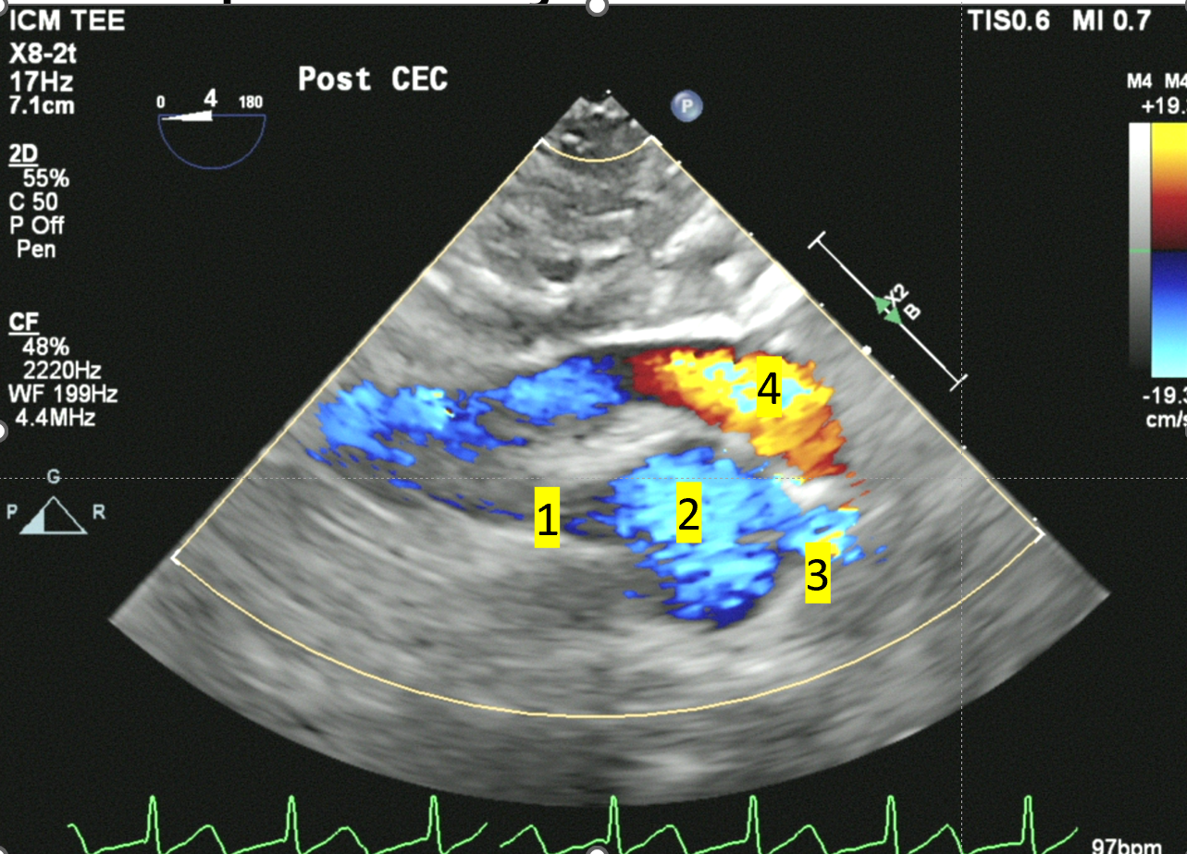
A) 1 right renal artery, 2 aorta, 3 left renal artery, 4 left renal vein
B) 1 left renal artery, 2 aorta, 3 right renal artery, 4 left renal vein
C) 1 right renal artery, 2 aorta, 3 left renal artery, 4 splenic vein
D) 1 left renal artery, 2 aorta, 3 mesenteric artery, 4 mesenteric vein

Answer: B
See figure 32.27. In this view both renal arteries are seen. In transgastric abdominal ultrasound, the ultrasound beam is directed posteriorly. In such a position, structures on the left side of the screen are anatomical the left side structures. Those on the right portion of the screen are on the right anatomical side of the patient. In order to reach the inferior vena cava, the left renal vein has to go beyond the aorta to the right under the superior mesenteric artery. In some patient, there is compression of the renal vein causing a “nutcracker syndrome”. In this case this might explain why the diameter of the left renal vein is slightly larger prior to reaching the inferior vena cava. The Doppler signal of the right renal artery and left renal vein are shown below. Note the abnormal renal vein Doppler signal with systolic reversal which corresponded to the abnormal right ventricular diastolic function after mitral valve repair in this 37-year-old man.
Right renal artery | Right renal vein
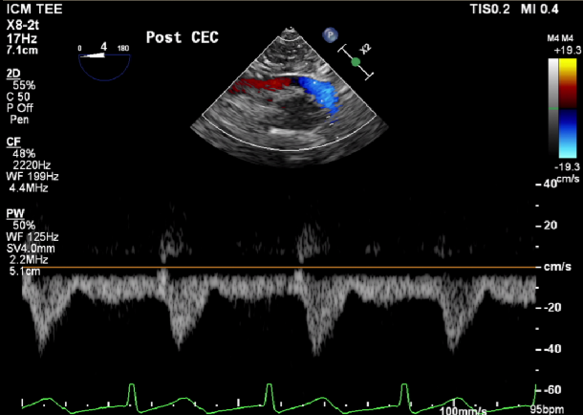 | 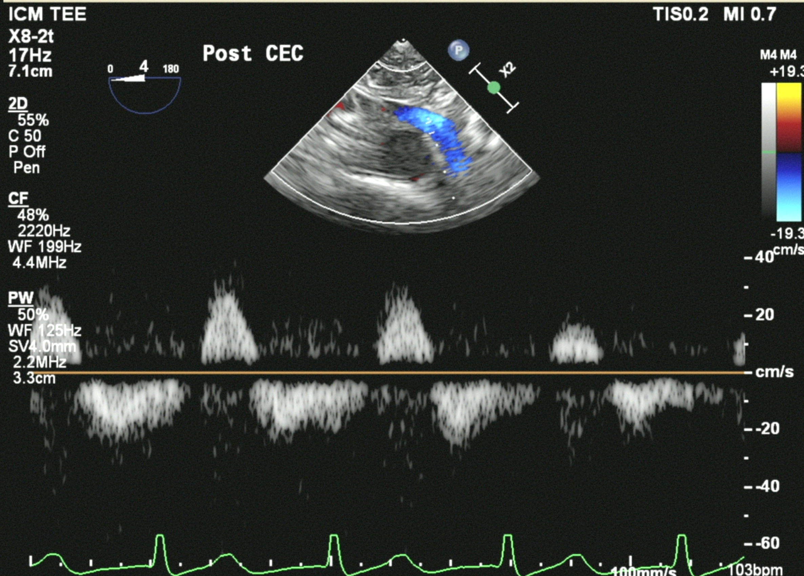

Q10 Identify the following structures (see video Chap32_Q10)

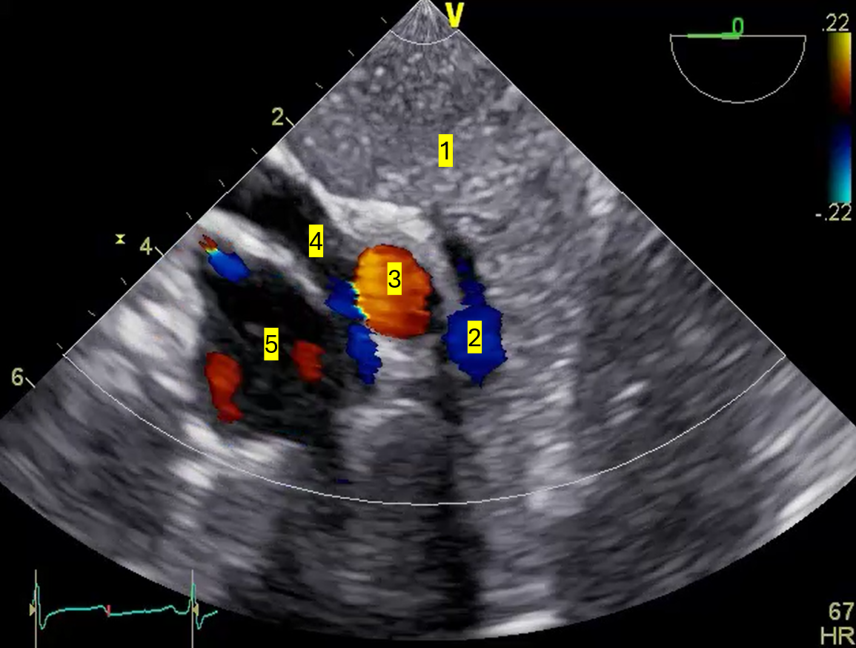

A) 1 Pancreas, 2 mesenteric vein, 3 celiac trunk, 4 right renal vein, 5 aorta
B) 1 Spleen, 2 splenic vein, 3 celiac trunk, 4 left vein, 5 aorta
C) 1 Pancreas, 2 splenic vein, 3 celiac trunk, 4 left renal vein, 5 aorta
D) 1 Spleen, 2 mesenteric vein, 3 celiac trunk, 4 right renal vein, 5 aorta

Answer: C
It is important to identify correctly the splenic vein from the renal vein. Pulsatility in the splenic vein is abnormal but normal in the renal vein. See Figure 32.27

