Chapter 35 Imaging modalities

Q1 What would be the advantage of using cardiac magnetic resonance (CMR) in the following case? (see video Chap35_Q1A and Chap35_Q1B)
A) CMR is superior to transesophageal echocardiography (TEE) in detecting thrombus.
B) CMR can identify myocardial viability.
C) CMR with gadolinium allow precise detection and quantification of myocardial fibrosis and scar.
D) CMR imaging is better than TEE in patients with non-sinus rhythm.

Answer C
Gadolinium-based contrast agents show late gadolinium enhancement sequences for the precise detection and quantification of myocardial fibrosis and scar (Figure 35.15). The late enhancement imaging approach yields white (necrosis, fibrosis) on black (normal myocardium) contrast, elegantly exploiting a higher volume of distribution in necrotic and fibrotic tissue and delayed contrast clearance in those tissues. Image quality is reliably very good, but a regular R-R interval on the EKG is necessary for EKG-gating, limiting the image quality in patients with arrhythmias. Myocardial viability is better assess using PET scan.

Q2 All the following elements regarding the importance of the calcium score derived from computed tomography (CT) are true EXCEPT?
A) A high calcium score correlates with high plaque burden and high relative risk of cardiac events.
B) The presence of a positive score alone increases cardiovascular event risk by four times in 3–5 years.
C) High calcium score is a proven predictive factor for myocardial infarction (MI) and death.
D) This score does not include uncalcified coronary plaques but accounts for the total plaque burden.

Answer D
The calculation of the calcium score uses a low-dose, unenhanced cardiac CT acquisition that detects the total coronary calcium burden. Although this score does not include uncalcified coronary plaques and only accounts for a portion of the total plaque burden, it remains a proven predictive factor for myocardial infarction (MI) and death. A high calcium score correlates with high plaque burden and high relative risk of cardiac events. The presence of a positive score alone increases cardiovascular event risk by four times in 3–5 years.

Q3. What is the etilogy of is this 58-year-old woman with hemodynamic instability after cardiac surgery?

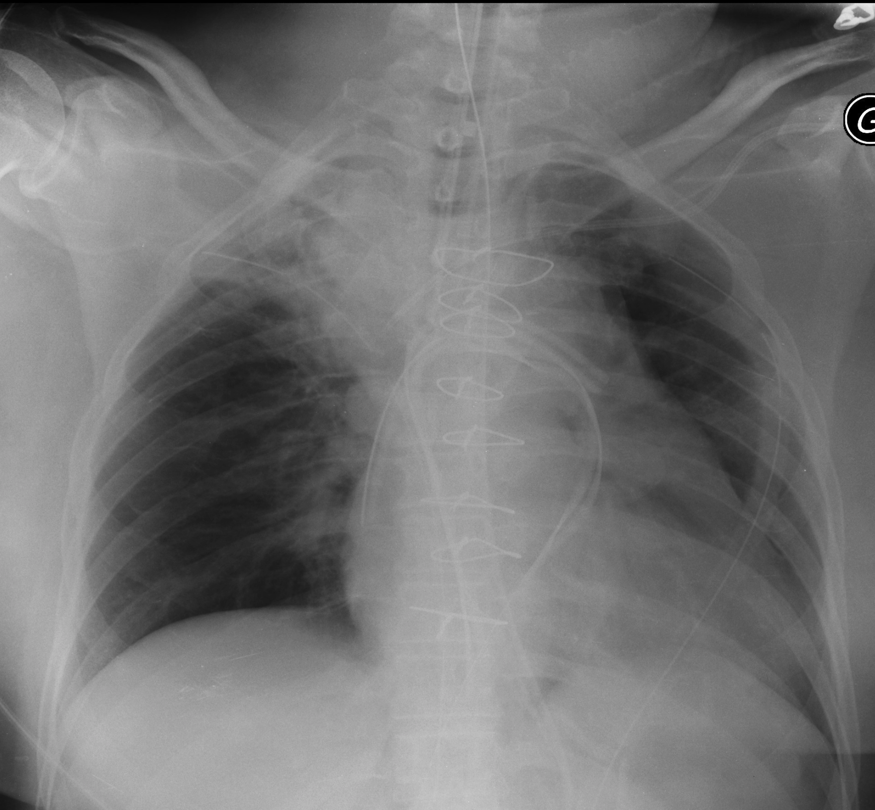

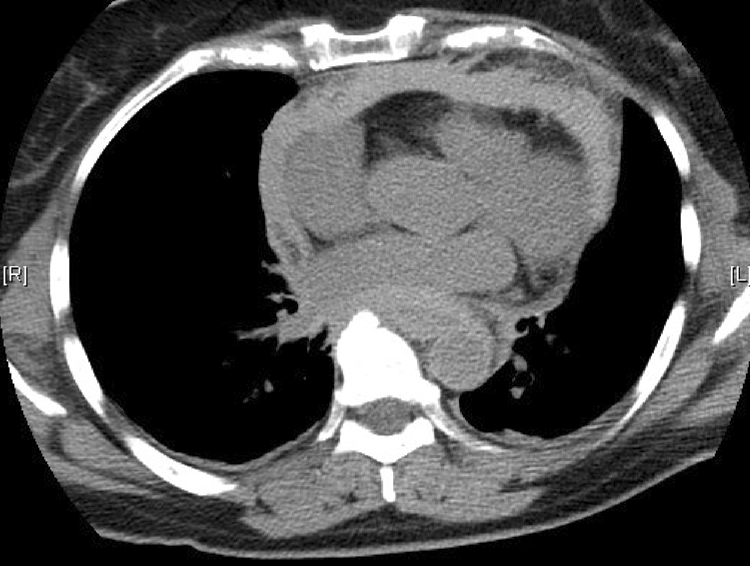
A) Right pneumothorax
B) Regional tamponade
C) Mediastinal tamponade
D) Left hemothorax

Answer: C
This is circumferential thickening mostly in the upper region of the thorax which in this case was compressing the superior vena cava. On the bicaval view, thrombus is surrounding the anterior portion of the right atrium with a small amount of free fluid. (see video Chap35_Q3).

Q4 Which statement is FALSE regarding the role of the chest radiograph (CXR) in the diagnosis of cardiac chamber enlargement or specific pathologies.
A) The left atrial appendage (LAA) curvature is usually not visible on the frontal CXR, unless it and/or the left atrium is dilated.
B) A right heart border displaced toward the right of the spine in the frontal film suggests right ventricular enlargement.
C) RV enlargement is unlikely when the RV contacts more than one-fourth of the length of the distal sternum on the lateral film or fills more than one-third of retrosternal clear space.
D) A displaced left heart border inferiorly, posteriorly, or toward the left suggests an enlarged left ventricle (LV).

Answer: B
CXRs can give clues to specific cardiac chamber enlargement. A displaced left heart border inferiorly, posteriorly, or toward the left suggests an enlarged LV. The LA appendage curvature is usually not visible on the frontal CXR, unless it and/or the LA dilates. A right heart border displaced toward the right of the spine in the frontal film suggests right atrial enlargement. Finally, when the RV contacts more than one-fourth of the length of the distal sternum on the lateral film or fills more than one-third of retrosternal clear space, enlargement is likely.

Q5 What is the impact of this computed tomography prior to cardiac surgery? (see video Chap35_Q5A, video Chap35_Q5B and video Chap35_Q5C)
A) It is an absolute contra-indication for using TEE.
B) TEE can be used without any added precautions.
C) Careful evaluation of the risk-benefit ratio of the procedure is to be considered.
D) A pediatric TEE probe needs be used to reduce complications.

Answer: C
There are many relative contraindications (see Table 8.5). These include various esophageal pathologies, hiatal hernia, previous gastroesophageal surgeries, bleeding diathesis, cervical abnormalities, or anatomic distortion from arthritis or radiation therapy. Relative contraindications may not preclude TEE examination but warrant careful evaluation of the risk-benefit ratio of the procedure. The chest radiograph obtained after the procedure below illustrates the irregular position of the nasogastric tube with the risk of perforation. In such patient, there is no issue in TEE probe insertion therefore there is no need to use a pediatric probe.
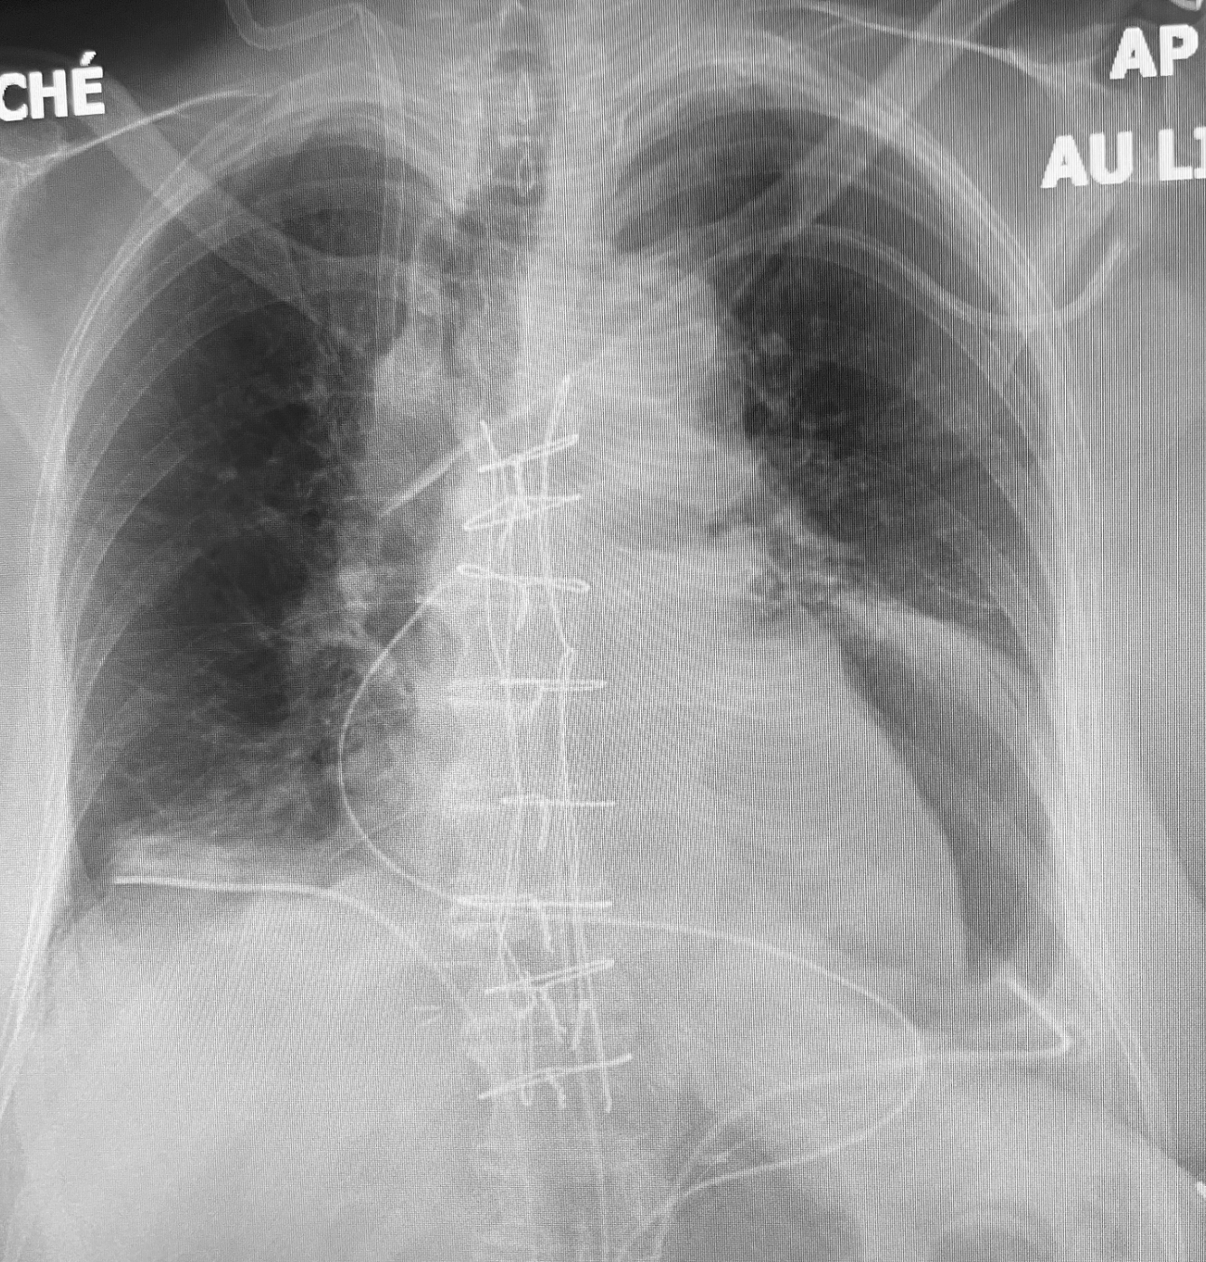

Q6. In myocarditis, which pattern of injury is typically seen on CMR?
A) Ischemic, subendocardial
B) Patchy, non-coronary distribution
C) Transmural, involving a single coronary artery
D) Concentric thickening of the myocardium

Answer: B
The inflammation pattern follows a non-ischemic distribution of injury, with patchy lesions randomly distributed beyond the perfusion territory of a single coronary artery.

Q7. What limits the use of CMR in valve assessment?
A) Inadequate image resolution
B) Inability to use contrast
C) Low temporal resolution
D) Limited magnetic strength

Answer: C
CMR can assess the left and right heart chambers with exquisite anatomical detail. In-plane spatial resolution is as high as 0.8 mm x 0.8 mm with a slice thickness of 5-8 mm. Low temporal resolution limits the imaging of small and rapidly moving structures, making anatomic heart valve assessment difficult.

Q8 Advantages of computed tomography (CT) include all the following EXCEPT?
A) CT is superior to TEE in calculating ejection fraction.
B) CT angiography is the most sensitive technique to assess valve calcification. The literature shows a good correlation between calcification quantification and the severity of aortic stenosis, the need for valve replacement, and prognosis.
C) Coronary computed tomography angiography (CCTA) is a fast and non-invasive method of evaluating coronary vessel patency as compared to conventional intra-arterial catheter angiography.
D) CCTA can detect significant coronary stenosis of over 50% with high sensitivity (100%) and specificity (94%).

Answer: A
The calculation of ventricular volumes and ejection fraction (EF) can occur over the entire cardiac cycle using a retrospective EKG-gated acquisition CT. However, the limited temporal resolution with cardiac CT may underestimate LV ejection fraction, as there is an overestimation of end-systolic volumes and an underestimation of end-diastolic volumes.

Q9. Identify the adequate correlation between CT chamber, TEE and angiographic views using S-curve.
A) Mid-esophageal (ME) two-chamber view and right anterior oblique (RAO) cranial view
B) ME commissural view and RAO caudal view
C) ME four chamber view and left anterior oblique (LAO) caudal view
D) ME long-axis chamber view and LAO cranial view

Answer: A
See eFigure 35.23.

Q10 What is the major difference between S-curve of the TV annulus showing the LV and the RV projection?
A) For the LV the mid-esophageal four-chamber view is in the LAO cranial view but in the LAO caudal view for the RV.
B) For the LV the mid-esophageal LAX view is in the LAO cranial view but in the LAO caudal view for the RV.
C) For the LV the mid-esophageal two-chamber view is in the RAO cranial view but in the RAO caudal view for the RV.
D) For the LV the mid-esophageal four-chamber view is in the LAO cranial view but in the LAO caudal view for the RV.

Answer: C
As shown in eFigure 35.22 and eFigure 35.23, the LV the mid-esophageal two-chamber view is in the RAO cranial view but in the RAO caudal view for the RV.

