Examples of Impact Models, also called Logic Models

- Model 1, on page 2, is of the Open Arms evaluation report that is described in Case Study 1. The full report is one of the sample evaluation reports – the model appears on page 12. This is an example with all details.
- Model 2, on page 3, is a conceptual example based on an actual impact model, with labels for many elements but no specific details of a somewhat similar but expanded model. This one provides separate elements within larger blocks.
- Model 3, on page 4, is another conceptual example also based on an actual impact model, with some general categories that illustrates another possible orientation – with movement from the top of the page to the bottom as well as left to right.
- Model 4, on page 5, is a different approach – using a method often associated with path analysis that implies causal relations among variables. It is from the Bridges to Tomorrow evaluation that is described in Case Study 5. This example also provides all the details of the original.
- See https://www.cdc.gov/eval/logicmodels/index.htm (search for “Logic Model”) for guidance on building logic models and for various detailed examples of models used in their evaluations.

`
Model 1
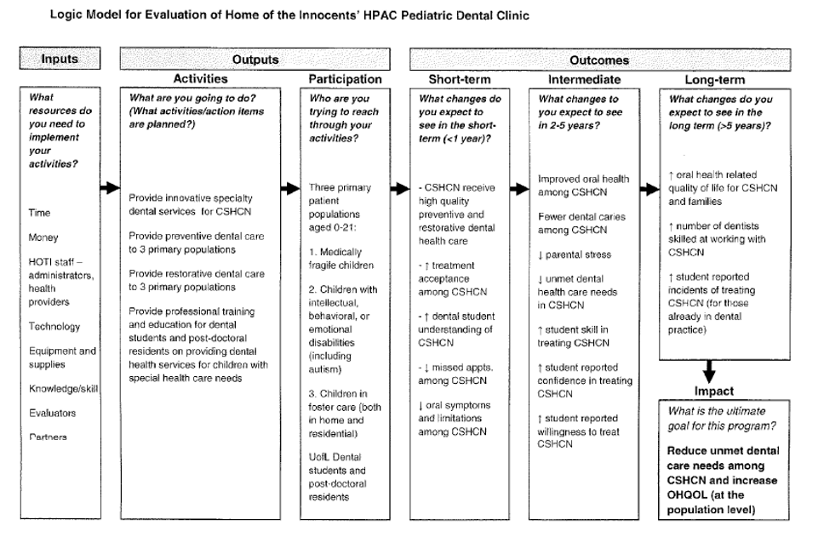
Model 2
System
First level change
Program
Kinds of improvement
Patient
Areas of improvement
Impact
Long-term goal
Program
Kinds of improvement
Patient
Areas of improvement
System
First level change
List of people and organizations
List of responsible member
List of supervisors
List of workers
Direct Services
List of categories
Quality Improvement
List of activities
Administration
List of needed tasks
Leadership
List of events
Community Relationships
List
Work Tools
List
Program Clients
List
Program Staff
List
Funding Sources
List
Outcomes
Short Term Intermediate Long Term
Outputs
Activities Participation
Inputs
Model 3

INTERMEDIATE (3 – 5 Years)
List of specific improvements and ways to measure them.

LONG TERM (5 + Years)
Global measure of outcome

SHORT TERM (1 – 3 Years)
List of specific improvements and ways to measure them.

PROGRAM OUTCOMES
How can we objectively measure each strategy?

Objective 5: Label
List of specific actions

Objective 4: Label
List of specific actions

Objective 3: Label
List of specific actions

Objective 2: Label
List of specific actions

Objective 1: Label
List of specific actions

OBJECTIVES AND ACTIONS
What goes on in the program?

PROGRAM INPUTS
What goes into the program?
Financial
Sources of funding

Personnel
Staff members from different organizations who are involved

Goal 3
Description

Goal 2
Description

Goal 1
Description

GOALS
What does the program hope to achieve?
One of the two target populations
Narrative about the needs of this population

NEEDS
What needs does the program address?
The other target population
Narrative about the different needs of this population

