APPENDIX

Illustrative Program Evaluation Report

An abbreviated program evaluation report is presented here. McKillip et al. (1985) evaluated a media-based program conducted by a university health center to communicate two messages concerning healthy attitudes toward alcohol use. The evaluation was an examination of whether the posters and newspaper ads would get the students’ attention. Clearly the outcome desired is for students to discourage friends from driving while intoxicated and to feel free to decline a drink in spite of social pressure. However, it is pointless to mount a media campaign if students don’t even notice the messages; this evaluation sought to be sure that the first step toward encouraging healthy attitudes did occur.
Note that this evaluation combined an interrupted time series with switching replications and the control construct design (see McKillip, 1992, for a detailed discussion of the analysis). The use of this design produced an evaluation carefully protected from threats to internal validity. Note the use of multiple sources of data. Finally, note the percentage of students who reported that they had seen the posters before the posters went up. These percentages should caution readers about a naive use of self-report in evaluations; these evaluators wisely based the evaluation on the change between when the posters were not up and when they were displayed, not on the percentage of students saying they saw the displayed posters.
The content of this illustrative report accurately reflects the findings of the original evaluation. However, the university name has been changed, two citations have been added, and a several fictional details have been used to better illustrate how a report would be presented to an agency. Reports to agencies are not done in the format used for papers in research journals.
Responsible Alcohol Use
Media Campaign: Can We
Get College Students’
Attention?
An evaluation of the media campaign in the Fall Semester of 2009 sponsored by the Alcohol Education Project of the Student Health Center to encourage social behaviors that counter the prevailing student culture fostering the overconsumption of alcohol

SSU

Jack McKillip, D. C. Lockhart, P. S. Eckert J. Phillips
March 19, 2010

Contents

Summary 4
Needs to Be Met by the Program 5
Program Description 6
Target Population 6
Multimedia Intervention 6
Evaluation Questions 7
Evaluation Design 7
Table 1 8
Evaluation Findings 9
Interviews 9
Figure 1 10
Mailed Survey 11
Media Information Table 11
Conclusions and Implications 12
References 13
Appendices (buff-colored pages) 14

SUMMARY

Responsible alcohol use was encouraged by a program sponsored by the Alcohol Education Project (AEP) at Southern State University (SSU). A needs assessment showed that students endorsed moderate drinking, but believed that their friends expected them to do more heavy drinking. The experiences of the AEP staff suggested that another problem on campus was drinking and driving. A campaign was planned to encourage students to (1) resist peer pressure to drink heavily and (2) stop friends from driving while drunk. Posters, newspaper ads, an information booth, and a radio call-in show were used by the AEP staff to stress these two themes. There is evidence that those students who are still forming their drinking habits can be influenced by appropriate information; however, information will not be received if the media used to provide the information do not attract the attention of the target audience.
Since the effectiveness of posters, ads, and other methods in attracting student attention was not known, an evaluation was conducted during a 10-week period. A two-week baseline period (with no AEP posters or ads in place) was followed by a two-week emphasis on resisting peer pressure to drink. A second two-week baseline period was followed by a two-week emphasis on keeping friends from driving while drunk. The evaluation ended with a third two-week baseline period. During the two intervention periods, posters, ads, and a radio show stressed one of the themes. For the first four periods (eight weeks), an information table was set up in the student union on Thursdays during the lunch hour. No AEP materials were available during the last two-week period.
Interviews during the 10-week evaluation showed that students became aware of the campaign and its themes, student recognition of Theme 1 increased abruptly during week 3, but the level of recognition of Theme 2 did not change. When Theme 2 materials were available (during weeks 7 and 8), recognition of Theme 2 increased abruptly. The conclusion that students were aware of the messages was also supported by the numbers and types of material taken from the information table during the weeks of the campaign. Last, a mailed survey during weeks 9 and 10 showed that the two themes targeted by the campaign were recognized more frequently than the other AEP themes not stressed in this media program.
It was concluded that the media campaign was effective in attracting student attention. Although getting student attention is merely a first step in a chain of events that is hoped to result in responsible alcohol use, it is an essential step. Staff members of student services can be confident that using well-placed posters and providing alcohol-related information is an effective use of educational resources.

Needs to be Met by the Program

Widespread evidence indicates that the rate of abuse of alcoholic beverages on U.S. college campuses is a current problem with implications for the future health of students. National statistics show a remarkable range of problems stemming from excessive drinking by college students (see A Snapshot of Annual High-Risk College Drinking Consequences, 2007). Informal observations suggested that alcohol abuse is a problem at SSU as well. In addition, answers to mailed surveys to students indicated that although the majority of SSU students viewed moderate drinking as desirable, they believed that their peers expected them to drink heavily. It seemed important for students to be encouraged to hold to their belief in moderate drinking by helping them to resist peer pressures to abuse alcohol. Drinking and driving was also found to be a frequently encountered alcohol-related problem on campus. On the basis of this needs assessment, the SSU AEP staff designed a media-based education program to address alcohol use as related to peer pressure and driving.

Program Description

Target Population

SSU students, approximately 18,700 undergraduates and 3,300 graduate students, made up the target population of a multimedia campaign to encourage responsible alcohol use.

Multimedia Intervention

Previous research (Ray, 1973; Rothchild, 1979) has implied that students who are not heavily involved in alcohol abuse and are just forming their alcohol-related attitudes can be influenced by material strengthening inclinations toward responsible alcohol use. Considerable research suggests that peer pressure is a major factor in college alcohol abuse (Nauert, 2009). Therefore, the staff of the AEP expected that a media-based education project could have positive effects. (Heavy drinkers and those whose drinking patterns are well practiced would probably not be influenced by this approach.)
The two themes for the intervention were selected on the basis of the needs assessment. Theme 1 was “It’s not rude to refuse a drink.” Theme 2 was “Friends don’t let friends drive drunk.” The AEP project began in September 2009.
The program sought to increase student awareness of these themes by (1) putting posters in public places throughout the campus (307 were used for the first theme and 203 for the second); (2) placing half-page ads identical to the posters in the Tuesday and Thursday issues of the campus newspaper; (3) creating a 9.8-square-foot window display in the student union concerning the theme being publicized; (4) having an AEP staff member on a radio call-in show during the first week each of the themes was stressed; and (5) providing an information table in the student union during the noon hours of each Thursday stocked with written material on responsible alcohol use with an AEP staff member available to answer questions.

Evaluation Questions

The materials could be ignored or they could be attended to by students. Thus, the evaluation sought to assess the degree to which the media campaign attracted student attention. Interviews, surveys, and behavioral measures were used to judge whether students were aware of the campaign.

Evaluation Design

To permit an evaluation of the program, the campaign was divided into five two-week periods as shown in Table 1. The five periods included the following:

1. A two-week baseline period that only involved the informational table in the student union.
2. A two-week period, weeks 3 and 4, during which the first theme was emphasized using posters, newspaper ads, the window display, and the radio call-in show.
3. A two-week baseline period during which all materials for the first theme had been removed except for the materials at the information table.
4. A two-week period, weeks 7 and 8, during which the second theme was emphasized in the same ways used with the first theme.
5. A two-week baseline period in which all campaign materials were removed including the information table.

TABLE 1 Timeline for Media Campaign and Evaluation Activities
 | WEEK OF SEMESTER
 | 1 | 2 | 3 | 4 | 5 | 6 | 7 | 8 | 9 | 10
Media*:
Theme 1 | O | O | X | X | O | O | O | O | O | O
Theme 2 | O | O | O | O | O | O | X | X | O | O
Measurements:
Interviews | + | + | + | + | + | + | + | + | + | +
Mailed Survey | n | n | n | n | n | n | n | n | + | +
Media Booth | + | + | + | + | + | + | + | + | n | n
*Includes posters, newspaper advertisements, window displays, and radio appearance.
Note: “O” indicates that media related to the theme were not available and “X” indicates that media were available, “+” indicates measurements were taken and an “n” indicates that measurements were not taken. All measurements were relevant to both campaign themes.

The use of baseline periods is frequently used in some forms of psychotherapy in order to show that the treatment had an effect. If the present program had an effect, one would expect students to be more aware of the themes of the campaign after the posters, ads, display, and radio show were in place compared to the weeks before. The use of two interventions permitted a replication of the design. That is, if any apparent effects of the first theme of the program were detected by comparing the first period with the second, the pattern could be verified by comparing the first six weeks of the program with the fourth period (weeks 7 and 8) using student reactions to the second theme. If the patterns were very similar, one could conclude confidently that the AEP media campaign was responsible for student awareness of the themes. Possible alternative interpretations based on national news reports or alcohol industry ads could be rejected as implausible.

Evaluation Findings

Interviews

Of the 371 students interviewed over the 10 weeks, 60 percent were male and 40 percent were female, approximating the composition of the student body. No student was interviewed more than once. During each of the 10 weeks, approximately 40 students were selected at random during the lunch hour from students at the library, a student union cafeteria, and a busy outdoor walkway. AEP staff members interviewed students concerning the recall of the poster and the newspaper ad. Respondents were shown a facsimile of the newspaper ad/poster for both campaign themes and were asked if they had seen them in the university newspaper or as a poster.
Figure 1 includes the percentages of students reporting that they recalled seeing the poster and the newspaper ad for each of the 10 weeks of the campaign. The upper panel of the figure shows the pronounced jump in awareness for Theme 1 in week 3. Note that the lower panel shows that Theme 2 was not recognized by as many students during weeks 3 and 4 as was the first theme. Since only the first theme was being publicized, these patterns support the interpretation that the campaign was effective in attracting student attention. The difference in the students’ reactions to the two themes shows that students were not simply saying that they saw the posters/ad because they thought that is what the interviewers wanted them to say.

FIGURE 1
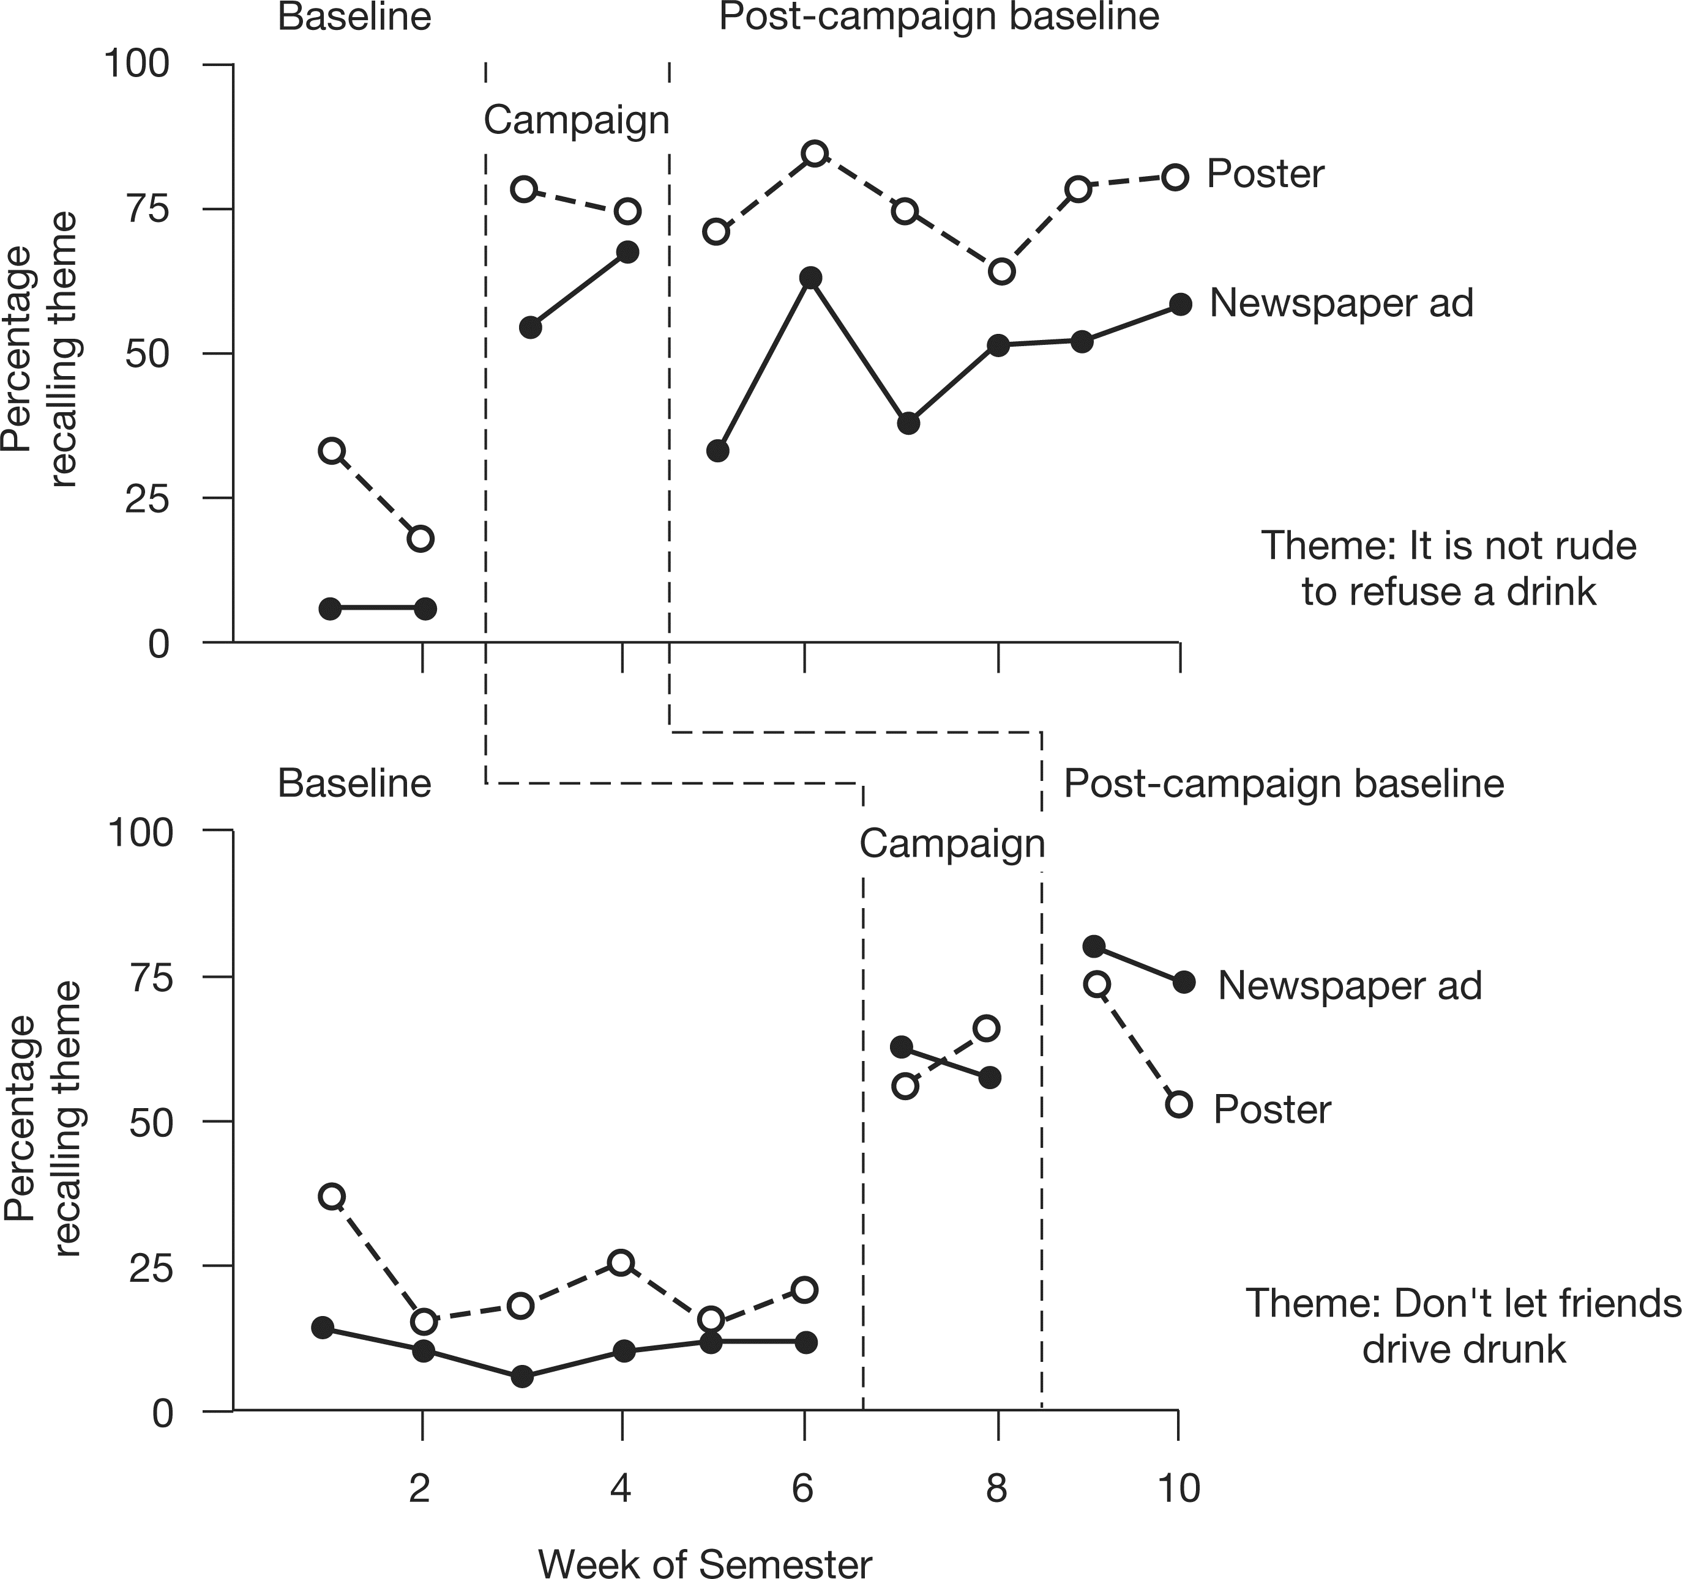
Record of percentage of students interviewed reporting recall of poster and newspaper ad containing media campaign themes. Baseline—period before theme’s posters or ads were introduced. Campaign—two-week period in which posters and ads for particular theme were displayed about campus and published in campus newspaper. Post-theme baseline—period following campaign, ads for theme were not published and posters for them were taken down.

In week 7 the materials for Theme 2 appeared. As expected, awareness of having seen Theme 2 material increased abruptly. Recall of Theme 1 material did not drop to the baseline level since students could remember having seen Theme 1 material earlier. This replication gave credibility to the interpretation that the multimedia campaign was responsible for student awareness of the program’s themes.

Mailed Survey

During the final two-week period, a 12-page survey on alcohol use was mailed to a random sample of 1,113 students. Usable questionnaires were received from 56.7 percent of this sample. Answers to demographic questions indicated that the respondents accurately reflected the characteristics of the student body.
In addition to questions about alcohol consumption, students were asked which of the seven AEP posters, two from the campaign themes and five not used in this campaign, they had seen. All posters were identified only by their textual content and had been available from AEP prior to this fall semester effort beginning in March 2008. The percentage of respondents who recalled having seen each of the posters “more than once” was the measure of program effectiveness. Theme 1 was recalled by 62 percent of the respondents and Theme 2 by 83 percent. By contrast, the other five AEP (noncampaign) posters were recalled by only 12–48 percent of the respondents. The difference between the campaign themes and the other messages was statistically significant (p = 0.03). The level of recall was not related to respondent gender, reported college class, or self-described level of alcohol consumption.

Media Information Table

During weeks 1 through 8, the information table was maintained during the Thursday lunch hours in the student union. An AEP staff member answered questions and seven different posters (two campaign theme posters and five others) as well as other materials were available for student use. Overall, more responsible alcohol-use literature was taken during the weeks of the campaign compared to baseline weeks. During the campaign weeks (weeks 3, 4, 7, and 8) an average of 13.00 campaign theme posters were taken per day compared to an average of 5.33 during the baseline weeks (t(14) = 2.38, p = 0.016, one-tailed). Furthermore, during the four weeks of the campaign an average of 75 pieces of material were taken compared to 51 pieces during the baseline weeks. This difference is in the direction that one would expect if the campaign had been successful; however, the difference was not statistical significant (t(14) = 1.42, p = 0.089, one-tailed).

Conclusions and Implications

These findings support the use of media, especially multiple media, to publicize responsible alcohol use. Attracting student attention is the essential first step in providing information that may be internalized and may, in turn, result in the development of responsible alcohol use habits.
It is important to note that the point of all health education campaigns is to improve health or prevent loss of health. This evaluation has not demonstrated that the media campaign had an effect on the well-being of students. Although the campaign effectively got the students’ attention, there are so many messages endorsing alcohol consumption that the Student Health Center’s goals can easily be thwarted. Like any other single health education effort, it would be hard to show a direct connection between the effort and health of the target population. Nevertheless, these data imply that media programs are effective uses of health educational resources.

References

A Snapshot of Annual High-Risk College Drinking Consequences. 2007. College drinking Changing the culture. Retrieved November 11, 2009. http://www.collegedrinking prevention.gov/.
Nauert, R. 2009. Peer pressure drives college drinking. PsychCentral. Retrieved November 11, 2009. http://psychcentral.com/news/2009/07/10/peer-pressuredrives-college-drinking/7041.html.
Ray, M. 1973. Marketing communication and the hierarchy of effects. In New models for mass communication research, ed. P. Clarke. Beverly Hills, CA: Sage.
Rothchild, M. L. 1979. Advertising strategies for high and low involvement situations. In Attitude research plays for high stakes, ed. J. Maloney and B. Silverman. New York: American Marketing Association.
[This page and all pages of the appendices would be
buff colored in the actual report.]

Appendices

1. List of the locations of the posters during the campaign.
2. Reproductions of the posters used.
3. Interview questions.
4. Mailed survey.
5. Means, standard deviations, and sample sizes.

[It is recommended that a written report also include these items. Many external evaluators (but few internal evaluators) also include letters of agreement relevant to the initiation of the evaluation project. To conserve space neither the items listed above nor letters of agreement have been included in this illustrative report.]

McKillip, J., Lockhart, D. C., Eckert, P. S., and Philips, J.,1985. Adapted with permission.

