4 Food and Agricultural Trade
A key reason for the adoption of the U.S. Constitution in 1789 was to permit free trade between the states. Questions 1 through 8 consider the following annual supply and demand situation for green leaf lettuce in the Northeast U.S. and the rest of the United States.

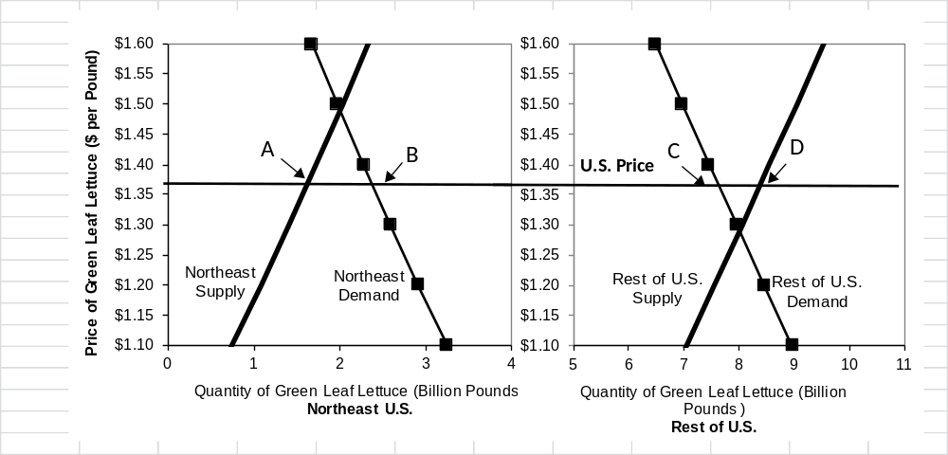

1. Choose one. At a free trade competitive equilibrium price of approximately $1.37/pound, how much would the Northeast want to import from other states?
- 0.75 billion pounds
- 1.6 billion pounds
- 2.4 billion pounds
- 7.6 billion pounds
- 8.4 billion pounds

2. Choose one. At this same price, how much would the other states want to export to the Northeast?
- 0.75 billion pounds
- 1.6 billion pounds
- 2.4 billion pounds
- 7.6 billion pounds
- 8.4 billion pounds

3. Choose one. If USDA sponsored a new mandatory checkoff program for green leaf lettuce farmers nationally, which supported effective advertisements to increase demand nationally, what farmers would benefit?
- No farmers
- Farmers in the Northeast, but not farmers in the rest of the U.S.
- Farmers in the rest of the U.S., but not the Northeast
- Farmers in both the Northeast and the rest of the U.S.

4. Choose one. If USDA sponsored a new mandatory checkoff program for green leaf lettuce farmers just in the Northeast, which supported effective advertisements to increase demand in the Northeast, what farmers would benefit?
- No farmers
- Farmers in the Northeast, but not farmers in the rest of the U.S.
- Farmers in the rest of the U.S., but not the Northeast
- Farmers in both the Northeast and the rest of the U.S.

5. Choose one. If the federal government instituted a “purchase and removal” policy, offering to purchase any amount offered at a support price of $1.34/pound, what farmers would benefit?
- No farmers
- Farmers in the Northeast, but not farmers in the rest of the U.S.
- Farmers in the rest of the U.S., but not the Northeast
- Farmers in both the Northeast and the rest of the U.S.

6. Choose one. If the Northeast sponsored a “buy local food” campaign that effectively ended imports from the rest of the U.S., what farmers would benefit?
- No farmers
- Farmers in the Northeast, but not farmers in the rest of the U.S.
- Farmers in the rest of the U.S., but not the Northeast
- Farmers in both the Northeast and the rest of the U.S.

7. Short answer. Suppose USDA greatly increased National School Lunch Program (NSLP) purchases for green leaf lettuce. Briefly discuss 1 or 2 likely implications for hired farm workers.

8. Short answer. Suppose USDA’s Agricultural Research Service (ARS) invested in a successful new automated harvesting technology for green leaf lettuce. Briefly discuss 1 or 2 likely implications for hired farm workers.

9. Choose one. Which of the following constituencies is most supportive of international trade agreements?
- U.S. food safety advocates
- U.S. local food advocates
- U.S. labor advocates
- U.S. wheat producers
- U.S. tomato growers

10. Choose one. This Reuters article in October 2021 describes several news developments in the organic soy industry.

Suppose Argentina usually exports organic soybeans to the United States under nearly free-trade conditions. Compared to these free-trade conditions, what is the consequence for organic soybean markets of a sudden blockage in global shipping (for example because of a shortage of shipping containers and labor problems in U.S. shipping ports)?

- Lower organic soybean prices in Argentina, higher organic soybean prices in the USA, and a smaller volume shipped.
- Higher organic soybean prices in Argentina, lower organic soybean prices in the USA, and a smaller volume shipped.
- Lower organic soybean prices in Argentina, lower organic soybean prices in the USA, and a smaller volume shipped.
- Higher organic soybean prices in Argentina, higher organic soybean prices in the USA, and a smaller volume shipped.

11. Choose one. Which of the following opinions about immigrant farm labor might really have appeared on the American Farm Bureau Federation's website? (It is permitted to check the answer here on the AFBF website, if you want, but make an initial guess before reading).
- Jobs in agriculture are physically demanding, conducted in all seasons and are often transitory. To most U.S. residents seeking employment, these conditions are not attractive.
- Immigrants will take American jobs, lower our wages, and especially hurt the poor.
- American farmers need protection from uncontrolled immigration at our southern border.

12. The graph below shows farm payments based on agricultural production in millions of dollars per year (see a larger version at this link). The data show that farmers received large payments based on what they grew in the 1990s and early 2000s when commodity prices were relatively low. Since then, the role of payments linked to production has declined. However, starting in 2017, farms again received large payments linked to their production due to 1) the effects of tariff escalation and 2) COVID-19 relief efforts. These payments totaled over $15 billion in 2021.

Please answer the following questions about this development in U.S. agricultural policy:
- What effect might these new payments have on the quantities supplied and demanded for commodities in the U.S. if they were to continue in the future?
- What would major stakeholders with connections to the U.S. food system say about these new payments? Explain whether they would be in support or in opposition. Please include at least 3 stakeholders in your answer.

