5 Food Manufacturing
1. What is the approach of the federal government toward the industrial organization of the seed industry? Choose the best response.
- The government enforces temporary monopolies through patent rights, as a reward to companies that develop innovative technologies.
- The government seeks a balanced approach, with no bias in favor either of competitive markets or monopolistic markets.
- The government encourages competitive markets, by breaking up monopolies and oligopolies.

2. Choose one. Consider the following table excerpt from USDA’s Economic Research Service, showing a concentration ratio known by the acronym “CR4.”

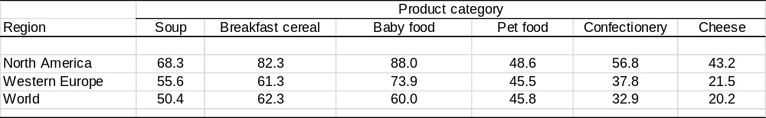
What is the meaning of the number “68.3” for Soup in North America?
A. The top 68.3% of firms provide the majority of soup sales.
B. The top 4 firms in North America combined have 68.3% of soup sales.
C. The monopolist/oligopolist price premium in North America is 68.3%.
D. 68.3% of soup sales are in North America.

3. Choose one. Continuing the previous question, what is the potential harm of a high concentration ratio?
A. Overproduction, leading to environmental damage.
B. High prices for consumers.
C. Low prices for unhealthy food products.
D. Mental exhaustion, from too much concentration.

4. Choose one. What manufacturing industry is most vertically integrated?
A. Corn ethanol.
B. Frozen pizza.
C. Chicken.
D. Tomatoes.

5. Short answer. Even if you do not really agree, give one commonly heard reason why vertical integration and contracting might be helpful to growers.

Total value of shipments by food manufacturing sector ($ billions), 2017 This figure is used in Question 6.
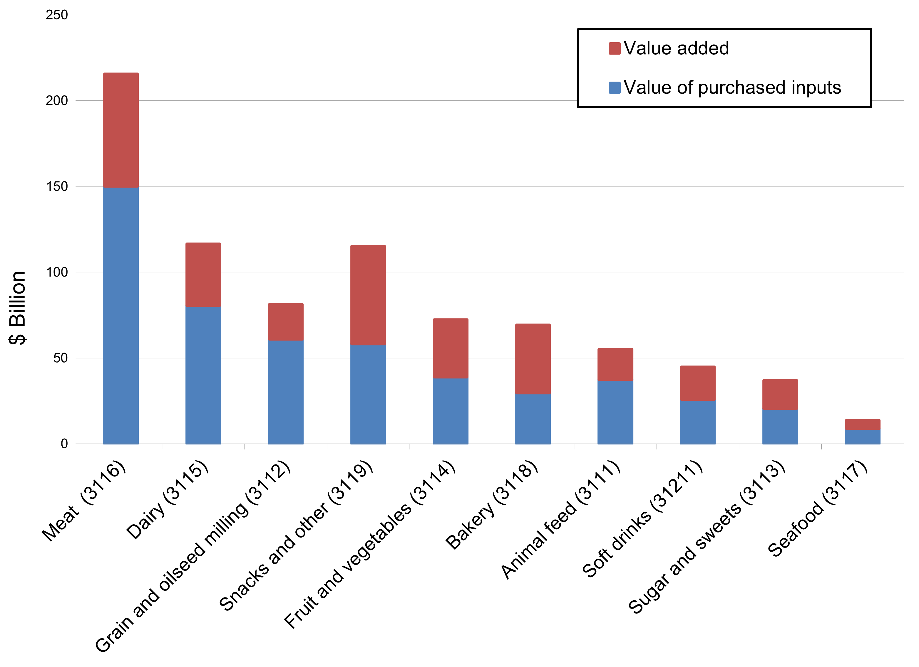

6. For which of the following manufacturing industries is value added comparatively small as a fraction of total value of shipments?
- Meat
- Snacks
- Bakery
- Sugar and sweets

