7 Food Safety
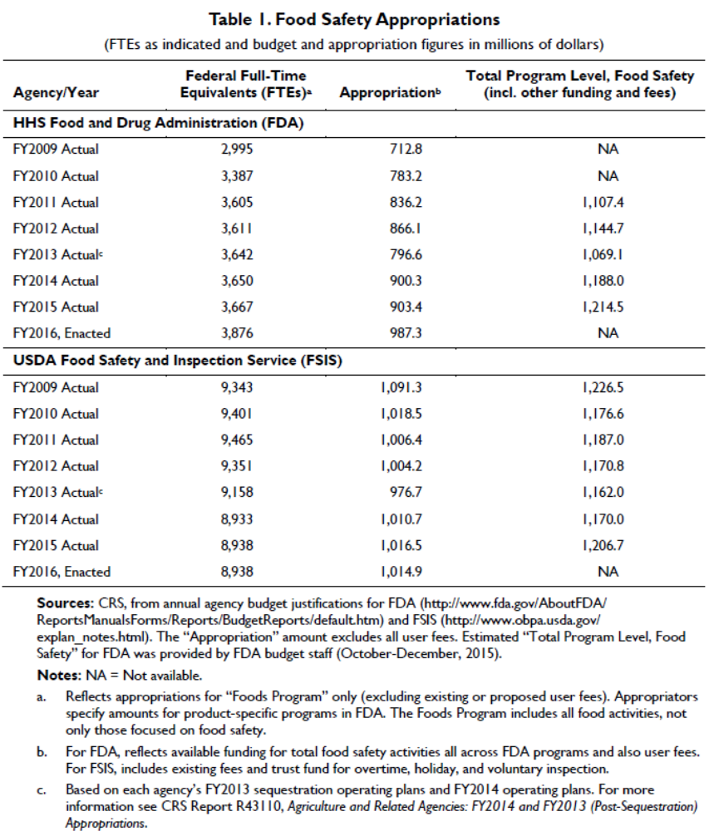
Table I (from CRS) is used for questions 1 through 4.

1. Choose one. What federal agency had the largest appropriations and full-time equivalent staff for food safety work in fiscal year 2011?
- Food and Drug Administration (FDA)
- Food Safety Inspection Service (FSIS)

2. Choose one. What agency’s budget had to increase to accommodate new responsibilities in the years following the 2009 Food Safety Modernization Act (FSMA)?
- Food and Drug Administration (FDA)
- Food Safety Inspection Service (FSIS)

3. Choose one. Why does FSIS have more employees than FDA?
- Because FSIS administrators are more bureaucratic and wasteful
- Because FSIS oversees a larger fraction of the U.S. food supply by value
- Because FSIS employees are required to spend more time in food production facilities
- Because FSIS is more aggressive about enforcement
- Because FSIS makes better use of modern technologies

4. Choose one. To what branch of government does “CRS” (mentioned in the table footnote) belong?
- Executive
- Legislative
- Judicial

5. Short answer. Food safety policy involves tradeoffs, both in terms of dollars and in terms of public interest goals. Can food safety policies ever cause harm for the natural environment? If so, briefly give an example.

6. Choose one. Select the department or agency that oversees the Food Safety Modernization Act.
- Food Safety and Inspection Service
- Centers for Disease Control and Prevention
- Food and Drug Administration
- Department of Homeland Security

8. Choose one. The Peanut Corporation of America filed for bankruptcy in 2009 following lawsuits over a devastating Salmonella outbreak. In 2015, executives received prison sentences. This unprecedented sentencing exemplified which type of policy instrument used to remedy food safety failures?
- Performance standards
- Consumer education
- Risk management
- Liability enforcement

9. In Danish pork abbatoirs (slaughterhouses), researchers estimated the cost and pathogen reductions for five food safety technologies:
- 4 methods of decontaminating the carcasses, plus
- 1 method for cleaning up the feed used for growing pork in the first place, so that no decontamination would be needed.

Here are the costs and % reduction in Salmonella contamination.
 | Decontamination Technologies |  |  |  | Clean Feed
 | Hot Water | Steam Ultrasound | Steam Vacuum | Lactic Acid Treatment | Clean Feed
Cost per Carcass (Euros) | 0.26 | 0.20 | 0.19 | 0.23 | 0.30
Salmonella Reduction (%) | 90 | 83 | 59 | 65 | 63

Suppose a company can afford to spend at most 0.24 Euros per carcass. Which technology should it choose?
- Hot Water
- Steam Ultrasound
- Steam Vacuum
- Lactic Acid Treatment
- Clean Feed

10. Choose 1 or more of the following responses. Continuing the previous question, for purposes of reducing Salmonella contamination (ignoring other advantages of the technology), which food safety technology or technologies are inefficient?
- Hot Water
- Steam Ultrasound
- Steam Vacuum
- Lactic Acid Treatment
- Clean Feed

11. A new report commissioned by the FDA. in fall 2022 recommends more money for food safety oversight and a clearer chain of command to make the agency more effective. Here is information about how stakeholders are reacting. Which stakeholders do you think are likely to support this report? Choose one or more responses.
- Consumer Reports (a publication that advocates for consumer interests)
- Environmental Working Group (an environmental advocacy organization)
- Consumer Brands Association (representing food manufacturers)
- the Association of Food and Drug Officials (representing officials)
12. Continuing the previous question. Sometimes, stakeholders will agree on some issues and disagree on other issues. A few years earlier, some organizations asked FDA to warn pregnant women not to eat any tuna fish at all. Which stakeholders do you think are likely to support this warning? Choose one or more responses.
- Consumer Reports (a publication that advocates for consumer interests)
- Environmental Working Group (an environmental advocacy organization)
- Consumer Brands Association (representing food manufacturers)
- the Association of Food and Drug Officials (representing officials)

