8 Dietary Guidance and Health
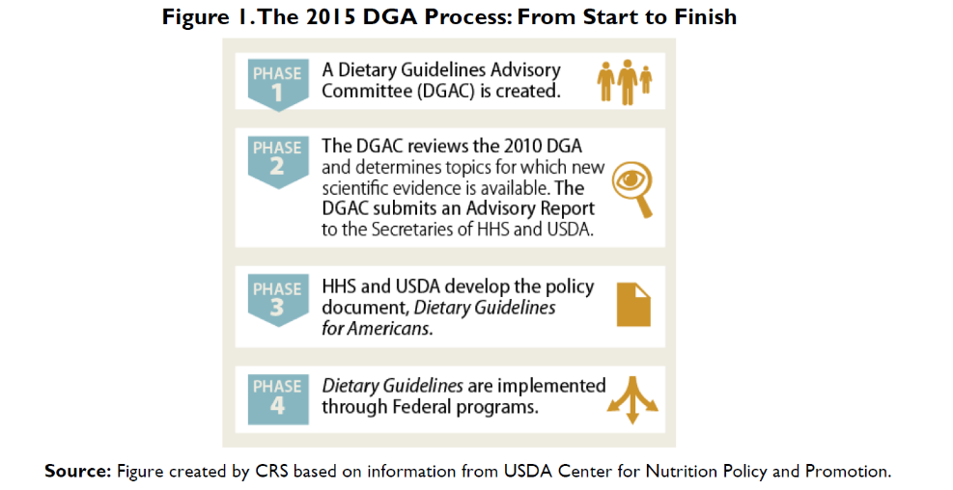
Figure I (from CRS) is used in questions 1 through 2.

1. Short answer. In the 2015 report, what surprising recommendation from the Dietary Guidelines Advisory Committee (DGAC) did not appear in the final 2015-2020 Dietary Guidelines for Americans?

2. Short answer. In Figure I, I masked several words. What federal department or departments are responsible for producing the Dietary Guidelines for Americans?

Table 8.4 is used in questions 3 through 5.

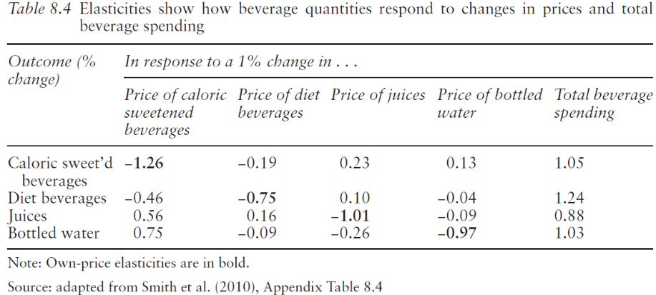
3. Choose one. Suppose the government used a tax to increase the price of caloric sweetened beverages by 10%. How much would the quantity of caloric sweetened beverages change?
- Increase 1.26%
- Decrease 12.6%
- Increase 0.75%
- Decrease 7.5%

4. Short answer. What industry might oppose the tax in question 3?

5. Short answer. In light of the industry opposition mentioned in question 4, suppose the government decided it could not impose a tax. Instead, it decided to subsidize bottled water, reducing the price of bottled water by 10%. According to the table, would caloric sweetened beverage quantities increase or decrease? By how much? From a public health perspective, does this bottled water subsidy seem like a good idea?

6. Choose one. According to Chapter 8 of the text, from 1970 to the most recent year, annual U.S. deaths per 100,000 population from leading causes (including heart disease) …
- ….fell.
- ….stayed almost unchanged.
- …rose.

7. Short answer. What is a leading reason for the trend or lack of trend mentioned in the previous question (Question 6)?

8. Choose one or more responses. The federal government's 2020-2025 Dietary Guidelines for Americans favorably mentions the following approaches to choosing a healthy diet:
- the anti-hypertension DASH diet
- a vegetarian diet
- a low-carb diet
- a Mediterranean diet

9. Short answer. Consider the dairy checkoff program’s 2015 Report to Congress.
Link: https://www.ams.usda.gov/sites/default/files/media/2015DairyReportToCongress.pdf

In a few sentences, answer the following questions:
- What findings might you expect from checkoff-funded research on chocolate milk?
- How do these expected findings compare with guidance on flavored milk from the 2015-2020 Dietary Guidelines for Americans?

10. Choose one. In developing the Dietary Guidelines for Americans (DGA), there is an opportunity for public comment. What is the approach of the federal government toward input from politically interested parties, including food producers and public interest organizations?
- Politically motivated input is disallowed, so that decisions about dietary guidance may be based on sound science.
- Politically motivated input is discouraged in principle, but in practice food producers have been able to meet secretly with federal officials to influence the DGA.
- Input of all sorts is openly invited and encouraged.

