11 Nutrition Assistance Programs for Children
1. Choose one. Which program feeds the largest number of children each day?
- Child and Adult Care Food Program
- WIC
- School Breakfast Program
- National School Lunch Program
2. Choose one. Which program is oldest?
- Child and Adult Care Food Program
- WIC
- School Breakfast Program
- National School Lunch Program
3. Short answer. What are the three elements or goals in the school nutrition “trilemma”?
4. Choose one. In what major omnibus legislation were the school meals programs and WIC most recently authorized?
- The 2004 Child Nutrition Reauthorization
- The 2010 Child Nutrition Reauthorization
- The 2016 Child Nutrition Reauthorization
- The 2014 Farm Bill
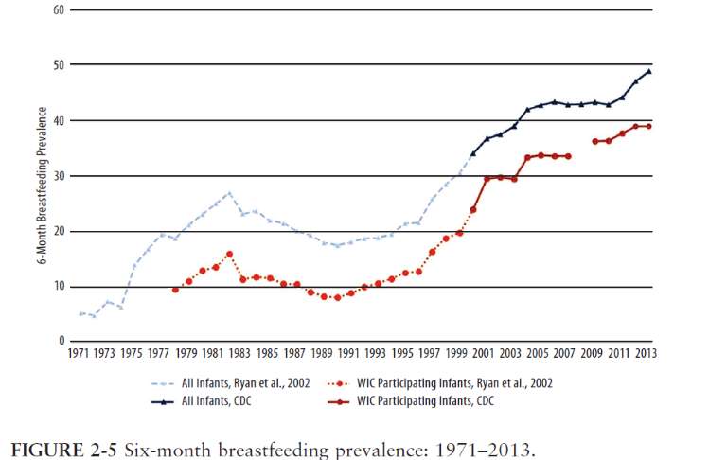
Figure 2-5 (from USDA), showing the breastfeeding prevalence for WIC infants (lower line) and all infants (upper line), is used in Question 5.
Note: The break in the lower line indicates missing data.
5. Essay question. Describe selected key strengths and weaknesses of the WIC program’s approach to breastfeeding promotion.

