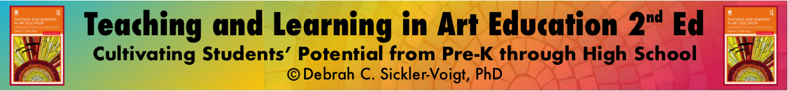

Weekly Art Curriculum Planning Template
Author ✅:
Course Name ✅:
Week # ✅:
Goals ✅:
Lesson Title(s) and Description(s) ✅:
Name(s) ✅:
Grade Level ✅:
Artistic Behavior(s) ✅
Idea Development
Observation
Imagination and Wonderment
Persistence
Making Creative Connections
Explain how students are applying the artistic behavior(s) ✅:
Big Idea ✅:
Essential/Guiding Question(s) ✅:
Materials ✅:
Instructional Resources ✅:
Vocabulary:
Elements of Art ✅:
line shape color form space value texture
Principles of Design ✅:
balance pattern rhythm repetition emphasis

variety proportion movement unity
Other ✅:

Objectives ✅:

Daily Learning Targets ✅:

Artists and Artworks ✅:

Quantitative and Qualitative Assessments

Informal Assessment ✅:
Formative Assessment ✅:
Formal-Summative Assessment ✅:
Authentic Rubric Checklist Test/Quiz Essay Portfolio Capstone Project Experiment Artist Statement Presentation Peer/Group Self-Assessment Interview Checklist Rating Scale Other

From Theory to Practice ✅:
Transformative Art Education
Multimodal Art Inquiry and Creation
Artistic Behaviors
Artists’ Lessons to Thrive!
Life Skills through Art
Artistic Concepts, Media, and Techniques
Holistic Arts and STEAM Integration
(Transformative) Participatory Action Research
Culturally Responsive Instruction

Standards ✅:

References ✅:

