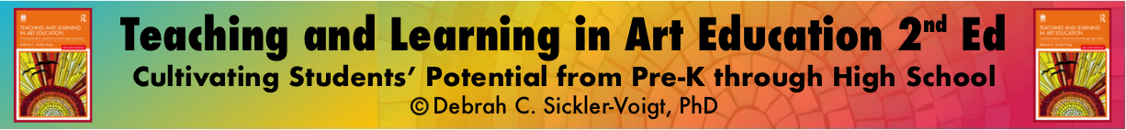

Analytic Rubric with Written Self-Assessment Template: Creating
Criteria | Approaching Basic Proficiency  (18-20 points) | Basic Proficiency  (21-23 points) | Accomplished Proficiency  (24-26 points) | Exemplary Proficiency  (27-30 points) | Scores  Student (S)  Peer (P)  Teacher (T)
✅ | ✅ | ✅ | ✅ | ✅ | (S) ______  (P) ______  (T) ______
✅ | ✅ | ✅ | ✅ | ✅ | (S) ______  (P) ______  (T) ______
✅ | ✅ | ✅ | ✅ | ✅ | (S) ______  (P) ______  (T) ______
Creating Score (Up to 90 Points):

Analytic Rubric with Written Self-Assessment Template:
Presenting, Responding, and Connecting
This Segment Is Worth up to 10 Points
Directions: I (the student) can write a 100+ word response to self-assess and reflect upon my artwork’s production. I can identify its successful components and my areas for future growth.
My response will:

- explain my inspirations for my artwork’s development (contexts, story, artworks, etc.).
- include at least one personal connection to its big idea and/or development.

In addition to my written response, I can respond orally during the class critique.
________________________________________________________________________________________________________________________________________________________________________________________________________________________________________________________________________________________________________________________________________________________________________________________________________________________________________________________________________________________________________________________________________________________________________________________________________________________________________________________________________________________________________________________________________________________________________________________________________________________________________________________________________________________________________________________________________________________________________________________________________________________________________________________________________________________________________________________________________________________________________________________________________________________________________________________________________________________________________________________________________________________________________________________________________________________________________________________________________________________________________________________________________________________________________________________________________________________________________________
Total score worth up to 100 points:

