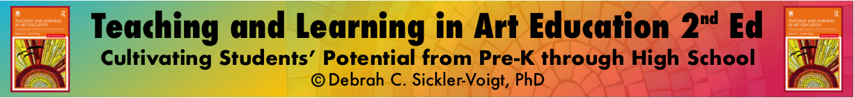

Art Assessment Action Plan Template

Directions: Fill in the blank textboxes with narrative descriptions and check the appropriate boxes as applicable.

Timeline ✅:

Grading Period | Semester | Academic Year | Other

- Setting Achievable Goals Through Learning Targets
The following explains how I have identified achievable student learning goals aligning with learning targets and standards as part of a transformative art curriculum that challenges students. They build on students’ prior knowledge and life experiences in the following ways ✅:

- Selecting Assessments

Check all that apply:

Informal Assessment | Holistic Scoring Rubric | Portfolio
Formative Assessment | Test/Quiz | Self-Assessment
Interim Assessment | Essay | Peer Assessment
Summative Assessment | Oral Exam | Group Assessment
Formal Assessment | Rating Scale | Discussion/ Interview/Conference
Basic Scoring | Checklist | Observation
Analytic Rubric | Journal | Authentic Assessment
Other | Other | Other

Using multiple assessments, I plan to measure and appraise student learning targets and expressive outcomes in the following ways: ✅
- Managing and Analyzing Assessment Data

Check all that apply:

Valid Assessment | Class Critique | Teacher Reflection Journal
Reliable Assessment | Student Self-Assessment | Teacher Reflection Portfolio
Ongoing Assessment | Peer Assessment | Summative Performance
Monitor Student Behavior | Group Assessment | Reteach
Accommodate All Students | Teacher Self-Assessment | Small Group Teaching
Review Formative Tasks | Observation | Individual Teaching
Discussion/Interview/Conference | Photographs/Videos/Documents | Curricular Change
Authentic Assessment | Other | Other

I will regularly analyze quantitative and qualitative data from valid and reliable assessments to identify strengths and make necessary instructional and curricular changes/improvements in the following ways: ✅
Routledge

