Welcome to the additional resource area for:
Creative Career Coaching, Theory into Practice.
Liane Hambly and Ciara Bomford
2026. Routledge

Copyright notice and guidelines for adaptation
Documents designed by Hambly and Bomford may be downloaded and adapted for educational or professional use. If adapting, please respect publication rights by clearly acknowledging the original source.
When adapting Hambly and Bomford materials, the following attribution must be clearly visible on the adapted document:
Source: Adapted from Hambly, L. and Bomford, C. (2026). Creative Career Coaching: Theory into Practice. Routledge.
Any commercial use or extensive reproduction requires prior written permission from the authors.
Please note: Models or materials belonging to other authors are not permitted for adaptation.

Contents

Chapter 1: The Bigger Picture
Reflective activity
Ideas for using metaphor

Chapter 2: A Brief History of Career Development Theory
Hope-Action Theory
Community Interaction – Bus metaphor, Stalker, L. and Hambly, L. (2023)

Chapter 3: The Brilliant Brain
Case study exercise – working with young brains

Chapter 4: Micro Skills
Powerful questions

Chapter 5: Process Models
Case study - using the Creative Career Coaching model

Chapter 6: Laying the Foundations
Broad outcome prompt cards for agreeing the purpose
Visuals for explaining the process
How we can work together prompt sheet/poster for agreeing ways of working together
Welcome poster

Chapter 7: Frameworks for exploring the client’s story
Examples of questions and activities used by practitioners to explore the story

Chapter 8: Goals and Actions
Example action plan formats
Ten years from now

Chapter 9: Digital Coaching
Prompts for using an AI as a Coach

Chapter 10: Trauma Informed Practice
Sensory grounding methods

Chapter 11: Working with Groups
Group Guidance models - Sue Meldrum and Sue Edwards (permission granted)

Chapter 12: Motivation and Readiness
Worksheet - how ready are you?

Chapter 13: Approach to Decision making
Worksheet – how would you decide
Worksheet - how do you make your decisions?

Chapter 14: Self-Awareness
The Challenge mindset – Sparkpath flipped model worksheet
The Careers Venn Diagram
What am I good at?
The skills suitcase
Rapid thinking activity

Chapter 15: Opportunity Awareness
Broadening ideas diagram

Chapter 16: Transition
Mapping your network activity
Poster of the STAR framework
Tips for writing CVS/Resumes

Chapter 17: Resilience
Comfort zones activity
Poster of famous people who failed - then succeeded

Chapter 18: The Resilient Coach
Wellbeing assessment and plan
A mindful week



Chapter 1: The Bigger Picture

Reflective activity for career practitioners on how the bigger picture can impact on clients

Ideas for using metaphors with clients

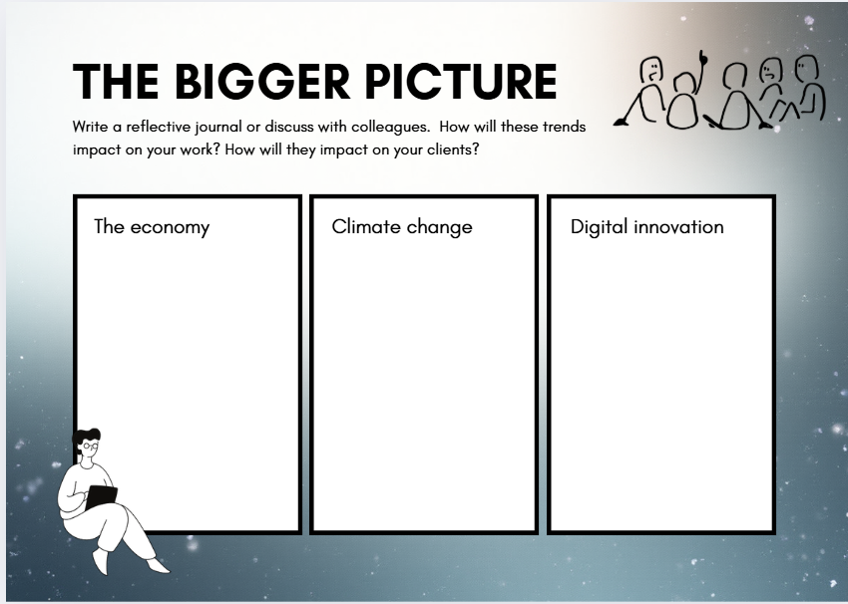

Using Metaphor with clients

Metaphors can create deep shifts in thinking. Here, we consider their use in understanding and challenging people’s concept of “career”. A starting point is to listen for the client’s own metaphors, for example:
- I’m on a treadmill and can’t get off.
- It’s an exciting journey and for the first time I don’t have to do what’s expected of me.
- I’m stuck … It's like wading through thick mud.
- It’s a maze.
- I want to climb the ladder.
- It’s a game … you have to jump through the hoops that they want.
- That fries my brain
- I guess that could open a new door

Such statements are a gem for a career coach, as they can be used as a vehicle for exploration. A coach might ask:
- How long have you been on the treadmill?
- Describe the treadmill … Tell me more about it.
- On a scale of 0–10, how much do you want to get off?
- What would need to happen for you to do so?
- Imagine not being on the treadmill … What would that be like? What would you be doing?
- Is there anything good about being on a treadmill? What have you learned? What qualities have you developed?

Sometimes it’s clear that a metaphor is helping the client to make sense of their path, but at other times it reveals problematic or stuck thinking. A coach can engage the imagination to create alternative metaphors and solutions. Take, for example, the metaphor of a ladder. It is important to start by understanding how it is construed by the client, possibly asking them to describe the ladder, its length, what rung they are on, what the rungs indicate and what lies at the top. A client who has been thrown off their ladder by redundancy may wish to get back on at exactly the same rung, with the same pay and conditions. If their aim is unlikely to succeed owing to economic downturns, then the career coach can use metaphors to encourage more flexible thinking:
- What if the ladder was scaffolding, allowing you to move sideways to go in a different direction?
- What could be gained from having scaffolding rather than a ladder?
- What directions could you go in?
- What could be gained from going downwards or sideways?

Another example is the client who feels stuck on a straight path that they have been following unconsciously for some time. They are now bored, as all they can see is more of the same lying ahead, rather like a long motorway. One can almost set cruise control and switch off (hopefully not falling asleep). It could be interesting to ask this client to imagine a slip road with an unknown destination.
- How would it feel to take that slip road?
- Imagine coming to a roundabout and circling, considering the different options. What could those options be?

Young people in particular are often under pressure to know their long-term goals even though many will change their minds within a few years. Having a fixed plan can be limiting, as they might miss alternative opportunities along the way. As we discover in Chapter 2, the Planned Happenstance approach encourages clients to have loose plans, to keep an open mind but ensure that they are prepared by being fully equipped for the journey. The metaphor of a road trip works well here – the winding road with its many opportunities and challenges will require resources such as money, food, music, company and fuel. A coach may ask:

- What are the benefits of the straight road, of knowing where you are heading?
- What are the downsides of the straight road?
- What are the benefits of an unpredictable winding road?
- What are the downsides of such a road?
- What would you need to take with you on such a journey?

The coach can make parallels between resources and career management skills, for example, fuel being energy, keys being the motivation to start the journey, music being positive thinking, company being one’s support network, the sat nav being information.


Chapter 2: A Brief History of Career Development Theory

Hope Action Theory (permission given by authors)

Community Interaction – the bus metaphor/ activity from Stalker and Hambly (2023) Sailplaning (permission given by authors). This can be used to map and reflect on sources of helpful and unhelpful support and influence.

Hope-ActionTheory Framework
The following model has been reproduced with kind permission from the authors.

Taken from https://www.hope-action.com/ (accessed 8.9.25)

Research shows that strengthening hope-action competencies is useful in planning and managing your career and life effectively. Hope-Action Theory consists of the following seven competencies:
- Hopefulness: The degree of hope you have about your future.
- Self-reflection: Examining your thoughts, beliefs, behaviors, and circumstances.
- Self-clarity: Having a clear understanding about yourself in terms of interests, values, skills, motivation, goals, etc.
- Visioning: Brainstorming future possibilities for your career and identifying desired future outcomes.
- Goal Setting and Planning: The process of specifying what you want to achieve and identifying specific steps to reach your goals.
- Implementing: Taking action to achieve your goals.
- Adapting: Using new information about yourself and your environment to inform your goals and plans.
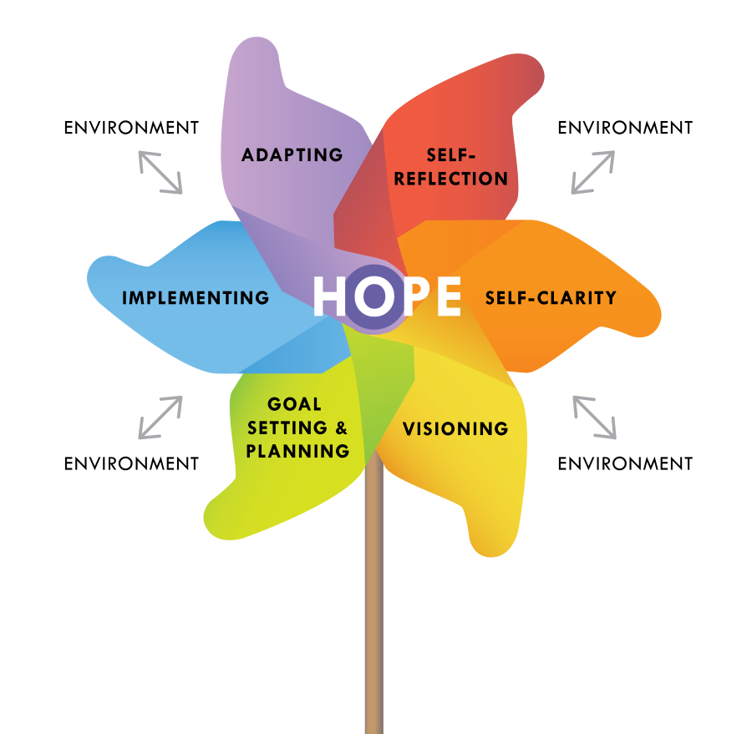
You could share the pinwheel with your clients, encouraging them to reflect on each area. You could use scaling to discover existing Hope-Action strengths and the areas they would like to focus on in their work with you.
It’s also interesting to discuss environmental influences, for example, other people’s expectations, the job market, geography, and how much they feel they are impacting on the pinwheel areas,
Map your existing toolkit to the six sails – if you’d like more ideas to support your work, there’s a practical workbook with activities for each area:

Fruling, A., and Amundson., N. (2024) Career Wayfinder - Discovering your career through delightfully practical projects. Doubleknot.works


- Reflect on how happy you are with that arrangement? Do you need to let some people nearer and move others to the back where they have less influence? Maybe even let some off the bus?

Copyright Stalker and Hambly (2023) Sailplaning, Creating a 4D life and career
(retain reference)
- Where do you want to sit in the bus? How much control over your career do you want?
- Using a pencil (so you can rub out), write people’s names on the seats around you to reflect people who influence you (as things are now). The nearer they are, the more influence they have.



Chapter Three - The Brilliant Brain

Case study exercise - working with young brains

Case Study Exercise - Working with Young Brains
Read through the following case study exercise. How do you think the young person’s stage of brain development is impacting their behaviour and the way they are managing their career? What could you do as a career coach to help them?
Cody is fourteen and has been referred to Lorraine, the school career coach, because although he is a bright boy, his behaviour is giving cause for concern.
When he first meets Lorraine, he feels anxious as he is not used to talking to adults one-to-one, but over time he becomes comfortable with her and enjoys the sessions. He does not have an easy relationship with the rest of his family, and has started to live with his grandmother because his mother couldn’t handle his behaviour.
Cody wants to be in less trouble at school and is keen to leave and get a job as soon as possible. Cody and Lorraine agree on a goal of behaving better in school, and another goal to find out more about the world of work and what sort of person employers are looking for.
Cody boasts about how he and his friends got caught taking ketamine and sounds excited as he tells the story. He seems to feel a sense of belonging with his friends that is missing at home. Lorraine explores this with him, and reflects back that getting into trouble was fun, but has also had some negative consequences. Cody is comfortable enough to agree with this. They explore whether showing off a bit is also part of the fun.
Lorraine introduces Cody to a Fire Cadets scheme, which Cody enjoys. He learns about the value of teamwork and discipline, and how to assess risk.

Ideas and Questions
- Do you think one long session or regular shorter sessions would be more beneficial for Cody?
- What brain chemicals do you think Cody might be flooded with as he meets Lorraine for the first time (he is feeling anxious)?
- How might Lorraine build up trust with Cody?
- As they build up a good level of trust, what brain chemicals do you think they will both be flooded with?
- What attachment style might Cody have with his mother? How might this impact his relationship with Lorraine?
- When Cody takes part in exciting events with his friends, what brain chemicals would be influencing him?
- If getting into trouble with his friends gives Cody a sense of belonging, how can Lorraine help him to rewire his brain, so that he associates feelings of belonging with more positive experiences?
- How does Cody’s need to show off in front of friends and seek excitement and risk, relate to the typical stage of development of the teenage brain?
- How might the fire cadets scheme help to rewire Cody’s brain?



Chapter Four – Micro Skills

Examples of powerful questions drawn from a variety of coaching approaches plus a few of our own. This could be read in conjunction with chapter 7 where a range of questions and activities used by Career Development Professionals is provided. Of course we don’t want a script, but they provide food for thought.

Powerful Questions

Any question that makes your client think and see their situation from a new perspective can be powerful. A well-chosen question can create a light bulb moment! Here are a few ideas:

The community question – “think of someone, they might be a friend, family member or someone famous, who you think would have something interesting to say about this dilemma. What would they say?” (you can repeat for a number of people so that they gain different perspectives). Similar questions are “What would your hero do in this situation?” “How would you advise a friend if they were in this situation?

Perceptual positions – this is similar, but particularly useful to develop empathy and understanding of other people’s feelings and the reason they see something very differently. Chairs can be used to inhabit other people’s perspectives. “so, looking at the situation from their point of view, what are they thinking and feeling? Why is that?”

Goal achievement and risk taking
- What could you do in ten minutes a day that would take you a little closer to your goal?
- If you had successfully achieved your goal and were looking back over the journey, what actions would you have taken?
- Is there a middle path you could take?
- What are the risks with this course of action? How likely is that?
- What is the worst that could happen? How likely is that?
- What part of your dream career could you do right now?
- What would happen if you acted like you had already achieved your goal?
- What might a more confident person do in this situation?
- What is the bravest thing you could do now?
- What could you do now that would give you the best chance of succeeding?
- What would be the consequences of not taking action?

Hypothetical, what if?
- What would you do if you knew you could not fail?
- What if that barrier wasn’t there – what would you do?
- If money wasn’t an issue, what would you do?
- What if you stepped outside the comfort zone/ broke the mold/ were made redundant/ … what would you do?
(these questions are designed to provide insight into the ideal which, if unrealistic, can still be worked towards)

Values and interests
- Look around you – your family, community, society, the world - what problem(s) would you like to help solve?
- What are you grateful for?
- When do you feel most truly your authentic self?
- How do your beliefs shape your sense of purpose?
- What does success mean for you?
- Are there people who you feel envious about – what does that tell you about what you want more of in your life?
- What makes you want to get up in the morning?
- Which parts of your job suck the joy out of your day?
- Which parts of your job bring you joy?
- What have you/are you most content, or lost in the moment when you lose a sense of time?
- What would you like to learn about or learn to do?

Personal Qualities
- How would your best friend describe you?
- How would your boss describe you?
- How would you like people to describe your life at your funeral?
- Describe yourself when you were young. How would other people have described you? To what extent have you changed or stayed the same?

The power of 3
It’s weird, but three is a powerful number – it is used in storytelling (the three little pigs, the three bears), in political speeches to drive a point home (education, education, education) and in jokes (3 men walked into a bar. I say, I say, I say).
- What three things do you really want to tell the employer about yourself?
- What three things make you the right person for this job?
- What are your top 3 skills?

What else?
People often give the most obvious, rehearsed or safe answer – so keep going with “what else?” or until there is no more to add. (If you ask “Anything else?” people will often say no, but if you ask “What else?” they will often think of something new.)

Challenging
We often hear language, phrases or rationales that sound incongruous for that person – that have been absorbed from other people. Then there are the myths, assumptions and limiting constructs that can be gently challenged through questioning rather than confrontation: “Where does that come from”, “Tell me, what makes you say that?”, “What if that weren’t true, what difference would it make?” “How do you know for sure that is true?”



Chapter Five - Process Models

Case study on using the creative career coaching model.

Case Study - Using the Creative Career Coaching Model

Review the following case study. Can you see each part of the Creative Career Coaching model at work? How does having a model benefit the customer?
Cari welcomes Alys into her room, inviting her to take off her coat and make herself comfortable. She asks Alys if she had a good journey and they chat about the buses. Cari has established a good balance of communication, and Alys is beginning to relax and feel comfortable.
Cari asks Alys what made her book the appointment. She finds out that Alys wants help to find an apprenticeship in engineering. Cari resists probing deeply into the reasons for that choice, using prompt cards to clarify broad outcomes. She finds out that Alys would like to find a career path that she enjoys and reflects her interests. Cari says they can a) just explore engineering apprenticeships, or b) look at apprenticeships but start by talking more broadly to make sure she’s got everything she needs to make the best decision for her. Alys is happy with the second option, saying that it’s more than what she expected – she feels committed to the process and can see that it will meet her needs.
Cari explains a bit more about how they can work together. She encourages Alys to say what she really thinks and ask questions. She explains she might help Alys think about things in a way she hasn’t before, and checks that Alys is happy to be challenged in this way. She explains confidentiality and safeguarding, checking Alys’s understanding. She checks how much time Alys has, and they agree to a one hour appointment. Alys feels confident now, as she knows how she can participate and what to expect.
Cari explores Alys’ story so far, asking questions, actively listening and probing into things that seem significant. She gives Alys the time and space to reflect on what has happened to her since she left school. Her questions allow her to build up a picture of what Alys’s career management strengths are, and where there are gaps in her knowledge, skills and confidence. Alys feels that she has been really listened to and that she is starting to make sense of her own story.
Cari uses reflective skills to help Alys recognise her own strengths - that she is persistent and motivated, and doesn’t give up easily, that she has good communication skills and is well organised. She also reflects back and Alys is a bit unsure of how to make a good career decision, having made a choice that didn’t work out when she left school. She picks up on Alys’ anxiety about making the wrong decision again and reflects this back. She also reflects back that Alys isn’t sure about all the options open to her or how to research them. Alys feels that she has learnt something about herself and got an insight into what she needs to develop.

Cari and Alys work together to prioritise what they will work on today. They agree that the most important guidance needs to address today are to help Alys feel confident about how to make a good decision, and to help Alys research her options including apprenticeships. Alys feels happy that the interview is focused around her needs and priorities. They both have a clear focus for what to work on in the remaining time.

Cari coaches Alys to use a decision-making technique which involves a combination of intuition (what feels right?) and researching pros and cons. They compare a couple of career paths in this way and Alys feels happy to use this technique independently when comparing options. Cari also signposts Alys towards reliable occupational information, and helps Alys to use the information to see if the jobs she is interested in will meet her needs and suit her skills set (or the skills she would like to develop). She also points Alys towards information about apprenticeships and college courses. Alys feels a lot more confident to research her options and then make a decision.

Cari helps Alys to decide what her next steps will be, and together they draw up an action plan. This includes a follow up appointment to help Alys make her final decision and take her next steps. Alys knows what she needs to do next.

Cari makes notes about the interview and records the action plan, so that she can review it next time she sees Alys. She offers to text it to Alys. Alys understands what records are being kept and why, and knows that Cari will be able to remember and review the actions with her at the next appointment. She is happy for Cari to get in touch with her about any suitable opportunities that come up, and Cari has her correct contact details. She is pleased that Cari can text her the action plan and some useful links so she doesn’t forget.



Chapter Six - Establishing the Foundations
Broad outcome prompt cards – these can be used in the contracting stage (agreeing the purpose), asking the client to pick any that they’d like to gain from the process. Helpful for quieter clients and/or those that have a limited understanding of the potential benefits of careers sessions.

Visuals for explaining the process e.g. “we work together to find out what’s already in place, and what action needs to happen to get me from where you are now (situation, decisions/changes faced) to where you want to be (broad outcomes).

Prompt cards for a) identifying the client’s priorities in terms of the working relationship b) introducing required “ground-rules” such as the parameters of confidentiality and data protection.

An example poster that conveys some of the core conditions underpinning the relationship

Agreeing the Purpose - Broad Outcomes
When agreeing the purpose, some clients find it useful to have prompts of broad outcomes they can gain from working with you (WIIFM) "What’s in it for me?”. The following can be adapted to suit your clients’ context and level.
Feel motivated
Do something worthwhile
Make the best decision for me
Feel clear about my future

Have a goal I can work towards
Feel confident in my plan
Feel confident about myself
Feel in control

Have more money
Stay out of trouble
Feel calmer
Be more independent
Feel listened to/ supported
Overcome this challenge

Feel hopeful/
optimistic
Start afresh

Choose a subject I enjoy
Find a place where I can be myself
Support my family
Know where I can go for help/support

Find something that reflects my strengths, interests and values
Know the steps I need to take to reach my goal
?
Feel happier about my future
Be clear about my skills and strengths
Increase the
chances of my plan working
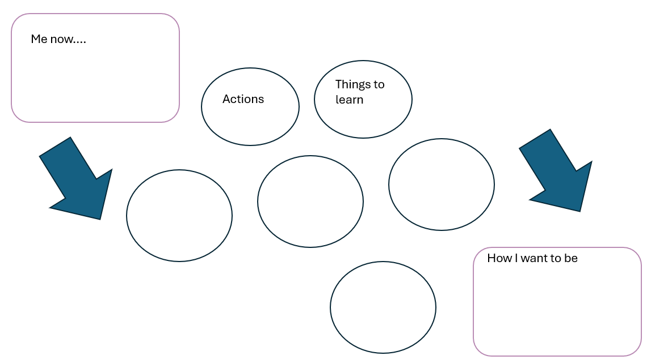

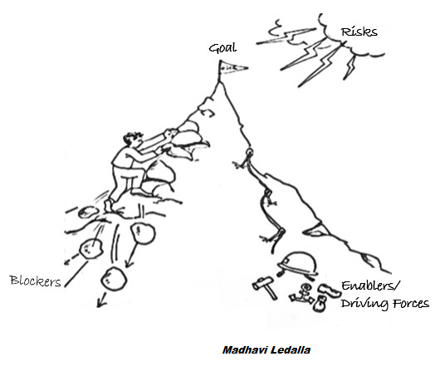
By working together, we can make sure you’ve got what you need to reach your goal. We can spot risks, what challenges you might face and what you need to overcome them. How does that sound?

Image source: retrospectivewiki. Free to share and use. http://www.retrospectivewiki.org/images/6/60/MH.png

How can we work together…what is most important to you?
There are no right and wrong answers
I feel listened to, my ideas taken seriously

We will work together – I will play an active part
I can say if I don’t understand

I can be open and honest
What we talk about isn’t shared with others (except if I or others are at risk)

I can take time to answer
I will be helped to find my own answers
I can finish the session when I need

I will be helped to find my own answers
?
Information about me will be stored securely

I understand you don’t have all the answers
Visuals and activities will be used to keep me engaged

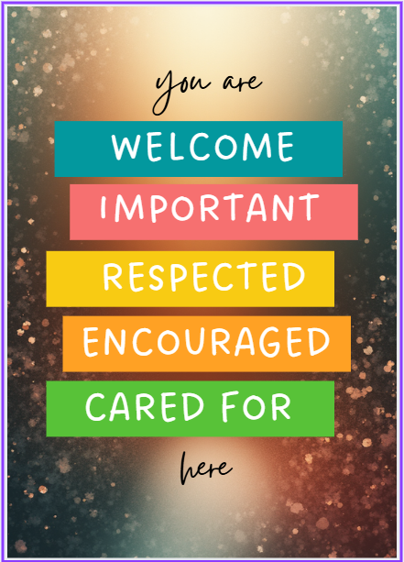



Chapter 7 - Frameworks for exploring the client’s story
Example questions and activities that practitioners use to explore the story

Example tactics for exploring the story
The following examples are adapted from a field study that took place from 2004 to 2006, with over 600 Career Development Practitioners throughout the UK. Subsequently further ideas have been added to reflect additional ideas from practitioners who have reviewed the initial study.
It is important to place a few caveats on the suggestions.
- Exploration would take place only after a rapport and contract had been established (stage 1, the foundations).
- The questions and activities are not intended as a script, merely as illustrative examples.
- They are written in note form and would have to be adapted to reflect the client’s communication style and needs.
- These are initial questions and tactics – the client would be encouraged to reflect and expand for a deeper response, the practitioner listening to content and body language, reflecting back and/or probing further.
Rephrasing the questions
An over-reliance on questions beginning with ‘What’ ‘why’ or ‘when’ can lead to it feeling like an interrogation and result in ‘I don’t know’ responses from the client. Examples of alternative phrasing using open and open-indirect questions include:
- ‘Tell me about ….’
- ‘Could you say more about ….’
- ‘How do you feel about that …?
- ‘How would it be if you …?’
- ‘Could you describe …’
- ‘Take me through …”
The questions and activities have been grouped to reflect the Career Management cycle (Hambly and Bomford 2019; 2026)

Mindset
NB In stage 1 of the interview, some indication of the client’s mindset may have been apparent from their response to questions such as ‘what brought you here today?’ and their body language.
- Could you say a little about how you feel about ….? (the decisions faced, changing jobs/ going back to work etc)
- Take me through anything you’ve done so far? (what have you looked into? who have you spoken to? Has anything stopped you from taking action?)
- What are you doing now to sort this out/ plan for the future?
- How long have you been trying to sort this out?
- What’s happened to make you want to change/ why now?
- Describe the level of change you’re looking for (big change/ small change?)
- What’s the worst thing that could happen if you didn’t make this decision/ face this change?
Activities
- Scaling questions (can be asked verbally, drawn or used kinesthetically).
- On a scale of 0–10, with 10 being very concerned about this situation/change/decision and 0 not being concerned, where are you on that scale?
- On a scale of 0–10, with 10 being very confident that if you try this, you can succeed, and 0 being not at all confident, where are you on that scale?
- On a scale of 0-10, with 10 being very ready and 0 being not at all ready, how ready do you feel?
- On a scale of 0-10, with 10 being very important and 0 being not at all important, how important is this to you?
- Emoji or pictures, asking the client to pick any that reflect how they feel about the situation, change or decision faced.
- Building bricks – build how you see your situation, your future (check with the recent workshop for wording)

Decision Making
NB There is overlap between decision making and mindset as mindset will impact on how confident and curious they are in their exploration, their ability to navigate pressures and expectations and step outside the comfort zone.
- Can you describe how you came to this decision? what made you think of ……../ where did that idea come from?
- Have you had any other ideas/ applied for anything else? What happened to those ideas? What made you change you mind? (ideas rejected and reasons for doing so)
- I’m wondering how you’re going to choose between option ‘A’ and option ‘B’? What steps do you think you need to take to make this decision?
- How would you feel about ­­­­____? (the different options available e.g. routes and their reactions to these/ reasons for rejecting options).
- Who have you talked to about this, if anyone? What have they said … what do you make of that? (influences)
- Imagine you were advising a friend on how to choose what to do, what would you say?
Activity: Draw a timeline: take me through how you have approached past decisions? (choosing work experience, options, past jobs or courses). Do you have any thoughts about how you decided? Looking back, what made you decide to do Option ‘A’ rather than Option ‘B’? (the reasons for rejecting options).
Activity: prompt cards of decision-making styles. Ask the client to reflect on how they have made decisions in the past and/or how they would like to approach this decision.
Self-Awareness
NB there will be some overlap with the opportunity awareness questions as you can use opportunities to reflect on what they are drawn to and what matters most to them.
- Reflect on past experiences (work experience, education, part-time work, voluntary experience, hobbies etc.), what have you enjoyed/ liked? What didn’t you like? What were you good at? What feedback did you get from others?
- When you were younger, how did you like to spend your time? What were you most interested in. What do you think about those interests now?
- Take me through how you like to spend your time (activities, interests, subjects, media etc.) Which are most important?
- Sometimes it’s easier to say what you don’t like or want. What don’t you like and why?
- What are you good at/ not so good at? What makes you say that (evidence)? If other people were to describe you, what would they say you’re good/not so good at? What do you make of that?
- What appeals to you about .. (that course, job, opportunity). What does that say about what’s important to you?
- What do other people say about you (friends/ family/ previous employers)?
- Who do you admire – real or fictional? What do you admire most about them? (discuss to what extent they have the same qualities and values)
- What kind of person are you? /describe yourself in three words.
- How do you feel about (the options available)?
- What sort of person are they looking for? Would you have these qualities/ skills etc?
- What experience, skills and qualities have you got? (backed by evidence)
- Is there anything you will need extra support with?
- Which of your identities (e.g. gender, ethnicity, religion, age, fashion tribe, profession, size, social class) seem most important or influential at the moment? Which seem less important or hidden?
Activity: The challenge approach. UN sustainable development goals. Which are you drawn to? Where would you like to make a difference? When you look around, what challenges do you see (social, environmental, business etc). Are there any that you’d like to help with?
Activity: visioning. Imagine a year from now, what would you ideally be doing? Imagine your perfect job (it doesn’t have to be a title). You are there – take me through the sort of activities you’d be doing, the environment, who’d be around …
Activity: strength cards and checklists. Which best describes you?
Activity: use lists or images of jobs/ courses/ occupational areas (including computer matching results), ask for their immediate reaction: ‘what would you not like/ not like? Describe what you think it would be like? (reflecting on why).
Activity: mind maps of interests, needs, qualities
Activity: personality and values assessments, reflecting on the results

Opportunity Awareness
NB this area is about more than knowledge – it's also concerned with their information management skills. In decision making you will already have gathered insights into what makes them explore some areas and not others (the interplay of factors such as constructs, mindset, influences and environment).
- It’s important to find out what you already know so that we can work out where to start. Cn you take me through what you’ve already found out about ….?
- What different options have you considered?
- What did you find out about what they are asking for?
- Where did you find this information from (discuss the reliability of the source, the pros and cons of any source)
- Can you think of anywhere else that you could get information on ….?
- What type of person would be good at that job?
- What sort of thing do you think this could lead to in the future?
- Can you think of similar jobs/ courses? (related)
- Can you think of any reason why you may find it difficult to get what you want? (criminal record/ barriers such as potential discrimination etc.)
- How competitive is it? What else could you go for if you don’t get in? (safety net plan)
- What do you know about the gender/age/ethnic/disability profile of people in this job/sector? What would it mean for you to be working in a sector where there are few people who are like you? What might it mean for others for you to lead the way there? What support and resources are there to help you?
Activity: job sort cards. Placing them into yes, no, maybe. Discussing their reasons (links with self-awareness), looking for themes/patterns
Activity: Imagine a typical day doing _____. Describe what it would be like .. what you’d be doing, the environment, the people
Activity: exploring the client’s response to computer matching programmes (links with self-awareness)
Activity: give the client the mouse and instruct them how to access sites and what to look for
Activity: building on the challenge-based approach, using AI and social media (safely) to explore organisations and roles involved in that area. Kickstart the research so they can continue by themselves.
Decide
- What have you learnt about yourself? about others? about the opportunities available?
- Which option best suits you? Which seems the best option? What makes it the best option?
- Are you able to/ struggling to decide? Have you any idea why you’re finding it difficult?
- Is there an option that seems better than the others, even if it’s not perfect? Is there such a thing as a perfect decision?
Transition
- Tell me about applications and interviews – what experience you have had and any feedback? So, what would you say your strengths are? And areas to strengthen?
- Where do you look for vacancies? What other ways are there of finding vacancies?
  - Do you think you will be able to do this/ is there anything you may need support with? Imagine the first few days/ weeks. What would they be like?
  - Is there anything you would need to manage in the first few days/ weeks?
  - What was it like when you started ‘A’ (a previous experience)
  - Is there anything you would do differently next time?
- What happened to make you drop out of __?
- So tell me, how do you feel about starting?
- Consider the last significant career transition that you made:
- Was it anticipated or unanticipated?
- Was it an active event or a non-event?
- What emotions did you experience as you navigated that transition?
- What application skills did you need?
- Who helped and supported you, and in what way?
- What helped you to stay motivated?
- How did you overcome any anxiety or lack of confidence?
- What personal characteristics helped you to navigate the transition?
Activity: timeline. Looking back at major changes, describe how you feel you handled the changes What did you do well? Is there anything you’d do differently next time? From your experience, what advice would you give someone else making the same change?
Resilience
- Take me through something you found challenging but got through. What got you through? What did you learn about yourself that could help if you were in a similar situation again?
- Scaling questions (asked, drawn or used kinesthetically)– on a scale of 0-10 (or 0-5), where the low score is not good at bouncing back from difficult experiences and high score is really good …
- Where are you on that scale?
- What made you choose that score?
- Has it ever been any different? What made the difference then?
- Where would you like it to be?
- What would help you move up one point?

- Who can help you to put your plans into action?
- When you feel confident and able to speak out, what is happening then? Who or what helps you to do that?
- What would you do if you knew you could not fail?
- Would it be useful to have a back up plan, just in case you don’t get the job/course?
- Is there anything that might get in the way? How can you overcome that barrier?
- What transferable skills could you develop that would enable you to transition into other sectors?
- What would you like to learn over the next five years?
- Looking back, how did it go? What did you learn?
- What did you do well? Is there anything you’d do differently next time?
- What advice would you give someone else making the same change?
- When do you feel most connected to your true purpose and your values? How can you get closer to your true purpose?
Activity: Map out sources of support, like a web that supports the client. They could include people, information, skills, wellbeing activities, plans, financial resources, technology, transport.
Activity: If you get a sense that resilience is a high leverage issue (for example someone who drops out quickly from a number of opportunities and talks about how stressful they find it, then you could, use free tests and quizzes for example https://www.psychologytoday.com/us/tests/personality/resilience-test Accessed 21/11/25



Chapter Eight - Goals and Action

Ideas for action plan formats

10 years from now activity sheet

Example action plan templates.

Action plan formats should reflect the needs and preferences of the client, so one size shouldn’t fit all. Also less is more – pre-populated sections tend to drive the conversation rather than the client’s story. Here are a few examples
NAME Form group

Where am I now?

Where do I want to be?

What’s needed to get me there

Signed (by both)
Date

My contact details:

NAME contact details

Current situation

Key points from our conversation

Agreed action

Signed (by both)
Date

My contact details:

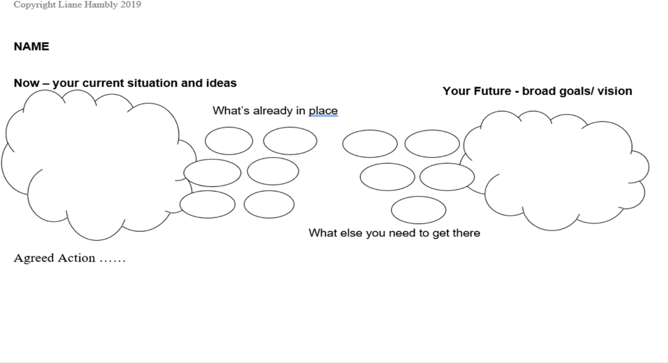

This is an example of a photo taken of a client’s action plan created on a wall with sticky notes

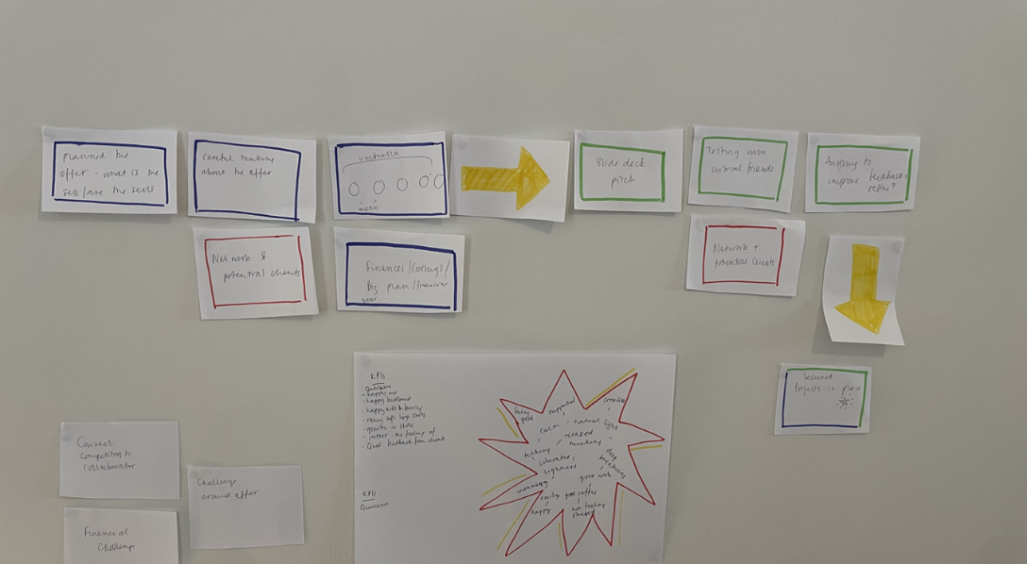

This is an example of one of Liane’s action plans used with all ages, that reflects the backwards action planning approach

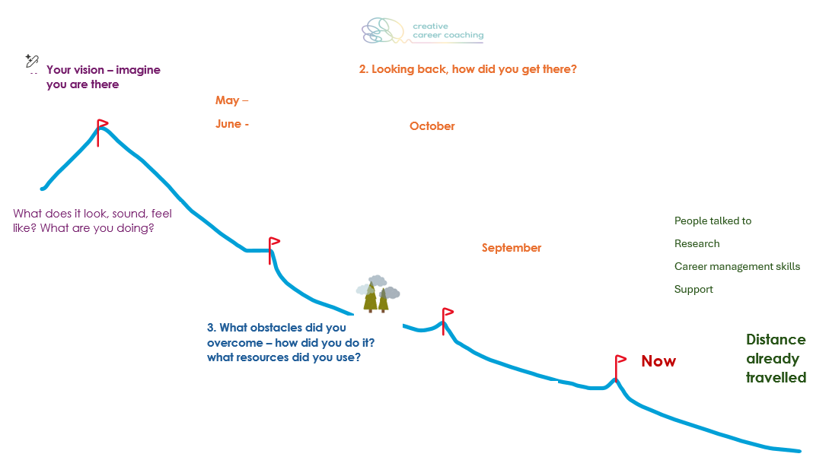

Name Contact details
Where do I want to be? Goal/ vision.

Where am I now? – situation, current thoughts and feelings. What’s already in place.

Action steps – what, who, when

Signed (both) date

10 Years From Now…

I will be……… years old!

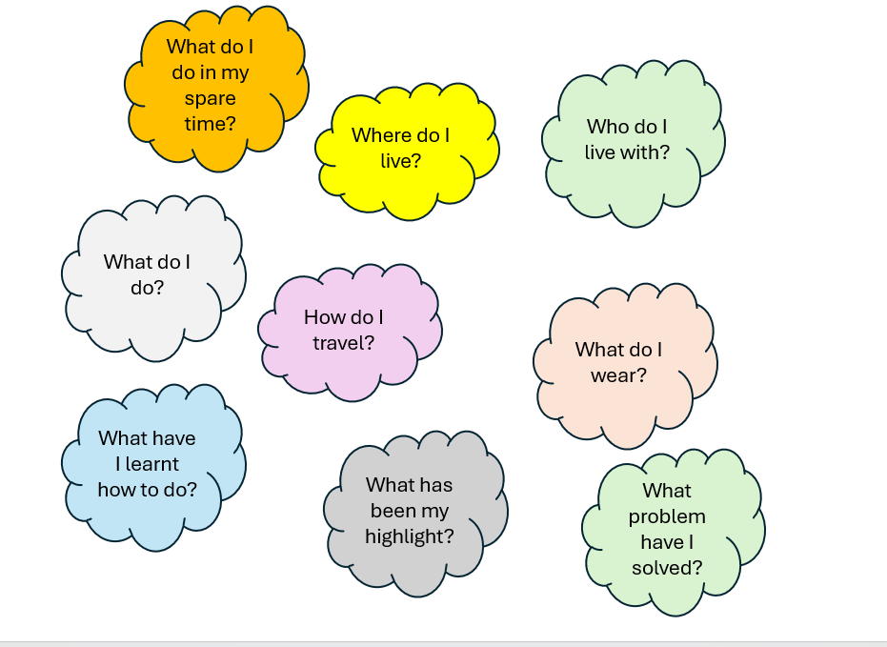



Chapter Nine - Digital Coaching

Prompts to use an AI as a Coach – your AI responses are only as good as the prompts you use!

Prompts to Use an AI as a Coach

If you want to use AI to help you improve how you work with your clients, you can use a set of prompts like this:
Prompt 1: I am a career coach and I am feeling a bit stuck with my client. Please can you act as my coach. I would like to describe the situation, and I would like you to give me some feedback, ask me some coaching questions to help me reflect and suggest some possible ways forward.
(Your AI will no doubt agree to help and ask you to describe your client.)
Prompt 2: I am not sure how to help this client. She is unsure of whether to go to university or do something different. She has all the information that she needs about the options, but she is still struggling to decide what to do for the best. She feels very anxious about making the decision. I am not sure how to help her now.
(Your AI is likely to give you some positive feedback on what you have done already and is likely to suggest some reasons why the customer might be finding it hard to make a decision, and suggest ideas for how to work with her).
Prompt 3: Can you suggest some questions or activities that I could use with her?
(Your AI should be able to suggest some).

Always remember - don’t put any personal data or information that could identify the client into a general AI (your work related AI may be different as it may be locked into your work systems).
Some of what the AI suggests may not be useful or even accurate. Use the AI to get ideas and prompt new reflections, but always use your own professional judgement.

You can also use an AI to coach yourself, for example:
Prompt: I am in a difficult situation at work. Act as my coach and help me think about the best way to deal with this situation. Please ask me coaching questions that will help me to reflect on the situation and what I should do next.
(The AI will no doubt be pleased to help you and ask you to describe your work situation).



Chapter Ten - Trauma Informed Practice

Sensory grounding methods poster

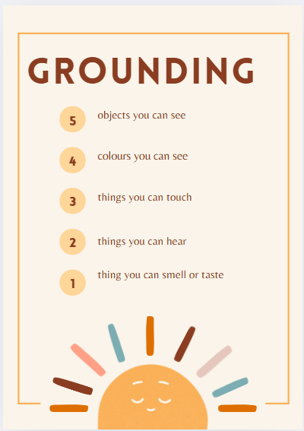



Chapter 11: Working with Groups

Models for group guidance – Meldrum and Edwards
Group guidance activities

Models for group guidance (reproduced with kind permission from the authors)
Meldrum’s model is socio-educational in that it recognises how social and group interaction contributes to the educational/learning process. The Group Integrative Narrative Approach, or GINA model uses a theoretical integration of coaching models such as GROW with counselling, learning theory and Professional Learning and Development. (Meldrum 2017). Savikas’ Career Story Interview is used as a narrative approach for facilitating the “telling of the story”.
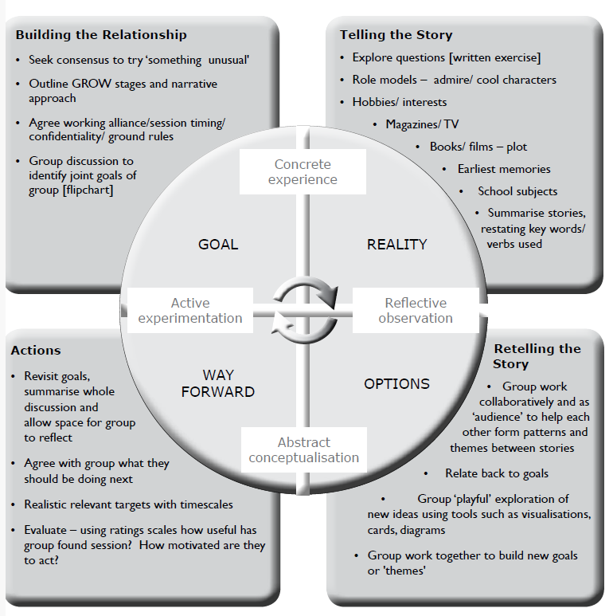

A visual revision of the GINA model allows for a wider range of narrative techniques and places the development of career management skills at the centre of learning with the four themes taken from the Skills Development Scotland Career Management Skills framework.
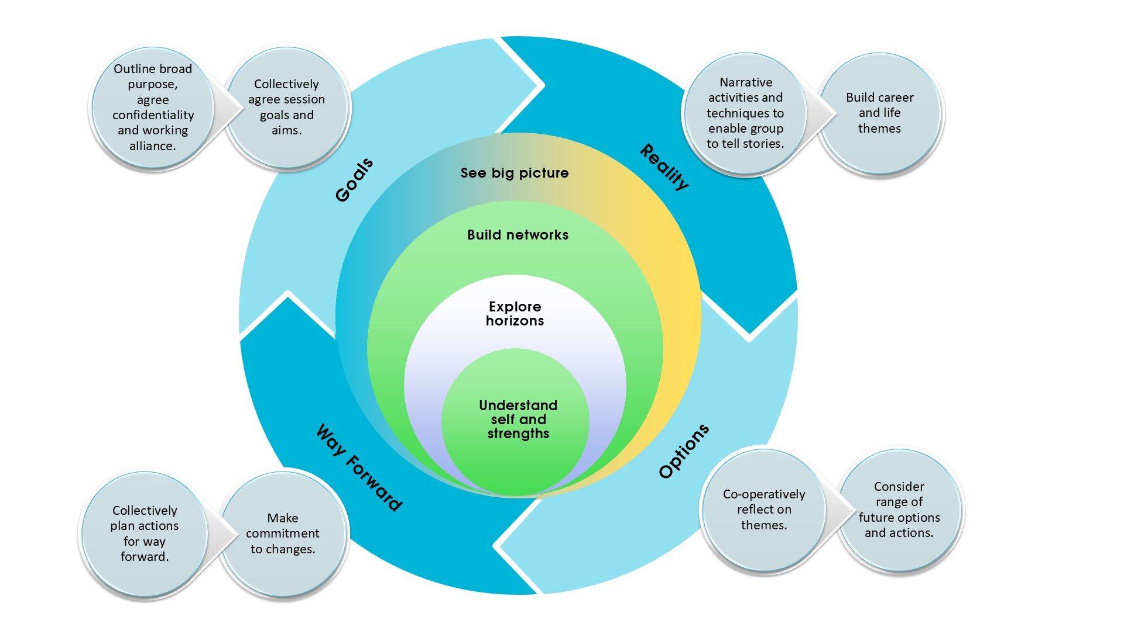
On the following page is the GATE model (2024), a development of GINA. All three models emphasis a constructionist approach whereby peers co-create a collective learning experience.
In the main text of Creative Career Coaching, we consider the Textures of Groupwork continuum (Edwards 2024) to clarify the relationship between group work and group guidance (see also overleaf). In group guidance:
- the agenda is not set by the practitioner but co-created with the participants
- the principles informing group relationships/how they will work together are jointly agreed
- there is a higher degree of uncertainty for the practitioner to manage as they do not know the direction or learning outcomes that will unfold
- the creation of a safe and collaborative relationship between the group is paramount, the practitioner having expertise in facilitating groups and managing dynamics.
- Groups are usually between 4-8 in size and meet more than once.

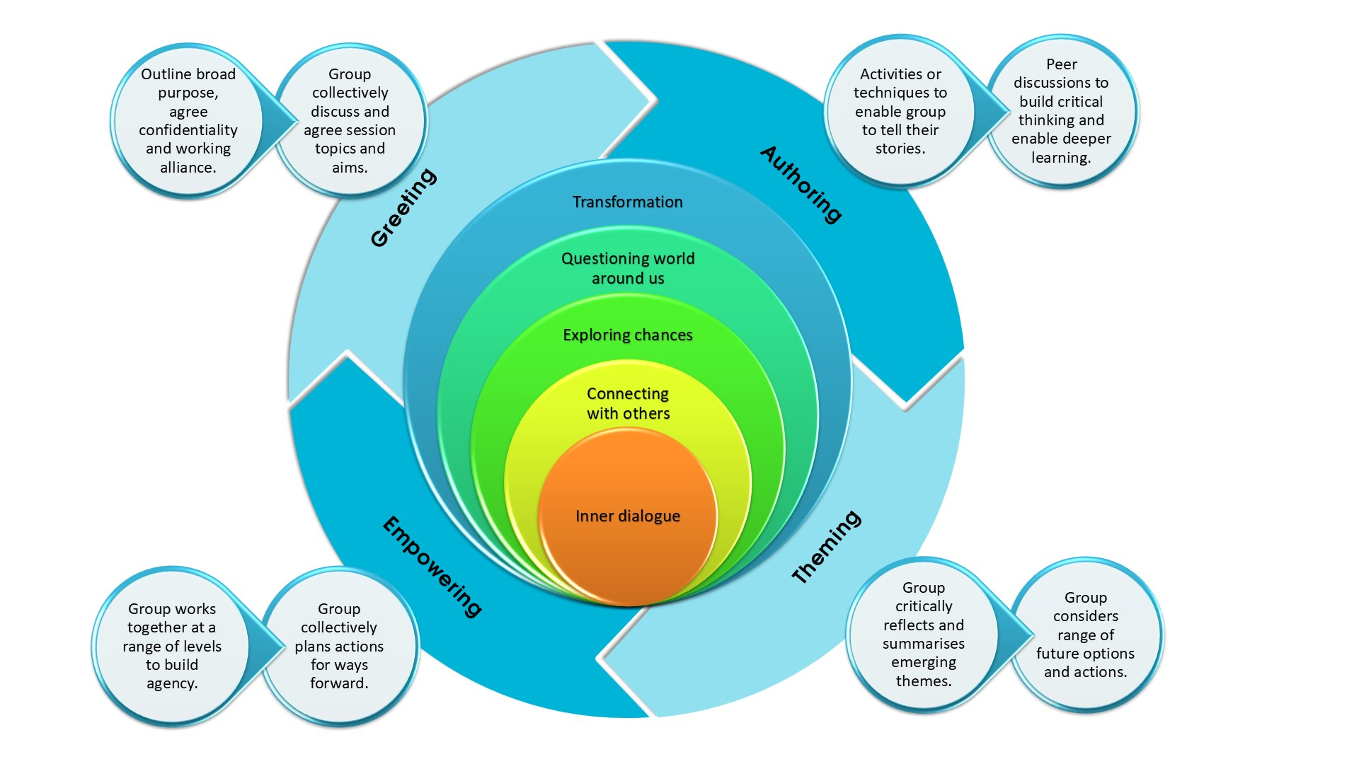
Meldrum, S. (2024) GATE model.
Am I ready for group-guidance? Practitioner Reflection
- How comfortable am I at letting go of controlling the learning process … not having a tight structure or set learning outcomes?
- Would I know what to do if one member started to dominate? How would I manage it without losing anyone? Do I feel equipped to positively and compassionately facilitate group dynamics?
- Which of my existing skills can I use? Which ones would I need to develop?

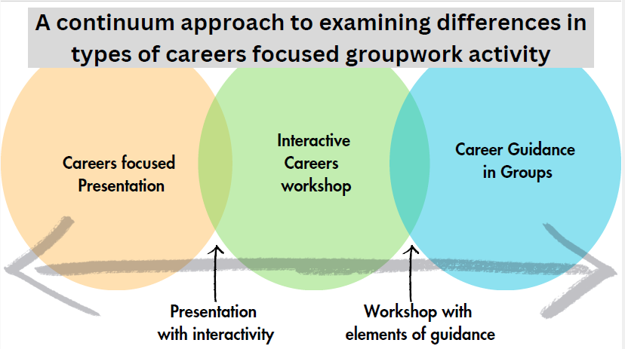
Edwards (2024) Textures of Guidance
Activities that could be offered to clients in a group guidance situation.
The following do not have any prescribed learning outcomes but can be used for whatever the group wishes to focus on.

- Challenge-solution island, a solution-focused approach using a visual of one island where all the challenges are drawn and written, and another island where the solutions to these challenges are likewise generated.
Instructions.
- Tape two large sheets together. On one side ask them to draw an island with problems – volcanos, shark infested waters et. On the other side they draw an ideal island with great features (hammocks, palm trees etc.).
- Problem island – list all the challenges and difficulties they face in relation to the situation being discussed e.g. leaving school, career change.
- On solution island they think of all the ways they can overcome these, the resources needed etc.
This can be adapted to online media via a whiteboard or other app.

- Storyboarding, a well-documented tool used for story narration and creation. It’s a visual representation of past, present, future … or any sequence of a story. On three sheets of paper (or 3 panels/pages), the group brainstorm words and images associated with the panel, reflecting on key characters involved, what’s happening, tools and resources needed, where it takes place, impact of environment and so on. They can give each page a chapter heading like that in a book or TV episode. Sometimes you can use 4 sheets with two future scenarios ... a predictable ending if they don’t make changes/change the direction of the narrative, and a twist – a new ending. This can be particularly useful when people need to consider becoming more active agents and not just going with the flow (school leavers, offenders, redundancy and letting the past determine what they are considering in the future.

- Peer coaching – see chapter 7 for questions usually asked by a career development professional. Identify any that relate to the topic they wish to work on, and are safe enough to use within their group. You can also consider the powerful questions in this resource (chapter on micro skills).

- Lego Guidance – Lego or other building bricks can be used to build anything –how they see themselves in relation to the choices ahead, what the future looks like, barriers and solutions (Targett 2017; Morrison and Targett 2025). According to Targett (ibid) the Lego Friends series works best as there are accessories such as guitars, spanners and tools. The characters are also diverse.


Chapter Twelve - Motivation and Readiness

Worksheet - How Ready are you?

How Ready Are You?

 | Strongly Agree | Agree | Not sure | Disagree
This feels important to me.
I have a clear goal.
I know what I need to do next.
I am confident that if I try I can succeed.
I know who can help me.
I will be able to manage if I hit a barrier.



Chapter Thirteen - Approach to Decision Making

Worksheets on decision making

How would you decide….

What to have for lunch?
- What to wear today?
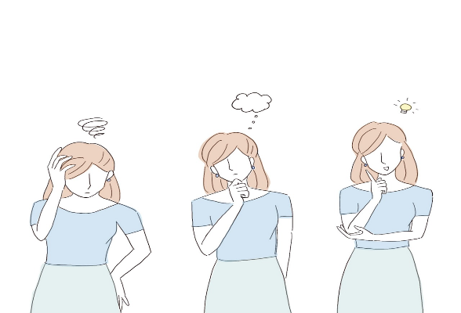
- Which trainers to buy?
- Which phone to buy?
- Where to go on holiday?
- What to do on the weekend?
- Where to live?
- Who to marry?
- Which college course to do?
- Which job to apply for?

Would you use different methods?
Are there some decisions you find easier than others?
Why do you think that is?

Different people make decisions in different ways.
What method or blend of methods do you want to use for deciding
about your future?
What advice would you give a friend as to how to go about deciding?
What if they got stuck and couldn’t make up their mind – what would you say then?

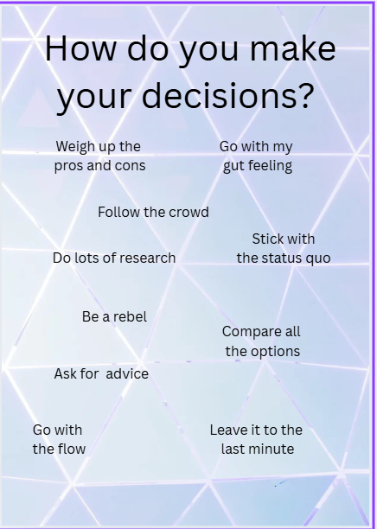


Chapter Fourteen - Self Awareness

The Challenge mindset – instead of asking what do you want to be, flip the matching approach to explore what problem or challenges do people want to solve? With kind permission from J.P Michel, we have reproduced his model and a worksheet from his book, The World Needs You.
- Source: JP Michel, Author, The World Needs You
- Worksheet link: https://mysparkpath.com/flipthemodel
- QR code: https://drive.google.com/file/d/1b56eEL92VchWQAEdwPTBbLQ2aCmRbh3W/view

A Careers Venn diagram poster

What are you good at worksheet – there are many excellent worksheets in existence that are similar to this. We’ve provided this in case you want somewhere to start without reinventing the wheel. There are also strengths, skills and values card sorts – see Katherine Jennick’s What’s Your Strengths cards as a great example

Following on from a skills activity such as the above, you can use the metaphor of a skills suitcase to ask them to pack their skills for the career journey ahead (this might have been one of Katherine Jennick’s ideas!)

Rapid fire activity – sometimes we over think. This is a fun activity to do in pairs with an egg timer or stop watch.

The Challenge Mindset
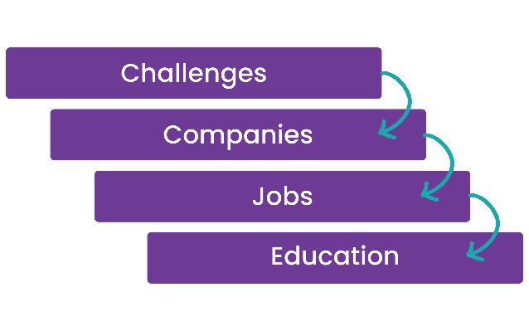
Attempting to match people’s interests to job titles is tricky - there are so many job titles, some are disappearing whilst new ones emerge in the face of technological developments. It can also create tunnelled vision as people’s identity becomes attached to a particular job. To survive and thrive in the face of unprecedented change, careers work can enable people to create a guiding north star of their interests, values and transferable skills. Michel (2023) explains how we can flip the traditional career matching approach to help people find their purpose.

Challenges
- What causes or challenges matter to you? (social, environmental, business, personal, for example). Consider what you’re drawn to on social media, your reactions to the UN Sustainable Development Goals, what you care about when you look around your world.

Companies
- What companies are involved? Search for key words on Linkedin or other media.

People
- Who works in those companies and what jobs do they do. Linkedin is useful for this. Connect with them, read and comment on their posts. Be genuine.
- Be curious – how did they get into those roles - what experiences and learning did they gain on the way that led them to where they are? What’s their story? If it’s not clear, ask them.

Learning
- Would you like to study/experience what they have done?
- What would you need to learn, gain experience in to get closer to contributing to that challenge?
Story
- Write your own story …. This involves “imagining the experiences you want to have, the challenges you want to solve, places you want to be, characteristics you want to develop, strengths you want to improve, struggles you want to overcome, and more” Michel 2023: 101)


mysparkpath.com

SparkPath Flip The Model
The world needs you. Use this roadmap to explore the challenges you care about most and discover how you can contribute.
  Challenges  What Challenges would you like to help solve and why? | Example:  I want to Protect Biodiversity and Landscape because I care about nature and I want to preserve it for generations to come. | Challenge 1: | Challenge 2:
  Companies  What organizations are working on this challenge and what do they do? | - Greenbelt Alliance: Protects open spaces and promotes resilient landscapes in the face of climate change.  - California Department of Fish and Wildlife: Manages wildlife resources and habitats responsibly.
  Jobs  What jobs exist at those organizations and what do they do? | - Grants Manager – Identify funding opportunities, prepare proposals, and track budgets.  - Community Outreach Coordinator – Engage with locals, organize public events, and build partnerships.  - Marketing Manager– Create and manage content like social media, websites, and emails.
  Learning  For each job, what knowledge, experience, or skills do you need? | - Grants Manager  - Degree in nonprofit management or public administration  - Skills in writing, budgeting, and project management  - Community Outreach Coordinator  - Degree in communications or environmental studies  - Skills in public speaking, event planning, and relationship building  - Marketing Manager  - Degree in marketing, business, or communications  - Skills in social media, copywriting, and design
  Action  What actions could you take to explore these jobs further? | - Volunteer at a nonprofit to gain hands-on experience  - Take a course in marketing or project management  - Reach out to someone at an environmental organization to learn more

Reflect:
How could a Challenge mindset help you explore potential career paths?

mysparkpath.com

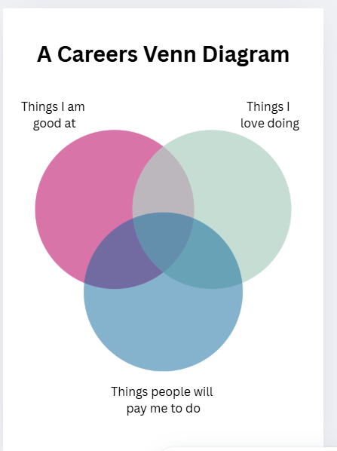
What am I good at?
Listening Being creative Presenting information

Working with numbers Being adaptable Using social media

Using computers Persuading people Working with customers

Working in a team Time management Attention to detail

Taking the lead Critical thinking Making music

Organising events Heavy lifting Using machines Mending things

Dancing Problem solving Being organised Selling things

Doing crafts Using my hands Working with plants and animals Sports

Being resilient Caring Helpful Asking for help

Being motivated Willing to learn Being independent Determined

Looking on the positive side Listen to feedback Confident

Trustworthy Reliable Honest Hard working

My ideas:

What would you put in your skills suitcase?



Finish these sentences! Do it as quickly as you can, without thinking too much.

I am good at….
I love to…
My childhood hero/heroine was…
The problem I want to solve is…
I can…
The best thing about me is…
My friends like me because…
I am proud of…
If I wasn’t afraid, I would…
My favourite school subject is/was…
When I was 8 I wanted to be a…
My motto is…
The most important thing is…
My perfect day would be…
My favourite thing at work is…
I like to read about…
I want to learn to…

Do this as quickly as you can, then read over your answers.



Chapter Fifteen - Opportunity Awareness

A simple diagram to illustrate how to kick start your research

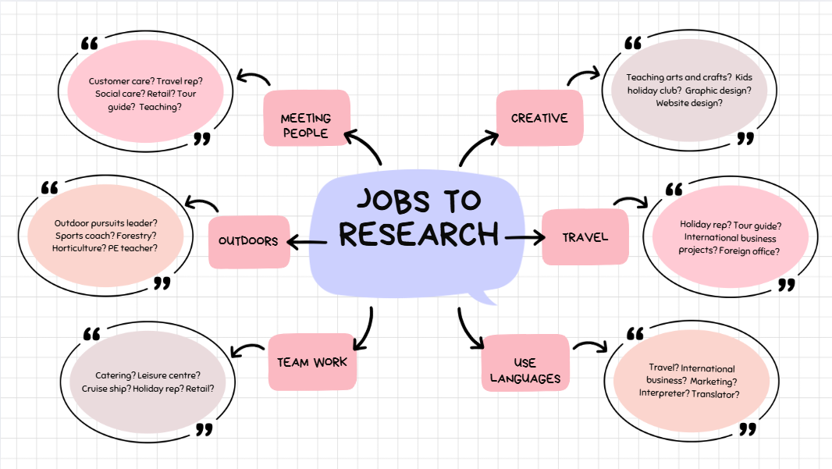



Chapter Sixteen – Transition

Mapping your network activity

A poster of the STAR framework – this (or CAR – context, action, result) is essential for writing your applications, CV, Linkedin profile and preparing for job interviews.

Tips for writing CVs/Resumes (this can be adapted to suit your country, age and stage of client)

Mapping your network – accessing the hidden job market

It has been reported that up to 80% of jobs aren’t advertised. The truth about the hidden job market isn’t that simple. It depends on what level and type of job we’re talking about, and it varies according from country to country. It does remain fair to say that who you know, and getting a foot in the door, plays a large part in recruitment. That places some people at a huge advantage. You can close the advantage gap through using and increasing your network of people who can open doors for you, put in a good word, and act as mentors.

Begin by mapping your existing network of friends, family and community contacts. Place them in the inner circle according to hope close they are (you can do this digitally, with a pencil or sticky notes so that you can move people around). Write what jobs and roles they do or have done in the past (include unpaid roles in the community).

In the second inner circle, write who they know that may be able to help (you’ll have to ask them), and their roles and contact details if they are willing to pass them on.

In the third circle identify where your gaps are – the types of people you need to connect with, the organisations and roles that you would like to know more about. This is where the safe use of social media can come in, as well as joining clubs and societies where people engage in your interests. It may even be going to a local café or work space where people meet. Networking isn’t being pushy – it’s about creating meaningful connections, giving before you ask, thinking about what you can offer someone rather than looking to take their valuable time. Read their posts and interact with the content for some time before letting them know you are looking for work or experience in their area.

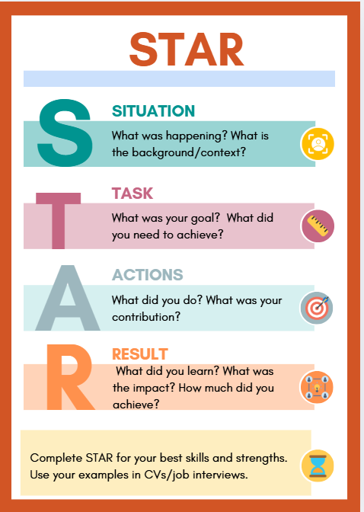

Tips on CV/resume writing

There are some great free resources online but here are a few basic tips

Your personal statement is what determines whether they read on or not. Around 3 lines/150 words – one or two well-crafted sentences that make you stand out as being the type of person they looking for. Always view your CV through their eyes. It should sum up you, your skills, what motivates you and what you are looking for. Just avoid the cliches!

Use the right format - use a format best suited to how your skills and experience match the type of job you are going for – check out chronological, skills based and hybrid. Find out the length and style preferred by the sector you’re applying for.

Always use STAR or CAR – avoid just listing your job responsibilities – pull out your skills, strengths and values, and how you have demonstrated these leading to results

Tailor each time to the vacancy – scour the job description for the essential skills and experiences they are looking for and make sure you address them.

Avoid cliches – find words that explain your unique contribution. If you are talking about team work, then consider the particular strengths and qualities you bring, the contribution you have made to specific projects and again, what were the results?

Sequence your content according to what shows you in the best light, for example are they more interested in your work experience and skills than education results? If so, work comes first. If you have some amazing voluntary work that demonstrates important skills, don’t leave it until the end.

Be AI compliant – some larger organisations use software to scan CVs/resumes to ensure key words and experiences are mentioned. Some software can’t read tables so avoid using them. Pretty templates from the web aren’t always compliant.

If you need help, don’t assume the more you pay, the better service you’ll receive. Check out the practitioner’s qualifications and experience. In the UK there is the British Association of CV writers as well as many highly qualified career development professionals. Using AI to improve your CV/resume might provide food for thought, but it can end up not sounding like you and using too many flowery words and cliches

Remember the F shape – if a human is scanning, then their eyes pay most attention to the F shape – the top and the left. So, avoid putting your highlights bottom right



Chapter Seventeen – Resilience

What takes you out of your comfort zone? Much career inaction is due to a very human avoidance of discomfort. We can strengthen our ability to take risks and step into the unknown by developing a habit of small steps into unfamiliar territory. The more we practice this, the better we get. This worksheet can be used for clients to choose small steps they could take to build resilience in the face of uncertainty.

Poster of famous people who failed – and then succeeded

What Takes You Out of Your Comfort Zone?

Using the telephone?
Learning to use a new piece of software?
Making a presentation to a group of people?
Going to the gym?
Singing solo?
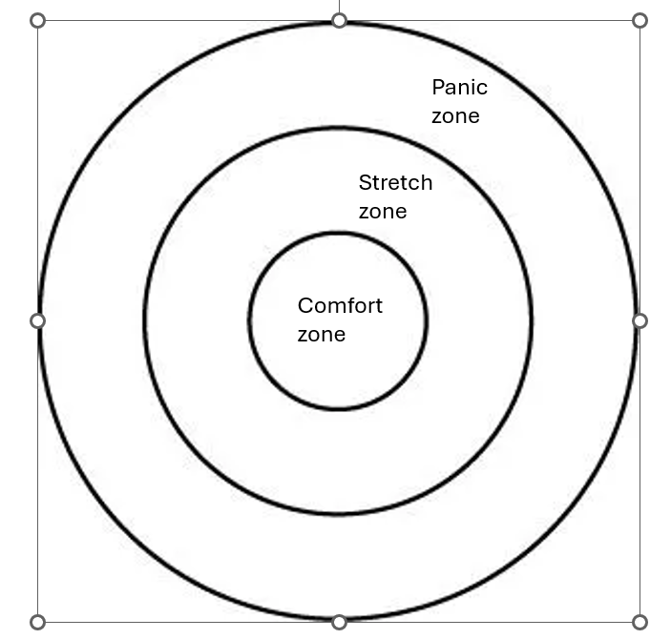
Going to a job interview?
Hanging out with friends?
Watching TV?
Talking about your feelings?
Being told what to do?
Enrolling for a college course?
Visiting a busy event?
Getting ready for a holiday?
Making up after an argument?
Filling in forms?
Reading a book?
Talking to a stranger?
Dressing smartly?
Starting a new job?
Talking to a customer?
Handling money?
Doing a group/team activity?
Using your phone?

Which activities are in your:
- Comfort zone (No stress!)
- Stretch/learning zone (I could do this - a little stress!)
- Panic zone? (Too much stress - I couldn’t do this)

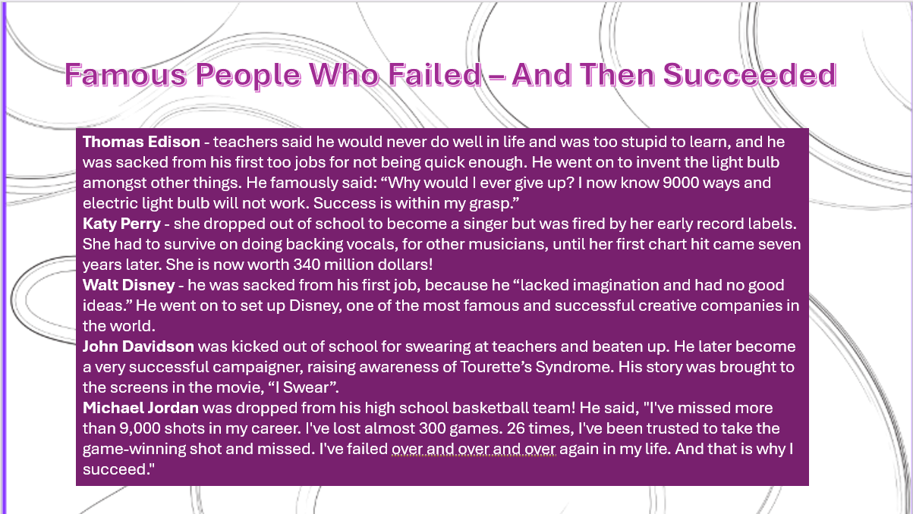



Chapter Eighteen - The Resilient Coach

Self-reflection chart for building your own resilience

Poster with ideas for mindfulness, a key skill for being resilient

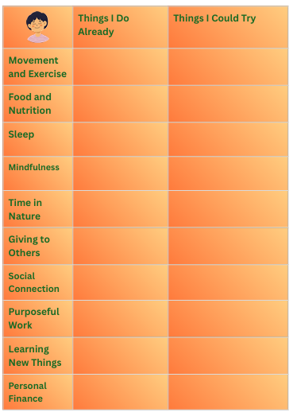

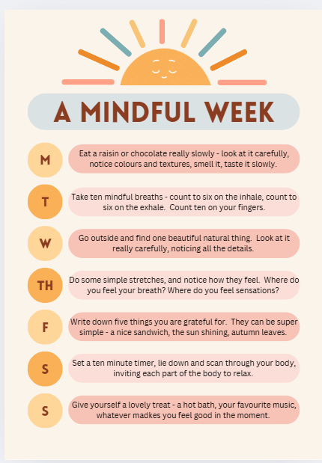

Meldrum, S. (2017) Group Guidance: Is it time to flock together? Journal of the National Institute for Career Education and Counselling, 38 (1): 36-43.
Skills Development Scotland (2012) Career Management Skills Framework for Scotland, Glasgow:SDS
Meldrum, S. (2024) Group Career Coaching – Empowering Learners and Innovating Practice, Opening a GATE to a Better Future, workshop presented at International Association for Educational and Vocational Guidance Conference, Jyväskylä, Finland, 12-14th November 2024.
Edwards, S. (2024) The Textures of Groupwork: a continuum model for career development practitioners. Prospects Luminate.
Targett, C., (2017) Lego Guidance. Career Matters. Career Development Institute. Issue 5.3
Morrison, J. and Targett., C., (2025) Group Guidance within sixth form college and school settings. Career Matters. Career Development Institute. Issue 13.3

