11.1 | All Blooms Levels: Communication Worksheet

Identify Communication Model Elements
All elements in the classic communication model interact to influence the fidelity (and thus the success) of the instructional message. Those elements include: the Source of the message, the Message itself, and the Channel it flows through, the Receiver of the message, and the Feedback and Noise involved. Use what you have learned about the communication process from Chapter 11 to analyze the communication contexts for your choice of a unit of instruction. Refer to the communication model illustrated below, and the explanation of it provided in Chapter 11 of Streamlined ID (2027). It will help you identify and analyze the key elements for your instructional design project. Fill in the information specific to your project in the blanks below:

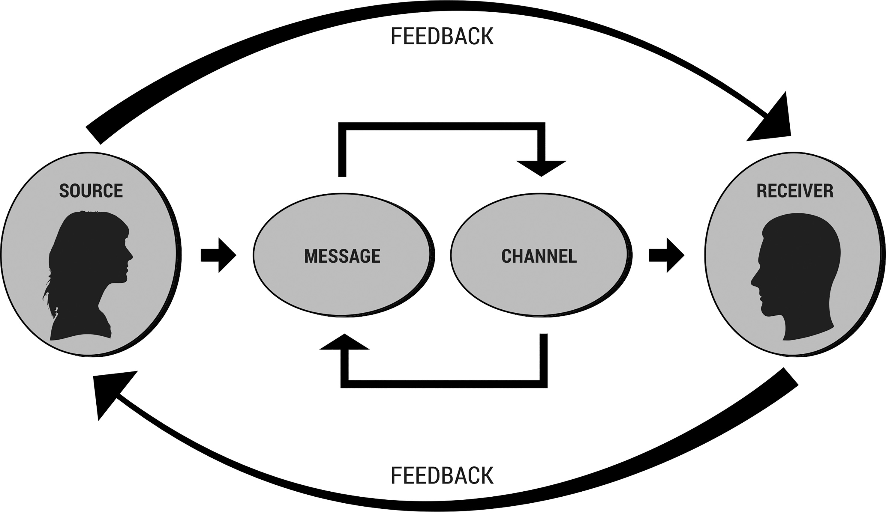
Message Source: ____________________________________________________________________________
Message Receiver: __________________________________________________________________________
Message: ___________________________________________________________________________________
_____________________________________________________________________________________________
Channel: ____________________________________________________________________________________
Feedback: __________________________________________________________________________________
Noise: ______________________________________________________________________________________

