Example Project Scope & Needs Analysis Report
The following pages provide an example of a project scope and needs analysis report compiled for stakeholder approval. The businesses, the market analysis, and the statistics cited in this example are largely fictitious, although the references provide a list of articles and reports consulted for guidance on the market analysis information.

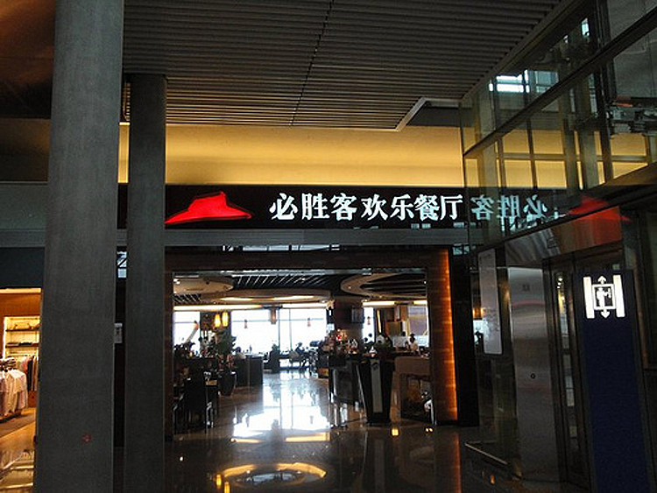
“PEK-Pizza Hut,” CC-BY 2.0 by Dave 2012-06-14, downloaded 2020-01-05.

Project Scope Proposal: Cultural Sensitivity Training
  - Prepared for Company X
  - by Josh Jacobs,
  - Designed-to-Work Training Consultants, LLC

Executive Summary
This proposal for the development of cultural sensitivity training for food service workers has been developed by Josh Jacobs for Company X. A summary of the key sections of the proposal follows:
Background and Client Profile
Company X is a U.S.-based talent search company that works with restaurants and other food service companies to help them find qualified servers, chefs and kitchen personnel. Company X desires to retain the training development services of Josh Jacobs, Designed-to-Work, LLC, to develop a two-part unit on cultural sensitivity training for its client’s employees.
Needs Analysis
A needs analysis was carried out internally by Company X. The analysis identified a need for a formal certification program for client employees concerning the cultures and food-related practices in the client locations in the Middle East and Southeast Asia regions. Cultural topics will likely include, but not be limited to, general food safety guidelines for the target cultures, and professional appearance and behavior standards that are consistent with the local cultures.
Project Instructional Goal
To provide a certification program covering cultural sensitivity, cultural food handling and food-related customs for employees of restaurant and food services clients wishing to equip those employees for success in locations in the Middle East and Southeast Asia. This training will be accessible via the Web and mobile devices so that client employees can take the training at their own convenience.
Learner Analysis
The primary target learner group consists of learners of average intelligence with varying degrees of food service experience in the 18 to 30-year-old range (68%). A secondary learner group in the 31 to 60-year-old age bracket (32%) may include learners who are more experienced and knowledgeable about the content. The availability of frequent help and support, chunked content, and the ability to test out of sections of content will be essential for both groups, while design considerations for the visually-challenged may be necessary for the upper age range of the secondary learner group.
Development Issues, Constraints & Resources
Variations by country will be addressed through the use of scenarios that highlight the different issues involved. Client schedule constraints dictate that all prototypes to be produced by the designer must be ready to test within three months of the approval of this project scope. Due to time limits, the training will initially be developed for a web-based platform, with a mobile platform for Smartphones and tablets to be developed as soon as possible. A print backup version will also be developed. Efforts will be made to utilize Open Educational Resources (OER), and the training will adhere to universal design guidelines. Content for the training units will be gleaned from existing Company X and client materials and any additional materials identified, and Company X will arrange for all required Subject Matter Expert (SME) reviews. The work will be completed for Company X by Designed-to-Work, LLC, on a cost-plus basis.
Scope Summary
Designed-to-Work proposes to design and develop a two-part certification training program on Cultural Sensitivity and Food Customs for Food Services Employees Working in the Middle East and Southeast Asia, that Company X will offer to its food services clients. Designed-to-Work will provide this training within three months of the approval of this project scope document, and mutual agreement on a budget and schedule.

Project Scope Proposal for Company X
Contents
Background and Client Profile 4
Needs Analysis 4
Project Instructional Goal 5
Learner Analysis 7
Development Issues, Constraints, and Resources 7
Scope Summary, Proposed Schedule, and Resource Projections 9
Scope Approval Agreement 12
References Consulted 12

Background and Client Profile

Company X is a U.S.-based talent search company that works with restaurants and other food service companies to help them find qualified servers, chefs and kitchen personnel. The company provides a referral and certification service and directs potential job candidates to the training programs that will provide them with the necessary knowledge and skills to meet certification requirements. They actively recruit a talent pool of individuals with experience and skill in various food service-related jobs, as well as individuals who desire to gain training and experience for food service industry careers. Company X directs these individuals to courses and programs for restaurant management, catering, cooks, chefs and bakers, and food servers. Most potential employees also lack knowledge of safe food handling operations which they are directed to obtain via the National Restaurant Association’s (NRA) ServSafe® training programs.
Recently, several of Company X’s clients have requested cultural sensitivity training for employees that they are sending overseas to open and manage restaurants and food service locations in foreign markets. Company X has been unable to locate a course or educational program that addresses the topics they feel are essential for food service workers operating in the countries identified by their clients. This instructional designer has been retained to develop training materials on cultural sensitivity for Company X for those specific countries. The training will be accessible via the Internet and mobile devices and will consist of a generic core unit, with customized units for specific foreign localities.
Key stakeholders and contacts at Company X include:
- Company X Owner
- Company X Board member & content consultant
- Company X Client Liaison & content consultant
- Company X Regional Manager & content consultant
- Company Y’s (client of Company X) International Operations Chief, Middle East Region
- Company Z’s (client of Company X) International Operations Chief, Southeast Asia
Contacts at other organizations may also be identified as the project progresses. Company X will arrange for members of the target learner population to participate in usability testing activities.

Needs Analysis

Company X identified a need for training of its clients’ employees on topics related to cultures and food-related practices in the Middle East and Southeast Asia regions where those clients have business interests. Training topics will likely include, but not be limited to, general food safety guidelines for the target cultures, and professional appearance and behavior standards that are consistent with the local cultures. To meet this need, Company X wants to provide its clients with a formal certification program for client employees.
Company X’s mission is: to bring excellent people and organizations together, supplying our food service customers with training resources and skilled and qualified personnel to meet their staffing needs. The following instructional goal for this project aligns well with that mission:

Project Instructional Goal
To provide a certification program covering cultural sensitivity, cultural food handling, and food-related customs for employees of restaurant and food services clients wishing to equip those employees for success in locations in the Middle East and Southeast Asia. This training will be accessible via the Web and mobile devices so that client employees can take the training at their own convenience.
In cooperation with Company X, the designer developed a client survey to gain additional information to support the need for the proposed training project (see Table 1). That survey was administered through the Company X Client Liaison’s office in September, 2012, and preliminary results indicated that a large percentage (72%) of existing clients claimed to already provide some type of cultural sensitivity training for their employees assigned to international locations. Another 51% claimed to provide training specific to proper food handling and food-related customs in the target country. A little over half of the existing clients (60%) indicated that they would be interested in Company X-supplied training on cultural sensitivity and food handling and food-related customs in Middle Eastern countries and Southeast Asian countries, whether or not they currently had restaurant operations in those areas. Therefore, there appears to be a moderate need and interest on the part of clients in the availability of cultural sensitivity and food-related cultural training. The interest of similar organizations currently not clients of Company X is assumed to be generally higher than that indicated by the client survey, and the available of this training may give Company X a marketing advantage over competitors.
Table 1: Company X Client Survey Results: Client-Provided Training (produced using Microsoft Excel)

With respect to desired content, the survey asked clients to rate the importance of topics that needed to be covered. This information is graphically illustrated as a word cloud in Figure 1. In the illustration, desirability is indicated by the type size of the words: the more desirable the topic, the larger the type size.

Figure 1: Desirable training topics. (Larger topics are more desirable. Produced with http://www.wordle.net).
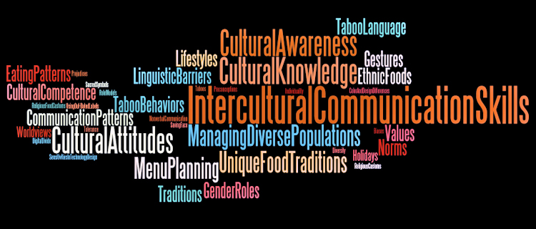
Due to the number of countries and cultures involved, the survey sought to gain an idea of the level of interest of clients in different geographic markets. Figures 2 and 3 provide a picture of the emerging markets in Southeast Asia and the Middle East, as indicated by client interest in the countries highlighted in those regions. This information establishes that the greatest need exists to develop training materials for Indonesia, Thailand, the Philippines, Malaysia, Vietnam, Cambodia and Laos in Southeast Asia, and for the Middle Eastern countries of the United Arab Emirates (UAE), Saudi Arabia, Qatar, Oman, and Bahrain.
Figures 2 and 3: Country priorities for cultural training in Southeast Asia and the Middle East, as indicated by percentage of clients desiring to extend operations in those markets. (produced with Adobe Photoshop)
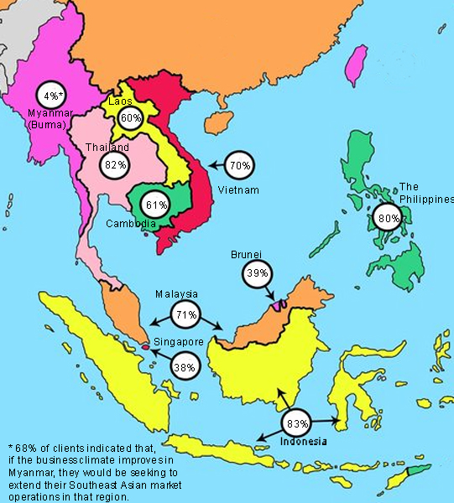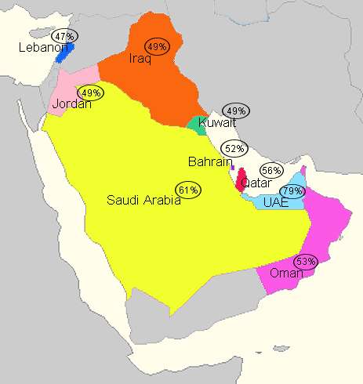

Learner Analysis

Based on Company X and client information and job descriptions, it appears that those client employees who will take the proposed instruction are learners of average intelligence and have varying degrees of food service experience. The instructional designer conducted an analysis of the characteristics and needs of the primary target learner group, identified as current and potential food service industry employees in the 18-30 year old range (68%). Learner characteristics in the primary group vary widely, therefore the training materials will be written at a reading level geared to the general public, the designer will make use of multimedia elements to maintain learner interest, the navigation of the materials will follow usability and accessibility guidelines to promote an intuitive design, and technological supports and help will be included. In addition, since the learner familiarity with portions of the instruction will likely vary widely, the training units will be designed in manageable chunks that culminate in assessments (i.e., Checks for Understanding). Learners may choose to take the section assessments first, and if their scores indicate mastery of the topic, they will be given the opportunity to skip that section of the instruction, if desired.
There is also a secondary group in the 31-60 age bracket (32%). This is a significantly-sized secondary learner group that may include learners who are more experienced and knowledgeable about the content. However, it might also include individuals with vision challenges for whom viewing small screen instruction on mobile technologies could represent a barrier to learning. Therefore, the size of text and graphics for the mobile platform will be designed with this potential constraint in mind, and the design will make use of user-friendly optional content formats such as video and audio presentations.
Either learner group described above could include individuals who are less digitally-literate. The availability of frequent help and support will be essential for this portion of the learner population.

Development Issues, Constraints, and Resources

One of the most challenging constraints involved in this project is the wide range of content. In consideration of the difference in food-related traditions and customs between countries, a general unit on cultural sensitivity and food issues will be developed that identifies and elaborates on the similarities between the countries identified for coverage. Variations by country will be addressed through the use of scenarios that highlight the different issues involved. Learners will be presented with scenario choices that are specifically identified by country or culture and will be provided with guidance as to those they should choose to experience. The use of such scenarios should expose learners to a range of issues specific to the targeted countries and should help maintain their motivation for learning.
Additional project constraints and strategies for addressing them include:
Schedule Constraints – The development of the cultural sensitivity and food customs training will be impacted by the business development schedules of several of Company X’s largest clients. Therefore, all prototypes to be produced by the designer must be ready to test within three months of the approval of this project scope.
Technical & Format Constraints – Due to the short timeframe of the project, the training will initially be developed for a web-based platform, with a mobile platform for Smartphones and tablets to be developed as soon as possible. (The designer requests that comments on this project scope proposal include a discussion of the timeline desirable for this secondary development, as well as the resources available for completing that development by the desired deadline.) Initial results from the client survey indicate that it is advisable to provide a print version of the training materials as a backup format to prevent delays in learning when issues with connectivity, bandwidth, or access are encountered, or when an employee’s physical characteristics or lack of familiarity with technology challenge their ability to use the primary training formats.
In addition to these general requirements, there are more specific formatting and learner-related issues that should be considered in the design/development process. These constraints and recommended plans for addressing them are summarized in Table 2.
Table 2: Summary of Digital Design Constraints & Learner Related Issues.
Digital Constraint or  Learner-Related Issue | What It Does | How to Plan
(Digital) Device Platform Constraints | Devices have different space options to consider. | Create several versions of each file for different types of devices.
(Digital) Graphic Constraints | Displays limited visual information in dots per inch (dpi) format (e.g., 72dpi vs. 132dpi). | Test training materials on different platforms. Limit color options to “web friendly” colors. Utilize line art for instructional content.
(Digital) Design Format Constraints for Printed Materials | Complex graphics, and /or video, will not transfer to printed materials. | Directions to full training on website. Provide link to PDF of text version of video content with still photos. Use black and white output of instructional material.
(Digital) Mobile Format Constraints Regarding Bandwidth & Battery Life | Inhibits user interactivity with designed training material | Chunking of material into smaller segments, limit color options, photos. Mobile checklist to summarize outcomes.
(Learner) Computer Literacy | Limits comprehension of applicable training information. | Have a redundancy plan if learners have limited understanding of Internet operations.
(Learner) Computer Access | Limits accessibility of learners to instructional content. | Have a redundancy plan if learners have limited access to computers or a limited understanding of Internet functions or connectivity.
(Learner) Low Vision | Limits the visibility of learning material for learners. | Images and forms should have ALT text or voice over of text material. Should provide ability to enlarge text.
(Learner) Color Blindness | Inhibits understanding of concepts concerning food safety determinations. | Emphasize the contrast or lightness of brightness.
(Learner) Physical Impairment | Restricts learners from performing certain functions. | Provide accessibility options for assistive technologies.
(Learner) Hearing impairment | Text must be provided for all versions of video or live streaming instruction | Prepare audio component that describes images and visual cue for blind and low-vision users.

Intellectual Property, Privacy & Permissions – Any images utilized for the learning materials must be accompanied by: (a) documentation of the appropriate public domain credentials, (b) appropriate attribution for Creative Commons images, and/or (c) the supporting permissions documentation from the image creator and any individuals pictured (i.e., a signed media release and consent form). Care should also be taken to avoid problems with clients’ intellectual property rights (e.g., formal client permission must be sought when using images that contain client locations, employees and logos). The designer will use Company X’s standard media release/consent forms for individuals and businesses. In addition, the designer will confer with Company X’s Legal Department concerning any possible issues of disclosure with its clients.
Accessibility & Universal Design for Learning (UDL) Considerations – To ensure that the training is accessible to all learners, the Web Content Accessibility Guidelines (WCAG) and key UDL checkpoints will be used to guide development. Along with other measures, the design of the instruction will adhere to these specific standards:
- Alternative text (ALT Text) descriptions will be supplied for all images and tables to accommodate the visually challenged;
- All video materials will be captioned and screen-readable transcripts provided for all audio and video;
- Links will be provided to detailed information that cannot be included in the “ALT” text field;
- All text and images will be designed to meet a minimum contrast ratio of 4.5:1 for images and large text (14 point or greater);
- Instruction will be developed using responsive design to ensure that it displays equally well on devices ranging from widescreen monitors to mobile phones, and to allow learners to easily change font and image size; and
- Whenever possible, content will be designed with consideration of learner variability using multiple means of representation, action and expression, and engagement (Rao, 2021).
Resources –
- Content for the training units will be gleaned from existing Company X and client materials, as well as from additional resources identified by the designer and Company X. For example, the designer/developers will use free and low-cost materials on cultural considerations for countries in the Middle East and Southeast Asia provided by the U.S. State Department, National Restaurant Association Educational Foundation (NRAEF), CultureGrams™, the CIA’s World Factbook, the World Bank’s data sources, the British Broadcasting Corporation’s (BBC) country profile website, Geert Hofstede’s Country Cultural Dimension comparison tool, and current books and articles on culture.
- The required Subject Matter Expertise (SMEs), for both content development and reviews, will be provided by Company X, by clients identified by Company X, and, if necessary, the services of a reliable and recognized cultural consulting agency will be engaged (identified and paid for by Company X).
- Designed-to-Work Training Consultants will provide the design and development expertise to complete the project. Company X will contract with Designed-to-Work on a cost-plus basis, with the details of the contract to be decided through joint collaboration of the legal departments for Company X and Designed-to-Work.

Scope Summary, Proposed Schedule, and Resource Projections

Based on the designer’s analysis of the needs, learner characteristics, and constraints and resources involved, it is proposed that:
Designed-to-Work will design and develop a two-part certification training program on Cultural Sensitivity and Food Customs for Food Services Employees Working in the Middle East and Southeast Asia. Company X will offer this training certification program to its food services clients. The program will be developed for the Web and mobile devices and will consist of a generic unit that addresses topics common to all countries in those regions, along with localized, country-specific content and scenarios designed to address food-related topics unique to each country. The instructional materials will be revised and finalized based on timely client reviews and based on the results of usability and functionality testing conducted with participants representative of the target learner audience.
Company X will provide (or arrange and pay for) subject matter expertise, content reviewers, and formative usability testing participants. The specific content to be addressed, the desired learning outcomes, instructional strategies, assessments, and the multimedia elements will be reviewed in a thorough and timely manner by Company X designees.
The documents and deliverables to be developed, reviewed and/or tested, and approved include:
- The Design Document – featuring the desirable learning outcomes, assessment descriptions, instructional strategies, a detailed content outline and plan for content treatment, a media plan, and a plan for implementation, formative testing and review, and summative evaluation.
- Interim instructional prototypes – nature and number to be determined based on the approved Design Document. These prototypes may consist of multimedia scripts and storyboards, scenarios and branching plans, assessment items, web site plans, and web and mobile screen designs.
- Final training program materials.
The proposed schedule and milestone dates for the above deliverables is provided in Table 3, and the resource projections are detailed in Table 4.
Table 3: Deliverable Milestones and Schedule for the Proposed Project.
Milestone/Deliverable | Responsible Party | Proposed Due Date
Project Proposal Scope Approval (this document) | Client | One (1) week from proposal delivery
Design Document | Designed-to-Work | One (1) week from scope approval
Design Document Approval | Client | One (1) week from design document delivery
Identification of SMEs, content reviewers, and usability test participants | Client | One (1) week from design document approval
Delivery of content summaries (scripts, web page content, etc.) for SME review and approval | Designed-to-Work | Two (2) weeks following SME content interview(s), scheduled as needed
Content summary feedback and/or approval | Client | Feedback one (1) week following content delivery, and approvals TBD based on nature of feedback and extent of changes
Interim prototype #1 for review | Designed-to-Work | One (1) week following approval of content
Feedback on Interim prototype #1 | Client | One (1) week following prototype delivery
Interim prototype #2 for review | Designed-to-Work | One (1) week following prototype #1 approval
Feedback on Interim prototype #2 | Client | One (1) week following prototype #2 delivery
Draft Prototype #3 ready for testing | Designed-to-Work | Two (2) weeks following prototype #2 feedback delivered
Prototype #3 testing (usability, functionality, and quality) | Designed-to-Work AND Client | One (1) week of testing of prototype #3
Revisions made based on testing results and Final Draft materials delivered for approval | Designed-to-Work | One (1) week after testing of prototype #3
Feedback/approval of final draft materials | Client | One (1) week after final draft delivered
Delivery of final product deliverables and supporting documentation and code, etc. | Designed-to-Work | One (1) week after final Client approval
Range of development and review weeks:  (assuming no major variances or delays) |  | 17 to 20 weeks*
* Final dates to be entered in the schedule following scope approval.

Table 4: Resource Projections for the Proposed Project*
Project Tasks | Resource Required | Resource/Person Hour Estimates
Project content meetings | Time of designer and SME | 6 to 10 hours, as needed
Development of content outlines, scripts, prototypes | Designed-to-Work | 80 hours
Development of multimedia assets | Designed-to-Work | 40 hours
Content and prototype reviews | SME(s) and/or other Client representatives | 20 hours total
Internal developer reviews, product testing | Designed-to-Work | 15 hours
Product testing | Client-designated testing participants | 6 hours per person  (number of persons to be decided)
Revisions, final production | Designed-to-Work | 40 hours
Estimate of Person-Hour Requirements for Designed-to-Work and Client: |  | 181-185 hours  (Designed-to-Work) | 32-48 hours  (Client, depending on # of test participants)
* Note that changes to the project and content scope may alter resource projections significantly.

Scope Approval Agreement
Designed-to-Work agrees to provide the proposed training materials based on the specifications of this project scope document (or a revised and approved version of this document), and within the schedule and budget parameters agreed upon by authorized parties from Company X and Designed-to-Work.
Respectfully Submitted,
Josh Jacobs, Designer
Designed-to-Work, LLC

NOTE: Reviewers are asked to address, in writing, any items in the above project scope document that should be elaborated, changed or deleted, and sign next to the applicable statement below to indicate review and/or approval of this document.
Sign your name next to the statement below that indicates your decision regarding this project scope | Signature
I have reviewed and APPROVE this project scope proposal, as written.
I have reviewed and APPROVE this project scope proposal with the changes I noted on the following pages of the document: __________________________
I have reviewed but do NOT approve this project scope proposal. (State reason, below.)
Other: (please elaborate)

References Consulted
Ernst & Young. (2012). Shifting perspectives: Ernst & Young’s Middle East attractiveness survey 2012. At http://emergingmarkets.ey.com/wp-content/uploads/downloads/2012/11/e174.1014_attractiveness_middle_east_2012_lr.pdf
Kate, D.T. (July 9, 2012). Asean reaps rewards as Clinton counters China: Southeast Asia. In Bloomberg.com At www.bloomberg.com/news/2012-07-10/asean-reaps-rewards-as-clinton-counters-china-southeast-asia.html
Rao, K. (2021). Inclusive Instructional Design: Applying UDL to Online Learning. The Journal of Applied Instructional Design, 10(1). https://dx.doi.org/10.51869/

