Appendix B: Categorical Logic with Venn Diagrams

We can adapt Venn diagrams to prove that valid categorical syllogisms are valid. As an added bonus, the Venn diagram technique can also be used to mechanically generate counterexamples for categorical syllogisms that are invalid. As noted in Chapter 2, there is no general mechanical technique for showing that invalid arguments are invalid, and hence, no general mechanical technique for generating counterexamples to invalid arguments. However, we show how to do it for this restricted class of arguments in section 2.

- Proving Categorical Syllogisms Valid With Venn Diagrams

An argument is valid if and only if it is impossible for all of its premises to be true and its conclusion to be false. In Chapter 2, we applied one technique to prove the validity of a variety of arguments and argument forms: demonstrate that impossibility. Our proofs consisted in explicitly showing that making the conclusion false is incompatible with making all of the premises true. Here’s a simple example:

(P1) All Fs are Gs.
(P2) All Gs are Hs.
(C) All Fs are Hs.

Suppose (C) is false. That demands that some F is not H. Suppose further that (P1) is true. That demands that all Fs are Gs. If all Fs are Gs and some F is not H, it follows that some G is not H. However, that is clearly incompatible with (P2) since it asserts that all Gs are Hs. So, what was required to make (C) false and (P1) true automatically renders (P2) false. It is impossible to make (P1) and (P2) true and (C) false. So, the argument is valid.

This technique has advantages. It’s broadly applicable. We used it to cover both standard propositional logic and categorical logic argument forms in Chapter 2, and it can also be applied to real-world arguments that don’t match any of our standard argument forms, provided they’re not too complex.

However, if we are only concerned with simple categorical arguments like the above, there is a way of refining the technique that some find helpful. To prove validity, we still demonstrate that it is impossible for all of the premises to be true and for the conclusion to be false. However, to do so we use a Venn Diagram, a diagram that pictures the relations that hold between sets of objects.

Let’s first demonstrate the validity of the above argument form using a Venn diagram, and then we’ll show how to apply the technique more generally.

We begin by drawing three interlocking circles: the F circle corresponds to the set of things that are F, the G circle to the set of things that are G, and so on. The intersection of a pair of sets is the set that consists of things that belong to both sets. So, the intersection of F and G is the lozenge-shaped region where the F and G circles overlap. Similarly, the intersection of G and H is the lozenge-shaped region where G and H overlap. The intersection of all three sets, F, G, and H, is the set of things that belong to all three. That is the region at the center of the diagram where all three circles overlap. The other regions can be similarly understood. The part of the F circle that does not overlap with either G or H corresponds to the set of things that are F and not G and not H. The part of the intersection of F and G that is outside of the H circle corresponds to the set of things that are both F and G, but not H, and so on.

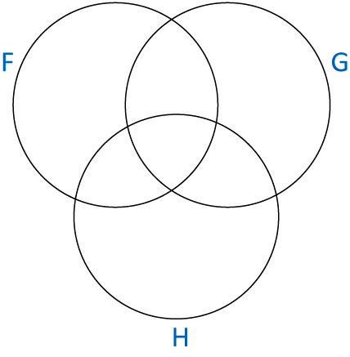
We now draw onto the diagram the conditions that would have to be met to make both premises true and the conclusion false. Let’s proceed in the order we did above. To make (C) false, there must be some F that is not an H, i.e., there must be at least one object that is in the F set but not in the H set. There are two places it could be: it could in the part of F that is outside of both G and H, or it could be in the in the part of F that overlaps G but not H. To represent this information, we draw a track through both those regions. When you see such a track in a diagram, you should think “there is some object somewhere on this track (but I don’t know where).”

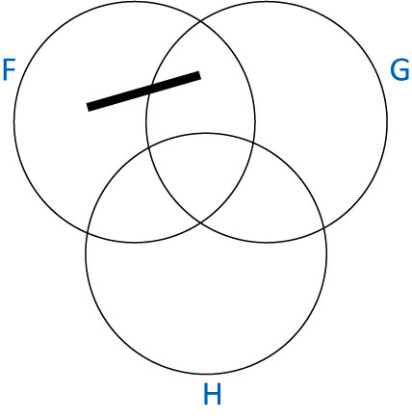
To make (P1) true we demand that all Fs are Gs i.e, that there are no Fs outside of G. So, the part of the F circle outside of the overlap with G must be empty. We indicate that a region is empty by cross-hatching over that part of the diagram.

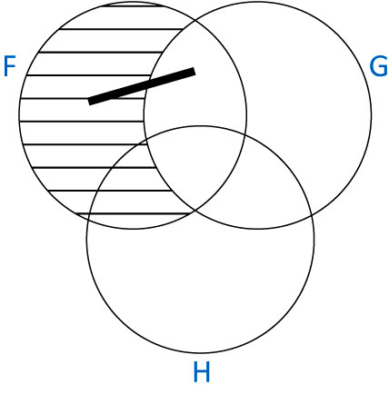

To make (P2) true, we similarly cross-hatch the part of G that is outside of H.

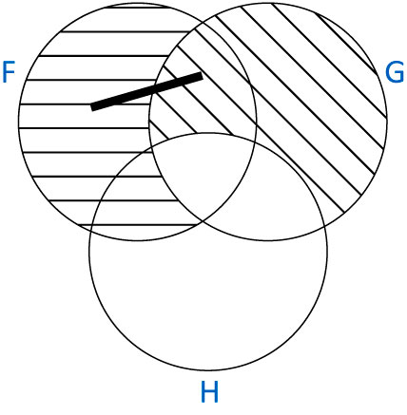
What we have here is a pictorial representation of the impossibility of making (P1) and (P2) true and (C) false. For (C) to be false, there must be something on the track. However, for (P1) and (P2) to be true, all of the cross-hatched regions must be empty. Since the track is entirely contained inside regions that must be empty, it is impossible to satisfy all the requirements. So, the argument is valid.

And that is the Venn diagram method in essence. Whenever you have a claim that asserts that there is something of some kind, you draw a track through all the regions of the diagram where such an object could be located. Whenever a claim asserts that some regions are empty, either directly (e.g. “There are no Fs”) or indirectly (e.g. “All Fs are Gs”), you cross-hatch all the regions of the diagram that must be empty. If, when you have marked on the diagram what is required to make all the premises true and the conclusion false, you have any track that is entirely contained within cross-hatched regions, you have demonstrated the impossibility of making all the premises true and the conclusion false, and the argument is valid.

Let’s do another example:

(P1) Some Fs are Gs.
(P2) All Gs are Hs.
(C) Some Fs are Hs.

It clearly doesn’t matter which order we choose to fill in the diagram. So, let’s start with (P1). We draw a track that goes through the entire intersection of F and G.

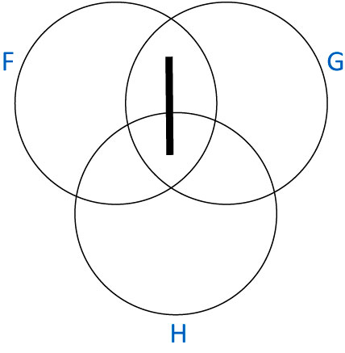
Again, you should read the track, as saying “there is some object somewhere on this track (but I don’t know where).” (P2) is a premise of familiar kind. To make it true, we need to cross-hatch all the parts of G that are outside of H.

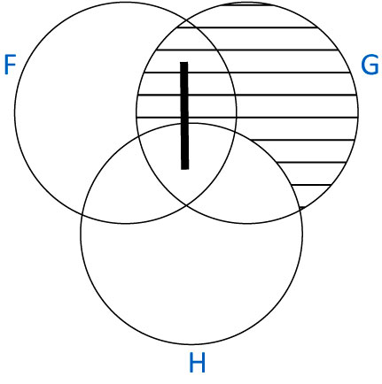
Finally, we need to make (C) false. For it to be false that some Fs are Hs, it must be true that no Fs are Hs i.e., we need to shade out the intersection of F and H.

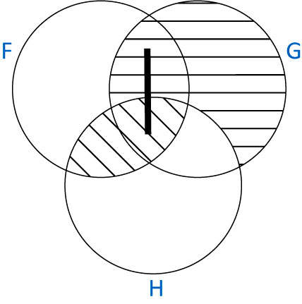

Again, we see that the argument is valid: to make both premises true and the conclusion false there would have to be some object somewhere on the track, and all the cross-hatched regions would have to be empty. But since the track is entirely contained within cross-hatched regions, that is impossible.

That’s really all there is to it. We encounter four basic kinds of sentences in classical categorical syllogisms, traditionally referred to as A, E, I, and O type sentences:

(A) All Fs are Gs.
(E) No Fs are Gs.
(I) Some Fs are Gs.
(O) Some Fs are not Gs.

To represent (A)’s truth, we cross-hatch the parts of F that are outside of G. To represent (E)’s truth, we cross-hatch the intersection of F and G. To represent (I)’s truth, we put a track through the entire intersection of F and G, and to represent (O)’s truth, we put a track through the parts of F that are outside of G.

What about if we want to make such sentences false? Easy. If you know how to represent what makes a sentence true, then you already know how to represent what makes it false. For example, to make (A) true we cross-hatch the parts of F that are outside of G, demanding that those regions are empty. Clearly, to make it false, you draw a track through those regions instead: you demand that there is something contained in those regions instead of demanding that they are empty. More generally, if making a sentence true demands cross-hatching some regions, making it false demands you put a track through exactly those regions. If making a sentence true demands you put a track through certain regions, making it false demands you cross-hatch those regions.

This technique can cover quite a range of categorical arguments including ones that are not of the classical syllogistic form. Consider the following argument:

(P1) All Heavy Fish are Green.
(P2) Some Fish are Heavy.
(P3) Some Fish are Green.

It has a slightly more complicated form than any of our standard categorical syllogisms:

(P1) Everything that is both F and H is G.
(P2) Some F are H.
(P3) Some F are G.

But it’s not too hard to diagram. (P1)’s the tricky one. It says that everything that is both an F and an H is a G. In other words, everything that is in the intersection of F and H is also in G. To represent this, we need to cross-hatch the part of the intersection of F and H that is outside of G:

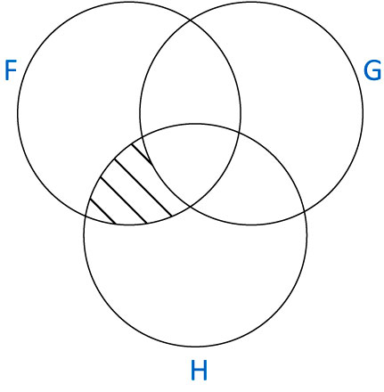
(P2) demands we put a line through the intersection of F and H. Making (C) false demands that the intersection of F and G is empty. So, the completed diagram looks like this:

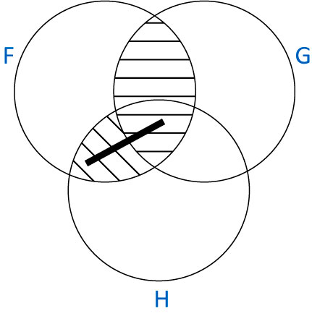
Again, the argument is valid.

- Proving Categorical Syllogisms Invalid with Venn Diagrams

How do we prove arguments invalid using Venn diagrams? Simple. We draw the Venn diagram for the argument exactly as we did before. If we find that the diagram does not contradict itself i.e, there is no track that is entirely contained within regions that have been cross-hatched, then there is a coherent way of making all the premises true and the conclusion false. Indeed, we can just read the counterexample off the Venn diagram. Let’s take a simple example:

(P1) All Fish have Gills.
(P2) Some things with Gills are Heavy.
(C) Some Fish are Heavy.

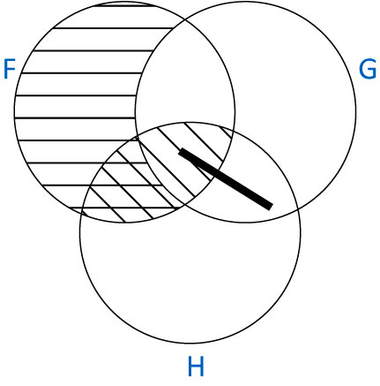
(P1) demanded we cross-hatch all the parts of F that are outside of G. (P2) demanded a track through the intersection of G and H, and (C)’s falsehood demanded that we cross-hatch the intersection of F and G. This diagram differs from all the ones we’ve seen thus far, because it’s coherent. We can make both premises true and the conclusion false, because we can put something on the track and keep all the cross-hatched regions empty. We just have to be careful to put that something on the part of the track that is not inside a cross-hatched region i.e., the thing must be in the intersection of G and H, but outside of F. It must have gills and be heavy, but not be a fish. And in addition, we must of course keep the cross-hatched regions empty. So, here’s our counterexample. Suppose there’s something heavy that has gills and isn’t a fish. Let’s say there is some kind of lizard that is heavy and has gills and isn’t a fish. Let’s also stipulate that all fish have gills and that there are no heavy fish. Those three sentences are clearly coherent and they specify our counterexample: There are fish, they all have gills (P1 true), none of the fish are heavy ((C) false), and there is some lizard with gills that is heavy (P2 true).

Let’s do one final example. We’ll take an argument and figure out whether it is valid or not using Venn diagrams. If it’s valid, the diagram will contradict itself; if it’s invalid, it won’t, and we can construct a counterexample from the diagram.

(P1) All Fs are Gs.
(P2) Some Hs are not Gs.
(C) No Hs are Fs.

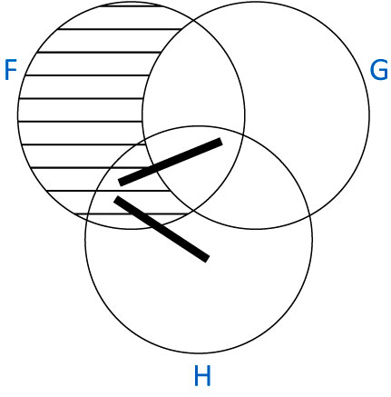
(P1) demands we shade out the parts of F that are outside of G. (P2) demands we draw a track through the parts of H that are outside of G. (C)’s falsehood demands we put a track in the intersection of H and F. Again, we have a coherent diagram. So, the argument’s invalid, and we can construct a counterexample from the diagram.

This time we have two tracks, and we need to put something on each of them, being careful to place each object on the part of the track outside the cross-hatched regions. So, we need something that is an H and is not an F and not a G, and we need something that is an F and a G and an H. Once we demand that all Fs are Gs (i.e., that we keep the cross-hatched region empty, we will have our counterexample. Let’s again suppose F are fish, Gs are things with gills, and Hs are heavy things. Suppose there is something heavy that is not a fish and does not have gills. Say, a heavy lizard without gills. That makes (P2) true. And suppose there is some fish that has gills and is heavy. That makes (C) false. If we additionally require that all fish (including that heavy one) have gills, we’ve made (P1) true also. So, we have our counterexample.

Exercise B.2

Redo the problems in exercise 2.8 using the Venn diagram method. In cases where you find that the argument is invalid, use the Venn diagram you have drawn to specify a counterexample.

