Exercise for Chapter 1 of Revising and Editing for Translators

Exercise 1 Fitness for Purpose

A pair of Giorgio Ricci shoes made in Italy was displayed in a store with the label seen below. Decide the purpose of the text. Then pick one of the three translations of the Italian source and say whether you think it is fit-for-purpose. If you think it is not, underline wordings which should be changed, and be prepared to say why you think they should be changed. Do not make any changes. (An English gloss of the Italian source is shown below the label, along with a more readable version of the three translations.)

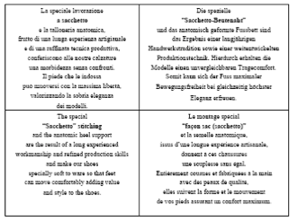
(thanks to Andrew Chesterman, University of Helsinki, for this text)

Gloss of Italian source text
The special working / in “little bag” style / and the anatomical heel, / fruit of a long handicraft experience / and of a refined productive technique, / confer to our shoes / a softness without rivals. / The feet which put them on / can move in the maximum liberty, / giving value to the sober elegance / of the models.

The special “Sacchetto” stitching and the anatomic heel support are the result of a long experienced workmanship and refined production skills and make our shoes specially soft to ware so that feet can move comfortably adding value and style to the shoes.

Die spezielle “Sacchetto-Beutenaht” und das anatomisch geformte Fussbett sind das Ergebnis einer langjährigen Handwerkstradition sowie einer weitentwickelten Produktionstechnik. Hierdurch erhalten die Modelle einen unvergleichbaren Tragecomfort. Somit kann sich der Fuss maximaler Bewegungsfreiheit bei gleichzeitig höchster Eleganz erfreuen.

Le montage special “façon sac (sacchetto)” et la semelle anatomique, issus d’une longue expérience artisanale, donnent à ces chaussures une souplesse sans égal. Entièrement cousues et fabriquées à la main avec des peaux de qualité, elles suivent la forme et le mouvement de vos pieds assurant un confort maximum.

