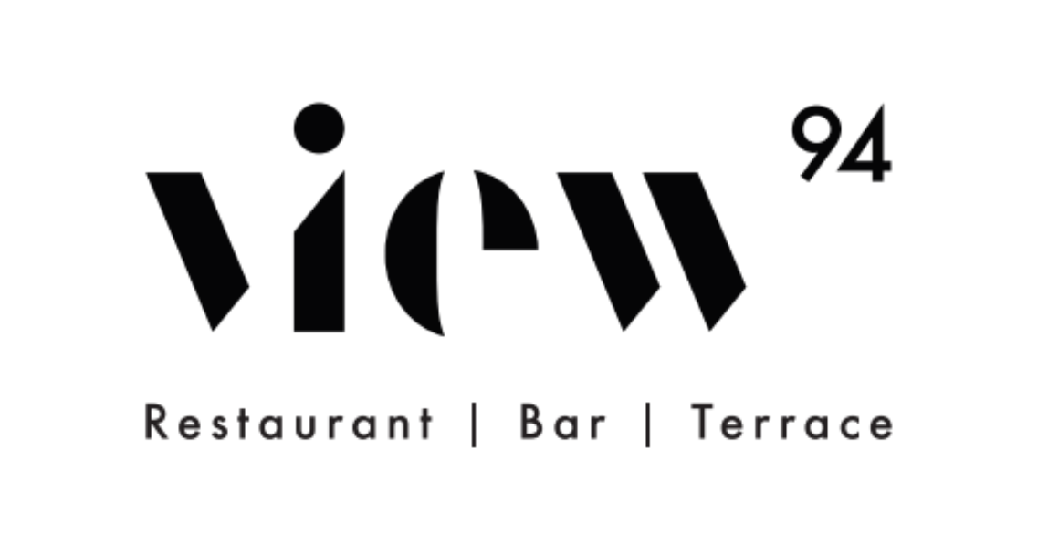

OCTOBER SET MENU
AVAILABLE FOR LUNCH & DINNER
£15PP FOR 2 COURSES

STARTER
PUMPKIN SOUP
OR
POTATO GNOCCHI WITH PRAWNS, GINGER & CARROTS

MAIN
PORK LOIN WITH ROASTED BABY POTATOES, ASPARAGUS & RED WINE SAUCE
OR
GRILLED SALMON WITH ROASTED CAULIFLOWER & LEMONGRASS MAYONNAISE
OR
ROASTED BUTTERNUT SQUASH LASAGNE

DESSERT
FONDANT BLACK FOREST WITH VANILLA ICE CREAM & SOUR CHERRY COULIS
OR
SOUP OF FRUITS

Discretionary service charge of 12.5% 94 Point Pleasant SW18 1PP tel. 02084259870 F:@view94ldn T:@view94ldn Insta: View94ldn
www.view94.com

