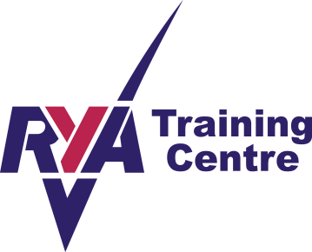


2016 Membership Application Form
Individual £32 Family £65 Junior (U18) £15 Social £10 Life £480

Membership Type | Membership No  (if known & renewing)
Name(s):
(For Family memberships please list here and complete a separate consent form for each under 18)
Address (including postcode):

Email:

Contact telephone number:
Name and telephone number of person to be contacted in an emergency:
Age ( if under 18):

Boat/s class, sail no, name:

Signed ……………………………………………………………………………….. Date ……………………………………………………..

NB: Junior members (including those under ‘Family’ category): a separate parent/guardian consent form MUST be attached with this membership form - PSBSC cannot accept juniors at any Club activity without this.

Membership Form | Complete and send to J Bullivant, Membership Secretary, PSBSC, Glenrowan, Erbusaig, Kyle of Lochalsh IV40 8BB or judithbullivant@googlemail.com
Payment: | Please tick method of payment - for ease of Club administration, standing order or BACS are preferred but cheque or cash also accepted.
Standing order | Complete standing order form (on web-site) and return to your own bank
BACS | Sort 83-24-09 – account 00235517
Cheque | Made payable to ‘Plockton Small Boat Sailing Club’
Cash | Hand to membership secretary

Data Protection: PSBSC will store membership details electronically for administrative purposes but will not release any information to third parties. Please contact the Club if you do not consent to this.

