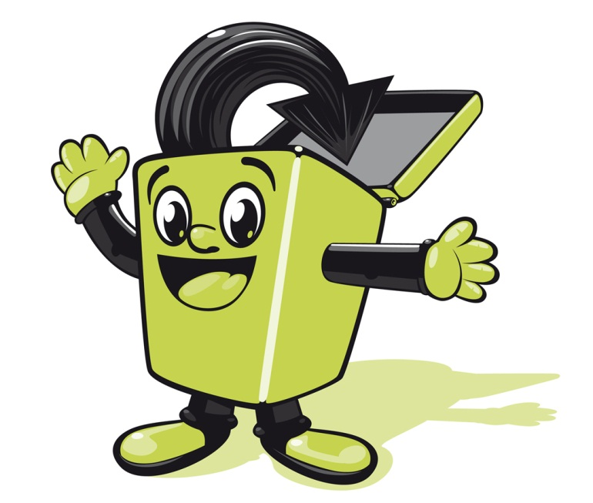
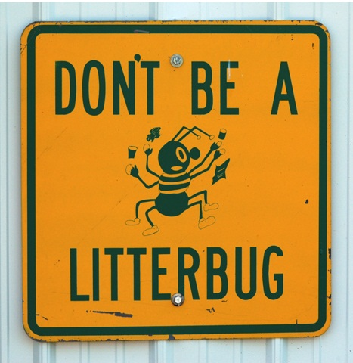
Litter Rules

WE CAN EAT:
- Outside
- In the GP Room during lunch time
- In the canteen during lunch time/indoor wet weather playtimes
- In the infant resource areas during indoor wet weather playtimes

WE CAN’T EAT:
- In corridors
- In cloakrooms
- On stairs
- Under stair wells

OUR LITTER TARGETS:
- Listen to the litter prefects who encourage you to keep the school litter free
- Put your own litter in the bin
- Pick up any rubbish you see, bin it and then wash your hands!
- Put apple cores and banana skins in horse buckets to be collected by Maggie from the playground
- Put paper, card and plastic bottles in the “Blue Bin” containers

CONSEQUENCES FOR LITTERING THE SCHOOL:
- Lose extra playtime on a Friday

