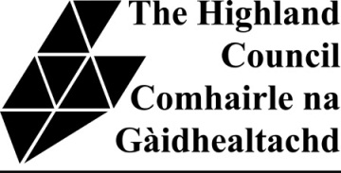
Understanding your child’s Profile and report
This guidance for parents / carers relates to the Highland Council Primary School Reporting Format for 2013. The Profile and Report give information about your child’s progress, performance and achievements across the curriculum and in the four capacities - successful learner; responsible citizen; effective contributor and confident individual.

Page 1
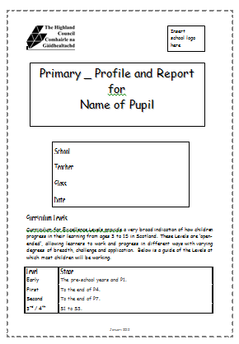
The first page shows the details of your child, his / her teacher and the school.
It also shows Curriculum for Excellence (CfE) levels that most children should be working at. The levels are open ended and allow children to progress in different ways. If your child is not working within the appropriate level then this will be reflected in the teacher’s comments.

Profile / Learner’s statement

Page 2
The second page combines a “Profile and Learner’s statement”. This is your child’s view of his / her learning and achievements throughout the year. Children are encouraged to reflect on their progress in their learning and their achievements.

Page 3

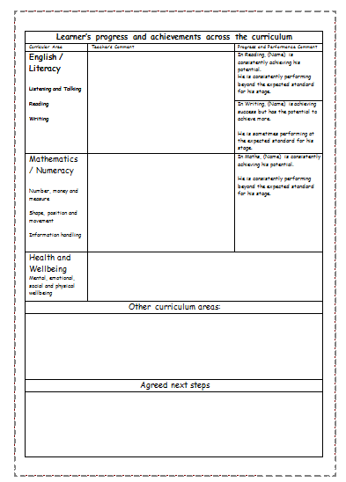
This page contains information about your child’s progress across the curriculum.
Literacy, Numeracy and Health and Wellbeing are priorities across Scotland so they have their own statements.
On the left hand side there is a comment written by your child’s teacher.
On the right hand side there are comments from a Highland-wide comment bank about how your child is progressing in relation to his /her potential and how your child is performing in relation to the standards expected for their age/ stage. This is explained in further detail below.
In this box the teacher comments on selected areas of the curriculum from Religious Education, Science, Expressive Arts (Art & Design, Dance, Drama and Music), Social Studies (people, past events and societies - people, place and environment - people in society, economy and business), Technologies and any other languages your child is learning.
At the bottom of this page will be your child’s agreed next steps in learning.

1 Whether your child is working to his/her full potential.
Your child’s teacher makes a professional judgement about this using a full range of evidence. The report shows one of the following four comments for reading, writing and maths.
is consistently achieving his / her potential | is achieving success but has the potential to achieve more | is only sometimes achieving his / her potential | is yet to achieve his / her potential

- Whether your child is performing compared to where he/she should be for his/her age and stage.
The second comment tells you about how your child is performing compared to where he /she is expected to be for his/her age and stage. Most children will have one of the following two comments for reading, writing and maths:
is consistently performing at the expected standard for his / her stage | is sometimes performing at the expected standard for his / her stage
Curriculum for Excellence allows all children to progress at their own pace. Sometimes children will be working beyond or behind the expected standard for their stage. If this is the case, schools will be providing extra support or challenge for your child and this will be reflected in the teacher’s comments:
is consistently performing beyond the expected standard for his / her stage | is not yet performing at the expected standard for his / her stage

Page 4
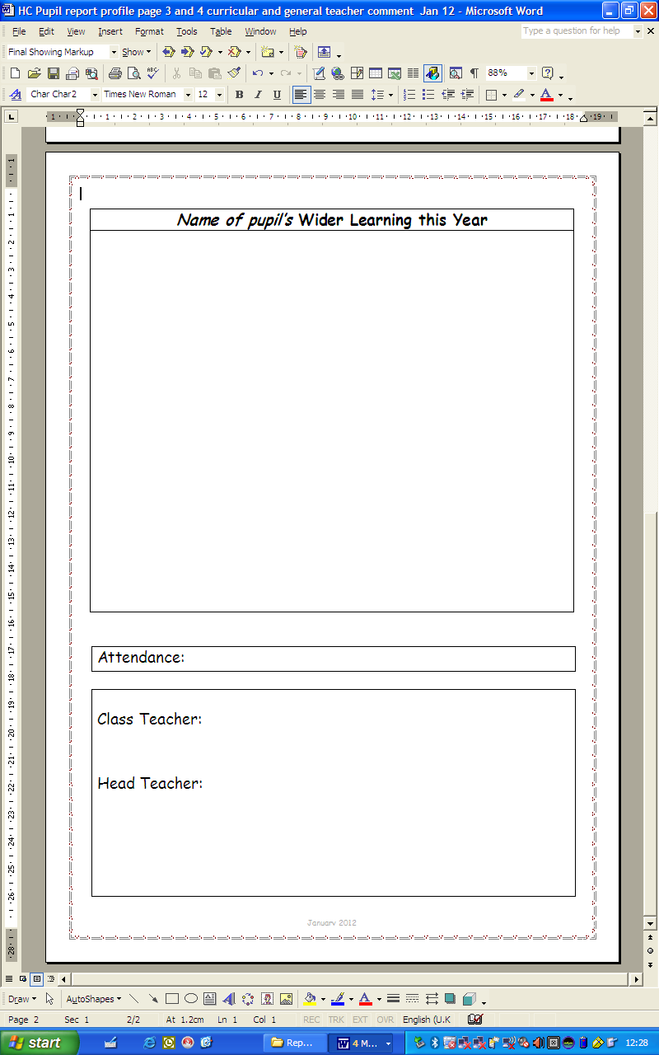
This contains the teacher’s comments about your child’s learning this year. It may mention academic work but will also include the wider aspects of your child’s achievements, both in and out of school.
Attendance is taken from the school’s electronic registration system and may be attached as a separate sheet.

Parents’ Comment sheet
Along with your child’s report, you will receive a parents’ comment sheet. This is for you to comment on your child’s report and schools are eager to know your views. You may want to use this sheet to comment on the following:
- if you feel the report reflects your understanding of your child’s progress at school or if you have any concerns
- how you feel you can help with your child’s agreed next steps
- provide any additional information about your child’s achievements that the school may not know.

If you have any concerns or questions about any aspect of your child’s report and profile, please do not hesitate to contact the school.
To request any of our information in an alternative format e.g. large print, Braille, CD, audio tape or suitable language, please contact the Head Teacher of your child’s school.
If you would like further information about Curriculum for Excellence then you may want to visit the Parentzone website. http://www.ltscotland.org.uk/parentzone/index.asp

