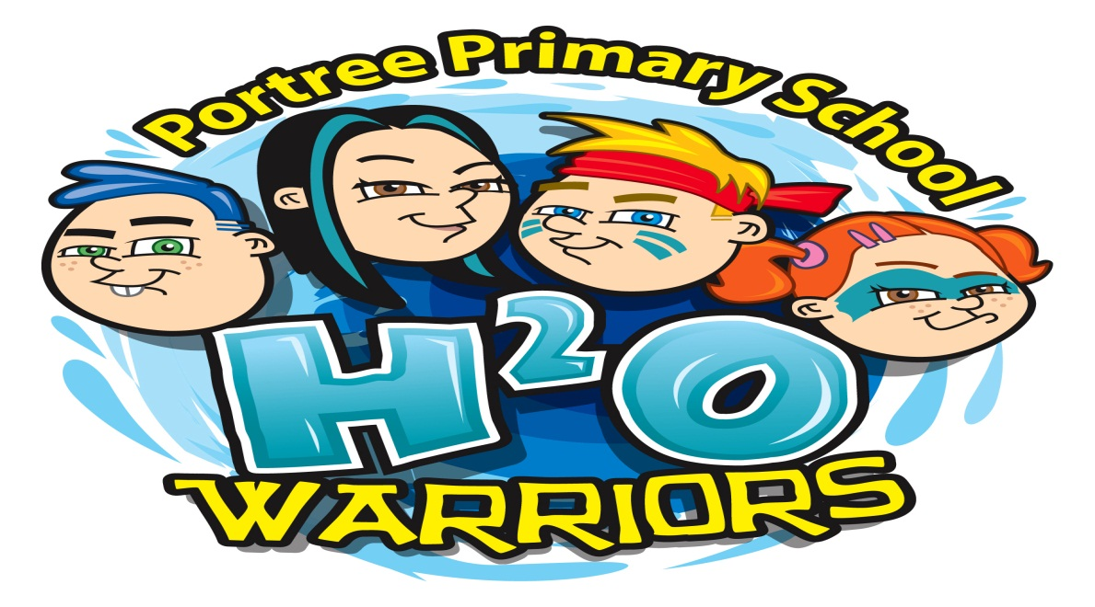
OUR MISSION STATEMENT

- We will work hard as a team to achieve our goals.
- We will raise as much money as possible to help children in India have access to clean water.
- We will be organised, creative and enterprising in what we do.
- We will communicate with pupils and parents our plans and be ready for anything that crops up.

