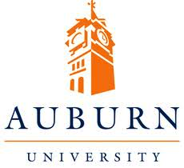

Who do you think you are?
Place-based learning research project looks at different approaches in Scotland, Norway) and Alabama (USA)

Place based learning is an approach to education that is rooted in local communities and seeks to build better understanding and more effective relationships between schools and other services and the communities they serve. But what does community mean and how do children, young people and other community members see this?

The survey will contribute to a two –year project begun in July 2012, examining the different approaches being taken to place based learning in Alabama, Norway and Scotland. It will help researchers from Alabama, Norway and Scotland develop a better understanding of how schools and other services can engage more effectively with the communities they serve.
There are two surveys – one for young people aged ten – eighteen years https://response.questback.com/nordlandsforskning/ufe1gw2azr and
one for adults https://response.questback.com/nordlandsforskning/8esq8bfbll

The surveys are intended for children and young people at school between the ages of 10 and 18, older students, parents and other family members including grandparents, teachers, school principles, volunteers, and all those providing or responsible for services for young people.

The survey in Scotland is facilitated in the Highlands and Islands by Highland Council and its partners. It will only take a few minutes to complete online. The data collected through the survey will be treated to ensure that each respondent is anonymous.

The researchers are :
Professor Bronwen Cohen, University of Edinburgh bronwen.cohen@ed.ac.uk

Dr. Wenche Rønning, University of Nordland
Dr. Jack Shelton and Dr Jennifer Adams, Pacers and Auburn University, Alabama

The research is funded by the Kettering Foundation

For further information contact Jim.Steven@highland.gov.uk

