MEMBERS OF THE PUBLIC ARE INVITED TO ATTEND

PLANNING MEETING

Monday 5th December 2016 in the Village Hall at 7pm

AGENDA

1. APOLOGIES FOR ABSENCE

- DECLARATION OF MEMBER’S INTERESTS/DISPENSATION APPLICATIONS

3. PLANNING APPLICATIONS
To consider a response to the following planning applications:
PA16/10569 Land off Greenwith Hill, Perranwell Station
A small agricultural building for servicing the 1.87Ha field
PA16/11097 Tullimaar, Perranarworthal
Listed building consent for the installation of fire alarm system
PA16/10898 5 Goonvrea, Perranarworthal
Works to two Quercus cerris/Turkey Oak, 4122 and 4123 as per survey provided

4. CORNWALL COUNCIL PLANNING DECISIONS

5. ANY OTHER PLANNING BUSINESS

6. NEIGHBOURHOOD DEVELOPMENT PLAN

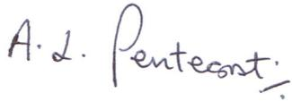
- L.Pentecost
Parish Clerk 1st December 2016

NB Applications received after publication of this agenda may be discussed, please contact the Clerk for confirmation.

