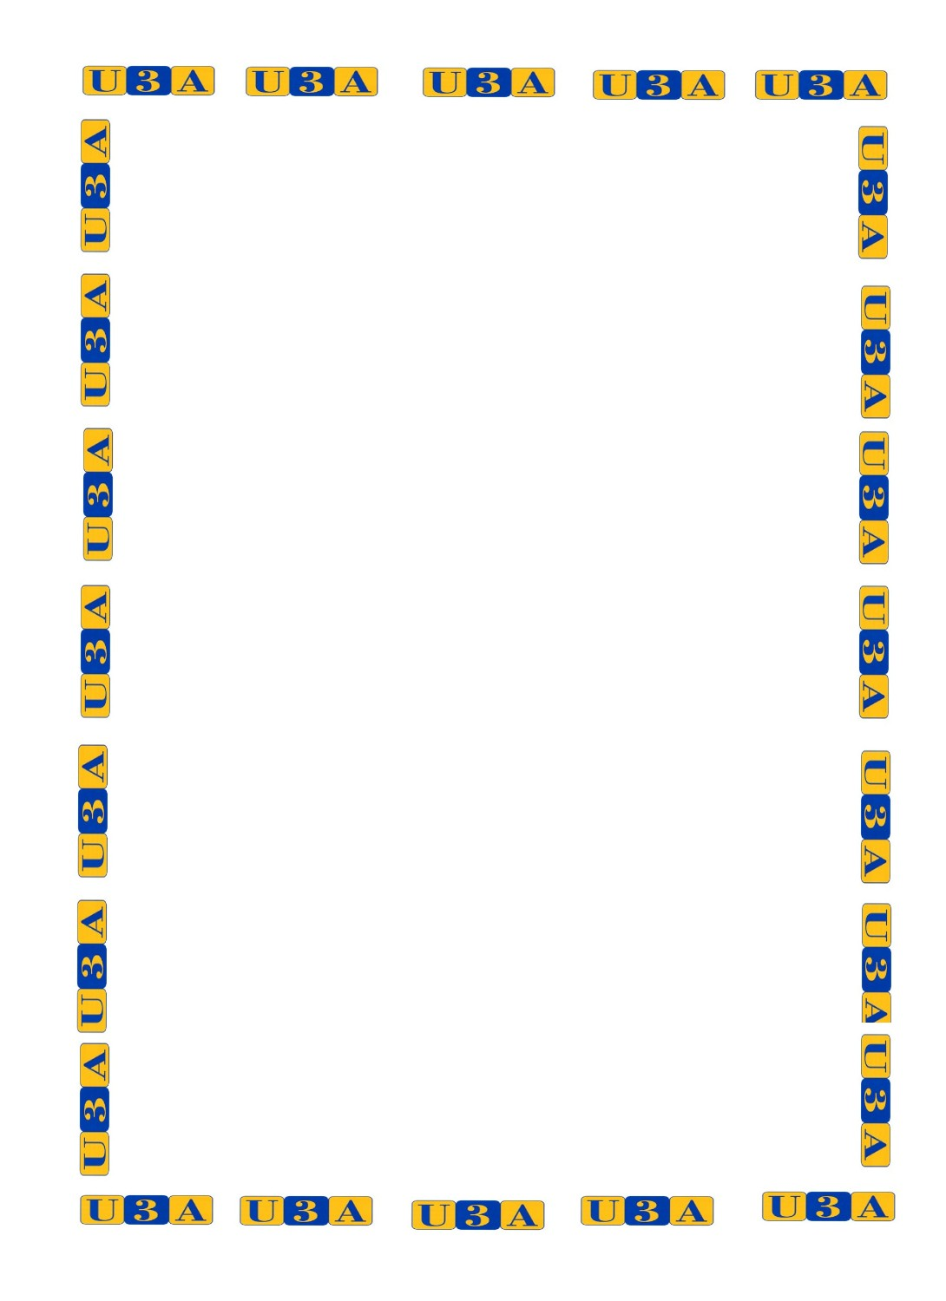
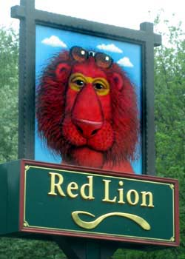
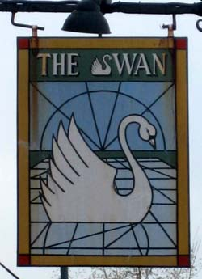
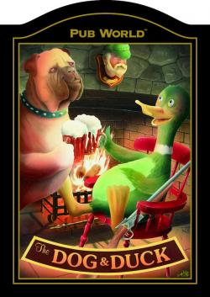

Thursday 6th October
At Draycott Memorial Hall 2.15pm

A History of Inn Signs
by John Fenner

Admission £1.00 on the door includes tea & biscuits

What’s in a Name? Where there’s an inn, there’s a name and a story. This talk, with the aid of real inn signs, aims to give a brief insight into the variety of the names and how they developed.
John is an avid collector of old inn signs, the largest of which is 6 feet by 4 feet, has a collection of over 100, and has been involved with several prestigious exhibitions in the past

For information see www.cheddarvalleyu3a.org.uk

