**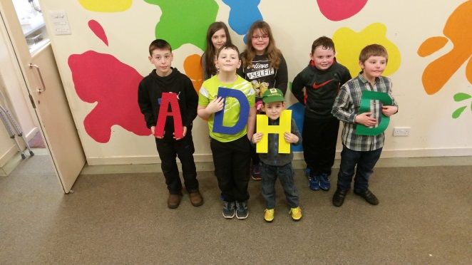  
Caithness**

Would you like to meet other families with children who have ADHD?

We are a new group who are meeting up monthly at the Thurso Youth Club.

At our first meeting on the 13th March the children had great fun making pizza’s and eating them ………Yum yum.

While the pizzas were cooking the children had fun playing pool, air hockey and dodge ball. The children also made up a wish list of activities they would like to do, and we all agreed on some ground rules, the most importing one being ….having fun☺

As parents all going through the same things it would be great to support each other and have fun times.

The children can also help each other as the older ones will be able to share their experiences with the younger ones. This would be great for the older ones as it will boost their self-esteem helping them to feel valued.

We are able to seek advice from other professionals. Chip+ are excited and support the group. They are helping to promote us through their own facebook, twitter pages and web site.

We have our own facebook page ADHD parental support Caithness. We aim to keeping this page for families of children with ADHD.

If you are interested please contact me on [nicolle.tait@btinternet.com](mailto:nicolle.tait@btinternet.com) or Tel no. 07917116984 or come along to our next session on the 10th April, 2pm – 4pm, Thurso Youth Club

The children decided on a junk modelling competition and a pamper session as well as playing pool etc.

LETS HELP TURN ADHD INTO SOMETHING POSSITIVE!

Nicolle Bremner

13/03/16