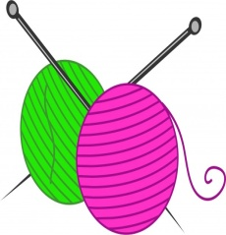

Nairn Crafty Carers

Meeting at the Wool Shop on the Brae in Nairn

First & third Wednesday of every month

9:30am - 11:30am

£3, includes tea, coffee and cake

(payable to Marie at the shop)

Bring your own project, knitting, crocheting etc and come along for a natter.

This is open to all carers, whether you are looking after elderly parents, spouses or your children, and will hopefully give you a place to relax and be crafty.

For further information please contact Sarah on 07799890864 or Vicky on 07885521710.

First few dates are March 4th and 18th, April 1st and 15th, May 6th and 20th, June 3rd and 17th.

