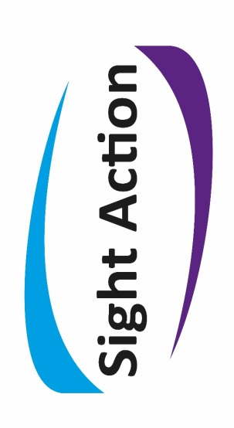

Working to make life better for blind and partially sighted people

sight action news

**Summer 2016 Edition**

Supported by the Highland & Islands Society for Blind People

Hello from all of us here at Sight Action. This edition includes information on a new service available to clients at Raigmore Hospital, our VIP walking group outings, some details and advice on using contactless bank card payments, our BT Telephone Hub and talking book library service and some other upcoming events and points of interest!

**SIGHT ACTION’S ROADSHOW SCHEDULE**

As you will see from the information below, Sight Action, in conjunction with the Scottish War Blinded, is holding a series of roadshows again during June.

**Monday June 6th Wick 10.00 – 12.00 Library**

**Thurso 2.00 – 4.00 Library**

**Melness 5.00 – 6.00 Village Hall**

**Tuesday June 7th Kinlochbervie 10.00-12.00 Ceilidh Hse**

**Lochinver 2.00-4.00 Lochinver Centre**

**Wednesday June 8th Lairg 10.00 -12.00 Community Centre**

**Brora 2.00 – 4.00 Learning Centre**

**Thursday June 9th Dornoch 10.00 – 12.00 Library**

**Alness 2.00 – 4.00 Library**

**Friday June 10th Nairn 10.00 – 12.00 Library**

**Aviemore 2.00 – 4.00 Library**

**Monday June 13th Portree 10.00 – 12.00 Library**

**Kyle of Lochalsh 2.00 – 4.00**

**Kyle Medical Practice**

**Tuesday June 14th Mallaig 10.00 – 12.00 Library**

**Fort William 2.00 – 4.00 Library**

**Wednesday June 15th Kinlochleven 10.00 – 12.00 Library**

**Ballachulish 2.00 – 4.00**

**Abbeyfield Nursing Home**

**Thursday June 16th Fort Augustus 10.00 – 12.00**

**Memorial Hall**

**Grantown on Spey 2.00 – 4.00 Library**

**Friday June 17th Dingwall 10.00 – 12.00 Library**

**Fortrose 2.00 – 4.00 Library**

**Monday June 20th Ullapool 10.00 – 12.00 Library**

**Gairloch 2.00 – 4.00 Library**

**Please contact us if you have any queries about the roadshow**

**_____________________________________________**

**EYE CLINIC SUPPORT WORKER**

SIGHT ACTION is happy to announce that MARK FORSBURY is now in his new post as “Eye Clinic Support Worker” at Raigmore Hospital. This is a pilot scheme initially for one year covering the Macular Clinics.

The post was created by NHS Highland and the Scottish Government to bridge the gap within the Eye Clinic system between point of diagnosis and support services. Mark will assist people of all ages, and their carers, providing information and support.

Mark will be in the Raigmore Eye Clinic every MONDAY and WEDNESDAY.

We, at SIGHT ACTION, are confident that people will find this to be a valuable new service on offer to our community.

**VISUALLY IMPAIRED WALKING GROUP**

Do you enjoy walking and discovering our beautiful Highlands? If you have a problem with your vision or a volunteer you are all welcome to join us on the first Tuesday of every month for a day of fun, discovery, laughter and good banter with like-minded people. A number of sighted guide volunteers will also normally be in attendance for those who require them.

Here follows a little example of the sort of outings we intend on doing:

Loch Torridon walk;

Depart from Morrison’s Inverness carpark at 9.30 am. The drive to Torridon takes at least 1 hour 30 mins, hence the early start. The walk begins at the Loch Torridon hotel just past Annat.



Distance – 7 km more or less, as we see fit on the day.

Ascent – 0 metres

Time – depending on the weather, if the sun is shining we may never leave…

We have to retrace our steps anyway. Basically we walk towards Shieldaig and back when we fancy. This is part of a very well known coastal walk from Torridon to Shieldaig. The view towards Beinn Alligin and its horns is astonishing, but even if the view is not available on the day, the calmness of the surroundings invades your soul and makes you smile.

And hopefully we'll finish with a nice cup of tea at the hotel..!

A small contribution of £3 is asked for to help towards fuel costs for our walking trips. We would love to grow our numbers for these great trips and with the summer (hopefully) just around the corner, come and give it a go!

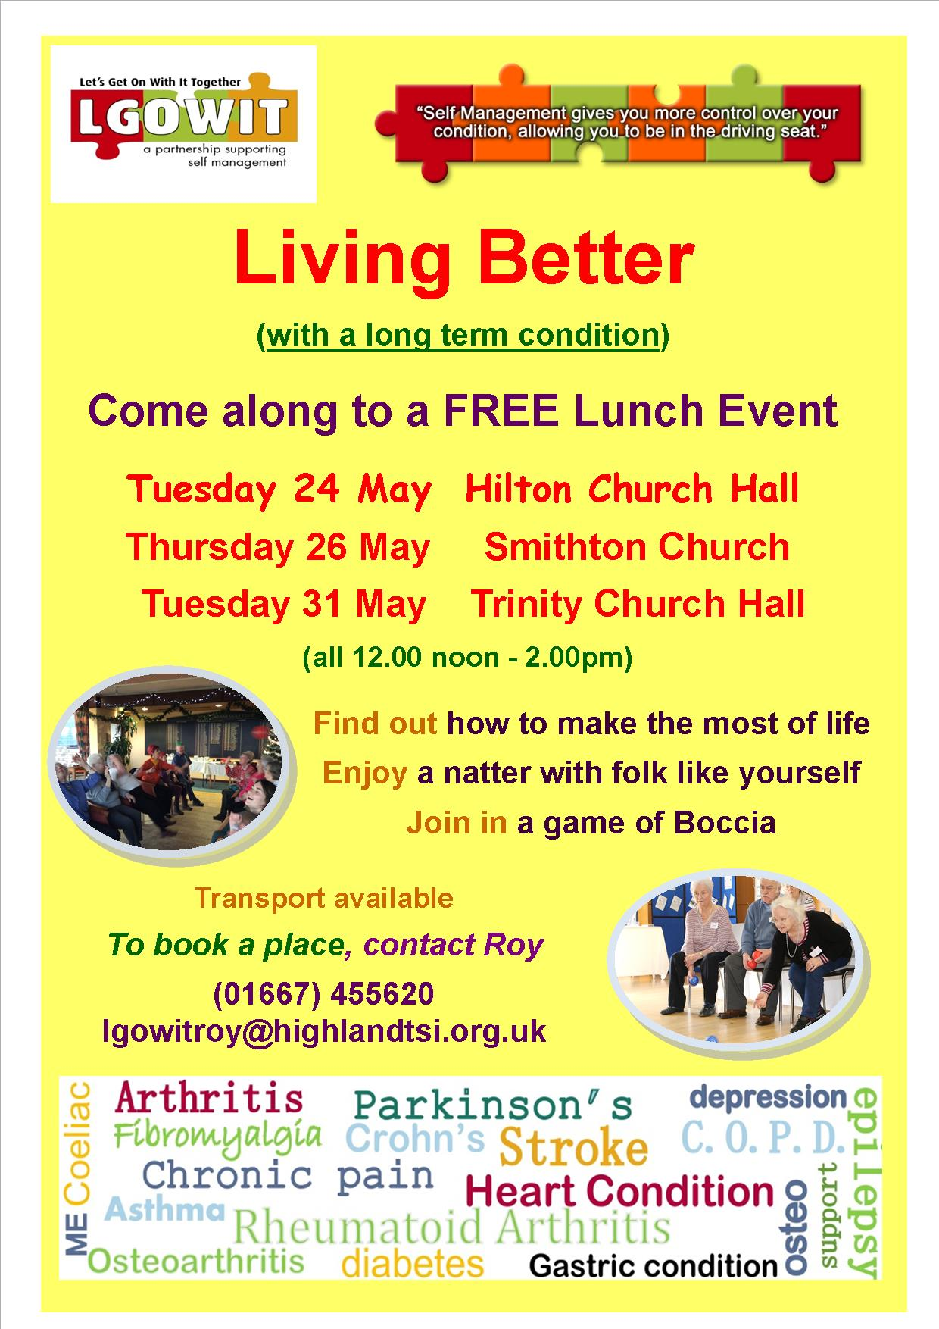

**CONTACTLESS CARD PAYMENTS**

**What is Contactless?**

Contactless is a function on certain debit, credit and prepaid cards that allows you to make a quick and easy payment for goods or services for an amount that is £30 or less without entering a PIN code.

Where you see the contactless wave displayed (like the one below) and have a contactless card (debit, credit or prepaid), you can make a contactless payment where the amount is £30 or less.

All you have to do is place your contactless card over the card reader to make the payment



**How do I know if I have a contactless card?**

Take a look at your card, if there is a logo (like the one shown), it means that you have a contactless card and can use it in any of the high street shops or outlets listed below.

**Where can I use my contactless card?**

If you have card that has contactless enabled on it, there are many high street shops that will take this type of payment.

**The following of our member organisations have issued contactless cards:**

* American Express
* Barclays (Barclays Bank and Barclaycard)
* Capital One
* Clydesdale Bank
* Co-operative Bank Plc
* HSBC
* Investec Bank
* Lloyds Banking Group (Lloyds and Halifax)
* Nationwide
* Santander
* The Royal Bank of Scotland Group (Natwest and RBS)
* TSB Bank

**What’s good about having a contactless card?**

**There are loads of reasons why paying with contactless is so good:**

* There’s no need to have the correct change.
* There’s no need to mess about entering your PIN code into the terminal every time. Occasionally you may be asked to enter your PIN, as a routine security measure to ensure it is still you in possession of the card.
* There’s no need to queue for as long; contactless speeds up the time it takes to make a payment.
* It reduces the need to find a cash machine or carry cash with you.
* There’s no need to carry an additional card – contactless functionality can be provided on a standard credit, debit, charge or prepaid card.

**DINGWALL CLUB**

The Sight Action Support Group in Dingwall reformed in 2014, details of which were circulated to everyone within the catchment area (Muir of Ord, Maryburgh, Strathpeffer etc.) inviting them to attend the initial meeting. We want to provide activities, events and outing which would be attractive and encourage attendance. There are about 35 people in this area so we had hoped to get at least half along to the Dingwall Community Centre.

Since then we have met on the last Thursday of each month (with the exception of January) from 2:00pm – 4:00pm, starting with tea and cake followed by a series of really interesting talks. Last July and August two groups went separately on the Seagull Trust Cruise on the Caledonian Canal and these proved very entertaining and successful. This summer we will repeating the trip on July 28th leaving Dingwall Community Centre at 1:15pm using Sight Action’s mini-bus. So anyone who is interested in this trip please get in touch!

We are a cheery welcoming group and would love to see a few more people attending – there is a small charge of £2.00 to help towards the costs.

Do give it a try or let us know what you would like us to organise and we shall do our best to oblige.

**VISION SUPPORT GROUP MEETINGS**

**AVIEMORE**

**When** Variable

**Where**

**Time** 2.00 – 4.00

**Contact** Joy Roberts – 01479 812456

**DINGWALL**

**When** 3rd Thursday of the month

**Where**     Dingwall Community Centre

**Time**        2.00 – 4.00

**Contact**   Sarah Shaw – 01463 233663

**GRANTOWN ON SPEY**

**When** 1st Wednesday of each month

**Where** Grant Arms Hotel

**Time** 2.00 – 4.00

**Contact** Peter McLaughlin - 01381 621572

**INVERNESS Chat Club**

**When** Meets every Friday

**Where** Various locations

**Time** 9.30 – 4.30 (includes being picked up and returned)

**Contact** Margaret Johnson – 01463 222527

**INVERNESS Daytrippers**

**When** 1st Wednesday of every month

**Where** Various locations

**Time** 10.00 – 4.30 (this includes being picked up and returned home)

**Contact** Sarah Shaw – 01463 233663

**INVERNESS Walking Group**

**When** 1st Tuesday of every month

**Where** Various locations

**Time** 10.00 – 4.30 (this is dependent on where the walks are taking place)

**Contact** Sarah Shaw – 01463 233663

**LOCHABER**

**When** 3rd Thursday of each month

**Where** Various venues

**Time** 2.00 – 4.00

**Contact** Catriona Menzies - 01463 233663

**NAIRN**

**When** 1st Tuesday of each month

**Where** Queenspark Gardens Sheltered Housing Complex

**Time** 2.00 – 4.00

**Contact** Bob Stewart – 01667 454101

John Mathieson – 01667 453508

**SKYE AND LOCHALSH**

**When** 3rd Thursday of each month

**Where** Various venues

**Time**  2.00 – 4.00

**Contact** Donald John MacLeod – 01599 522207

**THURSO**

**When** 1st Wednesday of each month

**Where** British Legion Hall

**Time** 2.00 – 4.00

**Contact** Edward Fraser – 01847 893391

**BT TELEPHONE HUB**

SIGHT ACTION has been a recognised BT HUB for six months. BT has supplied a wide selection of telephones to enable us to help visually impaired users in the Highlands choose a suitable telephone system. There are many features we can choose to have these days – some examples include:

* Cordless with keypad in the handset or a wall-mountable corded phone – both allow numbers to be seen close up.
* Keypad “beeps” so you know the right button has been pressed.
* Loudspeaker so your hands are free to make notes.
* Large, well-spaced keys with good contrast between background colour and number.

If you find it hard to pick up a phone handset, or hold it to your ear for a long time, it might help to try a different phone. You can do this by coming along to SIGHT ACTION and try the different phones we have on display. Call us on 01463 233 663, ask for Catriona, make an appointment to come in and have a look at the phones we have – do bring a relative or friend if it would help.

BT also offers services such as FREE 195 Directory Enquiries for customers who are unable to use a printed directory.

We look forward to hearing from you.

**TALKING BOOK LIBRARY**

You may be living with a visual impairment but you can still enjoy a good book! Let SIGHT ACTION’s Talking Book Service help you.

A team of five volunteers has been responsible for improving the service and are now able to offer a catalogue of over 740 books to suit everyone’s taste available on request – the catalogue itself comes as an audio recording or, if you prefer, a hard copy. Children’s and Scottish catalogues are currently being compiled.

Once a title has been chosen, contact Susan Fiddes or Belinda Gilbert at SIGHT ACTION, make your choices and you will receive a USB memory stick in a bright yellow pouch. Once you have listened to the book return the memory stick in the same pouch – no postage necessary. We aim to turn around requests in 2 - 3 days. To use the memory sticks users require either a BOOM BOX (listening box) which can be supplied by SIGHT ACTION, or a Roberts Concerto 2 Radio. Alternatively, for those using a computer, the stick is compatible with all main media-playing software so will work on most PC’s. Susan is happy to demonstrate the memory stick and Boom Box to all new users of the service.

SIGHT ACTION is grateful to all those who have donated titles to the Library and we still welcome all donations of audio books on CD.

So, do give YOUR Library a try – we would love to hear from you!

**SEEING THEIR WAY TO RETIRING!**

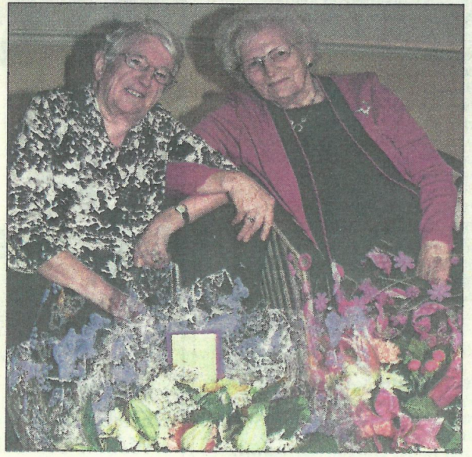

Evelyn Grant and Margaret McCulloch Have run a support group for the visually impaired for 17 years in Grantown and the surrounding area. This month they both finally decided to take things a little easier and retire, duly given a great send-off at the Grant Arms Hotel. They will be missed by all of us at Sight Action and everyone who has used the group. Support groups are an essential part of coping with low vision, a place where people with similar difficulties can get together, share knowledge and experiences, go on outings together and have speakers give informative presentations about community issues. We’d like to thank them for their years of commitment to the cause and wish them well for the future.

easyfundraising.org.uk

**easyfundraising.org.uk** is a great way to raise money for charities, including us at Sight Action, just by shopping online. You don’t pay anything extra. So far they’ve raised over **£9 million** for causes throughout the UK.

**How it works –**

**1. Start at easyfundraising.org.uk website**

Let's say you want to buy a pair of shoes from John Lewis. Instead of going to johnlewis.com directly, you would first go to easyfundraising.org.uk.

**2. Make a purchase**

From the easyfundraising website, click through to John Lewis to make your purchase. This tells John Lewis you came from easyfundraising. The price of the shoes is exactly the same.

**3. Get a donation**

After you buy your shoes, John Lewis will give you a cash reward that you can turn into a donation for your good cause. easyfundraising collect this and send it on at no extra cost.

**4. Get the easyfundraising Donation Reminder**

You can skip steps 1 and 2 with the easyfundraising Donation Reminder. Just click the reminder when you shop to receive any eligible donations. You’ll never forget a free donation again!

As always..

**You can contact Sight Action via -**

**Telephone: 01463 233663**

**Email: admin@highlandsensory.org.uk**

**Website:** [**www.sightaction.org.uk**](http://www.sightaction.org.uk)

Opening times: Mon – Thurs, 9pm - 5pm (Friday until 4pm)

_____________________________________

**NEWS**

**Car parking -** is limited here at our base at Beechwood. We do have 2 guest parking spaces, however, if unavailable, car parking is available nearby. Please do not hesitate to get in touch for more information.

[**www.sightaction.org.uk**](http://www.sightaction.org.uk) – Sight Action has a new website. Please do take the time to have look and let us know if you like it.

**Sight Action’s Minibus –** We are very grateful to **BIRRELL’S (MOT & Service Centre Ltd),** 3 Carsegate Road North, Inverness IV3 8DU for very kindly undertaking to have a look at the vehicle to see if the back hoist can be mended. Unfortunately it cannot be repaired and will be removed from the back of the vehicle.

