The Pines invites children with autism and their families to:

Storytime 2017

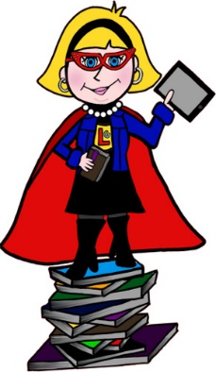

**Tuesday 7 March 2017**

**Tuesday 30 May 2017**

**Tuesday 14 November 2017**

**5.30pm – 7.00pm**

**Come along and listen to some stories with an autism focus. These lovely events are suitable for young people who are attentive to stories and have a language understanding which will enable them to enjoy the experience. ALL AGES WELCOME - teenagers enjoy this too!**

The Pines, Drummond Road, Inverness, IV2 4NZ

**Bring a picnic tea** (Nothing with nuts please in case of allergies)

**Booking essential** – please call Tricia Norton on

01463 720056 or email [highland.informationofficer@nas.org.uk](mailto:highland.informationofficer@nas.org.uk)

We hope you can join us!

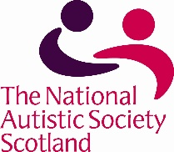

Supported by the National Autistic Society Scotland