

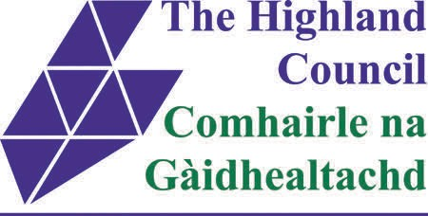**CHILDREN’S DISABILITY SERVICE - South**



**An Update**

**February 2014**

**BIG PICTURE**

“Change, the one true constant”.

The Children’s Disability Service has been changing quite a bit in the last 2 years and this update will mainly cover the South service which continues to be managed by Jonathan Turner with wider disability issues still being co-ordinated by Marlyn Campbell based at the Pines as the Development Officer for Disability.

The joining of Health and Social Care has strengthened the service with an increased number of Health focused staff being within the Service which is good news.

For services outside of the South area, there are still many disability dedicated workers based in children’s service teams e.g. Lochaber, Skye and Drummuie offices.

There are also still a number of staff at the Conon Family Resource Centre to cover the work in the Mid area under the Mid service management team.

**ACCESS TO THE SERVICE**

We have now been working with the Getting It Right for Every Child model for some years

and this is still the basis for how the services will assess need and try to support families. If a child has an additional need, the Service most involved is probably known as the Named Person or Agency and a plan should be drawn up to meet the needs. . If it is thought that a specialized or targeted Service may be required, the Named Person (quite often the school) should talk with the Integrated Service Officer (the ISO) who has access to certain additional resources and has knowledge of what all the services do. If the ISO believes the

need is beyond their Early Intervention Support and there is a clear and complex

disability, they will speak to the Team Manager for the Disability Service and this should lead to agreement about what happens next. The family will then be informed whether the Disability Service can become involved.

There will be further changes in the way that services work in the coming months with some new job titles and functions but the changes have been made to ensure that Health and Social Care are working even more closely together.

**CURRENT SITUATION FOR THE SOUTH TEAM**



The South service is now working steadily with around 200 children with additional needs such as learning disability, autism and cerebral palsy.

Unfortunately, a specialized Disability Service cannot engage with all children with additional needs and so we link, of course, to many other creative and supportive services such as Educational Psychology, Speech and Language Therapy, Paediatricians, Occupational and Physio-Therapists, the CAMH Service - so children with complex needs do have a range of services which can meet their needs.

**WHAT WE DO**

Previously, we have noted the range of staff who work for the Service and this mix of people has not changed. You may have heard of roles like Social Worker, Autism Practitioner, Learning Disability Nurse, Family Key Worker, Senior Community Children’s Worker, Children’s Service Workers focused on schools and Support Workers. These posts are allocated to families because of the varying needs that we come across. In all areas, such posts continue and Team Managers look for their staff to do the following:

•  Problem solve to find practical solutions to difficulties.

•  Support and facilitate communication in multi-agency teams.

•  Link with money advisors and the Benefits Agency.

•  Registered Social Workers will pick up on Child Protection matters, investigation work cases where there is involvement of the Authority Reporter and where children are Looked After.

•  Give advice on Autism, link to Autism Services and/or consult with our own Autism

Practitioners.

•  Advise and work on sleep, continence, diet and challenging behaviour, especially via our nursing colleagues.

•  Raise themes and issues of unmet need and particular challenges arising from disability with Service Managers and Policy makers.

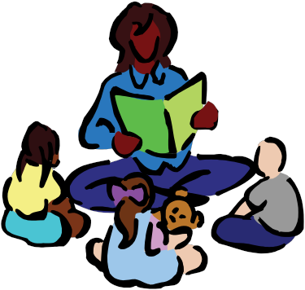

**SUPPORT AND RESPITE**

One of the most common requests to the Children’s Disability Service is for Support and Respite. The most important thing to say about this is that the basis of allocation of any resource is assessment of need. Recommendations may come from Child Plans completed by inter-agency groups and we may lead on the assessment or be a partner to the Child Plan but the nature of the support required must be clearly stated in the Child Plan.

Once conclusions are reached about levels of support, the Children’s Disability Service

uses experience and knowledge of resources, in a phased way to address need. The types of Services we consider include:

•  Meeting Playgroup/Nursery costs for low income families.

•  1:1 support within mainstream after-school clubs.

•  Specialized after-school and out of school providers e.g. SOAR, SCY, SNAP, Nairn

Play and Leisure Scheme.

•  Carr-Gomm and home-based respite Services.

•  Social Skills Group (Invergordon) and other group work arrangements.

•  Specialist childminding.

•  Our own support workers.

•  Seasonal Saturday Football Group.

•  The Orchard After-School Group.

•  Family based short-breaks.

•  The Orchard Services.

One of the **BIG ISSUES** that we will all be talking about over the next months and years

is that all services for support and respite will be called Self Directed Support and there

will be information and advertising about this very soon. Highland has been very positive

about Self Directed Support and we have been working with a number of families as part of trials and pilot projects to develop a scoring system to help make allocation of very limited resources as fair as possible across the whole of Highland. The key thing to remember here

is that assessment and the child plan are at the heart of how we can share out the

resources that we have. This is a work in progress and we will try to explain it as clearly as

possible along the way.

**HOW ARE WE DOING?**



We would like your feedback about our service whether we are new to you or you have been receiving any service from us for some time. Please just tear off this page and

return to our Service at the addresses below

I have found your service helpful because:-

I have not been satisfied because:-

Please feel free to contact us:

**Marlyn Campbell, The Pines, Drummond Road, Inverness, IV2 4NZ, 01463 720030**

**Jonathan Turner-Ness House, Drummond Road, Inverness, IV2 4NZ, 01463 668683**