

**NEWSLETTER**

**December 2016**

**Parents as Partners**

**Parent Surveys**

I would like to express thanks to all parents who responded to our recent Learning Survey. A summary of the responses is now available on the school website. A paper copy can be obtained from the school office on request.

Your feedback from this survey will contribute to the review of the Curriculum Rationale later in the year.

Thanks too to all who responded to our survey on modern languages. Our third language will be British sign language. More information on this will follow.

**Christmas Morning**

Thanks to all parents, family and friends who supported our Christmas Morning.

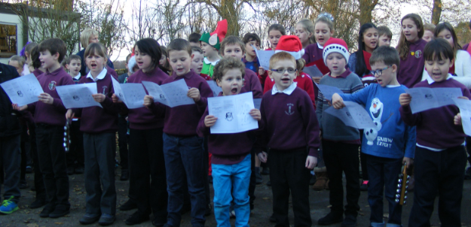This event was organised as an enterprise activity led by the children and each group was given a budget of £30. After reconfiguration, we have therefore raised £261.62 towards Christmas parties and towards our science workshop next term. Thanks again to all who joined in our wonderful morning.

**Parental Involvement in School Improvement**

In our recent survey, a number of parents expressed an interest in supporting the school. A get together will be organised in the new term to talk about how we can work together to support a parent team that works alongside the school in providing exciting learning opportunities for the children in a creative community setting.

**Science Workshops**

I am delighted to say that next term The Glasgow Science Centre will be running science workshops at the school for all the children from P1 to P7. These will be on the 1st of February and the learning will be around Food’s Journey through the Body and Digestion.

**Bus Transport**

As of the beginning of January, our new transport provider will be Frasers of Munlochy. Their telephone number is 01463 212147.

I have been informed that their timetable will be as follows:

**Route No: 4106/1**

**Morning**

Drynie Park 8.25am

Newton of Ferintosh 8.35am

Arrive at school 8.40am

Bishop Kinkell 8.45am

Leanaig 8.50am

Arrive at School 8.55am

**Afternoon**

1. Leave school 3.05pm

Newton of Ferintosh 3.10pm

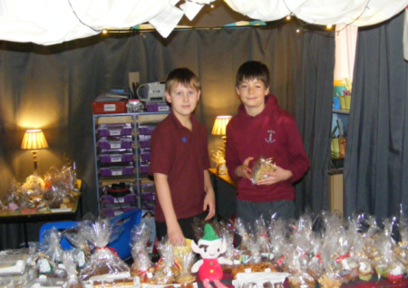Drynie Park 3.20pm

1. Leave School 3.05pm

Leanaig 3.10pm

Bishop Kinkell 3.20pm

**Dates for the Diary**

**January**

9th School re-opens at 9am, nursery at 8.40am

**February**

1st Science workshops – P1-7

14th Parents’ Evening

20th and 21st School Closed – Mid term break

22nd INSET day – school closed to pupils



From all at

MuLbuie Primary School