LLANWERN COMMUNITY COUNCIL

MINUTES OF MEETING
HELD AT LLANWERN VILLAGE HALL
MONDAY 30th SEPTEMBER 2024 AT 7.00 PM

PRESENT: Cllr M George (Chair), Cllrs Brown, Clemo, Collingbourne and Davies

Clerk: Mandy George

In Attendance: Inspector Giles Rowland

Item | Description | Action
1. | APOLOGIES FOR ABSENCE  Apologies were received from Cllr Jones (work), Cllr Grant and Ward Cllr Kellaway.
2. | MINUTES OF PREVIOUS MEETINGS  The Minutes of the meeting held on 29th July were duly approved and signed.
3. | DECLARATIONS OF INTEREST  None.
4. | Redrow – Station Road Drainage and Junction etc  The Chair and Ward Cllr Kellaway met with Jane Carpenter and Zoe Aubrey (Redrow). Various applications have been called in by Cllr Kellaway which would enable to Planning Committee to make the decision, this applies to the following applications - 22/0124, 22/0789 and 23/0798.  The Chair advised that if Planning Committee refused these applications Redrow could revert back to the original scheme which was unsuitable. 198 properties can be built to the North and still use the basin. What will happen after this number is reached. Cllr Davies will speak to Cllr Kellaway to clarify the agreed strategy.  - Open spaces (especially around the basins and areas adjoining Llanwern Village) – these have now been cleared and strimmed  - Parking for the sports pitches and allotments would appear to be insufficient in terms of the number of allotments allocated and also the two football pitches – these were in line with Welsh Government legislation  - Drainage update – works to start imminently  - Cllr Grant reported that there are missing diversion signs when coming out of Bishton, leading to unwanted traffic using the one-way system. The Chair will advise Redrow  Flood and Coastal Erosion Grant update – investigative works and surveys have been carried out on Monks Ditch. | OD  Chair
5. | Glan Llyn  The Chair welcomed Inspector Rowland and thanked him for attending.  Cllr Clemo voiced the concerns from Glan Llyn residents regarding car break-ins. Inspector Rowland advised that from April to date there have been 9 reported property break-ins for the Llanwern Ward (old boundary), 5 of which were Glan Llyn, 3 were in relation to one property in Llanwern.  There have been 20 car crime incidents reported for the Llanwern Ward, 14 of which have been theft from vehicles, 10 of these from Glan Llyn.  Anti-social behaviour incidents reported this year to date are 52, with 32 being classed as nuisance, of these 32, 12 were personal and 20 environmental ie flytipping.  Inspector Giles emphasised the importance of advising residents to log incidents with the Police through email, Facebook, X or telephone calls. Unless incidents are reported a picture cannot be built up. He advised he has 14 PCSOs and 4 Police Officers.  Motorcycles cutting through and being ridden in the park were discussed which is a UK wide problem, 140 have been seized this year. The bikes are probably being used for drug dealing. Residents have been asked to take photos of these bikes which are causing the problem.  Inspector Giles confirmed that he will ask his PCSOs, in conjunction with the Council, to look around this area. Drugs have been found in the park but nothing to this effect has been reported.  Speeding was also discussed and parking outside the School. A construction road has now been closed and traffic is forced passed the School. Once the road is adopted the Council can use double yellow lines. Traffic enforcement is down to the Local Council.  Inspector Giles will instruct his Go-Safe Teams to come out and assess the adopted Eastern Distributor Road, with a view to using a speed gun.  A further meeting will be arranged and any concerns forwarded in advance. Inspector Giles will contact the Clerk for suitable dates.  Defib and ‘Slow Down Cut-Outs’  Cllr Brown had discussed with the School, the siting of a defib in the school grounds, this isn’t feasible as access would need to be 24/7. Outside the school grounds wouldn’t be suitable as the defib would need access to an electricity supply.  Cut-outs to slow traffic would need to be put on the highway which needs to be with the authority of St Modwen. There was also the issue of who would put these signs out at the start and end of the school day. Cllr Clemo will contact St Modwen.  Cllr Clemo also advised that the Residents’ Association is going to be reinstated. Cllr Brown suggested that if any monies are required (budgeted amount £1,000) then a request be put to this Council rather than the Residents’ Association having their own bank account. | DClemo
6. | 20/0986 – Reserved Matters Application for 32no. Residential Flat Units (Housing Phase 2), Associated Infrastructure and Landscaping all Pursuant to Outline Permission 16/0864 for Residential Development of up to 1100 Dwellings, a Primary School, Village Centre, Public Open Space, Landscaping and Associated Infrastructure Works and Details to Partially Discharge the Following Conditions in Relation to Phase 2, 01 (Reserved Matters), 05 (Building Materials), 06 (Hardscaping Materials), 07 (Boundaries), 09 (Construction Details of Roads, Footways and Highways), 12 (Drainage), 21 (Parking) and 24 (Landscaping) – Llanwern Village Development Site Phase 2 Cot Hill.  On-going (part approved and part refused). To be read in conjunction with 22/0435 which is part approved and part refused.  21/0293 – Reserved Matters Application for 77 no Homes, Associated Infrastructure and Landscaping Pursuant to Outline Planning Permission 16/0864 for Residential Development of up to 1100 Dwellings and Provision of Primary School, Village Centre, Public Open Space, Landscaping and Associated Infrastructure Works Affecting Public Rights of Way 397/3, 397/7, 397/9 and 397/10, and Details to Partially Discharge Conditions 5 (Building Materials), 6 (Hardscaping Materials), 7 (Boundary Treatments), 9(Highway Construction Details), 12 (Drainage), 15 (Aboricultural Impact Assessments), 18 (Ecological Management Plan), 21 (Parking) and 24 (Landscaping)  Part approved, part approved with conditions and part refused (drainage). To be read in conjunction with 22/0163 – approved and conditions. 22/0437 – approved. 23/0047 – approved and conditions. 23/0232 – approved. 23/0760 – approved.  21/1301 - Reserved Matters Application for 85 no Dwelling Houses, Associated Infrastructure (Including Substation) and Landscaping Pursuant to Outline Planning Permission 16/0864 for Residential Development of up to 1100 Dwellings and Associated Infrastructure Works Affecting Public Rights of Way 397/3, 397/7, 397/9 and 397/10 and Details to Partially Discharge Conditions 05 (Building Materials), 06 (Hardscaping Materials), 07 (Boundary Treatments), 08 (Highway Construction Details), 12 (Drainage), 15 (Arboricultural Impact Assessments) 18 (Ecological Management Plan) 19 (Noise Assessment), 21 (Parking) And 24 (Landscaping) – Land to North of Little Milton Farm, Cot Hill, Llanwern  On-going. This application has been called-in.  22/0124 - Reserved Matters Application for 57 no. Homes, Associated Infrastructure (Including Substation) and Landscaping and Partial Discharge of Conditions 5 (Building Materials), 6 (Hardscaping Materials), 7 (Boundary Treatments), 9 (Highways Construction Details), 12 (Drainage), 16 (Arboricultural Construction Details), 18 (Ecological Management Plan) 19 (Noise) and 24 (Landscaping) Pursuant to Outline Planning Permission 16/0864 for Residential Development of up to 1100 Dwellings and Provision of Primary School, Village Centre, Public Open Space, Landscaping and Associated Infrastructure Works Affecting Public Rights of Way 397/3, 397/7, 397/9 And 397/10  See note 4.  22/0284 - Partial Discharge of Condition 12 (Foul and Surface Water Drainage and Surface Water Attenuation) of Planning Permission 16/0864 (Phase 2 Only) For Variation of Conditions of Planning Permission 13/0806 Varying Time Limits of Planning Permission 06/0845 for Residential Development (Up To 1100 Dwellings) and Provision of Primary School, Village Centre, Public Open Space, Landscaping and Associated Infrastructure Works (Affecting Public Rights of Way 397/3, 397/7, 397/9 and 397/10 Llanwern)  On-going. This application has been called-in.  22/0789 - Partial Discharge of Conditions 4 (Infrastructure Phasing) in Respect of Phases 2, 3 and the Site Attenuation Ponds and 12 (Drainage) of 16/0864 Variation of Conditions 02 (Reserved Matters), 03 (Masterplan) and 05 (Design Code) of Planning Permission 13/0806 for Variation of Condition (Time Limits) of Planning Permission 06/0845 for Residential Development (Up to 1100 Dwellings) and Provision of Primary School, Village Centre, Public Open Space, Landscaping and Associated Infrastructure Works (Affecting Public Rights of Way 397/3, 397/7, 397/9 and 397/10 Llanwern)  See note 4.  22/0801 - Reserved Matters Application (Pursuant to Outline Permission 06/0471) for Residential Development on Phases 4b & 5d at the Glan Llyn Regeneration Site to Provide 170 Dwellings Including Details of Access, Appearance, Landscaping, Layout and Scale Together With Details to Partially Discharge Outline Planning Conditions 6 (Recreation Areas), 8 (Materials), 9 (Hard Landscaping), 10 (Boundary Treatments), 11 (Management Of Open Space), 12 (Parking), 15 (Emergency Access), 16 (Roads, Cycleways and Footways), 18 (Road Works), 22 (Streetlighting), 24 (Site Levels), 33 (Surface Water), 34 (Foul and Surface Water Drainage), 35 (Oil Interceptors), 39 (Carbon Reduction and Sustainability) and 43 (Firefighting Access) Llanwern Works Queensway Llanwern Newport  On-going.  23/0404 – Proposed New Dwelling with Car Parking and Associated Site Works – The Fields, Land North of and Adjacent to Milton Hill  On-going.  23/0440 Reserved Matters Application for 176 Dwellings and Associated Works on Phase 4d, Pursuant to Outline Planning Permission 06/0471 for the Redevelopment of Site to Create a Mixed Use Urban Extension. Phase 4D Glan Llyn Development Site Queensway Llanwern Newport South Wales  On-going.  23/0798 – Partial Discharge of Condition 12 (Drainage) of 16/0864 Variation of Conditions 02 (Reserved Matters), 03 (Masterplan) and 05 (Design Code) of Planning Permission 13/0806 for Variation of Condition (Time Limits) Of Planning Permission 06/0845 For Residential Development (Up To 1100 Dwellings) and Provision of Primary School, Village Centre, Public Open Space, Landscaping and Associated Infrastructure Works (Affecting Public Rights of Way 397/3, 397/7, 397/9 and 397/10 Llanwern) | Llanwern Village Development Site Phase 1 Cot Hill Llanwern  See note 4.  24/0465 - Reserved Matters Application for New Homes, Associated Infrastructure and Landscaping at Cedars 4 Pursuant to Outline Planning Permission 16/0864 for Residential Development of up to 1100 Dwellings and Provision of Primary School, Village Centre, Public Open Space, Landscaping and Associated Infrastructure Works Affecting Public Rights of Way 397/3, 397/7, 397/9 and 397/10, and Details to Discharge Conditions 5 (Building Materials), 6 (Hardscaping Materials), 7 (Boundary Treatments), 9 (Highway Construction Details), 12 (Drainage), 18 (Ecological Management Plan), 19 (Noise Assessment), 21 (Parking) And 24 (Landscaping)  On-going.  24/0467 Reserved Matters Application for Sports Pitches, Changing Facilities and Allotments, Associated Infrastructure and Landscaping Pursuant to Outline Planning Permission 16/0864 for Residential Development of up to 1100 Dwellings and Provision of Primary School, Village Centre, Public Open Space, Landscaping and Associated Infrastructure Works Affecting Public Rights of Way 397/3, 397/7, 397/9 and 397/10, and Details to Discharge Conditions 5 (Building Materials), 6 (Hardscaping Materials), 7 (Boundary Treatments), 12 (Drainage), 21 (Parking) and 24 (Landscaping) Llanwern Village Development Site Phase 1 Cot Hill, Llanwern.  See note 4.  24/0515 – Conversion of Existing Internal Single Garage into Living Space (Part Retrospective) – 44 Spencer Way, Newport  On-going.  24/0537 – Reserved Matters Application for a Primary School, Nursery, and Learning Resource Base, Mugas, Diversion of Existing Prow and Other Associated Works Pursuant to 16/0864 Variation of Conditions 02 (Reserved Matters), 03 (Masterplan) and 05 (Design Code) of Planning Permission 13/0806 for Variation of Condition (Time Limits) of Planning Permission 06/0845 for Residential Development (up to 1100 Dwellings) and Provision of Primary School, Village Centre, Public Open Space, Landscaping and Associated Infrastructure Works (Affecting Public Rights of Way 397/3, 397/7, 397/9 and 397/10 Llanwern)  SITE: Site of Future Primary School Great Milton Park Cot Hill Llanwern  The Clerk has submitted our response that we have no objections to this application.  Ellyn Ridge Traveller Site  On-going.  Craig Y Perthi Solar Farm Proposal  The Clerk has resubmitted our observations and comments.
 | SECTION B  FINANCE AND LOCAL GOVERNMENT  Bank Statements:  Current account statement 29th July 2024 £2,417.81  Less £147.12 (SSE Energy)  £12.36 (Microsoft)  £31.14 (Talk Talk)  £183.31 (YuEnergy)  £1,068 (T and P Regeneration)  Closing balance £975.88  Current account statement 30th August 2024 £975.88  Less £837.68 (Towergate Insurance)  £24.00 (Chair’s Purse raffle)  £416.75 (Clerk’s salary July)  £12.36 (Microsoft)  £31.14 (Talk Talk)  £416.75 (Clerk’s salary August)  Plus £1,000 (transfer from deposit a/c 31/07/24)  Closing balance £237.20  Deposit account statement 29th July 2024 £59,302.60  Closing balance £59,302.60  Deposit account statement 27th August 2024 £59,302.60  Less £1,000 (transfer to current a/c 31/07/24)  Closing balance £58,302.60  Second Precept  £17,835 was received on 3rd September.  Accounts for Payment  YuEnergy - £72.76 cr (August) £48.84 cr (September)  TalkTalk - £31.14 (dd August) £31.14 (dd September)  Microsoft - £12.36 (dd August) £12.36 (dd September)  British Gas - £73.80 annual dd (Boiler Service)  SSE - £147.12 (bank transfer)  Chair’s purse - £9.99 (flowers for Chair VHMC) bank transfer  Clerk’s salary - £416.75 (August) £416.75 (September) (bank transfer)  British Gas - £478.39 refund  Local Government and Elections (Wales) Act 2021: Community and Town Councils Statutory Guidance  The Clerk has circulated the list of the latest training modules available from One Voice Wales.  Financial Regulations  Cllr Brown will look at our Financial Regulations with a view to discussion at the next meeting of this Council. | TB
 | SECTION C – LEISURE AND AMENITIES  Village Hall  Car Park – Cllr Jones will resubmit the necessary forms. Payment is authorised for the fee of £280 to be paid by the Community Council’s debit card.  Halls together Rural Development Project – on-going.  Grants – an email was received from the Chair requesting written confirmation of support for any grant applications to the Welsh Church Fund. The Clerk will arrange.  Xmas Tree – the Chair will arrange collection prior to the Tree Lighting event on 7th December.  Playing Field  A price is awaited from W M Garden Services for the removal of the multi-unit. An email has been sent requesting the identified repairs be carried out as soon as possible.  Dog Fouling - Advice awaited from our Ward Councillor. | Chair  Clerk  Chair
SECTION D – HIGHWAYS AND UTILITIES

Llanwern Park Bridge
On-going.

7. | CORRESPONDENCE – the following were emailed to Councillors:  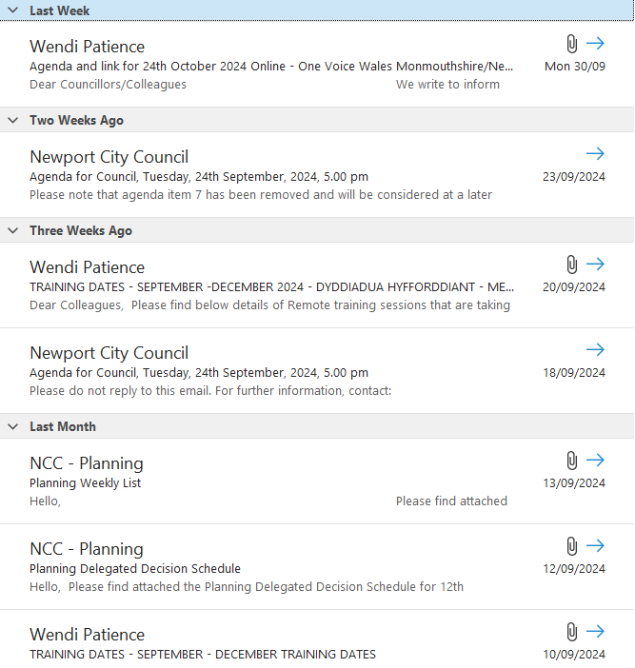  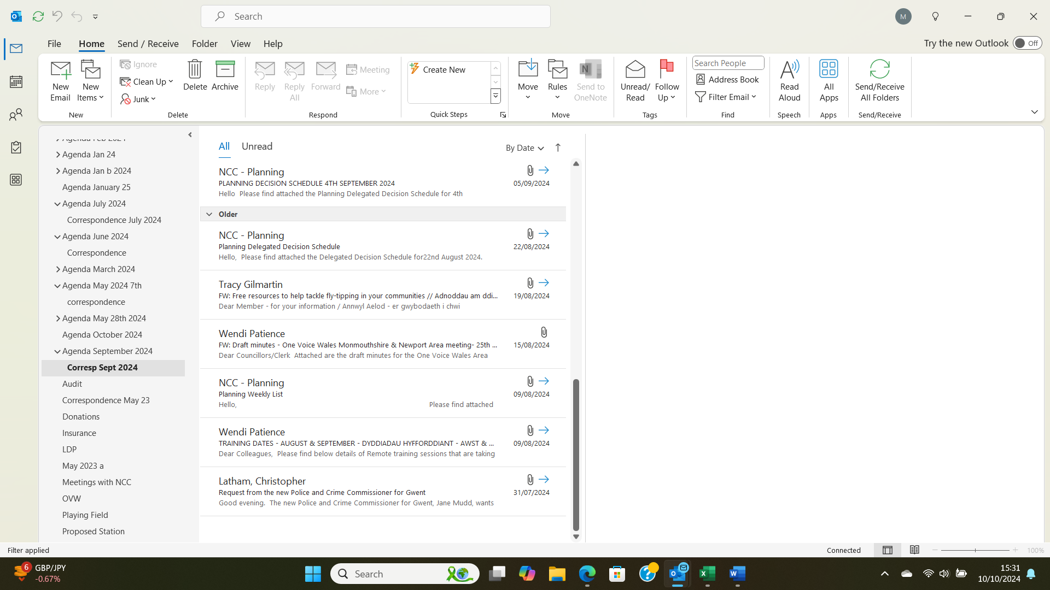
8. | ANY OTHER BUSINESS  Sheep  A request was received for sheep to return to the field behind the Village Hall. It was agreed that the Clerk contact the shepherd to confirm the start date.  Hedge Cutting  The Chair has arranged for the field behind the Village Hall to be cut inside and roadside. The invoice is awaited which will amount to £378. The Clerk is authorised to pay this amount on receipt.  Poppies  The Clerk was requested to purchase 40 lamp post poppies, 20 of which are for Glan Llyn at a cost of £5 each, totalling £200. This will add to the 40 already purchased last year. The debit card is authorised to be used as this is an on-line purchase. | Clerk  Clerk  Clerk
9. | DATE OF NEXT MEETING  The next meeting will be held on Monday 28th October 2024. This meeting will be held at the Village Hall and also remotely. The meeting closed at 9.25 pm.

