LLANWERN COMMUNITY COUNCIL

MINUTES OF MEETING

HELD AT LLANWERN VILLAGE HALL
MONDAY 24th NOVEMBER 2025 AT 7.00 PM

PRESENT: Cllrs M George (Chair), Brown, Collingbourne, Davies and Jones

1 member of the general public

Clerk: Mandy George

Item | Description | Action
1. | APOLOGIES FOR ABSENCE  Apologies were received from Cllrs Clemo (personal) and Grant (personal).
2. | MINUTES OF PREVIOUS MEETINGS  The Minutes of the meeting held on 27th October 2025 were duly approved and signed.
3. | DECLARATIONS OF INTEREST  It was resolved that any declarations of interest should be stated during the course of the meeting, noted here and the necessary form completed.  Cllr Collingbourne declared his interest in the item regarding a donation to Llanwern Tots Group.
4. | PUBLIC PARTICIPATION  Cllr Kellaway has received a definitive answer regarding the dog/litter bins:  ‘If the area is adopted, cleansing and bin emptying are functions covered by the local authority – whereas if not adopted, it comes under the developer’s responsibility and it would be for them to provide and empty those bins (or get into an agreement with NCC where we could do it at a charge); reading your email it looks this is the current situation at present.  Also, please be aware that according to current legislation, dog waste is classified as hazardous waste when collected separately, necessitating specialised collection and treatment processes which would result in significant logistical challenges and costs. However, dog waste can be disposed of in normal litter bins as mixed waste, this allows for efficient and safe disposal without the need for specialised handling. So I’d say if anything, residents should request that Redrow install additional litter bins.’  The Chair has contacted Redrow regarding the bin promised for the bottom of the spine road:  It seems our dog litter bins that were delivered have gone missing, so we have ordered two more which are being delivered next week. We will install one by the attenuation basins by the end of November. Another will be installed in a suitable location on our phases North of Cot Hill.’
5. | Redrow – (also see above comments)  The recent storm caused the sewers to surcharge on November 14th and sewerage was seen running down the Spine Road. There was a fault with the pumps and the manufacturers will be investigating. Tankers were later seen on site. Monks Ditch breached its banks and flooded into the field behind the village hall and also on the opposite bank towards the Forge and Barn Farm. Ditch water flooded the whole of Station Road. The Llanwern Ditch was full to capacity. No reports of any properties flooding were received but the horse riding arenas at Barn Farm were badly affected.  Contractors were heard working outside on a Sunday morning, the working hours on weekends are Saturday morning to midday and no Sundays (unless indoors). The Clerk will advise Redrow of this breach.  The road is due to be re-closed opposite Little Milton Gardens, the Chair will be chase this again.  A copy of the Outline Business Case report for the Station Road Flood Alleviation Scheme has been received. The Chair has forwarded a copy to a drainage expert for help in understanding its contents.  The latest stats were received from Gwent Police for the Llanwern Ward and circulated to all. A copy was also sent to GMPRA. | Clerk  Chair
Glan Llyn

Responses are still being chased from Revantage regarding the meeting with the Chair, Ward Cllr Kellaway and Cllr Clemo. Ward Cllr Kellaway has escalated.

20/0986 – Reserved Matters Application for 32no. Residential Flat Units (Housing Phase 2), Associated Infrastructure and Landscaping all Pursuant to Outline Permission 16/0864 for Residential Development of up to 1100 Dwellings, a Primary School, Village Centre, Public Open Space, Landscaping and Associated Infrastructure Works and Details to Partially Discharge the Following Conditions in Relation to Phase 2, 01 (Reserved Matters), 05 (Building Materials), 06 (Hardscaping Materials), 07 (Boundaries), 09 (Construction Details of Roads, Footways and Highways), 12 (Drainage), 21 (Parking) and 24 (Landscaping) – Llanwern Village Development Site Phase 2 Cot Hill.

On-going (part approved and part refused). To be read in conjunction with 22/0435 which is part approved and part refused.

22/0801 – Reserved Matters Application (Pursuant to Outline Permission 06/0471) for Residential Development on Phases 4b & 5d at the Glan Llyn Regeneration Site to Provide 170 Dwellings Including Details of Access, Appearance, Landscaping, Layout and Scale Together With Details to Partially Discharge Outline Planning Conditions 6 (Recreation Areas), 8 (Materials), 9 (Hard Landscaping), 10 (Boundary Treatments), 11 (Management Of Open Space), 12 (Parking), 15 (Emergency Access), 16 (Roads, Cycleways and Footways), 18 (Road Works), 22 (Streetlighting), 24 (Site Levels), 33 (Surface Water), 34 (Foul and Surface Water Drainage), 35 (Oil Interceptors), 39 (Carbon Reduction and Sustainability) and 43 (Firefighting Access) Llanwern Works Queensway Llanwern Newport

A comprehensive revision was submitted by the applicant and circulated to all.

24/0465 - Reserved Matters Application for New Homes, Associated Infrastructure and Landscaping at Cedars 4 Pursuant to Outline Planning Permission 16/0864 for Residential Development of up to 1100 Dwellings and Provision of Primary School, Village Centre, Public Open Space, Landscaping and Associated Infrastructure Works Affecting Public Rights of Way 397/3, 397/7, 397/9 and 397/10, and Details to Discharge Conditions 5 (Building Materials), 6 (Hardscaping Materials), 7 (Boundary
Treatments), 9 (Highway Construction Details), 12 (Drainage), 18 (Ecological Management Plan), 19 (Noise Assessment), 21 (Parking) And 24 (Landscaping)

On-going.

24/0466 - Reserved Matters Application for new Homes, Associated Infrastructure and Landscaping at Parcels Known as Hollies 5 and Hollies 6 Pursuant to Outline Planning Permission 16/0864 for Residential Development of up to 1100 Dwellings and Provision of Primary School, Village Centre, Public Open Space, Landscaping and Associated Infrastructure Works Affecting Public Rights of Way 397/3, 397/7, 397/9 and 397/10, and Details to Discharge Conditions 5 (Building Materials), 6 (Hardscaping Materials), 7 (Boundary Treatments), 9 (Highway Construction Details), 12 (Drainage), 21 (Parking) and 24 (Landscaping) Site: Llanwern Village Development Site Phase 1 Cot Hill Llanwern Newport NP18 2DP

Additional/amended information submitted. Circulated to all.

24/0467 – Reserved Matters Application for Sports Pitches, Changing Facilities and Allotments, Associated Infrastructure and Landscaping Pursuant to Outline Planning Permission 16/0864 for Residential Development of up to 1100 Dwellings and Provision of Primary School, Village Centre, Public Open Space, Landscaping and Associated Infrastructure Works Affecting Public Rights of Way 397/3, 397/7, 397/9 and 397/10, and Details to Discharge Conditions 5 (Building Materials), 6 (Hardscaping Materials), 7 (Boundary Treatments), 12 (Drainage), 21 (Parking) and 24 (Landscaping) – Llanwern Village Development Site Phase 1 Cot Hill, Llanwern.

On-going.

25/0152 – Reserved Matters Application Relating to Layout, Scale, Appearance, Access and Landscaping for Residential Development at Phase4e/4g Pursuant To Outline Planning Permission 06/0471 for a Mixed Use Regeneration of the Former Llanwern Steelworks and Partial Discharge of Conditions 01 (Reserved Matters), 06 (Recreational Areas), 08 (Materials), 09 (Details of Hard Landscaped Access), 10 (Boundary Treatments), 11 (Management Strategy for Maintenance of Open Space), 12 (Off Street Parking and Cycle Parking), 15 (Emergency Access), 16 (Details of Roads/Cycleways/Footways), 18 (Estate Roads), 22 (Street Lighting and Car Parking Areas), 24 (Site Levels), 33 & 34 (Foul and Surface Water Drainage), 39 (Sustainability Statement) and 43 (Fire
Fighting Access) Site: Glan Llyn Development Site Phase 4e/4g
Queensway Llanwern Newport South

A revised Plan Package was received and circulated to all.

25/0177 - Reserved Matters Application Relating to Layout, Scale, Appearance, Access and Landscaping for 3 No. Commercial Units (Use Class B1, B2, B8) Pursuant to Outline Planning Permission 06/0471 for a Mixed Use Regeneration of the Former Llanwern Steelworks and Partial Discharge of Conditions 01 (Reserved Matters), 08 (Materials), 09
(Details of Hard Landscaped Access), 10 (Boundary Treatments), 11 (Management Strategy for Maintenance of Open Space), 12 (Off Street Parking and Cycle Parking), 15 (Emergency Access), 16 (Details of Roads/Cycleways/Footways), 18 (Estate Roads), 22 (Street Lighting and Car Parking Areas), 24 (Site Levels), 33 (Surface Water Disposal), 34 (Foul and Surface Water Drainage), 39 (Sustainability Statement) and 43 (Fire Fighting Access)Site: Llanwern Works Queensway Llanwern
Newport South Wales

On-going.

Flooding of Subway to Dawson Close

On-going.

Newport LDP

On-going.
 | SECTION B  FINANCE AND LOCAL GOVERNMENT  Bank Reconciliation Statement as at 24th November 2025:  Accounts for Payment  DDs  YuEnergy - £173.46  TalkTalk - £33.37  Microsoft - £12.10  BACS  Clerk (November) – £446.25  K Grant (Speaker) - £27.94  SSE - £158.27  Budget Monitoring  The Clerk presented a spreadsheet up to the end of the second quarter.  Local Government and Elections (Wales) Act 2021: Community and Town Councils Statutory Guidance  Training modules were circulated.  Audit 2024/25  No response received from Audit Wales regarding the disputed statement. The Clerk will chase.  Defibrillator Maintenance  Two new batteries have been installed.  S 106 Monies  Cllr Davies asked the Clerk to find out what the 106 contribution was for application 06/0845 and what has and hasn’t been received.  The Clerk was asked again to chase the S106 payment due to be made towards the playing field.  Budget Requirements for 2026/2027  Paperwork was received for submission to NCC by 9th January 2026. Cllr Brown and the Clerk will report to the next meeting. | Clerk  Clerk  TB/Clerk
   |  | £
  A | Balance on current a/c bank statement at 30th Oct 2025  Balance on deposit a/c bank statement at 24th Nov 2025  Total | 673.27  82,510.47  83,183.74
   | Outstanding items
  B | Less unpresented cheques:  YuEnergy  Microsoft  TalkTalk  K Grant - Speaker  Total | 173.46  12.10  33.37  27.94  246.87
  C | Plus uncleared payments into bank  0  Total | 0  0
  D | Balance at 24th November A-B+C | 82,936.87
 | SECTION C – LEISURE AND AMENITIES  Village Hall  Car Park – The S73 variation is being undertaken.  Halls together Rural Development Project – on-going.  Future Funding – Cllr Brown presented a report to consider any financial requirements for the next financial year. The principal concern of the VHMC is the present condition of the roof, there is serious deterioration in the timbers, soffits, facias and battens etc. A survey has been undertaken and various quotations received. The contractor chosen to undertake the works quoted a fixed price of £24,750. A request was received for a grant of £10,000. It was proposed and agreed that we allocate, in our budget for 2026/2027, the sum of £10,000 which would be released on evidence of a contract between the contractor and the VHMC, together with a contingency allowance of £2,000 in respect of any unanticipated items, not price variation. The balance would be funded by the VHMC.  The VHMC would also like to replace 60 of the existing chairs with a stacking and storage system which would ease pressure on storage and offer protection to the floor. It was proposed and agreed that the sum of £5,000 be budgeted by this Council for the provision of 60 stacking chairs.  Discussion with the VHMC also included refurbishment of the ladies cloakroom, provision of disabled toilet facilities and a review of the current financial model for the management, without any final outcomes.  Future Events – The annual tree lighting and visit from Santa will be held on 6th December.  Christmas Trees – The Chair has arranged for the collection of two Christmas trees, one for the Village Hall and one for Glan Llyn.  St Mary’s Tots Group  An email was received advising that no financial help was now required, they will ask if they are in need. | Chair
SECTION D – HIGHWAYS AND UTILITIES

Llanwern Park Bridge

On-going.

6. | CORRESPONDENCE – the following were emailed to Councillors:  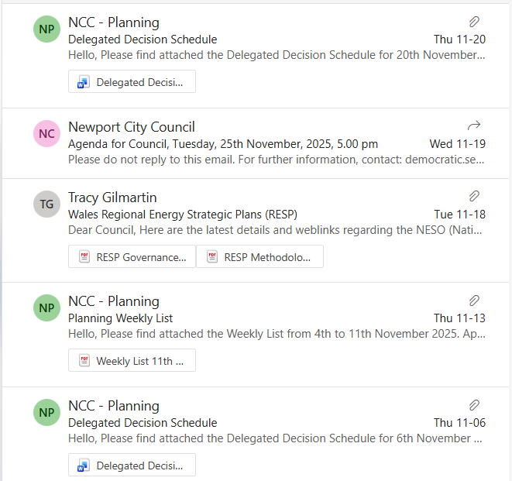  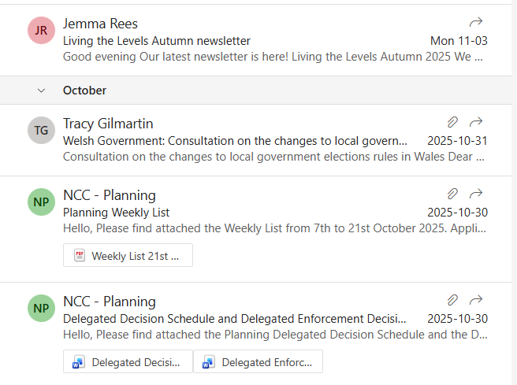
7. | DATE OF NEXT MEETING  The next meeting will be held on Tuesday 16th December 2025 at 7.30pm. This meeting will be held at the Village Hall and also remotely. The meeting closed at 9.10 pm.

