LLANWERN COMMUNITY COUNCIL

MINUTES OF MEETING and AGM
HELD AT LLANWERN VILLAGE HALL
TUESDAY 27th MAY 2025 AT 7.00 PM

PRESENT: Cllr M George (Chair), Cllrs Brown, Clemo, Collingbourne, Davies, Jones and Grant

Clerk: Mandy George

In attendance: 2 residents of Glan Llyn

Item | Description | Action
1. | APOLOGIES FOR ABSENCE  Apologies were received from Cllr Jones and Ward Cllr Kellaway
2. | MINUTES OF PREVIOUS MEETINGS  The Minutes of the meeting held on 28th April 2025 were duly approved and signed.
3. | DECLARATIONS OF INTEREST  None.
4. | ELECTION OF CHAIR AND VICE CHAIR  Cllr Brown proposed Cllr George for the Office of Chair, this was seconded by Cllr Collingbourne and unanimously agreed. Cllr George accepted.  Cllr Brown proposed Cllr Davies for the Office of Vice Chair, this was seconded by Cllr George and unanimously agreed. Cllr Davies accepted.  Section Representatives: It was unanimously agreed that these remain the same as the previous year:  Section A – Planning (Cllrs Clemo, Davies and Grant)  Section B – Finance and Local Government (Cllrs Brown and Davies)  Section C – Leisure and Amenities (Cllrs Collingbourne and Grant)  Section D – Highways and Utilities (Cllrs George and Davies)  Election of Representatives to Outside Bodies: It was unanimously agreed that these remain the same as the previous year:  Liaison Committee – Clerk  One Voice Wales – Cllr Brown  Gwent Association of Voluntary Organisations – Cllr Collingbourne  Governor Glan Llyn Primary School – Cllr Brown  Governor Llanmartin Primary School – Cllr Collingbourne
5. | REVIEW OF STANDING ORDERS AND FINANCIAL REGULATIONS  It was agreed that the Standing Orders and Financial Regulations be reapproved. With regard to high-end contracts it was agreed that an addendum be approved when the need arises.
6. | Redrow – Station Road Drainage and Junction  The Chair together with Ward Cllr Kellaway met with the Leader of NCC, Steve Jarrett (Infrastructure Manager), Paul Jones, John Griffiths MS and Mr Chris Dartnell on 2nd May. The constraints on the proposed drainage scheme and the alternatives were discussed. Redrow have instructed Bells to do chamber surcharging and a pressure leak test on the Bishton Road drains.  Redrow have confirmed that white lines will be painted throughout the estate and roads re-tarmac’d within one month.  The roundabout is large to accommodate buses as per the active travel route.  The Chair met with Redrow management on 16th May. It was confirmed that more parking will be made available for the sports pitches and allotments.  The monthly report for the Llanwern Ward was received from PCSO Dan Sutherland and circulated to all.
7. | Glan Llyn  Two residents of Glan Llyn attended the meeting. They advised that they don’t have sufficient volunteers to operate the speed watch group. Three people are required to undertake the task.  Radar speed signs would be ideal to advise motorists of their speed, these can’t be installed until speeding is proven. One set of results have been received from PCSO Dan Sutherland. Between 11.05 and 11.40, 66 vehicles were monitored, 17 were over the 20mph speed limit. Further results are required. Speed bumps would also be beneficial but they could affect the adoption of the roads.  The Chair will converse with Highways to try and find a way forward regarding signage.  Four ‘children’ signs have been purchased, 2 of which are outside the school. Twenty-eight children cannot enrol at the school for September as it is over-subscribed.  The flooded playing area is still on-going.  Miller Homes have acquired St Modwen. | Chair
8. | 20/0986 – Reserved Matters Application for 32no. Residential Flat Units (Housing Phase 2), Associated Infrastructure and Landscaping all Pursuant to Outline Permission 16/0864 for Residential Development of up to 1100 Dwellings, a Primary School, Village Centre, Public Open Space, Landscaping and Associated Infrastructure Works and Details to Partially Discharge the Following Conditions in Relation to Phase 2, 01 (Reserved Matters), 05 (Building Materials), 06 (Hardscaping Materials), 07 (Boundaries), 09 (Construction Details of Roads, Footways and Highways), 12 (Drainage), 21 (Parking) and 24 (Landscaping) – Llanwern Village Development Site Phase 2 Cot Hill.  On-going (part approved and part refused). To be read in conjunction with 22/0435 which is part approved and part refused.  21/1301 - Reserved Matters Application for 85 no Dwelling Houses, Associated Infrastructure (Including Substation) and Landscaping Pursuant to Outline Planning Permission 16/0864 for Residential Development of up to 1100 Dwellings and Associated Infrastructure Works Affecting Public Rights of Way 397/3, 397/7, 397/9 and 397/10 and Details to Partially Discharge Conditions 05 (Building Materials), 06 (Hardscaping Materials), 07 (Boundary Treatments), 08 (Highway Construction Details), 12 (Drainage), 15 (Arboricultural Impact Assessments) 18 (Ecological Management Plan) 19 (Noise Assessment), 21 (Parking) And 24 (Landscaping) – Land to North of Little Milton Farm, Cot Hill, Llanwern  Approved with conditions.  22/0284 - Partial Discharge of Condition 12 (Foul and Surface Water Drainage and Surface Water Attenuation) of Planning Permission 16/0864 (Phase 2 Only) For Variation of Conditions of Planning Permission 13/0806 Varying Time Limits of Planning Permission 06/0845 for Residential Development (Up To 1100 Dwellings) and Provision of Primary School, Village Centre, Public Open Space, Landscaping and Associated Infrastructure Works (Affecting Public Rights of Way 397/3, 397/7, 397/9 and 397/10 Llanwern)  On-going. This application has been called-in.  22/0789 - Partial Discharge of Conditions 4 (Infrastructure Phasing) in Respect of Phases 2, 3 and the Site Attenuation Ponds and 12 (Drainage) of 16/0864 Variation of Conditions 02 (Reserved Matters), 03 (Masterplan) and 05 (Design Code) of Planning Permission 13/0806 for Variation of Condition (Time Limits) of Planning Permission 06/0845 for Residential Development (Up to 1100 Dwellings) and Provision of Primary School, Village Centre, Public Open Space, Landscaping and Associated Infrastructure Works (Affecting Public Rights of Way 397/3, 397/7, 397/9 and 397/10 Llanwern)  Pending decision.  22/0801 - Reserved Matters Application (Pursuant to Outline Permission 06/0471) for Residential Development on Phases 4b & 5d at the Glan Llyn Regeneration Site to Provide 170 Dwellings Including Details of Access, Appearance, Landscaping, Layout and Scale Together With Details to Partially Discharge Outline Planning Conditions 6 (Recreation Areas), 8 (Materials), 9 (Hard Landscaping), 10 (Boundary Treatments), 11 (Management Of Open Space), 12 (Parking), 15 (Emergency Access), 16 (Roads, Cycleways and Footways), 18 (Road Works), 22 (Streetlighting), 24 (Site Levels), 33 (Surface Water), 34 (Foul and Surface Water Drainage), 35 (Oil Interceptors), 39 (Carbon Reduction and Sustainability) and 43 (Firefighting Access) Llanwern Works Queensway Llanwern Newport  On-going.  23/0440 Reserved Matters Application for 176 Dwellings and Associated Works on Phase 4d, Pursuant to Outline Planning Permission 06/0471 for the Redevelopment of Site to Create a Mixed Use Urban Extension. Phase  4D Glan Llyn Development Site Queensway Llanwern Newport South Wales  On-going.  24/0465 - Reserved Matters Application for New Homes, Associated Infrastructure and Landscaping at Cedars 4 Pursuant to Outline Planning Permission 16/0864 for Residential Development of up to 1100 Dwellings and Provision of Primary School, Village Centre, Public Open Space, Landscaping and Associated Infrastructure Works Affecting Public Rights of Way 397/3, 397/7, 397/9 and 397/10, and Details to Discharge Conditions 5 (Building Materials), 6 (Hardscaping Materials), 7 (Boundary  Treatments), 9 (Highway Construction Details), 12 (Drainage), 18 (Ecological Management Plan), 19 (Noise Assessment), 21 (Parking) And 24 (Landscaping)  On-going.  24/0467 – Reserved Matters Application for Sports Pitches, Changing Facilities and Allotments, Associated Infrastructure and Landscaping Pursuant to Outline Planning Permission 16/0864 for Residential Development of up to 1100 Dwellings and Provision of Primary School, Village Centre, Public Open Space, Landscaping and Associated Infrastructure Works Affecting Public Rights of Way 397/3, 397/7, 397/9 and 397/10, and Details to Discharge Conditions 5 (Building Materials), 6 (Hardscaping Materials), 7 (Boundary Treatments), 12 (Drainage), 21 (Parking) and 24 (Landscaping) Llanwern Village Development Site Phase 1 Cot Hill, Llanwern.  On-going.  24/0537 – Reserved Matters Application for a Primary School, Nursery, and Learning Resource Base, Mugas, Diversion of Existing Prow and Other Associated Works Pursuant to 16/0864 Variation of Conditions 02 (Reserved Matters), 03 (Masterplan) and 05 (Design Code) of Planning Permission 13/0806 for Variation of Condition (Time Limits) of Planning Permission 06/0845 for Residential Development (up to 1100 Dwellings) and Provision of Primary School, Village Centre, Public Open Space, Landscaping and Associated Infrastructure Works (Affecting Public Rights of Way 397/3, 397/7, 397/9 and 397/10 Llanwern)  SITE: Site of Future Primary School Great Milton Park Cot Hill Llanwern  Awaiting decision  24/0782 - Reserved Matters (Condition 01) for Proposed Retail Store, Nursery (D1) and 3no. Commercial Units and Associated Works in Local Centre and Partial Discharge of Conditions 07 (Landscaping), 08 (Materials/Finishes to External Surfaces), 9 (Materials/Finishes for  Hard Landscaped Areas), 10 (Boundary Treatments), 12 (Parking), 15 (Emergency Access), 16 (Roads, Cycleways and Footways), 17  (Green Travel Strategy), 19 (Noise Assessment), 22 (Lighting), 23 (Ecological Management Plan), 24 (Site Levels), 27 (Ground Conditions), 28 (Verification Report), 32 (Piling Works), 33 (Surface Water), 34 (Foul and Surface Water Drainage and Storage) and 39 (Carbon  Reduction Strategy) Relating to Outline Planning Permission 06/0471 for Redevelopment of Site to Create a Mixed Use Urban Extension  SITE: Land West of 1 Kings Wall Drive Newport South Wales  Awaiting decision.  25/0152 – Reserved Matters Application Relating to Layout, Scale, Appearance, Access and Landscaping for Residential Development at Phase4e/4g Pursuant To Outline Planning Permission 06/0471 for a Mixed Use Regeneration of the Former Llanwern Steelworks and Partial Discharge of Conditions 01 (Reserved Matters), 06 (Recreational Areas), 08 (Materials), 09 (Details of Hard Landscaped Access), 10 (Boundary Treatments), 11 (Management Strategy for Maintenance of Open Space), 12 (Off Street Parking and Cycle Parking), 15 (Emergency Access), 16 (Details of Roads/Cycleways/Footways), 18 (Estate Roads), 22 (Street Lighting and Car Parking Areas), 24 (Site Levels), 33 & 34 (Foul and Surface Water Drainage), 39 (Sustainability Statement) and 43 (Fire  Fighting Access) Site: Glan Llyn Development Site Phase 4e/4g  Queensway Llanwern Newport South  On-going.  25/0176 - Reserved Matters Application Relating to Layout, Scale, Appearance, Access and Landscaping for 4 No. Commercial Units (Use Class B1, B2, B8) Pursuant to Outline Planning Permission 06/0471 for a Mixed Use Regeneration of the Former Llanwern Steelworks and Partial Discharge of Conditions 01 (Reserved Matters), 08 (Materials), 09  (Details of Hard Landscaped Access), 10 (Boundary Treatments), 11 (Management Strategy for Maintenance of Open Space), 12 (Off Street Parking and Cycle Parking), 15 (Emergency Access), 16 (Details of Roads/Cycleways/Footways), 18 (Estate Roads), 22 (Street Lighting and Car Parking Areas), 24 (Site Levels), 33 (Surface Water Disposal), 34 (Foul and Surface Water Drainage), 39 (Sustainability Statement) and 43 (Fire Fighting Access)Site: Llanwern Works Queensway Llanwern  Newport South Wales  On-going.  25/0177 - Reserved Matters Application Relating to Layout, Scale, Appearance, Access and Landscaping for 3 No. Commercial Units (Use Class B1, B2, B8) Pursuant to Outline Planning Permission 06/0471 for a Mixed Use Regeneration of the Former Llanwern Steelworks and Partial Discharge of Conditions 01 (Reserved Matters), 08 (Materials), 09  (Details of Hard Landscaped Access), 10 (Boundary Treatments), 11 (Management Strategy for Maintenance of Open Space), 12 (Off Street Parking and Cycle Parking), 15 (Emergency Access), 16 (Details of Roads/Cycleways/Footways), 18 (Estate Roads), 22 (Street Lighting and Car Parking Areas), 24 (Site Levels), 33 (Surface Water Disposal), 34 (Foul and Surface Water Drainage), 39 (Sustainability Statement) and 43 (Fire Fighting Access)Site: Llanwern Works Queensway Llanwern  Newport South Wales  On-going.  Craig Y Perthi Solar Farm Proposal  Documents were circulated advising of a further suspension.  Flooding of Subway to Dawson Close  On-going.  Newport LDP  Correspondence was circulated advising of a consultation on draft documents.
 | SECTION B  FINANCE AND LOCAL GOVERNMENT  Bank Reconciliation Statement as at 27th May 2025:  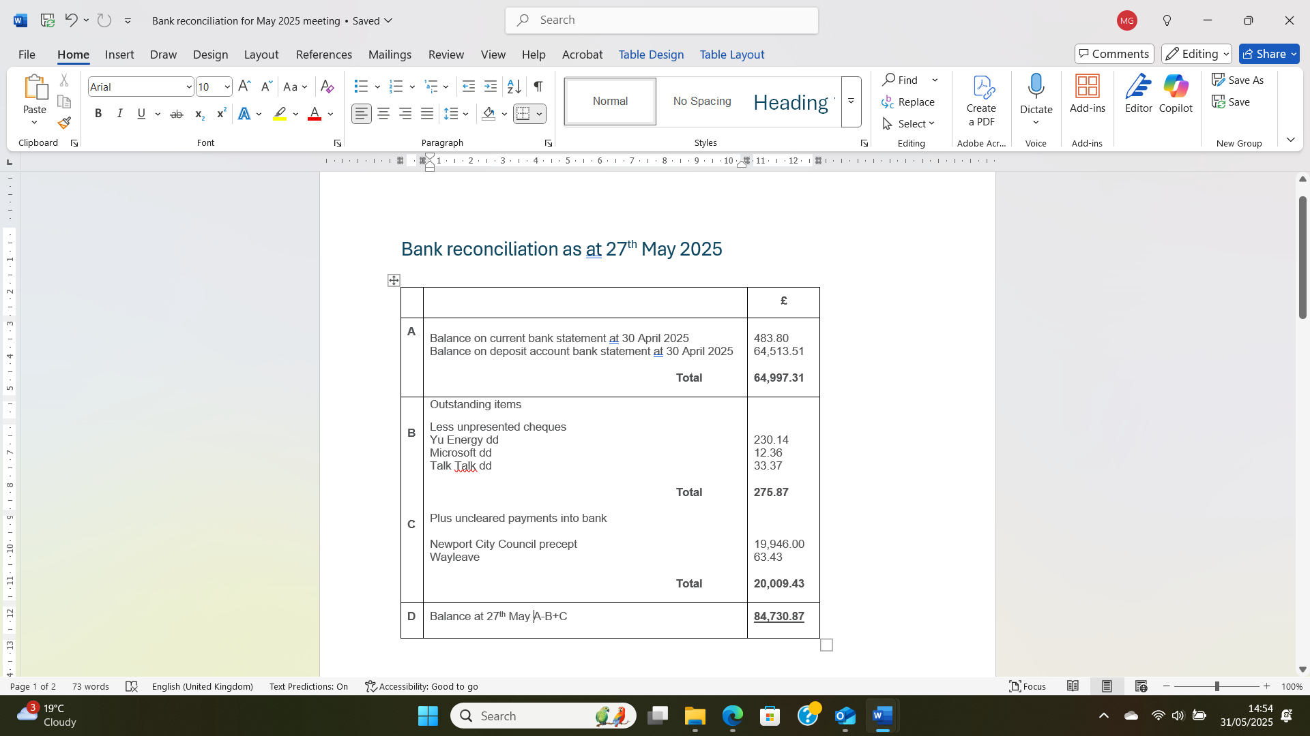  Audit 2024/25  Our Internal Audit has now taken place and the Clerk will publish the necessary notices on the noticeboard and website. It was agreed that the Clerk purchase a gift card for £100 for our internal auditor.  Accounts for Payment  YuEnergy - £230.14 (dd May)  TalkTalk - £33.37 (dd May)  Microsoft - £12.36 (dd May)  Clerk - £432.25 (BACS)  Chair (raffle prize for fete) - £29.99  Chair’s Purse  A purse of £200 was approved for this financial year.  Local Government and Elections (Wales) Act 2021: Community and Town Councils Statutory Guidance  Training modules were circulated.  Newport City Council Precept  Our first payment of £19,946 has been received.  Clerk’s Report for 2024/25  The Clerk circulated her report for the past financial year. It was agreed that this be published to the website. | Clerk  Clerk
 | SECTION C – LEISURE AND AMENITIES  Village Hall  Car Park – Newport City Council planning department are now requesting additional information owing to the recent updates made to Chapter 6 of Planning Policy Wales Edition 12. A Green Infrastructure Statement (GIS) is required to be submitted with the application, as this is a material policy change since the original approval. The Chair is now seeking the advice of a consultant to undertake this and advise on how biodiversity enhancement can be achieved for the development.  Halls together Rural Development Project – on-going.  Future Events – The village fete will be held on 28th June  Dog Fouling – Ward Cllr Kellaway is awaiting a response. | Chair
SECTION D – HIGHWAYS AND UTILITIES

Llanwern Park Bridge

On-going.

9. | CORRESPONDENCE – the following were emailed to Councillors:  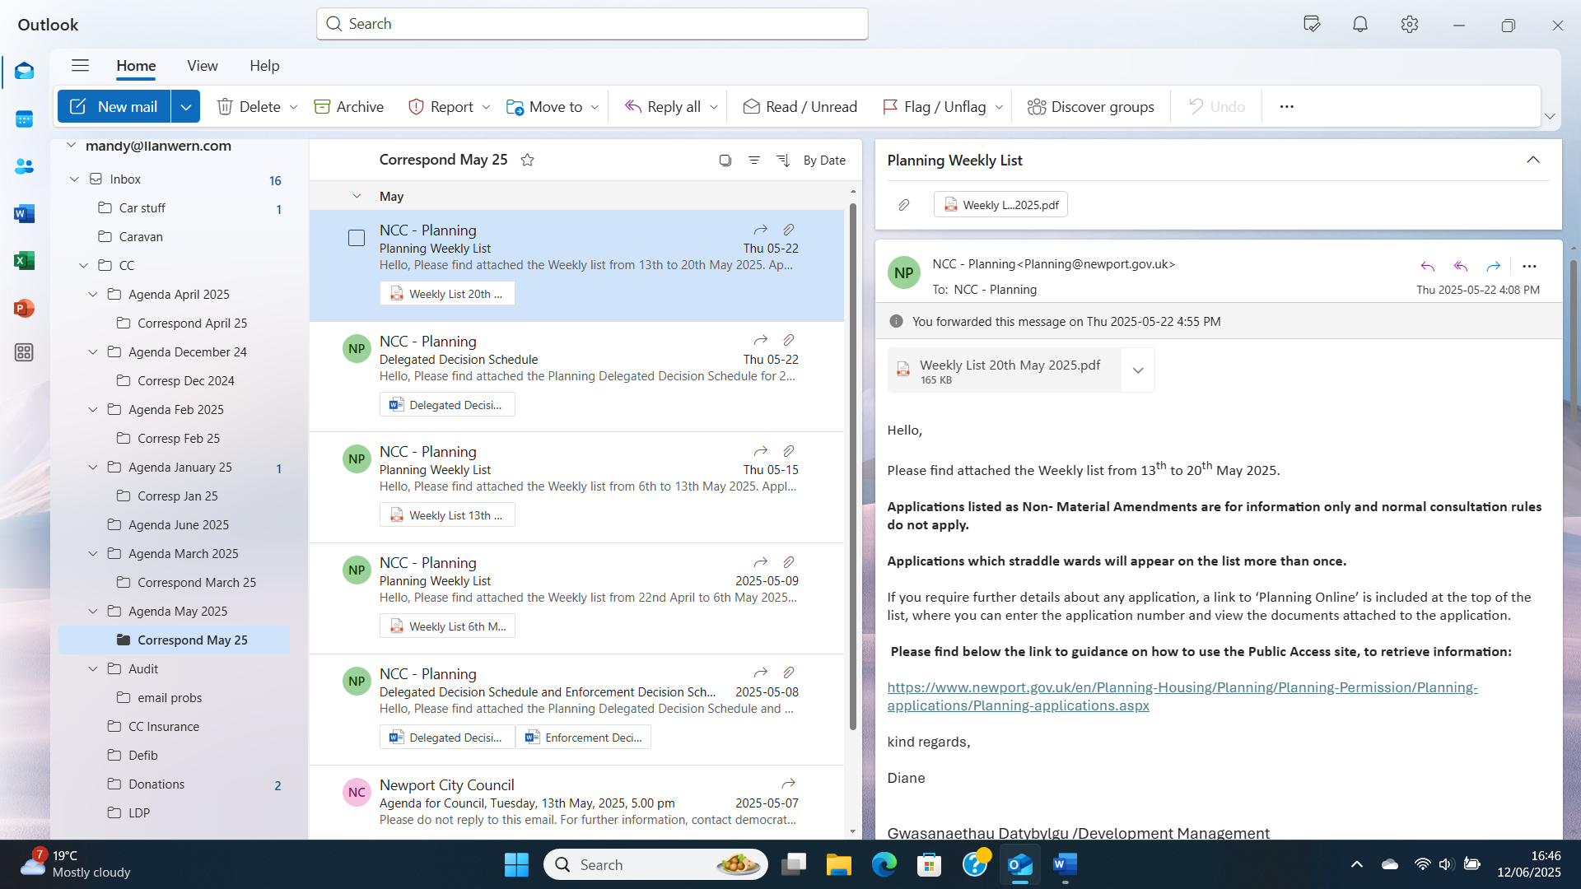  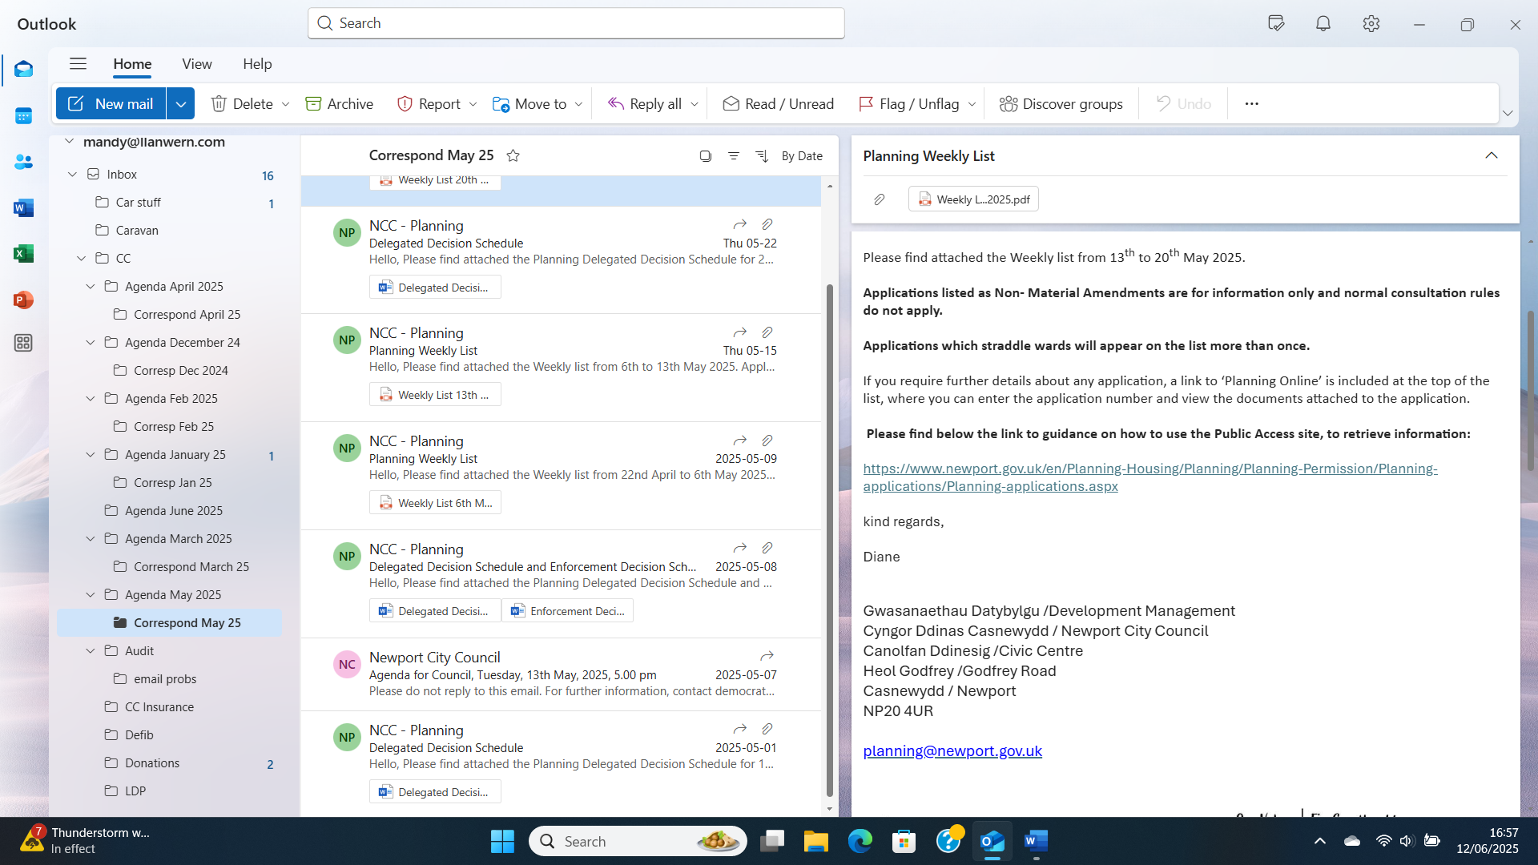
10. | DATE OF NEXT MEETING  The next meeting will be held on Monday 30th June 2025. This meeting will be held at the Village Hall and also remotely. The meeting closed at 8.33 pm.

