LLANWERN COMMUNITY COUNCIL

MINUTES OF MEETING

HELD AT LLANWERN VILLAGE HALL
MONDAY 27th OCTOBER 2025 AT 7.00 PM

PRESENT: Cllrs M George (Chair), Brown, Clemo, Collingbourne, Davies and Grant

3 members of the general public (one via Teams)

Clerk: Mandy George

Item | Description | Action
1. | APOLOGIES FOR ABSENCE  Apologies were received from Cllr Jones.
2. | MINUTES OF PREVIOUS MEETINGS  The Minutes of the meeting held on 29th September 2025 were duly approved and signed.
3. | DECLARATIONS OF INTEREST  It was resolved that any declarations of interest should be stated during the course of the meeting, noted here and the necessary form completed.  Cllr Collingbourne declared his interest in the item regarding a donation to Llanwern Tots Group.
4. | PUBLIC PARTICIPATION  A local resident attended the meeting via Teams but was concerned that she couldn’t hear very well and that no introductions were given. Efforts were made to move the laptop and it was agreed that a speaker be purchased. Cllr Grant to source.  One concern raised by all 3 residents present were a lack of dog/litter bins on the Redrow Development. The Chair will again lobby Redrow for the one promised for the bottom of the Spine Road. A resident advised that the Community Council could purchase a bin, as Redrow residents paid a precept to this Council. It was pointed out that the Community Council cannot purchase a bin to be placed on unadopted land, this would be something Redrow had to arrange through the Management Company. This was disputed and the Clerk will check that this Council’s information is correct. A resident cited Trelewis and Bedlinog Community Council who had paid for litter/dog bins for their residents and arranged for their emptying.  Grass cutting is an on-going problem and the Management Company have contractors cutting grass in adverse weather conditions, which is causing an unsightly mess. Cllr Grant suggested that the residents petition Redrow to change the Management Company. Some residents are withholding their payments in protest.  The Clerk has contacted Newport Transport regarding the DRT route, they are aware of the problem and hope to resolve it with the resident. | KG  Clerk
5. | Redrow – (also see above comments)  The Clerk is awaiting a list of concerns detailing specific dates and incidents regarding POBL residents.  The road is due to be re-closed opposite Little Milton Gardens, the Chair will find out when – this will be chased again.  Cllr Kellaway has again requested that a copy of the Outline Business Case report for the Station Road Flood Alleviation Scheme be sent to this Community Council for review and comment – nothing yet received.  The latest stats were received from Gwent Police for the Llanwern Ward and circulated to all. A copy was also sent to GMPRA. | Chair  MK
Glan Llyn

Responses are still being chased from Revantage regarding the meeting with the Chair, Ward Cllr Kellaway and Cllr Clemo. Ward Cllr Kellaway has escalated. Phase 1 has still not all been adopted. A bus shelter has been erected on the small stretch of adopted road and a glass pane has been smashed. This is the responsibility of NCC to repair.

20/0986 – Reserved Matters Application for 32no. Residential Flat Units (Housing Phase 2), Associated Infrastructure and Landscaping all Pursuant to Outline Permission 16/0864 for Residential Development of up to 1100 Dwellings, a Primary School, Village Centre, Public Open Space, Landscaping and Associated Infrastructure Works and Details to Partially Discharge the Following Conditions in Relation to Phase 2, 01 (Reserved Matters), 05 (Building Materials), 06 (Hardscaping Materials), 07 (Boundaries), 09 (Construction Details of Roads, Footways and Highways), 12 (Drainage), 21 (Parking) and 24 (Landscaping) – Llanwern Village Development Site Phase 2 Cot Hill.

On-going (part approved and part refused). To be read in conjunction with 22/0435 which is part approved and part refused.

22/0801 – Reserved Matters Application (Pursuant to Outline Permission 06/0471) for Residential Development on Phases 4b & 5d at the Glan Llyn Regeneration Site to Provide 170 Dwellings Including Details of Access, Appearance, Landscaping, Layout and Scale Together With Details to Partially Discharge Outline Planning Conditions 6 (Recreation Areas), 8 (Materials), 9 (Hard Landscaping), 10 (Boundary Treatments), 11 (Management Of Open Space), 12 (Parking), 15 (Emergency Access), 16 (Roads, Cycleways and Footways), 18 (Road Works), 22 (Streetlighting), 24 (Site Levels), 33 (Surface Water), 34 (Foul and Surface Water Drainage), 35 (Oil Interceptors), 39 (Carbon Reduction and Sustainability) and 43 (Firefighting Access) Llanwern Works Queensway Llanwern Newport

A comprehensive revision was submitted by the applicant and circulated to all.

23/0440 – Reserved Matters Application for 176 Dwellings and Associated Works on Phase 4d, Pursuant to Outline Planning Permission 06/0471 for the Redevelopment of Site to Create a Mixed Use Urban Extension. Phase
4D Glan Llyn Development Site Queensway Llanwern Newport South Wales
This application was approved with conditions.

24/0465 - Reserved Matters Application for New Homes, Associated Infrastructure and Landscaping at Cedars 4 Pursuant to Outline Planning Permission 16/0864 for Residential Development of up to 1100 Dwellings and Provision of Primary School, Village Centre, Public Open Space, Landscaping and Associated Infrastructure Works Affecting Public Rights of Way 397/3, 397/7, 397/9 and 397/10, and Details to Discharge Conditions 5 (Building Materials), 6 (Hardscaping Materials), 7 (Boundary
Treatments), 9 (Highway Construction Details), 12 (Drainage), 18 (Ecological Management Plan), 19 (Noise Assessment), 21 (Parking) And 24 (Landscaping)

On-going.

24/0466 - Reserved Matters Application for new Homes, Associated Infrastructure and Landscaping at Parcels Known as Hollies 5 and Hollies 6 Pursuant to Outline Planning Permission 16/0864 for Residential Development of up to 1100 Dwellings and Provision of Primary School, Village Centre, Public Open Space, Landscaping and Associated Infrastructure Works Affecting Public Rights of Way 397/3, 397/7, 397/9 and 397/10, and Details to Discharge Conditions 5 (Building Materials), 6 (Hardscaping Materials), 7 (Boundary Treatments), 9 (Highway Construction Details), 12 (Drainage), 21 (Parking) and 24 (Landscaping) Site: Llanwern Village Development Site Phase 1 Cot Hill Llanwern Newport NP18 2DP

Additional/amended information submitted. Circulated to all.

24/0467 – Reserved Matters Application for Sports Pitches, Changing Facilities and Allotments, Associated Infrastructure and Landscaping Pursuant to Outline Planning Permission 16/0864 for Residential Development of up to 1100 Dwellings and Provision of Primary School, Village Centre, Public Open Space, Landscaping and Associated Infrastructure Works Affecting Public Rights of Way 397/3, 397/7, 397/9 and 397/10, and Details to Discharge Conditions 5 (Building Materials), 6 (Hardscaping Materials), 7 (Boundary Treatments), 12 (Drainage), 21 (Parking) and 24 (Landscaping) – Llanwern Village Development Site Phase 1 Cot Hill, Llanwern.

On-going.

25/0152 – Reserved Matters Application Relating to Layout, Scale, Appearance, Access and Landscaping for Residential Development at Phase4e/4g Pursuant To Outline Planning Permission 06/0471 for a Mixed Use Regeneration of the Former Llanwern Steelworks and Partial Discharge of Conditions 01 (Reserved Matters), 06 (Recreational Areas), 08 (Materials), 09 (Details of Hard Landscaped Access), 10 (Boundary Treatments), 11 (Management Strategy for Maintenance of Open Space), 12 (Off Street Parking and Cycle Parking), 15 (Emergency Access), 16 (Details of Roads/Cycleways/Footways), 18 (Estate Roads), 22 (Street Lighting and Car Parking Areas), 24 (Site Levels), 33 & 34 (Foul and Surface Water Drainage), 39 (Sustainability Statement) and 43 (Fire
Fighting Access) Site: Glan Llyn Development Site Phase 4e/4g
Queensway Llanwern Newport South

On-going.

25/0177 - Reserved Matters Application Relating to Layout, Scale, Appearance, Access and Landscaping for 3 No. Commercial Units (Use Class B1, B2, B8) Pursuant to Outline Planning Permission 06/0471 for a Mixed Use Regeneration of the Former Llanwern Steelworks and Partial Discharge of Conditions 01 (Reserved Matters), 08 (Materials), 09
(Details of Hard Landscaped Access), 10 (Boundary Treatments), 11 (Management Strategy for Maintenance of Open Space), 12 (Off Street Parking and Cycle Parking), 15 (Emergency Access), 16 (Details of Roads/Cycleways/Footways), 18 (Estate Roads), 22 (Street Lighting and Car Parking Areas), 24 (Site Levels), 33 (Surface Water Disposal), 34 (Foul and Surface Water Drainage), 39 (Sustainability Statement) and 43 (Fire Fighting Access)Site: Llanwern Works Queensway Llanwern
Newport South Wales

On-going.

Craig Y Perthi Solar Farm Proposal

This application was refused. The Inspector’s Report was circulated to all.

Flooding of Subway to Dawson Close

On-going.

Newport LDP

On-going

 | SECTION B  FINANCE AND LOCAL GOVERNMENT  Bank Reconciliation Statement as at 27th October 2025:  Accounts for Payment  DDs  YuEnergy - £87.31  TalkTalk - £33.37  Microsoft - £12.10  HMRC - £254.07 (PAYE and NI)  BACS  Clerk – £446.25  RBLI - £228.98 (poppies – soldier design)  RBL - £50 (poppies)  Defib World – £482.59 (replacement pads for 2 x defibs)  Local Government and Elections (Wales) Act 2021: Community and Town Councils Statutory Guidance  Training modules were circulated. The Clerk has booked a place on the Biodiversity Report writing training.  Audit 2024/25  No response received from Audit Wales regarding the disputed statement.  Defibrillator Maintenance  The Clerk advised that the batteries for the 2 defibrillators have a life expectancy of 5 years. As the defibrillators are just over 5 years old it was unanimously agreed that the Clerk order 2 replacements at a cost of £199 plus vat (each) and delivery.  S 106 Monies  Cllr Davies had asked the Clerk to obtain the latest list of 106 commitments / payments to Newport Council – this was received and Cllr Davies asked the Clerk to find out where the S106 contributions are listed that related specifically to the school and bus service on the Redrow Development.  The Clerk was asked to chase the S106 payment due to be made towards the playing field. | Clerk  Clerk  Clerk  Clerk
   |  | £
  A | Balance on current a/c bank statement at 30th Sept 2025  Balance on deposit a/c bank statement at 27th Oct 2025  Total | 366.65  83,510.47  83,877.12
   | Outstanding items
  B | Less unpresented cheques:  British Gas  RBL Poppies  Fire and Safety  RBLI Poppies  Clerk Salary and back pay  YuEnergy  Microsoft  TalkTalk  HMRC  Total | 73.80  50.00  173.66  228.98  426.85  87.31  12.10  33.37  254.07  1,340.14
  C | Plus uncleared payments into bank  0  Total | 0  0
  D | Balance at 27th October A-B+C | 82,536.98
 | SECTION C – LEISURE AND AMENITIES  Village Hall  Car Park – The Green Infrastructure Statement has been received and circulated to all. The architect has suggested an area of fruit trees to satisfy some of the bio-diversity requirements but these aren’t mandatory. The Chair will liaise with the architect.  Halls together Rural Development Project – on-going.  Future Funding – a meeting has been arranged for 7th November.  Future Events – A festive craft fayre is being held on 29th November and Christmas tree lighting on 6th December.  St Mary’s Tots Group  The Clerk advised that the Tots Group are short of money due to lack of numbers attending and their discounted rent has come to an end. Although numbers were excellent last week this is not usually the case. The rent is £8.50 per hour and they meet for 1½ hours per week, during term time. It was agreed that a donation be made in December to tide them over until the end of March. This can then be reviewed. The Clerk will advise the organisers. | Chair  Clerk
SECTION D – HIGHWAYS AND UTILITIES

Llanwern Park Bridge

On-going.

6. | CORRESPONDENCE – the following were emailed to Councillors:  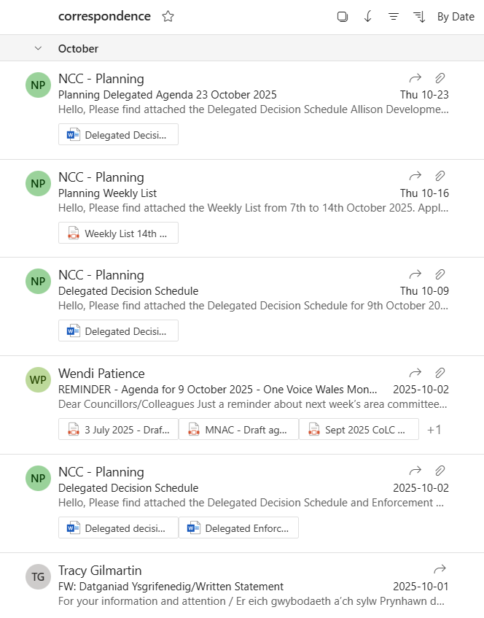
7. | DATE OF NEXT MEETING  The next meeting will be held on Monday 24th November 2025. This meeting will be held at the Village Hall and also remotely. The meeting closed at 9.00 pm.

