LLANWERN COMMUNITY COUNCIL

MINUTES OF MEETING

HELD AT LLANWERN VILLAGE HALL
MONDAY 28th JULY 2025 AT 7.00 PM

PRESENT: Cllrs M George (Chair), Brown, Clemo, Collingbourne, Davies and Grant

Clerk: Mandy George

Item | Description | Action
1. | APOLOGIES FOR ABSENCE  Apologies were received from Cllr Jones (holiday).
2. | MINUTES OF PREVIOUS MEETINGS  The Minutes of the meeting held on 30th June 2025 were duly approved and signed.
3. | DECLARATIONS OF INTEREST  It was resolved that any declarations of interest should be stated during, the course of the meeting.  The Chair declared his interest in Section B – Clerk’s Pay 2025/2026 and took no part in the discussion, voting thereon and vacated the Chair.
4. | PUBLIC PARTICIPATION  None.
5. | Redrow – Station Road Drainage and Junction  The Clerk has obtained a contact name and email address for POBL. The residents’ association will forward a list of concerns detailing specific dates and incidents.  The road is due to be re-closed opposite Little Milton Gardens, the Chair will find out when.  The Clerk will enquire via our Ward Councillor, for the latest information regarding the new school.  Cllr Davies asked the Clerk to obtain the latest list of 106 commitment/payments to Newport Council.  The Chair will arrange a meeting in early September to find out the current position with the Station Road drainage scheme.  The latest stats were received from Gwent Police for the Llanwern Ward and circulated to all. A copy was also sent to GMPRA. | Clerk  Clerk  Chair
 | Glan Llyn  NCC Highways have now advised that no signage/speed signs can be positioned until after the roads have been adopted.  The Clerk was requested to set up a meeting with the contact Cllr Clemo has from Revantage who have taken over the responsibilities of St Modwen.  Cllr Brown advised that the Head Teacher of Glan Llyn Primary School has approached the developer but not received a response. | Clerk
 | 20/0986 – Reserved Matters Application for 32no. Residential Flat Units (Housing Phase 2), Associated Infrastructure and Landscaping all Pursuant to Outline Permission 16/0864 for Residential Development of up to 1100 Dwellings, a Primary School, Village Centre, Public Open Space, Landscaping and Associated Infrastructure Works and Details to Partially Discharge the Following Conditions in Relation to Phase 2, 01 (Reserved Matters), 05 (Building Materials), 06 (Hardscaping Materials), 07 (Boundaries), 09 (Construction Details of Roads, Footways and Highways), 12 (Drainage), 21 (Parking) and 24 (Landscaping) – Llanwern Village Development Site Phase 2 Cot Hill.  On-going (part approved and part refused). To be read in conjunction with 22/0435 which is part approved and part refused.  22/0284 - Partial Discharge of Condition 12 (Foul and Surface Water Drainage and Surface Water Attenuation) of Planning Permission 16/0864 (Phase 2 Only) For Variation of Conditions of Planning Permission 13/0806 Varying Time Limits of Planning Permission 06/0845 for Residential Development (Up To 1100 Dwellings) and Provision of Primary School, Village Centre, Public Open Space, Landscaping and Associated Infrastructure Works (Affecting Public Rights of Way 397/3, 397/7, 397/9 and 397/10 Llanwern)  This application has been withdrawn.  22/0789 - Partial Discharge of Conditions 4 (Infrastructure Phasing) in Respect of Phases 2, 3 and the Site Attenuation Ponds and 12 (Drainage) of 16/0864 Variation of Conditions 02 (Reserved Matters), 03 (Masterplan) and 05 (Design Code) of Planning Permission 13/0806 for Variation of Condition (Time Limits) of Planning Permission 06/0845 for Residential Development (Up to 1100 Dwellings) and Provision of Primary School, Village Centre, Public Open Space, Landscaping and Associated Infrastructure Works (Affecting Public Rights of Way 397/3, 397/7, 397/9 and 397/10 Llanwern)  This application has been withdrawn.  22/0801 - Reserved Matters Application (Pursuant to Outline Permission 06/0471) for Residential Development on Phases 4b & 5d at the Glan Llyn Regeneration Site to Provide 170 Dwellings Including Details of Access, Appearance, Landscaping, Layout and Scale Together With Details to Partially Discharge Outline Planning Conditions 6 (Recreation Areas), 8 (Materials), 9 (Hard Landscaping), 10 (Boundary Treatments), 11 (Management Of Open Space), 12 (Parking), 15 (Emergency Access), 16 (Roads, Cycleways and Footways), 18 (Road Works), 22 (Streetlighting), 24 (Site Levels), 33 (Surface Water), 34 (Foul and Surface Water Drainage), 35 (Oil Interceptors), 39 (Carbon Reduction and Sustainability) and 43 (Firefighting Access) Llanwern Works Queensway Llanwern Newport  On-going.  23/0440 Reserved Matters Application for 176 Dwellings and Associated Works on Phase 4d, Pursuant to Outline Planning Permission 06/0471 for the Redevelopment of Site to Create a Mixed Use Urban Extension. Phase  4D Glan Llyn Development Site Queensway Llanwern Newport South Wales  On-going.  24/0465 - Reserved Matters Application for New Homes, Associated Infrastructure and Landscaping at Cedars 4 Pursuant to Outline Planning Permission 16/0864 for Residential Development of up to 1100 Dwellings and Provision of Primary School, Village Centre, Public Open Space, Landscaping and Associated Infrastructure Works Affecting Public Rights of Way 397/3, 397/7, 397/9 and 397/10, and Details to Discharge Conditions 5 (Building Materials), 6 (Hardscaping Materials), 7 (Boundary  Treatments), 9 (Highway Construction Details), 12 (Drainage), 18 (Ecological Management Plan), 19 (Noise Assessment), 21 (Parking) And 24 (Landscaping)  On-going.  24/0467 – Reserved Matters Application for Sports Pitches, Changing Facilities and Allotments, Associated Infrastructure and Landscaping Pursuant to Outline Planning Permission 16/0864 for Residential Development of up to 1100 Dwellings and Provision of Primary School, Village Centre, Public Open Space, Landscaping and Associated Infrastructure Works Affecting Public Rights of Way 397/3, 397/7, 397/9 and 397/10, and Details to Discharge Conditions 5 (Building Materials), 6 (Hardscaping Materials), 7 (Boundary Treatments), 12 (Drainage), 21 (Parking) and 24 (Landscaping) – Llanwern Village Development Site Phase 1 Cot Hill, Llanwern.  On-going.  24/0782 - Reserved Matters (Condition 01) for Proposed Retail Store, Nursery (D1) and 3no. Commercial Units and Associated Works in Local Centre and Partial Discharge of Conditions 07 (Landscaping), 08 (Materials/Finishes to External Surfaces), 9 (Materials/Finishes for  Hard Landscaped Areas), 10 (Boundary Treatments), 12 (Parking), 15 (Emergency Access), 16 (Roads, Cycleways and Footways), 17  (Green Travel Strategy), 19 (Noise Assessment), 22 (Lighting), 23 (Ecological Management Plan), 24 (Site Levels), 27 (Ground Conditions), 28 (Verification Report), 32 (Piling Works), 33 (Surface Water), 34 (Foul and Surface Water Drainage and Storage) and 39 (Carbon  Reduction Strategy) Relating to Outline Planning Permission 06/0471 for Redevelopment of Site to Create a Mixed Use Urban Extension  SITE: Land West of 1 Kings Wall Drive Newport South Wales  This application has been approved with conditions.  25/0152 – Reserved Matters Application Relating to Layout, Scale, Appearance, Access and Landscaping for Residential Development at Phase4e/4g Pursuant To Outline Planning Permission 06/0471 for a Mixed Use Regeneration of the Former Llanwern Steelworks and Partial Discharge of Conditions 01 (Reserved Matters), 06 (Recreational Areas), 08 (Materials), 09 (Details of Hard Landscaped Access), 10 (Boundary Treatments), 11 (Management Strategy for Maintenance of Open Space), 12 (Off Street Parking and Cycle Parking), 15 (Emergency Access), 16 (Details of Roads/Cycleways/Footways), 18 (Estate Roads), 22 (Street Lighting and Car Parking Areas), 24 (Site Levels), 33 & 34 (Foul and Surface Water Drainage), 39 (Sustainability Statement) and 43 (Fire  Fighting Access) Site: Glan Llyn Development Site Phase 4e/4g  Queensway Llanwern Newport South  On-going.  25/0176 - Reserved Matters Application Relating to Layout, Scale, Appearance, Access and Landscaping for 4 No. Commercial Units (Use Class B1, B2, B8) Pursuant to Outline Planning Permission 06/0471 for a Mixed Use Regeneration of the Former Llanwern Steelworks and Partial Discharge of Conditions 01 (Reserved Matters), 08 (Materials), 09  (Details of Hard Landscaped Access), 10 (Boundary Treatments), 11 (Management Strategy for Maintenance of Open Space), 12 (Off Street Parking and Cycle Parking), 15 (Emergency Access), 16 (Details of Roads/Cycleways/Footways), 18 (Estate Roads), 22 (Street Lighting and Car Parking Areas), 24 (Site Levels), 33 (Surface Water Disposal), 34 (Foul and Surface Water Drainage), 39 (Sustainability Statement) and 43 (Fire Fighting Access)Site: Llanwern Works Queensway Llanwern  Newport South Wales  On-going.  25/0177 - Reserved Matters Application Relating to Layout, Scale, Appearance, Access and Landscaping for 3 No. Commercial Units (Use Class B1, B2, B8) Pursuant to Outline Planning Permission 06/0471 for a Mixed Use Regeneration of the Former Llanwern Steelworks and Partial Discharge of Conditions 01 (Reserved Matters), 08 (Materials), 09  (Details of Hard Landscaped Access), 10 (Boundary Treatments), 11 (Management Strategy for Maintenance of Open Space), 12 (Off Street Parking and Cycle Parking), 15 (Emergency Access), 16 (Details of Roads/Cycleways/Footways), 18 (Estate Roads), 22 (Street Lighting and Car Parking Areas), 24 (Site Levels), 33 (Surface Water Disposal), 34 (Foul and Surface Water Drainage), 39 (Sustainability Statement) and 43 (Fire Fighting Access)Site: Llanwern Works Queensway Llanwern  Newport South Wales  On-going.  25/0399 – Installation of Air Source Heat Pump. 109 Bessemer Drive, NP19 4TN  This application has been approved with conditions.  25/0438 – Proposed Swale and Greenway on Land East of Phase 4c and West of Phase 4e/4g – Glan Llyn Development Site  This application was circulated to all. Cllr Davies will report back.  25/0453 – Installation of a Temporary Weir at Drain 2 – Glan Llyn Development Site  This application was circulated to all. Cllr Davies will report back. The Chair advised that the purpose is to hold water at a certain level and there has been no objection by NRW.  Craig Y Perthi Solar Farm Proposal  On-going.  Flooding of Subway to Dawson Close  On-going.  Newport LDP  On-going | OD  OD
 | SECTION B  FINANCE AND LOCAL GOVERNMENT  Bank Reconciliation Statement as at 28th July 2025:  £  A Balance on current bank statement at 30 June 2025 Balance on deposit account bank statement at 28 July 2025 Total 512.48 82,513.51 83,025.99  Outstanding items  B Less unpresented cheques Yu Energy dd SSE Energy Microsoft dd Talk Talk dd Clerk’s salary June HMRC Total 13.98 197.44 12.36 33.37 359.65 224.67 841.47  C Plus uncleared payments into bank HMRC vat Total 1,252.64 1,252.64  D Balance at 28th July A-B+C 83,437.16  Accounts for Payment  YuEnergy - £13.98 (dd July)  TalkTalk - £33.37 (dd July)  Microsoft - £12.36 (dd July)  Towergate (Village Hall Insurance) - £1,097.68 (BACS)  Clerk - £432.25 (BACS)  HMRC (PAYE and Employers NI) - £ 224.67 (dd)  Local Government and Elections (Wales) Act 2021: Community and Town Councils Statutory Guidance  Training modules were circulated.  Audit 2024/25  The Clerk will take our paperwork to Audit Wales by 8th August.  Members’ Allowances  All those present declined all Councillor Allowance Payments.  Budget Monitoring  The Clerk presented the first quarter’s budget monitoring spreadsheet which was circulated to all.  Clerk’s Pay 2025/2026  Cllr Brown presented a report after receiving notification from One Voice Wales that the National Joint Council for Local Government Services had reached agreement on rates of pay applicable from 1st April 2025 to 31st March 2026.  It was unanimously agreed that with effect from 1st August 2025, the Clerk’s hourly rate be increased to £17.85 per hour (£446.25 pcm) based on the current 25 contracted hours, equating to £5,355 pa and that the increase by backdated to 1st April 2025, total backpay £56 (£14 pm x 4). | Clerk
 | SECTION C – LEISURE AND AMENITIES  Village Hall  Car Park – The Chair has contacted the landscape architect to agree the quotation of £1,800 plus vat. The work will now be undertaken and Roberts Limbrick will liaise with Hugh Dixon. The Chair will contact Cllr Jones with a view to preparing draft drawings and costings.  Insurance – A renewal premium of £1,097.68 was received from Towergate Brokers. This is a new 3 year lta until renewal in 2028.  Halls together Rural Development Project – on-going.  Future Events – An enquiry was received regarding the use of the field for a children’s party involving a bouncy castle. The Clerk has contacted our insurance company who have advised that our policy will only cover for activities organised by us. For a private party our insurance will only cover public liability for the land. The hirer of the bouncy castle should carefully check the public liability cover, inspection certificate etc and adhere to the rules the company asks of them. This Council felt that they would still be responsible to check that this had been done and as such will decline all future requests for a bouncy castle in the field. The Clerk will report this to the next VHMC meeting who need to be aware when requests are received for a bouncy castle in the hall. | Chair  Clerk
SECTION D – HIGHWAYS AND UTILITIES

Llanwern Park Bridge

On-going.

6. | CORRESPONDENCE – the following were emailed to Councillors:  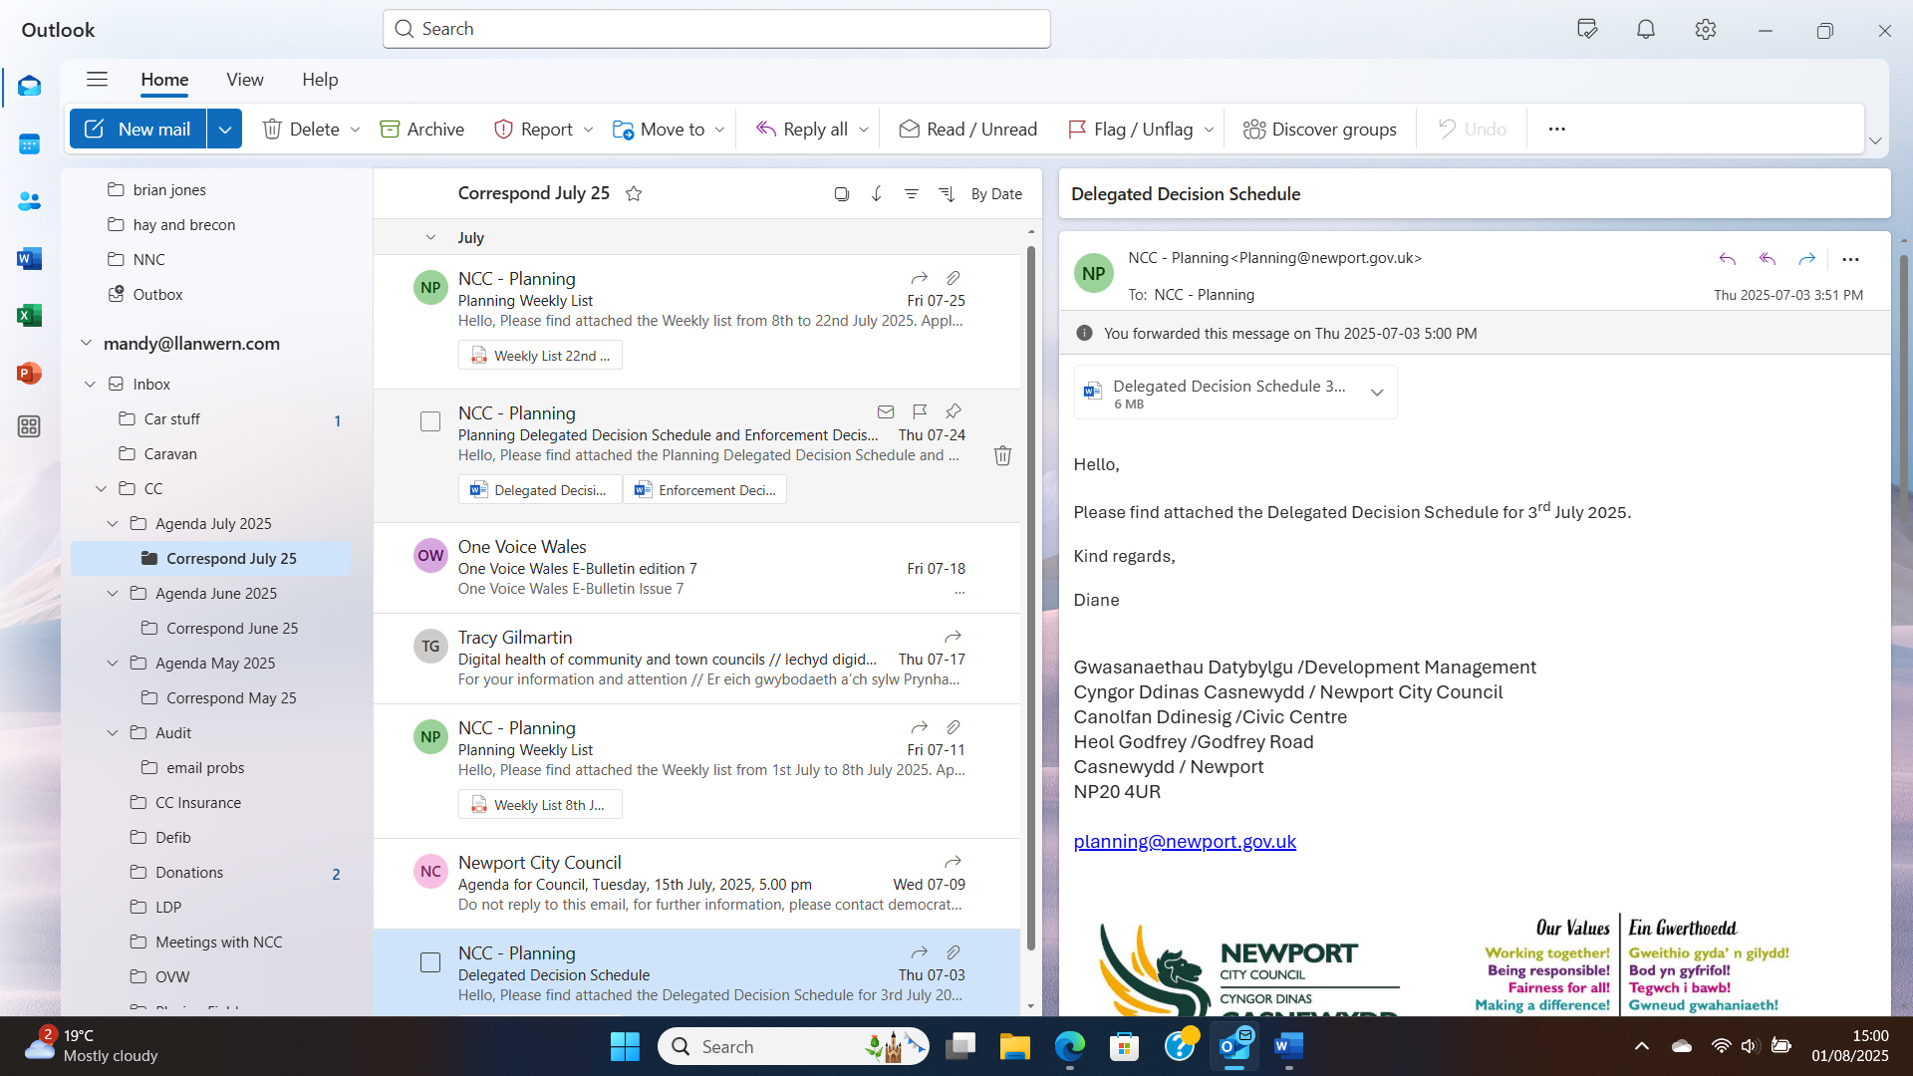  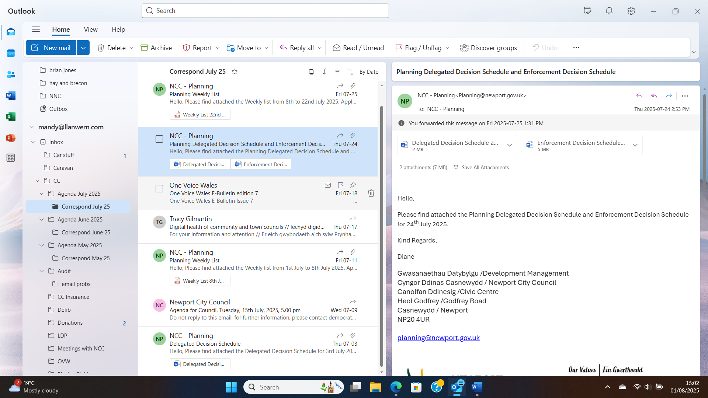
7. | DATE OF NEXT MEETING  The next meeting will be held on Monday 29th September 2025. This meeting will be held at the Village Hall and also remotely. The meeting closed at 8.40 pm.

