LLANWERN COMMUNITY COUNCIL

MINUTES OF MEETING

HELD AT LLANWERN VILLAGE HALL
MONDAY 29th SEPTEMBER 2025 AT 7.00 PM

PRESENT: Cllrs M George (Chair), Brown, Clemo, Collingbourne, Davies, Grant and Jones

2 members of the general public

Clerk: Mandy George

Item | Description | Action
1. | APOLOGIES FOR ABSENCE  Cllr Collingbourne sent his apologies and joined the meeting at 7.45pm.
2. | MINUTES OF PREVIOUS MEETINGS  The Minutes of the meeting held on 28th July 2025 were duly approved and signed.
3. | DECLARATIONS OF INTEREST  It was resolved that any declarations of interest should be stated during the course of the meeting, noted here and the necessary form completed.  Cllr Brown declared his interest in the item regarding future donations to Glan Llyn Primary School.
4. | PUBLIC PARTICIPATION  A local resident attended the meeting to voice concerns over the lack of signage to indicate that Cot Hill is now a dead end. Redrow had previously put up signage which has now disappeared. Cllr Davies explained that Redrow haven’t applied for a permanent road closure yet. Redrow are responsible for putting up the divert signs.  Another query raised by the resident was the fact that the DRT bus doesn’t now pick her up from outside her home as was previously the case. She has been told that the hill is dangerous to turn around on and the turning head opposite Woodland Cottage is sometimes blocked. The Clerk will contact Newport Transport. | Clerk
5. | Redrow – Station Road Drainage and Junction  The Clerk has obtained a contact name and email address for POBL. The residents’ association will forward a list of concerns detailing specific dates and incidents – nothing received to date.  The road is due to be re-closed opposite Little Milton Gardens, the Chair will find out when – nothing received.  The Clerk will enquire via our Ward Councillor, for the latest information regarding the new school – email received to confirm that planning permission has been granted and discussions are taking place about delivery of the school which may be Barratt Redrow or NCC.  Cllr Davies asked the Clerk to obtain the latest list of 106 commitment/payments to Newport Council – nothing received, the Clerk will chase.  The Chair and Cllr Kellaway have written to the Leader of NCC, advising that following the May meeting, a response was received from Officers on 2nd September, inferring that the Outline Business Case report for the Station Road Flood Alleviation Scheme will be completed by the end of September. Cllr Kellaway requested that a copy of the report be sent to this Community Council for review and comment, preferably before being submitted to Welsh Government. This Community Council are concerned that should Barratt Redrow apply for further phases for the development, Newport will have little option to grant same as the S106 monies have been paid towards Station Road drainage improvements.  The latest stats were received from Gwent Police for the Llanwern Ward and circulated to all. A copy was also sent to GMPRA. | Chair  Clerk
 | Glan Llyn  The Clerk was requested to set up a meeting with the contact Cllr Clemo has from Revantage who have taken over the responsibilities of St Modwen – the meeting was held and responses being chased.  The second primary school for Glan Llyn is scheduled for 2028.  Cllr Brown, who is a Trustee, wishes this Council to consider future donations to the School after he attended an excellent school play. Cllr Brown declared his interest in this item. This was agreed. | DClemo
20/0986 – Reserved Matters Application for 32no. Residential Flat Units (Housing Phase 2), Associated Infrastructure and Landscaping all Pursuant to Outline Permission 16/0864 for Residential Development of up to 1100 Dwellings, a Primary School, Village Centre, Public Open Space, Landscaping and Associated Infrastructure Works and Details to Partially Discharge the Following Conditions in Relation to Phase 2, 01 (Reserved Matters), 05 (Building Materials), 06 (Hardscaping Materials), 07 (Boundaries), 09 (Construction Details of Roads, Footways and Highways), 12 (Drainage), 21 (Parking) and 24 (Landscaping) – Llanwern Village Development Site Phase 2 Cot Hill.

On-going (part approved and part refused). To be read in conjunction with 22/0435 which is part approved and part refused.

22/0801 - Reserved Matters Application (Pursuant to Outline Permission 06/0471) for Residential Development on Phases 4b & 5d at the Glan Llyn Regeneration Site to Provide 170 Dwellings Including Details of Access, Appearance, Landscaping, Layout and Scale Together With Details to Partially Discharge Outline Planning Conditions 6 (Recreation Areas), 8 (Materials), 9 (Hard Landscaping), 10 (Boundary Treatments), 11 (Management Of Open Space), 12 (Parking), 15 (Emergency Access), 16 (Roads, Cycleways and Footways), 18 (Road Works), 22 (Streetlighting), 24 (Site Levels), 33 (Surface Water), 34 (Foul and Surface Water Drainage), 35 (Oil Interceptors), 39 (Carbon Reduction and Sustainability) and 43 (Firefighting Access) Llanwern Works Queensway Llanwern Newport
On-going.

23/0440 Reserved Matters Application for 176 Dwellings and Associated Works on Phase 4d, Pursuant to Outline Planning Permission 06/0471 for the Redevelopment of Site to Create a Mixed Use Urban Extension. Phase
4D Glan Llyn Development Site Queensway Llanwern Newport South Wales

On-going.

24/0465 - Reserved Matters Application for New Homes, Associated Infrastructure and Landscaping at Cedars 4 Pursuant to Outline Planning Permission 16/0864 for Residential Development of up to 1100 Dwellings and Provision of Primary School, Village Centre, Public Open Space, Landscaping and Associated Infrastructure Works Affecting Public Rights of Way 397/3, 397/7, 397/9 and 397/10, and Details to Discharge Conditions 5 (Building Materials), 6 (Hardscaping Materials), 7 (Boundary
Treatments), 9 (Highway Construction Details), 12 (Drainage), 18 (Ecological Management Plan), 19 (Noise Assessment), 21 (Parking) And 24 (Landscaping)

On-going.

24/0466 - Reserved Matters Application for new Homes, Associated Infrastructure and Landscaping at Parcels Known as Hollies 5 and Hollies 6 Pursuant to Outline Planning Permission 16/0864 for Residential Development of up to 1100 Dwellings and Provision of Primary School, Village Centre, Public Open Space, Landscaping and Associated Infrastructure Works Affecting Public Rights of Way 397/3, 397/7, 397/9 and 397/10, and Details to Discharge Conditions 5 (Building Materials), 6 (Hardscaping Materials), 7 (Boundary Treatments), 9 (Highway Construction Details), 12 (Drainage), 21 (Parking) and 24 (Landscaping) Site: Llanwern Village Development Site Phase 1 Cot Hill Llanwern Newport NP18 2DP

Additional/amended information submitted. Circulated to all.

24/0467 – Reserved Matters Application for Sports Pitches, Changing Facilities and Allotments, Associated Infrastructure and Landscaping Pursuant to Outline Planning Permission 16/0864 for Residential Development of up to 1100 Dwellings and Provision of Primary School, Village Centre, Public Open Space, Landscaping and Associated Infrastructure Works Affecting Public Rights of Way 397/3, 397/7, 397/9 and 397/10, and Details to Discharge Conditions 5 (Building Materials), 6 (Hardscaping Materials), 7 (Boundary Treatments), 12 (Drainage), 21 (Parking) and 24 (Landscaping) – Llanwern Village Development Site Phase 1 Cot Hill, Llanwern.

On-going.

25/0152 – Reserved Matters Application Relating to Layout, Scale, Appearance, Access and Landscaping for Residential Development at Phase4e/4g Pursuant To Outline Planning Permission 06/0471 for a Mixed Use Regeneration of the Former Llanwern Steelworks and Partial Discharge of Conditions 01 (Reserved Matters), 06 (Recreational Areas), 08 (Materials), 09 (Details of Hard Landscaped Access), 10 (Boundary Treatments), 11 (Management Strategy for Maintenance of Open Space), 12 (Off Street Parking and Cycle Parking), 15 (Emergency Access), 16 (Details of Roads/Cycleways/Footways), 18 (Estate Roads), 22 (Street Lighting and Car Parking Areas), 24 (Site Levels), 33 & 34 (Foul and Surface Water Drainage), 39 (Sustainability Statement) and 43 (Fire
Fighting Access) Site: Glan Llyn Development Site Phase 4e/4g
Queensway Llanwern Newport South

On-going.

25/0176 - Reserved Matters Application Relating to Layout, Scale, Appearance, Access and Landscaping for 4 No. Commercial Units (Use Class B1, B2, B8) Pursuant to Outline Planning Permission 06/0471 for a Mixed Use Regeneration of the Former Llanwern Steelworks and Partial Discharge of Conditions 01 (Reserved Matters), 08 (Materials), 09
(Details of Hard Landscaped Access), 10 (Boundary Treatments), 11 (Management Strategy for Maintenance of Open Space), 12 (Off Street Parking and Cycle Parking), 15 (Emergency Access), 16 (Details of Roads/Cycleways/Footways), 18 (Estate Roads), 22 (Street Lighting and Car Parking Areas), 24 (Site Levels), 33 (Surface Water Disposal), 34 (Foul and Surface Water Drainage), 39 (Sustainability Statement) and 43 (Fire Fighting Access)Site: Llanwern Works Queensway Llanwern
Newport South Wales

This application was approved with conditions.

25/0177 - Reserved Matters Application Relating to Layout, Scale, Appearance, Access and Landscaping for 3 No. Commercial Units (Use Class B1, B2, B8) Pursuant to Outline Planning Permission 06/0471 for a Mixed Use Regeneration of the Former Llanwern Steelworks and Partial Discharge of Conditions 01 (Reserved Matters), 08 (Materials), 09
(Details of Hard Landscaped Access), 10 (Boundary Treatments), 11 (Management Strategy for Maintenance of Open Space), 12 (Off Street Parking and Cycle Parking), 15 (Emergency Access), 16 (Details of Roads/Cycleways/Footways), 18 (Estate Roads), 22 (Street Lighting and Car Parking Areas), 24 (Site Levels), 33 (Surface Water Disposal), 34 (Foul and Surface Water Drainage), 39 (Sustainability Statement) and 43 (Fire Fighting Access)Site: Llanwern Works Queensway Llanwern
Newport South Wales

On-going.

25/0438 – Proposed Swale and Greenway on Land East of Phase 4c and West of Phase 4e/4g – Glan Llyn Development Site

This application was approved with conditions.

25/0453 – Installation of a Temporary Weir at Drain 2 – Glan Llyn Development Site

This application was approved with conditions.

Craig Y Perthi Solar Farm Proposal

On-going.

Flooding of Subway to Dawson Close

On-going.

Newport LDP

On-going

 | SECTION B  FINANCE AND LOCAL GOVERNMENT  Bank Reconciliation Statement as at 29th September 2025:  Accounts for Payment  DDs  YuEnergy - £12.66 (August)  YuEnergy - £9.42 (September  TalkTalk - £33.37 (August)  TalkTalk - £33.37 (September)  Microsoft - £12.10 (August)  Microsoft - £12.10 (September)  British Gas Boiler Service – £73.80 (annual)  BACS  Hostworld (email and dns) - £56.16  W M Garden Services (new play equipment and safety inspection) - £15,180  Roberts Limbrick (Green Infrastructure Statement) - £2,160  Clerk (August Salary) - £432.25  Clerk (September Salary) £446.25  Clerk (backpay) - £70  Defib World (replacement pads for 2 defibs) - £136.99  Spanglefish (website for 3 years) - £119.85  FSSS Ltd (village hall extinguishers) - £173.66  Local Government and Elections (Wales) Act 2021: Community and Town Councils Statutory Guidance  Training modules were circulated.  Audit 2024/25  The Auditor General’s report and audit opinion were received. The audit opinion was qualified on the following basis:  - The Council did not provide an explanation for variances between 2024-25 and 2023-24.  This was disputed by the Clerk and evidenced by the documents being in the folder submitted to Audit Wales. The Clerk has emailed to dispute this statement and has forwarded the documents to Audit Wales.  - The Council had not provided evidence that it calculated its budget requirement in accordance with the LG Finance Act 1992 and that the precept has been set in line with the budget. The Act requires the Council to take into account its income and level of reserves when setting its budget requirement.  The high level of reserves have been accumulated over a number of years and are to reflect the amount required to construct the village hall car park.  - Outdated published schedule of Members’ interests and interests declared at meetings.  Noted. The Clerk will arrange for new forms to be completed.  - Standing Orders and Financial Regulations are compared with model documents available from One Voice Wales  This is what we use.  The Clerk will arrange for the Notice of Completion of Audit and necessary documents to be published on the website and noticeboard.  Second Precept  The second installment of £19,946 has been received.  Sheep  A request was received for the use of the field. This was agreed. | Clerk  Clerk
   |  | £
  A | Balance on current a/c bank statement at 29th August 2025  Balance on deposit a/c bank statement at 27th August 2025  Total | 328.69  67,013.51  67,342.20
   | Outstanding items
  B | Less unpresented cheques  Yu Energy dd  Hostworld Internet  Microsoft dd  Talk Talk dd  Defib World  Roberts Limbrick  Total | 9.42  56.16  12.10  33.37  136.99  2,160.00  2,408.04
  C | Plus uncleared payments into bank  NCC Precept  Total | 19,946.00  19,946.00
  D | Balance at 29th September A-B+C | 84,880.16
 | SECTION C – LEISURE AND AMENITIES  A motion was hereby passed to exclude the Press and Public from the next item on the Agenda (Village Hall Car Park) due to the confidential nature of the business to be transacted.  Village Hall  Car Park – The Chair and Cllr Jones have received an indication of the costs involved in constructing the car park. This was discussed and noted. The purpose of this indication of costs was to answer any questions Audit Wales might have on our level of reserves.  The Green Infrastructure Statement is awaited, the Chair will chase.  Halls together Rural Development Project – on-going.  Altercation at Event – An altercation occurred at the hall which was being hired at the time. The Chair of the VHMC has contacted their insurance company who are happy with the hall being sub-let, provided the hirer has PL insurance. This is the case and this Council ask that the VHMC keep a copy of the PL insurance on file.  The issue that a resident was threatened with being barred from the hall was discussed.  Future Funding – the Clerk will arrange a meeting with the Chair of the VHMC and Cllrs Brown and CC Chair to discuss a future funding request.  Christmas Trees  It was agreed that the Chair arrange for 2 Christmas trees to be purchased. | Clerk  Clerk  Chair
 | SECTION D – HIGHWAYS AND UTILITIES  Llanwern Park Bridge  On-going.  Lamp Post Poppies  It was requested that the Clerk order further supplies of lamp post poppies up to the value of £300. The poppies with the soldier silhouette were requested.  Hedgecutting  It was agreed that the Chair arrange for hedgecutting after a health and safety concern was raised:  - Opposite Dockwell Terrace (trees overhanging road, obscuring visibility)  - Opposite 15 Public House (hedge overhanging road, obscuring visibility)  - Field behind village hall (responsibility of this Council) | Clerk  Chair
6. | CORRESPONDENCE – the following were emailed to Councillors:  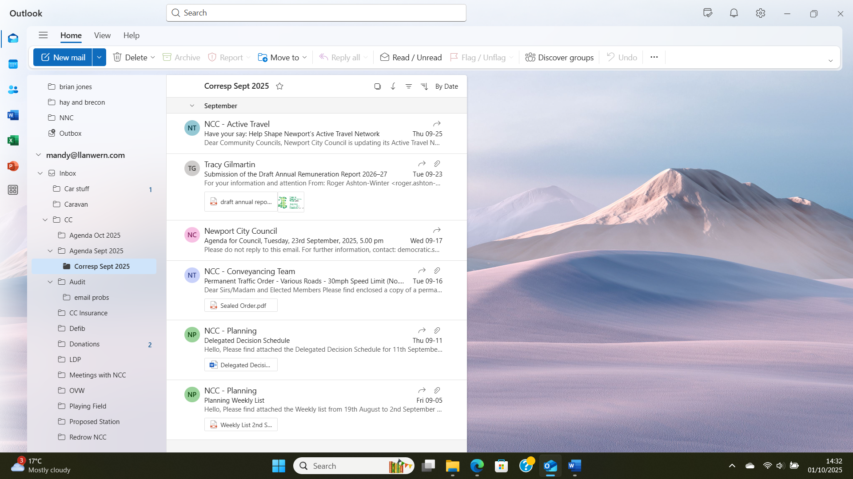
7. | DATE OF NEXT MEETING  The next meeting will be held on Monday 27th October 2025. This meeting will be held at the Village Hall and also remotely. The meeting closed at 8.50 pm.

