LLANWERN COMMUNITY COUNCIL

MINUTES OF MEETING

HELD AT LLANWERN VILLAGE HALL
MONDAY 30th JUNE 2025 AT 7.00 PM

PRESENT: Cllrs M George (Chair), Collingbourne, Davies, Grant and Jones

Clerk: Mandy George

In attendance: 4 members of Great Milton Park Residents’ Association

Item | Description | Action
1. | APOLOGIES FOR ABSENCE  Apologies were received from Cllrs Brown (illness) and Clemo (holiday).
2. | MINUTES OF PREVIOUS MEETINGS  The Minutes of the meeting held on 27th May 2025 were duly approved and signed.
3. | DECLARATIONS OF INTEREST  It was resolved that any declarations of interest should be stated during, the course of the meeting.
4. | PUBLIC PARTICIPATION  The Neighbourhood Watch scheme was discussed. It was suggested that this could include the whole village. Gwent Police don’t have any formal liaison, but South Wales Police do. Funding for signs etc could be available from the Community Council.  Issues were raised regarding certain POBL residents. The Clerk will contact Andrew Bettridge from John Griffiths’ office for a contact. The Clerk will be sent a list of problems by GMPRA with a view to arranging a meeting with POBL and this Council. | Clerk
5. | Redrow – Station Road Drainage and Junction  The main spine road through Redrow has now been temporarily closed for surfacing works to take place from Monday 30th June 2025, they expect the works to take 3 weeks to be completed (weather permitting).  The monthly report for the Llanwern Ward was received from PCSO Dan Sutherland and circulated to all. The Clerk will forward a copy of this report to GMPRA. | Clerk
 | Glan Llyn  The Chair has spoken to Highways and putting signs on the lamp posts would not be allowed. Regarding the radar speed sign(s), they would prior to considering this, put down rumble strips that record vehicles speed, this information would influence their decision on allowing a radar speed sign to be erected. Cllr Clemo is liaising with residents to ascertain the best places for the rumble strips.  The flooding of the playing area is still on-going. | DC
 | 20/0986 – Reserved Matters Application for 32no. Residential Flat Units (Housing Phase 2), Associated Infrastructure and Landscaping all Pursuant to Outline Permission 16/0864 for Residential Development of up to 1100 Dwellings, a Primary School, Village Centre, Public Open Space, Landscaping and Associated Infrastructure Works and Details to Partially Discharge the Following Conditions in Relation to Phase 2, 01 (Reserved Matters), 05 (Building Materials), 06 (Hardscaping Materials), 07 (Boundaries), 09 (Construction Details of Roads, Footways and Highways), 12 (Drainage), 21 (Parking) and 24 (Landscaping) – Llanwern Village Development Site Phase 2 Cot Hill.  On-going (part approved and part refused). To be read in conjunction with 22/0435 which is part approved and part refused.  22/0284 - Partial Discharge of Condition 12 (Foul and Surface Water Drainage and Surface Water Attenuation) of Planning Permission 16/0864 (Phase 2 Only) For Variation of Conditions of Planning Permission 13/0806 Varying Time Limits of Planning Permission 06/0845 for Residential Development (Up To 1100 Dwellings) and Provision of Primary School, Village Centre, Public Open Space, Landscaping and Associated Infrastructure Works (Affecting Public Rights of Way 397/3, 397/7, 397/9 and 397/10 Llanwern)  On-going. This application has been called-in.  22/0789 - Partial Discharge of Conditions 4 (Infrastructure Phasing) in Respect of Phases 2, 3 and the Site Attenuation Ponds and 12 (Drainage) of 16/0864 Variation of Conditions 02 (Reserved Matters), 03 (Masterplan) and 05 (Design Code) of Planning Permission 13/0806 for Variation of Condition (Time Limits) of Planning Permission 06/0845 for Residential Development (Up to 1100 Dwellings) and Provision of Primary School, Village Centre, Public Open Space, Landscaping and Associated Infrastructure Works (Affecting Public Rights of Way 397/3, 397/7, 397/9 and 397/10 Llanwern)  Pending decision.  22/0801 - Reserved Matters Application (Pursuant to Outline Permission 06/0471) for Residential Development on Phases 4b & 5d at the Glan Llyn Regeneration Site to Provide 170 Dwellings Including Details of Access, Appearance, Landscaping, Layout and Scale Together With Details to Partially Discharge Outline Planning Conditions 6 (Recreation Areas), 8 (Materials), 9 (Hard Landscaping), 10 (Boundary Treatments), 11 (Management Of Open Space), 12 (Parking), 15 (Emergency Access), 16 (Roads, Cycleways and Footways), 18 (Road Works), 22 (Streetlighting), 24 (Site Levels), 33 (Surface Water), 34 (Foul and Surface Water Drainage), 35 (Oil Interceptors), 39 (Carbon Reduction and Sustainability) and 43 (Firefighting Access) Llanwern Works Queensway Llanwern Newport  On-going.  23/0440 Reserved Matters Application for 176 Dwellings and Associated Works on Phase 4d, Pursuant to Outline Planning Permission 06/0471 for the Redevelopment of Site to Create a Mixed Use Urban Extension. Phase  4D Glan Llyn Development Site Queensway Llanwern Newport South Wales  On-going.  24/0465 - Reserved Matters Application for New Homes, Associated Infrastructure and Landscaping at Cedars 4 Pursuant to Outline Planning Permission 16/0864 for Residential Development of up to 1100 Dwellings and Provision of Primary School, Village Centre, Public Open Space, Landscaping and Associated Infrastructure Works Affecting Public Rights of Way 397/3, 397/7, 397/9 and 397/10, and Details to Discharge Conditions 5 (Building Materials), 6 (Hardscaping Materials), 7 (Boundary  Treatments), 9 (Highway Construction Details), 12 (Drainage), 18 (Ecological Management Plan), 19 (Noise Assessment), 21 (Parking) And 24 (Landscaping)  On-going.  24/0467 – Reserved Matters Application for Sports Pitches, Changing Facilities and Allotments, Associated Infrastructure and Landscaping Pursuant to Outline Planning Permission 16/0864 for Residential Development of up to 1100 Dwellings and Provision of Primary School, Village Centre, Public Open Space, Landscaping and Associated Infrastructure Works Affecting Public Rights of Way 397/3, 397/7, 397/9 and 397/10, and Details to Discharge Conditions 5 (Building Materials), 6 (Hardscaping Materials), 7 (Boundary Treatments), 12 (Drainage), 21 (Parking) and 24 (Landscaping) – Llanwern Village Development Site Phase 1 Cot Hill, Llanwern.  On-going.  24/0537 – Reserved Matters Application for a Primary School, Nursery, and Learning Resource Base, Mugas, Diversion of Existing Prow and Other Associated Works Pursuant to 16/0864 Variation of Conditions 02 (Reserved Matters), 03 (Masterplan) and 05 (Design Code) of Planning Permission 13/0806 for Variation of Condition (Time Limits) of Planning Permission 06/0845 for Residential Development (up to 1100 Dwellings) and Provision of Primary School, Village Centre, Public Open Space, Landscaping and Associated Infrastructure Works (Affecting Public Rights of Way 397/3, 397/7, 397/9 and 397/10 Llanwern)  SITE: Site of Future Primary School Great Milton Park Cot Hill Llanwern  Granted with conditions.  24/0782 - Reserved Matters (Condition 01) for Proposed Retail Store, Nursery (D1) and 3no. Commercial Units and Associated Works in Local Centre and Partial Discharge of Conditions 07 (Landscaping), 08 (Materials/Finishes to External Surfaces), 9 (Materials/Finishes for  Hard Landscaped Areas), 10 (Boundary Treatments), 12 (Parking), 15 (Emergency Access), 16 (Roads, Cycleways and Footways), 17  (Green Travel Strategy), 19 (Noise Assessment), 22 (Lighting), 23 (Ecological Management Plan), 24 (Site Levels), 27 (Ground Conditions), 28 (Verification Report), 32 (Piling Works), 33 (Surface Water), 34 (Foul and Surface Water Drainage and Storage) and 39 (Carbon  Reduction Strategy) Relating to Outline Planning Permission 06/0471 for Redevelopment of Site to Create a Mixed Use Urban Extension  SITE: Land West of 1 Kings Wall Drive Newport South Wales  Awaiting decision.  25/0152 – Reserved Matters Application Relating to Layout, Scale, Appearance, Access and Landscaping for Residential Development at Phase4e/4g Pursuant To Outline Planning Permission 06/0471 for a Mixed Use Regeneration of the Former Llanwern Steelworks and Partial Discharge of Conditions 01 (Reserved Matters), 06 (Recreational Areas), 08 (Materials), 09 (Details of Hard Landscaped Access), 10 (Boundary Treatments), 11 (Management Strategy for Maintenance of Open Space), 12 (Off Street Parking and Cycle Parking), 15 (Emergency Access), 16 (Details of Roads/Cycleways/Footways), 18 (Estate Roads), 22 (Street Lighting and Car Parking Areas), 24 (Site Levels), 33 & 34 (Foul and Surface Water Drainage), 39 (Sustainability Statement) and 43 (Fire  Fighting Access) Site: Glan Llyn Development Site Phase 4e/4g  Queensway Llanwern Newport South  On-going.  25/0176 - Reserved Matters Application Relating to Layout, Scale, Appearance, Access and Landscaping for 4 No. Commercial Units (Use Class B1, B2, B8) Pursuant to Outline Planning Permission 06/0471 for a Mixed Use Regeneration of the Former Llanwern Steelworks and Partial Discharge of Conditions 01 (Reserved Matters), 08 (Materials), 09  (Details of Hard Landscaped Access), 10 (Boundary Treatments), 11 (Management Strategy for Maintenance of Open Space), 12 (Off Street Parking and Cycle Parking), 15 (Emergency Access), 16 (Details of Roads/Cycleways/Footways), 18 (Estate Roads), 22 (Street Lighting and Car Parking Areas), 24 (Site Levels), 33 (Surface Water Disposal), 34 (Foul and Surface Water Drainage), 39 (Sustainability Statement) and 43 (Fire Fighting Access)Site: Llanwern Works Queensway Llanwern  Newport South Wales  On-going.  25/0177 - Reserved Matters Application Relating to Layout, Scale, Appearance, Access and Landscaping for 3 No. Commercial Units (Use Class B1, B2, B8) Pursuant to Outline Planning Permission 06/0471 for a Mixed Use Regeneration of the Former Llanwern Steelworks and Partial Discharge of Conditions 01 (Reserved Matters), 08 (Materials), 09  (Details of Hard Landscaped Access), 10 (Boundary Treatments), 11 (Management Strategy for Maintenance of Open Space), 12 (Off Street Parking and Cycle Parking), 15 (Emergency Access), 16 (Details of Roads/Cycleways/Footways), 18 (Estate Roads), 22 (Street Lighting and Car Parking Areas), 24 (Site Levels), 33 (Surface Water Disposal), 34 (Foul and Surface Water Drainage), 39 (Sustainability Statement) and 43 (Fire Fighting Access)Site: Llanwern Works Queensway Llanwern  Newport South Wales  On-going.  25/0399 – Installation of Air Source Heat Pump. 109 Bessemer Drive, NP19 4TN  This application was circulated to all. The Clerk was instructed to advise NCC that we have no comments to make.  25/0438 – Proposed Swale and Greenway on Land East of Phase 4c and West of Phase 4e/4g – Glan Llyn Development Site  This application was circulated to all. Cllr Davies will report back.  25/0453 – Installation of a Temporary Weir at Drain 2 – Glan Llyn Development Site  This application was circulated to all. Cllr Davies will report back. The Chair advised that Dave Penny is aware of this.  Craig Y Perthi Solar Farm Proposal  On-going.  Flooding of Subway to Dawson Close  On-going.  Newport LDP  On-going  Street Naming  Redrow Development – one street name is required and as this Council has previously suggested Barley Field Drive, this name will be used.  Glan Llyn – 3 official addresses were received, Furnace Way, Monks Ditch Drive and Decoypool Road. | Clerk  OD  OD
SECTION B

FINANCE AND LOCAL GOVERNMENT

Bank Reconciliation Statement as at 30th June 2025:

 |  | £
A | Balance on current bank statement at 30 May 2025  Balance on deposit account bank statement at 27 May 2025  Total | 1,217.36  83,513.51  84,730.87
 | Outstanding items
B | Less unpresented cheques  Yu Energy dd  Welsh Water  Microsoft dd  Talk Talk dd  Clerk’s salary  Auditor gift  Raffle prize fete  Total | 12.65  156.96  12.36  33.37  359.65  100.00  29.89  704.88
C | Plus uncleared payments into bank  Total | 0  0
D | Balance at 30th June A-B+C | 84,025.99
Audit 2024/25

The notices advising of Electors’ Rights have been published on the notice board and website. The date is from 1st to 28th July.

Accounts for Payment

YuEnergy - £12.65 (dd June)
TalkTalk - £33.37 (dd June)
Microsoft - £12.36 (dd June)

Clerk - £432.25 (BACS)
Welsh Water - £156.96 (BACS)

Local Government and Elections (Wales) Act 2021: Community and Town Councils Statutory Guidance

Training modules were circulated.

 | SECTION C – LEISURE AND AMENITIES  Village Hall  Car Park – The Chair has contacted a landscape architect who has quoted £1,800 plus vat. It was agreed that the Chair advise that this is accepted and for the work to be undertaken.  Halls together Rural Development Project – on-going.  Future Events – A very successful fete was held with funds raised of approximately £2,500.  Storage – A request was received from the VHMC to site a container for storage. The Clerk was requested to ask for more details re location and size. Concern was expressed regarding flood risk and neighbour nuisance. | Chair  Clerk
SECTION D – HIGHWAYS AND UTILITIES

Llanwern Park Bridge

On-going.

6. | CORRESPONDENCE – the following were emailed to Councillors:  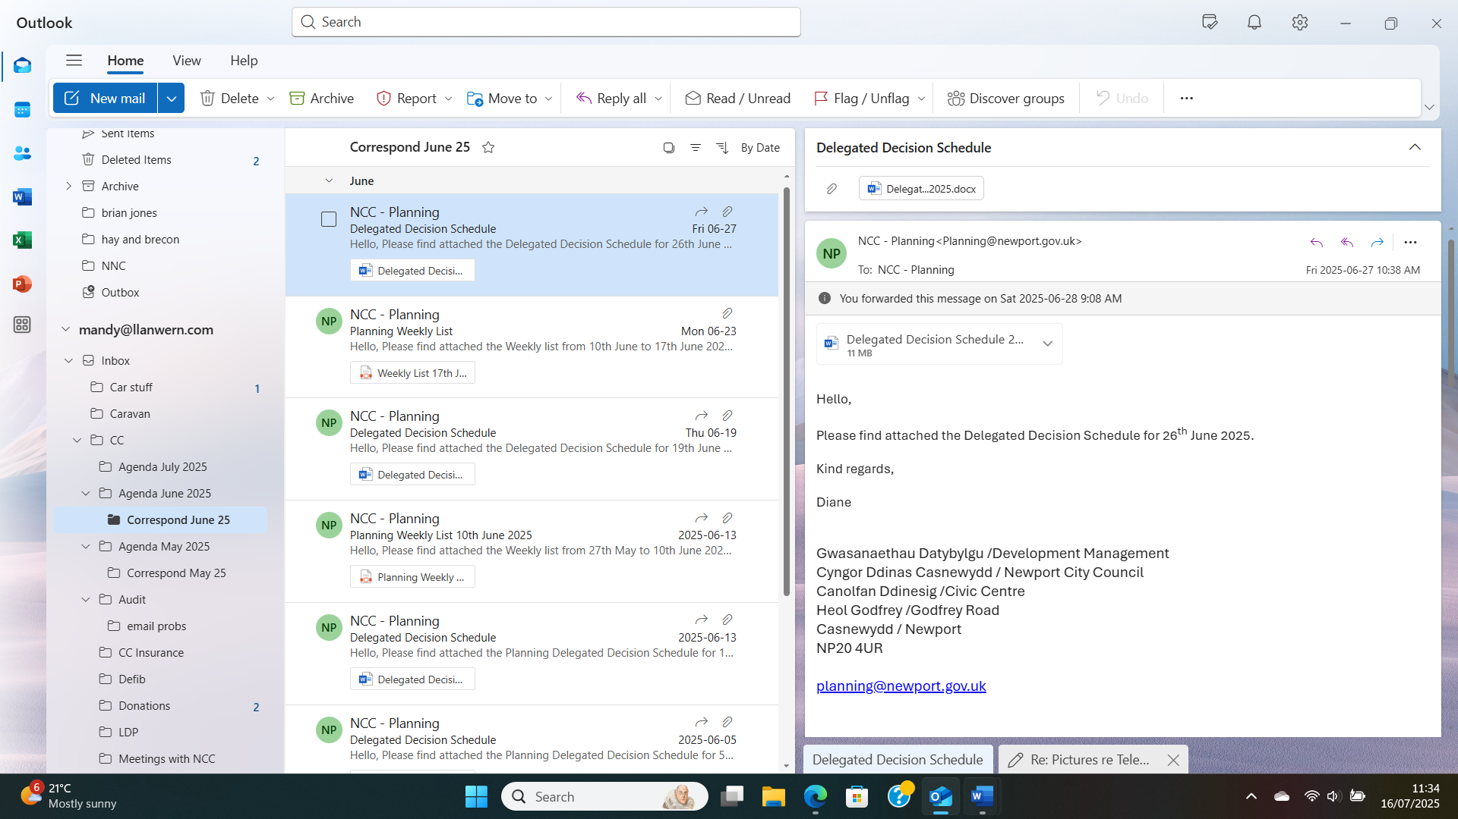  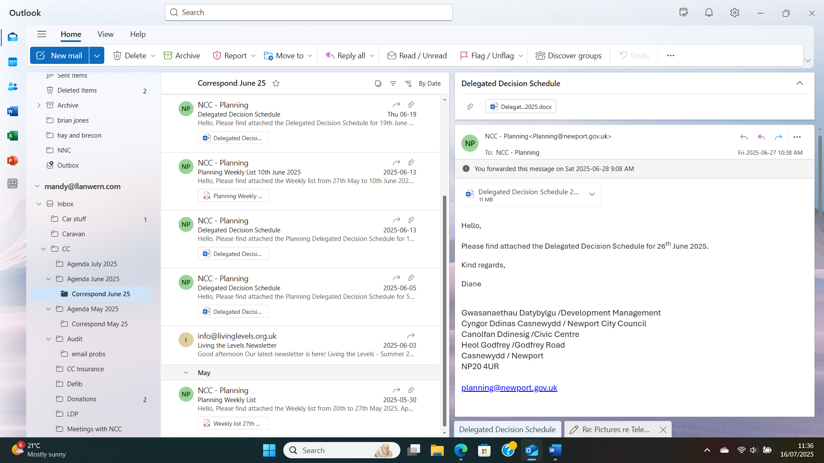
7. | DATE OF NEXT MEETING  The next meeting will be held on Monday 28th July 2025. This meeting will be held at the Village Hall and also remotely. The meeting closed at 8.30 pm.

