LLANWERN COMMUNITY COUNCIL

MINUTES OF MEETING

HELD AT LLANWERN VILLAGE HALL
TUESDAY 24th MARCH 2026 AT 7.00 PM

PRESENT: Cllrs M George (Chair), Brown, Davies and Grant

Clerk: Mandy George

Item | Description | Action
1. | APOLOGIES FOR ABSENCE  Apologies were received from Cllrs Clemo (work), Collingbourne (holiday) and Jones (work).
2. | MINUTES OF PREVIOUS MEETINGS  The Minutes of the meeting held on 23rd February 2026 were duly approved and signed.
3. | DECLARATIONS OF INTEREST  It was resolved that any declarations of interest should be stated during the course of the meeting, noted here and the necessary form completed.
4. | PUBLIC PARTICIPATION  None.
5. | SECTION A PLANNING  Station Road Flood Risk Management Scheme – Outline Business Case.  The Chair has asked Ward Cllr Kellaway to check for updates.  Redrow  Copies of letters have been circulated to all:  - Letter from John Griffiths MS and Jessica Morden MP to the Senydd  - Reply from the Senydd  - Letter from John Griffiths MS to Barratt-Redrow  An email was received from Cllr Deb Davies, Cabinet Member for Education and Early Years:  Having checked with officers regarding the current situation and school place availability unfortunately, I am not currently able to confirm an anticipated opening date for the proposed school at Great Milton Park.  Due to unforeseen circumstances, the previous proposal did not proceed beyond the first stage of consultation. There will be another public consultation on this proposal when a new proposed opening date is identified.  In the meantime, there is an overall sufficiency of primary school places in other schools in the Llanwern High cluster. The nearest schools are Milton Primary School, at a walking distance of approximately half a mile, and Ringland Primary School at a driving distance of approximately 1.5 miles. Both of these schools have places available in all year groups.  I have specifically worked with our highways team to ensure the walking route to Milton Primary School is safe, as I was made aware the underpass was a concern and this has now been resolved.  The Clerk will forward this email to GMPRA.  Glan Llyn  Responses are still being chased from Revantage (Adrian Andrews) by Cllr Clemo, regarding the meeting with the Chair and Ward Cllr Kellaway.  Prohibition of Traffic Order to Cot Hill  The Clerk has contacted the Traffic, Transport and Road Safety Team to object on the grounds that the road should not be closed until the highway, that traffic is now diverted onto, is adopted. Traffic is being diverted onto an unadopted road which is unlawful. No response has been received. | Chair  Clerk
20/0986 – Reserved Matters Application for 32no. Residential Flat Units (Housing Phase 2), Associated Infrastructure and Landscaping all Pursuant to Outline Permission 16/0864 for Residential Development of up to 1100 Dwellings, a Primary School, Village Centre, Public Open Space, Landscaping and Associated Infrastructure Works and Details to Partially Discharge the Following Conditions in Relation to Phase 2, 01 (Reserved Matters), 05 (Building Materials), 06 (Hardscaping Materials), 07 (Boundaries), 09 (Construction Details of Roads, Footways and Highways), 12 (Drainage), 21 (Parking) and 24 (Landscaping) – Llanwern Village Development Site Phase 2 Cot Hill.

On-going (part approved and part refused). To be read in conjunction with 22/0435 which is part approved and part refused.

22/0801 – Reserved Matters Application (Pursuant to Outline Permission 06/0471) for Residential Development on Phases 4b & 5d at the Glan Llyn Regeneration Site to Provide 170 Dwellings Including Details of Access, Appearance, Landscaping, Layout and Scale Together With Details to Partially Discharge Outline Planning Conditions 6 (Recreation Areas), 8 (Materials), 9 (Hard Landscaping), 10 (Boundary Treatments), 11 (Management Of Open Space), 12 (Parking), 15 (Emergency Access), 16 (Roads, Cycleways and Footways), 18 (Road Works), 22 (Streetlighting), 24 (Site Levels), 33 (Surface Water), 34 (Foul and Surface Water Drainage), 35 (Oil Interceptors), 39 (Carbon Reduction and Sustainability) and 43 (Firefighting Access) Llanwern Works Queensway Llanwern Newport

This application has been approved with conditions.

24/0465 - Reserved Matters Application for New Homes, Associated Infrastructure and Landscaping at Cedars 4 Pursuant to Outline Planning Permission 16/0864 for Residential Development of up to 1100 Dwellings and Provision of Primary School, Village Centre, Public Open Space, Landscaping and Associated Infrastructure Works Affecting Public Rights of Way 397/3, 397/7, 397/9 and 397/10, and Details to Discharge Conditions 5 (Building Materials), 6 (Hardscaping Materials), 7 (Boundary
Treatments), 9 (Highway Construction Details), 12 (Drainage), 18 (Ecological Management Plan), 19 (Noise Assessment), 21 (Parking) And 24 (Landscaping)

This application has been approved with conditions.

24/0466 - Reserved Matters Application for new Homes, Associated Infrastructure and Landscaping at Parcels Known as Hollies 5 and Hollies 6 Pursuant to Outline Planning Permission 16/0864 for Residential Development of up to 1100 Dwellings and Provision of Primary School, Village Centre, Public Open Space, Landscaping and Associated Infrastructure Works Affecting Public Rights of Way 397/3, 397/7, 397/9 and 397/10, and Details to Discharge Conditions 5 (Building Materials), 6 (Hardscaping Materials), 7 (Boundary Treatments), 9 (Highway Construction Details), 12 (Drainage), 21 (Parking) and 24 (Landscaping) Site: Llanwern Village Development Site Phase 1 Cot Hill Llanwern Newport NP18 2DP

Decision awaited.

24/0467 – Reserved Matters Application for Sports Pitches, Changing Facilities and Allotments, Associated Infrastructure and Landscaping Pursuant to Outline Planning Permission 16/0864 for Residential Development of up to 1100 Dwellings and Provision of Primary School, Village Centre, Public Open Space, Landscaping and Associated Infrastructure Works Affecting Public Rights of Way 397/3, 397/7, 397/9 and 397/10, and Details to Discharge Conditions 5 (Building Materials), 6 (Hardscaping Materials), 7 (Boundary Treatments), 12 (Drainage), 21 (Parking) and 24 (Landscaping) – Llanwern Village Development Site Phase 1 Cot Hill, Llanwern.

On-going. This application has been called-in.

25/0152 – Reserved Matters Application Relating to Layout, Scale, Appearance, Access and Landscaping for Residential Development at Phase4e/4g Pursuant To Outline Planning Permission 06/0471 for a Mixed Use Regeneration of the Former Llanwern Steelworks and Partial Discharge of Conditions 01 (Reserved Matters), 06 (Recreational Areas), 08 (Materials), 09 (Details of Hard Landscaped Access), 10 (Boundary Treatments), 11 (Management Strategy for Maintenance of Open Space), 12 (Off Street Parking and Cycle Parking), 15 (Emergency Access), 16 (Details of Roads/Cycleways/Footways), 18 (Estate Roads), 22 (Street Lighting and Car Parking Areas), 24 (Site Levels), 33 & 34 (Foul and Surface Water Drainage), 39 (Sustainability Statement) and 43 (Fire
Fighting Access) Site: Glan Llyn Development Site Phase 4e/4g
Queensway Llanwern Newport

Decision awaited.

Flooding of Subway to Dawson Close

It would appear that this has now been resolved (see email from Cllr Deb Davies.

Newport LDP

On-going.

Gwent Police – Llanwern Ward

A breakdown of calls was received and circulated to all. Regular Police Surgeries are being held for residents to voice their concerns.

SECTION B

FINANCE AND LOCAL GOVERNMENT

Bank reconciliation as at 24th March 2026

 |  | £
A | Balance on current a/c bank statement at 27 February 2026  Balance on deposit a/c bank statement at 24 March 2026 Total | 603.38  78,010.47  78,613.85
 | Outstanding items
B | Less unpresented cheques  J Lawrence and Sons  Microsoft  Yu Energy  Talk Talk  Planning Aid Wales  Total | 216.00  12.10  260.07  33.37  53.00  574.54
C | Plus uncleared payments into bank  Transfer from deposit a/c  Total | 500.00  500.00
D | Balance at 24th March A-B+C | 78,539.31

Accounts for Payment

DDs
YuEnergy - £260.07
TalkTalk - £33.37
Microsoft - £12.10

BACS
J Lawrence and Sons (Hedgecutting) - £216.00
Clerk (March) – £446.25
Planning Aid Wales (Training) - £53.00
Clerk’s Annual Office Expenses - £350.69

Local Government and Elections (Wales) Act 2021: Community and Town Councils Statutory Guidance

Training modules were circulated. Cllr Davies attended the Planning Aid Wales Training.

Audit 2025/26

Documentation has been received. Our internal auditor has agreed to audit the accounts for this year.

S 106 Monies towards new Primary School

The Clerk has sent in a FOI request for details of all S106 monies that Redrow have paid to NCC for Great Milton Park. Response awaited.

Section 137 Donations

It was agreed by all that the following donations be made:

£100 – St David’s Hospice Care
£100 – Wales Air Ambulance
£100 – Macmillan Cancer Research
£100 – Ty Hafan Children’s Hospice
£100 – Prostate Cymru

 | SECTION C – LEISURE AND AMENITIES  Village Hall  Car Park – Cllr Jones is awaiting further information from 2 of the contractors. The Chair advised that the S73 is being submitted to NCC.  Fire Risk Assessment – the Clerk will advise the VHMC that the last assessment was done approximately 5 years ago and that another will need to be arranged.  Use of Field on 6th June – a request was received from the VHMC for the field to be used for an ice/cream/coffee van. This request was agreed. Clerk to advise.  S106 monies for Playing Field  The Clerk will again chase the S106 monies amounting to £24,233.  Pedestrian Gates into Playing Field  It was agreed that these be removed for inspection and repair, with the exception of the ones leading into the children’s play equipment area which are in good order. The Clerk to arrange. | Clerk  Clerk  Clerk  Clerk
SECTION D – HIGHWAYS AND UTILITIES

Llanwern Park Bridge

On-going.

6. | CORRESPONDENCE – the following were emailed to Councillors:  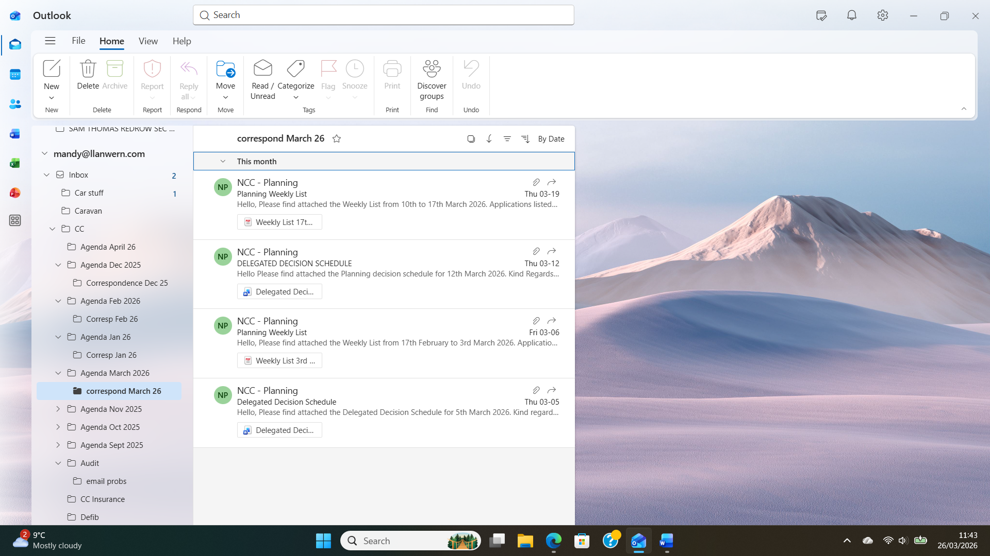
7. | DATE OF NEXT MEETING  The next meeting will be held on Monday 27th April 2026 at 7.00pm. This meeting will be held at the Village Hall and also remotely. The meeting closed at 8.20 pm.

